EDITING CODE

All code is text. As such, you can edit code any way you can normally edit text.

In the Pseudocode Execution Tool, code is edited in the code window, shown here outlined in red.

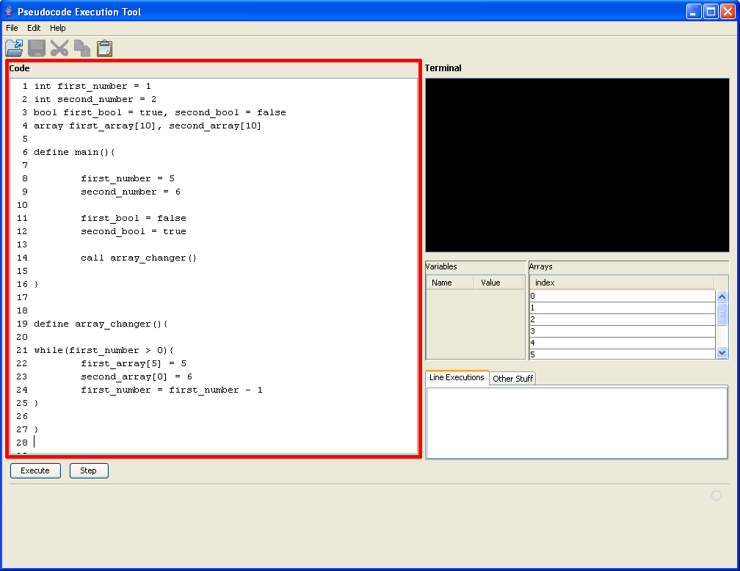
You can type code as you would normally type text, or copy and paste code, insert new lines and write more code... Anything you can do with text, you can do with your code in the code window. However, in order for it to make sense to the computer so that it can be run (or executed), it must be valid code.

