
OFFER FOR
{{equipment_name}}
Project / Equipment | {{equipment_name}}
Client | {{company_name}}
Enquiry No. | {{enquiry_ref}}

ENCON Thermal Engineers (P) Ltd
Your Answer to the Continued Need for Energy Conservation
297, Sector‑21B • Faridabad – 121 001 • Haryana, India
Tel: +91 (129) 4047847, 2439458
sales@encon.co.in • www.encon.co.in

{{company_name}}
{{company_address}}
Mobile No: {{mobile_no}}
Email: {{ email }}

KIND ATTN : {{poc_name}} ({{poc_designation}})

OUR REF: DATE:
{{enquiry_ref_short}} {{enquiry_date_str}}

SUB: {{subject}}

Dear {{ poc_greeting }},

Thank you for your enquiry regarding your requirement of our {{equipment_name}}. Please find attached herewith our offer for the same.

We hope the offer suits your present requirement. Though we have tried to be very elaborate in our offer, should you need any further assistance from our end to enable you to finalize the requirement, please contact us immediately. We would be happy to assist you anytime.

Thanking you. Looking forward to the pleasure of serving you in the near future.

With best regards,

{{ technical_person }}
ENCON Thermal Engineers Pvt. Ltd.
53 K.M Stone Vill- Baghola, Tehsil-Palwal
Mobile: {{ technical_phone }}
Email: {{ technical_email }}
Website: www.encon.co.in

NATIONAL ENERGY EFFICIENCY INNOVATION AWARD


TABLE OF CONTENTS
1. | COMPANY PROFILE
2. | ABOUT THE CLIENT
3. | TECHNICAL SPECIFICATIONS

LIST OF ANNEXURES
Annexure No. | Item | Remarks
Annexure - I | SCOPE OF SUPPLY | Attached
Annexure – II | PRICE SCHEDULE | Attached
Annexure - III | TERMS & CONDITIONS | Attached
Annexure - IV | REFERENCE LIST | Attached

1. ABOUT THE CLIENT

CLIENT DETAILS
Company | {{company_name}}
Contact Person | {{poc_name}}
Designation | {{poc_designation}}
Contact No. | {{mobile_no}}
Email | {{email}}

MARKETING PERSON DETAILS
Name | {{marketing_person}}
Email | {{marketing_email}}
Contact No. | {{marketing_phone}}

2. TECHNICAL SPECIFICATIONS

SEN PREHEATING OVEN
TECHNICAL SPECIFICATIONS: SEN PREHEATING OVEN

Equipment Type | SEN / SES Preheating Oven
Heating Medium | {{ fuel_name }} Fired Burners
Quantity | {{ sen_quantity }}
Operating Temperature | 1200°C
Heating Cycle Time | {{ heating_time }}
Insulation Lining | 200 mm Ceramic Fiber Module (1260°C)
{{ gas_line }} Burner Capacity | {{ burner_capacity_sen }}
No. of Burners | {{ num_burners_sen }}

ANNEXURE I — SCOPE OF SUPPLY: SEN PREHEATING OVEN
{{ pipeline_scope_text }}

OBJECTIVE
{{ sen_objective }}

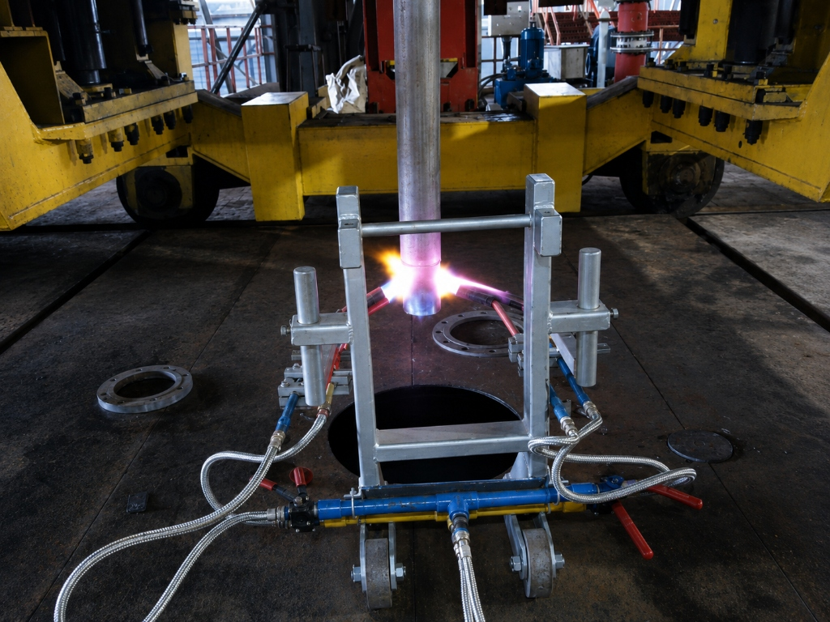

SCOPE OF SUPPLY
Our scope of supply will cover design, engineering, manufacture supply, supervision of commissioning & erection of the following main components for SEN Preheating Oven:

1. OVEN CHAMBER & STEEL STRUCTURE
Fabricated heavy-duty mild steel casing with structural reinforcement to form a rigid heating enclosure designed for 1200°C operating temperature.

2. CERAMIC FIBER INSULATION LINING
The internal walls and roof will be lined with 200 mm thick Ceramic Fiber Modules (1260°C grade) anchored with SS-304 hardware to minimize heat loss and maximize energy efficiency.

3. {{ sen_burners_heading }}
{{ sen_burners_body }}

4. {{ gas_line }} LINE FOR BURNERS
The {{ gas_line }} line for main burners shall consist of the following components:
{%p for x in fuel1_line_items %}
• {{ x.item }}
{%p endfor %}

5. AIR LINE FOR MAIN BURNERS
{%p for x in air_pipeline_items %}
• {{ x.item }}
{%p endfor %}

6. DOOR & TROLLEY RACK ASSEMBLY
{{ sen_trolley_text }}

ANNEXURE II — PRICE SCHEDULE
S. No. | Item Description | Qty | Unit Price (INR) | Total Price (INR)
1. | SEN Preheating Oven ({{ gas_line }} Line) | {{ item_qty }} | {{ unit_price }} | {{ total_price }}
 | TOTAL |  |  | {{ grand_total }}
(Rupees {{ total_in_words }} Only)

ANNEXURE III — TERMS & CONDITIONS
Prices | {{ tnc_prices }}
Delivery | {{ tnc_delivery }}
GST | {{ tnc_gst }}
HSN Code | {{ tnc_hsn_code }}
PAN / GST No. | {{ tnc_pan_gst }}
Terms of Payment | {{ tnc_payment_terms }}
Packing & Forwarding | {{ tnc_packing_forwarding }}
Freight Charges | {{ tnc_freight }}
Transit Insurance | {{ tnc_transit_insurance }}
Validity | {{ tnc_validity }}
Inspection | {{ tnc_inspection }}
Guarantee | {{ tnc_guarantee }}

