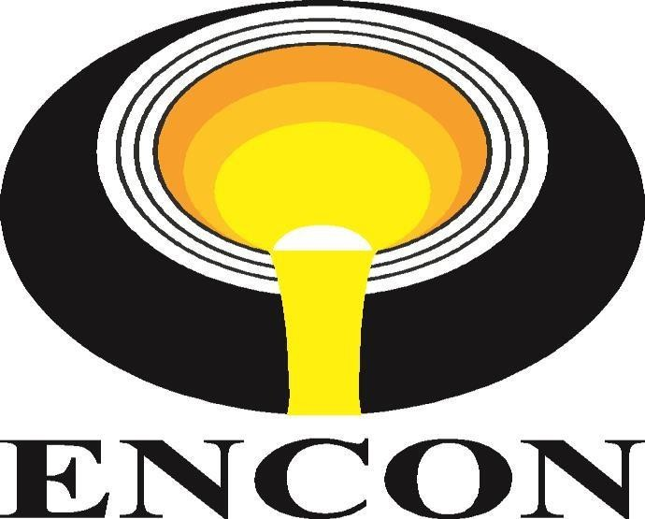

OFFER FOR
PROJECT/EQUIPMENT : Project
NAME OF EQUIOMENT : Recuperator
CLIENT : Real Ispat & Power Ltd.
ENQ. No./DATE : Mail enquiry, 05/08/2025
OUR REF. /DATE : ENCON.04026.049/FBD/JS
DT.13/08/2025

ENCON Thermal Engineers. (P) Ltd
297, Sector- 21B Faridabad – 121 001 (Haryana) India
Tel: +91(129) 4047847, 2439458
E-mail: sales@encon.co.in Website: www.encon.co.in


ENCON Thermal Engineers. (P) Ltd
297, Sector- 21B Faridabad – 121 001 (Haryana) India
Tel: +91(129) 4047847, 2439458,
E-mail: sales@encon.co.in Website: www.encon.co.in

ENCON YOUR ANSWER TO THE CONTINUED NEED FOR “ENERGY – CONSERVATION”

To,
Real Ispat & Power Ltd.
Urla Road, Raipur (C.G)
E: soumenbose@realgroup.org
Phone: +91 9229339029
Kind Attn. - Mr. Soumen Bose

YOUR REF: | OUR REF: | DATE:
Mail Enquiry | ENCON.04026.049/FBD/JS | 13/08/2025

Sub: Offer for Recuperator

Dear Sir,

We refer to your e-mail and specification sheet provided dated 5th August 2025, the requirement of Recuperators for 50 TPH Furnace.

We are enclosing here with our most competitive and comprehensive Offer for the same for your kind perusal.

Though we have tried to make the offer self-explanatory, still if you require any clarification or information, please feel free to contact us.

Regards
Jagdeep Singh
ENCON Thermal Engineers Pvt. Ltd.
53 K.M Stone Vill- Baghola, Tehsil-Palwal
Mob +91 7428488633
Email: operations@encon.co.in | www.encon.co.in
NATIONAL ENERGY EFFICIENCY INNOVATION AWARD


TABLE OF CONTENTS
S No. | Items
1. | COMPANY PROFILE`
2. | ABOUT THE CLIENT
3. | TECHNICAL SPECIFICATIONS
4. | GENERAL INFORMATION

LIST OF ANNETURES

Annexure No. |  | Items | Remarks
Annexure - I |  | SCOPE OF SUPPLY | Attached
Annexure - II |  | EXCLUSIONS | Attached
Annexure – III |  | PRICE SCHEDULE | Attached
Annexure - IV |  | TERMS & CONDITIONS | Attached
Annexure - V |  | REFERENCE LIST | Attached

- Company Profile

  - ABOUT US
Founded during the energy crisis of 1978 in India, ENCON Thermal Engineers Pvt Ltd is a pioneer in industrial heating and energy conservation solutions. The name “ENCON” stands for Energy Conservation & Conversion, reflecting the company’s commitment to sustainable energy practices. With over four decades of industry experience, ENCON specializes in providing innovative, reliable, and cost-effective thermal systems and equipment for various industries, including iron and steel, automotive, foundries, aluminum, glass, cement, pharmaceutical, and more.
We are well known for Designing, Manufacturing, Supplying and Commissioning of -FUEL EFFICIENT HEATING SYSTEMS on Turnkey basis

  - INDUSTRIES WE SERVE







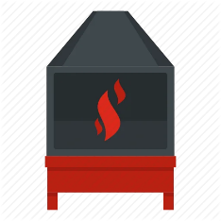

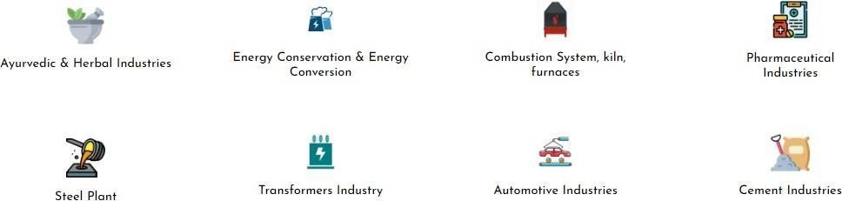

  - SOME OF OUR ESTEEMED CLIENTS

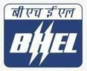















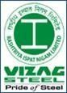




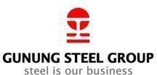


  - RESEARCH & DEVELOPMENT
At ENCON, our dedicated R&D division plays a crucial role in driving innovation and new developments. Our team of experts is continuously engaged in research to improve existing products and develop new technologies that enhance energy efficiency and performance. This commitment to R&D allows us to offer cutting-edge solutions that meet the evolving needs of our clients.
Recent developments from our R&D team include advancements in SELF Recuperative Burner and Regenerative Burners, which significantly improve thermal efficiency and reduce energy consumption in high temperature application. We are also exploring new materials and designs to further enhance the durability and effectiveness of our products.

  - OUR COMMITMENT
We have been committed to building long-term partnerships with our clients for the last 46 years and providing tailored solutions that meet specific needs and contributing to a sustainable future through energy conservation and innovation. ENCON‟s dedication to excellence is reflected in our core values: integrity, quality, customer focus, and continuous improvement.
As a trusted name in the industry, ENCON has successfully executed numerous projects worldwide, earning a reputation for reliability and technical expertise. Our customer-centric approach ensures that we not only meet but exceed client expectations, offering support and guidance throughout the project lifecycle.

  - ENCON’S GLOBAL PRESENCE



ABOUT THE CLIENT

Client Details:
Real Ispat & Power Ltd.
Urla Road, Raipur (C.G)
Kind Attn. - Mr. Soumen Bose
E: soumenbose@realgroup.org

Marketing Person Details:
Jagdeep Singh
E. operatios@encon.co.in
Contact No. +91 7428488633

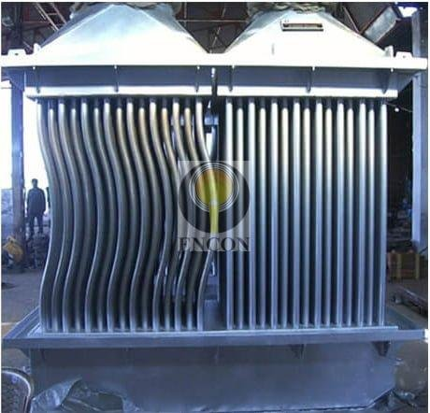

SCOPE OF SUPPLY
ANNEXURE –I

The Scope of supply will cover Design, manufacturing and supply of the recuperator as per the specifications provided by the client mentioned below.

RECUPERATOR (Waste Heat Recovery System)
The furnace will be provided with a waste heat recovery Recuperator for suitable capacity, which will preheat the combustion air to a temperature of about (300-350) °C. which in turn decreases fuel consumption. Recuperator will be of Convective type having two passes for air and single passes for flue gas. The flue gas will pass over the bank while air passes through the tubes. The tubes for hot Banks (CS Boiler Grade) and cold Banks used (CS Boiler Grade). The outer body of the recuperator shall be fabricated from MS plates of suitable thickness so that it may sustain thermal stresses developed during its work. The recuperator will be installed above the ground.

Recuperator Designing Parameters as per the data provided by Client
Volume of Flue Gas | 22,000 | Nm³/hr
Inlet Temperature of Flue Gas at Recuperator | 650 | °C
Outlet Temperature of Flue Gas at Recuperator | 320 | °C
Volume of Combustion Air to be Preheated | 20,000 | Nm³/hr
Initial Temperature of Preheated Air | 30 | °C
Final Temperature of Preheated Air | 350 | °C
Surface Area of Recuperator | 230 | m²
Hot Bank (CS Boiler Grade)
Diameter of the Tube | 48.3 | mm
Length of the Tube | 1.18 | metre
Thickness of Each Pipe | 3.68 | mm
Cold Bank (CS Boiler Grade)
Diameter of the Tube | 48.3 | mm
Length of the Tube | 1.18 | metre
Thickness of Each Pipe | 3.68 | mm

EXCLUSIONS
ANNEXURE –II

All parts and services, which are not specifically mentioned in “Scope of Supply Division”, with reference to the following:

EXCLUSIONS FOR ALL SYSTEMS
All parts or materials, which are not specifically mentioned in our Scope of supply with reference to the following.
- Civil work, Cabling, Piping work
- Any material handling equipment
- Installation accessories
- Any Refractory near the Recuperator

PRICE SCHEDULE
ANNEXURE –III

S. No. | ITEM DESCRIPTION | QTY | UNIT PRICE  (INR) | TOTAL PRICE  (INR)
1. | Recuperator for 50 TPH Furnace | 01 No. | 28,12,000.00 | 28,12,000.00
INR. TWENTY EIGHT LAKHS TWELVE THOUSAND ONLY. |  |  |  | 28,12,000.00

TERMS & CONDITIONS
ANNEXURE –IV

PRICES : Ex Works Bhagola, Dist: Palwal, Haryana unpacked

DELIVERY : 16 -20 Weeks from our ENCON works from the date of receipt of
Advance & Drawing approval whichever is later.

GST : @18 % will be charged Extra.

HSN CODE : 84541000
PAN NO / GST NO : AAACE0327M / 06AAACE0327M1ZV

TERMS OF PAYMENT : 30 % advance with the purchase order
70 % against Performa invoice prior to dispatch

PACKING : 4% Extra

FREIGHT CHARGES : In client‟s Scope

TRANSIT INSURANCE : To be arranged by the client.

VALIDITY : 45 days from the date of our offer

INSPECTION : If required, materials can be inspected at our works before dispatch at your cost with earlier intimation.

GUARANTEE : Materials will be guaranteed for a period of 18 months from the date
of dispatch or 12 months from the date of commissioning whichever is earlier against any manufacturing defects / poor workmanship
.

REFERENCE LIST
ANNEXURE –V

We have supplied Recuperators to various clients, some of them are listed below:

- Jordan Steel, Jordan
- Utility Alloys Pvt. Ltd., Coimbtatore
- CUMI Refractories, Chennai
- Sunflag Iron & Steel Company Ltd., Maharashtra
- Tata Steel Ltd, Boisar, MH
- Modern Steel Ltd, Mandi Gobindgarh
- Raj Shree Udyog, Mandi Gobindgarh
- Dhiman Iron & Steel Industries, Mandi Gobindgarh
- Bharat Ispat Udyog Pvt. Ltd., Mandi Gobindgarh
- Tameer Steel Factory Company Ltd., Saudi Arabia
- Premier Rolling Mills, Kenya
- Gulf Steel Industries, Abu Dhabi
- GTB Columbo Corporation, Sri Lanka
- Divine Alloys & Power Company Ltd., Jamshedpur
- Maadi Steel, Egypt
- Steel Rolling Mills Ltd., Uganda
- Star Wire, Faridabad
- Sadhu Forging Ltd., Faridabad
- Hindustan Udyog Ltd., Kolkata
- Steel Makers Ltd., Kenya

