

PROJECT/EQUIPMENT | : | PROJECT
NAME OF PROJECT | : | {{project_name}}
CLIENT | : | {{company_name}}, {{company_city}}, {{company_state}}
ENQ. No./DATE  ENCON REF. /DATE | :  : | {{enquiry_ref}}  {{quote_no}}5.048/FBD/JS  Dated: {{date}}
OFFER FOR

ENCON Thermal Engineers. (P) Ltd
297, Sector- 21B Faridabad – 121 001 (Haryana) India
Tel: +91(129) 4047847, 2439458
E-mail: sales@encon.co.in Website: www.encon.co.in


ENCON Thermal Engineers. (P) Ltd
297, Sector- 21B Faridabad – 121 001 (Haryana) India
Tel: +91(129) 4047847, 2439458,
E-mail: sales@encon.co.in Website: www.encon.co.in

ENCON YOUR ANSWER TO THE CONTINUED NEED FOR “ENERGY – CONSERVATION”
To,

{{company_name}}
{{company_state}}
India

Kind Attn. Mr. {{poc_name}} ({{poc_designation}})
Email: {{email}}
Mobile {{mobile_no}}

YOUR REF: | OUR REF: | DATE:
{{your_ref}} | {{quote_no}}5.048 /FBD/JS | {{date}}

Sub: {{subject}}

Dear Sir,

This is in reference to your enquiry about the requirement of ladle preheaters for the capacity of {{ladle_tons}} ton.

We are enclosing here with our most competitive and comprehensive Offer for the same for your kind perusal.

Though we have tried to make the offer self-explanatory, still if you require any clarification or information, please feel free to contact us.

Regards

{{technical_person}}
ENCON Thermal Engineers Pvt. Ltd.
53 K.M Stone Vill- Baghola, Tehsil-Palwal
Mob {{marketing_phone}}
Email: operations@encon.co.in | www.encon.co.in

NATIONAL ENERGY EFFICIENCY INNOVATION AWARD
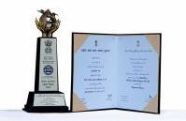

TABLE OF CONTENTS
S No. | Items
1. | COMPANY PROFILE`
2. | ABOUT THE CLIENT
3. | TECHNICAL SPECIFICATIONS
4. | GENERAL INFORMATION

LIST OF ANNETURES

Annexure No. |  | Items | Remarks
Annexure - I |  | SCOPE OF SUPPLY | Attached
Annexure - II |  | EXCLUSIONS | Attached
Annexure – III |  | PRICE SCHEDULE | Attached
Annexure - IV |  | TERMS & CONDITIONS | Attached
Annexure - V |  | REFERENCE LIST OF CLIENTS | Attached
Annexure - VI |  | MAKE LIST | Attached

- Company Profile

  - ABOUT US
Founded during the energy crisis of 1978 in India, ENCON Thermal Engineers Pvt Ltd is a pioneer in industrial heating and energy conservation solutions. The name “ENCON” stands for Energy Conservation & Conversion, reflecting the company’s commitment to sustainable energy practices. With over four decades of industry experience, ENCON specializes in providing innovative, reliable, and cost-effective thermal systems and equipment for various industries, including iron and steel, automotive, foundries, aluminum, glass, cement, pharmaceutical, and more.
We are well known for Designing, Manufacturing, Supplying and Commissioning of -FUEL EFFICIENT HEATING SYSTEMS on Turnkey basis

  - INDUSTRIES WE SERVE







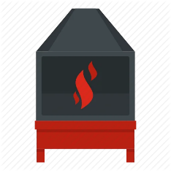

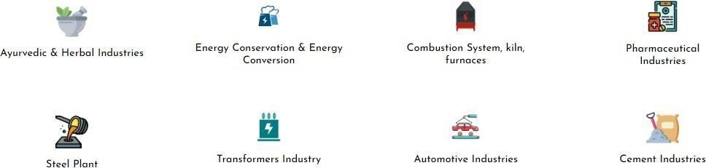

  - SOME OF OUR ESTEEMED CLIENTS

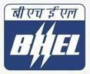






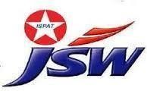








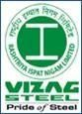


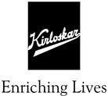

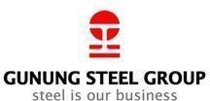


  - RESEARCH & DEVELOPMENT
At ENCON, our dedicated R&D division plays a crucial role in driving innovation and new developments. Our team of experts is continuously engaged in research to improve existing products and develop new technologies that enhance energy efficiency and performance. This commitment to R&D allows us to offer cutting-edge solutions that meet the evolving needs of our clients.
Recent developments from our R&D team include advancements in SELF Recuperative Burner and Regenerative Burners, which significantly improve thermal efficiency and reduce energy consumption in high temperature application. We are also exploring new materials and designs to further enhance the durability and effectiveness of our products.

  - OUR COMMITMENT
We have been committed to building long-term partnerships with our clients for the last 46 years and providing tailored solutions that meet specific needs, and contributing to a sustainable future through energy conservation and innovation. ENCON‟s dedication to excellence is reflected in our core values: integrity, quality, customer focus, and continuous improvement.
As a trusted name in the industry, ENCON has successfully executed numerous projects worldwide, earning a reputation for reliability and technical expertise. Our customer-centric approach ensures that we not only meet but exceed client expectations, offering support and guidance throughout the project lifecycle.

  - ENCON’S GLOBAL PRESENCE



ABOUT THE CLIENT

Client Details:
{{company_name}}
({{company_state}})
E. {{email}}
M. {{mobile_no}}
Marketing Person Details:
{{marketing_person}}
as@encon.co.in
Contact No. +91 9650900279

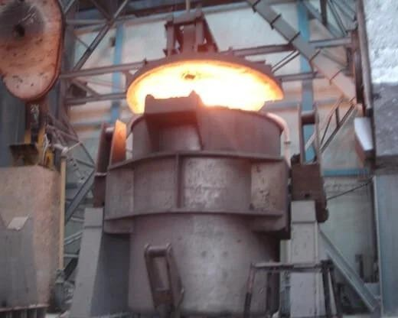

- TECHNICAL SPECIFICATIONS

  - DESIGN PARAMETERS

TECHNICAL DATA FOR {{ladle_tons}}T LADLE PREHEATER

Ladle Dimensions | {{ladle_dim}} {{ladle_drawing_no}}
Refractory Weight | {{refractory_weight_kg}}
Heating Schedule | {{heating_schedule}}
No. of Burner | 1 No.
Fuel | LDO
Calorific Value of Fuel | {{fuel_cv}}
Ignition of Burner | Through LPG fired Pilot Burner
Fuel Consumption | {{fuel_consumption}}
Burner Size & Capacity | {{burner_model}}
Combustion Air Blower | Centrifugal type, {{blower_model}}
Blower Size | {{blower_size}}
Capacity of Blower | {{blower_capacity}}
Lifting & Lowering, Swivel angle | Through Hydraulic cylinder operated with Power Pack, 85⁰
Motor recommended for Power Pack | {{hydraulic_motor_hp}}
Temperature Control | Manually, Temp. Indicator with Thermocouple is added.
Maximum Electrical Load | {{max_electrical_load}}

SCOPE OF SUPPLY
Our scope of supply will cover design, engineering, manufacture supply, supervision for erection & commissioning of the following main components.

SUPPORTING STRUCTURE
Necessary steel structures to hold & support the burner holding frame will be fabricated from mild steel plates and steel sections. The burner holding frame will be fixed along with column in such a way to maintain the gap of 100 mm from preheater face to ladle face. Fiber lined Heat Shield for column and arm of mild steel will be provided. Utility piping and other auxiliary equipment necessary for regulation of fuel and airflow will also be fabricated from mild steel pipes and sections.

HOOD & LINING
The hood fabricated out of MS of suitable thickness will be held with suitable supports. The hood will be lined with ceramic fiber blankets having density 128kg/m3. The fiber lining will be held through specially designed SS-304 studs. Total lining thickness will be 200 mm.

LIFTING & LOWERING MECHANISM
The Lifting Lowering mechanism of the Ladle hood will be done by a hydraulic cylinder in conjunction with power pack. The maximum lift of the arm shall be 85⁰. The hydraulic system will consist of an oil tank, oil gear pump with motor, suction strainer, pressure gauges with thumb operated needle valve, Direction valves, pilot operated check valves, pressure hoses, level switch and flow control valves. We will provide the following to minimize the exposure of the cylinder to dust and heat.

HYDRAULIC SYSTEM
To take out the Ladle easily after heating, the system will be provided with “Up and Down” movement of hood. The lifting/ lowering of the Ladle hood will be provided by single acting (in push) hydraulic cylinder fitted in Ladle column with dedicated power pack. Limit switches LS1 & LS2 will be provided to specify its location. LS1 will indicate its parking position & LS2 will indicate its working position. The maximum lift of the arm shall be 85° to its parking position. One no. of dedicated power pack of suitable capacity shall be provided for operating the hydraulic cylinder.
{%p if is_oil %}
ENCON FILM BURNER
For preheating the system, we have provided 1 No. Oil fired ENCON IIP Film Burner of suitable firing rate to achieve the desired temperature at required time. The burner will be consisting of the following main components:
- Burner alone
- Micro valve
- High alumina burner block
- CI Burner mounting plate
- Isolation valve on oil line
- Butterfly valves on air line
- Y-Strainer for oil line
{%p endif %}
{%p if is_gas %}
ENCON GAS BURNER
For preheating the system, we will supply 1 No. ENCON gas burner of suitable firing rate to achieve the desired temperature in the required time. The burner will consist of:
Burner alone
High alumina burner block
CI burner mounting plate
Ball valve on gas line
Butterfly valve on air line
Flexible hose set
{%p endif %}

PILOT BURNER & UV-SENSOR
We will be supplying 1 no. automatically LPG fired Pilot Burner having a rating of 7kW for ignition of main burner. The pilot burner will be equipped with electrode assembly, flame sensor, ignition transformer and burner control unit.

COMBUSTION AIR BLOWER
To supply combustion air to the above burners, we will be supplying a centrifugal type of mild steel plate air blower equipped with squirrel cage induction motor of reputed make such as ABB/CGL. The Blower will be directly driven mounted.

{%p if is_manual %}

COMBUSTION AIR LINE
The air train will be consisting of following main components:
- Pressure gauge with manual cock.
- Butterfly valve for manual air regulation
- Rotary Joint
{%p endif %}
{%p if is_automatic %}
AIR TRAIN FOR MAIN BURNER
The air train will consist of the following main components:
Pressure gauge with manual cock.
Orifice Plate with DPT
Pneumatic Flow control valve
Butterfly Valve (BFV)
Rotary Joint
{%p endif %}

{%p if is_oil %}

LD OIL PUMPING UNIT
To supply fuel oil to the above burner at requisite pressure, we will supply a suitable pumping unit type Duplex-1 comprising of the following main parts:
- 2 Nos. oil pumps each fitted with suitable electric motor.
- 1 No. each of Duplex type coarse and fine filter.
- 1 No. Pressure regulating valve.
- 1 No. of Pressure gauge.
{%p endif %}
{%p if is_gas %}
GAS TRAIN
To supply natural gas to the burner at the required pressure and flow, we will supply a packaged gas train comprising main components:
Ball valve (manual isolation)
Filter
Slam-shut-off valve
Pressure regulator
Pressure gauges (inlet & outlet)
Solenoid valve
Flexible hose pipe
{%p endif %}
{%p if is_automatic %}
BURNER CONTROL SYSTEM
The above burners will be governed by the following scheme fitted on the main fuel and air pipeline:
{%p if is_oil %}
On the main oil pipeline:
Micro Valve
Flow Meter
Motorized Control Valve
Manual Ball Valve
{%p endif %}
{%p if is_gas %}
On the main gas pipeline:
Gas Train with integral shut-off and regulation
Control Valve
{%p endif %}
On the main air pipeline:
Orifice Plate with DPT
Pneumatic Flow control valve
Manual butterfly valve
{%p endif %}

LPG TRAIN FOR PILOT BURNER
The pilot gas line will consist of following main components:
- Ball valve
- Filter
- Slam shut off Valve
- Pressure Regulator
- Pressure Gauge
- Solenoid Valve
- Flexible Hose Pipe

{%p if is_manual %}

TEMPERATURE CONTROL SYSTEM
There shall be provision of one ‘R’ Type simplex thermocouple in the Ladle hood for temperature measurement and a temperature indicator on the Control Panel. The control and maintenance of Ladle’s temperature will be manual. The thermocouple will be fitted in the Ladle hood at a suitable location.
{%p endif %}
{%p if is_automatic %}
TEMPERATURE CONTROL SYSTEM
The temperature of the ladle will be measured using one R-Type simplex thermocouple installed in the ladle hood, connected to a temperature transmitter. The transmitter signal will be fed to the PLC for automatic burner control. A temperature indicator will also be provided on the control panel. The PLC will manage the complete heating cycle — from ignition to temperature setpoint — with auto cut-off on reaching the target temperature.
{%p endif %}

{%p if is_manual %}

ELECTRICAL CONTROL PANEL
1 No. of Control Panel will be supplied along with the system. All the electrical equipment shall be conforming to the Indian Electricity Regulations for safety, earthing etc. & panel box to IP54 protection. The control panel will be fitted with the following main items.
- Ampere meter & Voltmeter of suitable capacity
- Combustion Air Blower start /stop push buttons.
- Burner Start / Stop Push Buttons
- Indicating lamps and fuses
- Safety relays and contactor
- Temperature Indicator
- MCB of suitable capacity
- Burner control unit for pilot Burner
- Push buttons for hydraulic cylinder operation.
{%p endif %}
{%p if is_automatic %}
ELECTRICAL CONTROL PANEL (PLC-BASED)
1 No. of PLC-based Control Panel with HMI (Touch Screen) will be supplied. The panel will include:
PLC with HMI for automatic burner sequencing and temperature control
Temperature transmitter input from R-Type thermocouple
Automatic burner ignition and flame monitoring sequence
DPT (Differential Pressure Transmitter) for combustion air and fuel flow monitoring
Control valves for proportional air and fuel regulation
Ampere meter & Voltmeter of suitable capacity
Combustion Air Blower start/stop with interlocks
Safety relays, contactors, and MCBs
Indicating lamps, alarms, and fault diagnostics on HMI
Push buttons for hydraulic cylinder operation
{%p endif %}

PIPELINE
The scope of supply of pipeline will include combustion air pipeline, blower to the burner, LPG gas train to Pilot Burner, Oil Pipeline From Pumping unit to Burner. From Oil Tank to Pumping unit shall be in client scope.

CABLING
All necessary cabling shall be done by the client. We will provide the specifications of cable after receipt of the order.

PAINTING
All steel material will be painted, and the surface will be cleaned according to general specifications of painting. All bought out components will remain in standard supplier’s finish. Pipelines shall be painted as per color code.

SCOPE OF SUPPLY
ANNEXURE –I

SCOPE OF SUPPLY:
Our scope of supply will cover design, engineering, manufacture, and supply, of the following components:

- VERTICAL LADLE PREHEATER
- Column
- Ladle hood with arm
- Hydraulic Cylinder with Power Pack
- Oil Burner
- LD oil Pumping unit
- Blower
- Pilot Burner with Accessories
- Control Panel
- Pipeline up to Battery limits as mentioned above

EXCLUSIONS
ANNEXURE –II

All parts and services, which are not specifically mentioned in “Scope of Supply Division”, with particular reference to the following:

EXCLUSIONS FOR ALL SYSTEMS
All parts or materials, which are not specifically mentioned in our Scope of supply with reference to the following.
- Civil wok, Cabling, Piping work
- Any fume extraction system
- Any material handling equipment
- Foundation Bolts for column/structure.
- Ladle Stand/Support
- All Electrical Cablings

PRICE SCHEDULE
ANNEXURE –III

S. No. | ITEM DESCRIPTION | QTY | UNIT PRICE  (INR) | TOTAL PRICE  (INR)
1. | {{equipment_name}} | 01 Set | {{total_price_vertical}} | {{total_price_vertical}}
2. | Supervision Charges  for  Erection  &  Commissioning  Erection By Client  &  Supervision by Encon |  | {{supervision_mech}} (Mechanical)  {{supervision_plc}} (PLC & Instrumentation)  +  To & Fro Air fare from Delhi to Site  +  Boarding & Loading, Local Conveyance & Medical assistance if required
INR. {{total_in_words}} |  |  |  |  | {{total_price_vertical}}

TERMS & CONDITIONS
ANNEXURE –IV

PRICES : Ex Works Bhagola, Dist: Palwal, Haryana unpacked

DELIVERY : 10-12 Weeks from our ENCON works from the date of receipt of
Advance & Drawing approval whichever is later

GST : 18 % Extra

HSN CODE : 84541000
PAN NO / GST NO : AAACE0327M / 06AAACE0327M1ZV

TERMS OF PAYMENT : 30 % advance with the purchase order
70 % against Performa invoice prior to dispatch
PACKING &
FORWARDING : 4% & 2 % respectively

FREIGHT CHARGES : In client’s Scope

TRANSIT INSURANCE : To be arranged by the client

VALIDITY : 45 days from the date of our offer

INSPECTION : If required, materials can be inspected at our works before dispatch at your cost with earlier intimation.

GUARANTEE : Materials will be guaranteed for a period of 18 months from the date
of dispatch or 12 months from the date of commissioning whichever is earlier against any manufacturing defects / poor workmanship

.

REFERENCE LIST
ANNEXURE –V

REFERENCE FOR LADLE PREHEATERS
1 | Primetals Technology | Ladle Preheaters 350T & 370T
2 | JSW, Vidyanagar, Bellary | Vertical Ladle PH - 165T
3 | Tata Steel (Angul) | Ladle Preheaters - 200T
4 | JSPL, Raigarh | Vertical Ladle Preheater - 100T
5 | JSPL, Raigarh | Vertical Ladle Preheater - 65T
6 | Vardhman Special Steel Ltd. | 30T Vertical Ladle Preheater - NG
7 | RML Chaliyama | Vertical Ladle Dryer & Horizontal Ladle Preheater
8 | Ganesh Steel & Alloys Ltd. | 10T Vertical Ladle Preheater
9 | SMS India Pvt. Ltd. | Ladle Stirring Valve Rack
10 | Emirates Steel | Vertical Ladle Preheater - 50T
11 | Kisco Casting India Limited | Ladle Preheaters services
12 | RML Dhenkanal | Vertical Ladle Dryer & Horizontal Ladle Preheater
13 | Rungta Mines Limited KSP | Vertical Ladle Drier and Horizontal LPH
14 | JSW Dolvi | Tundish Preheaters
15 | JSL Jajpur | Horizontal & Vertical Ladle Preheaters -100 T
16 | Aarti Steels Limited | Ladle Hood & Heater - 4kW
17 | Glorious Green Gate Co. Ltd | 20 Vertical Ladle Preheaters
18 | Devbhoomi Casting Pvt. Ltd. | 15 T Ladle Preheaters
19 | RML Dhenkanal | Vertical Ladle Dryer & Horizontal Ladle Preheater
20 | Muscat Steel | Ladle Pre Heaters
21 | Electrotherm | Ladle Pre Heaters
22 | Mukand Steel | Ladle Pre Heater
23 | Danieli India | Ladle Pre Heaters
24 | JSW Salem | Ladle Pre Heater
25 | BSRM | Ladle Pre Heater-50T

MAKE LIST
ANNEXURE –VI

ITEM | MAKE

