
OFFER FOR
{{equipment_name}}
Project / Equipment | {{equipment_name}}
Project Name | {{project_name}}
Client | {{company_name}}
Enquiry No. | {{enquiry_ref}}
ENCON Thermal Engineers (P) Ltd
Your Answer to the Continued Need for Energy Conservation
297, Sector‑21B • Faridabad – 121 001 • Haryana, India
Tel: +91 (129) 4047847, 2439458
sales@encon.co.in • www.encon.co.in

COVER LETTER
To,
{{company_name}}
Kind Attn: {{poc_name}} ({{poc_designation}})
{{company_address}}
Contact No.: {{mobile_no}}
Email: {{email}}
OUR REF: DATE:
{{enquiry_ref_short}} {{enquiry_date_str}}
Subject: {{subject}}
Dear {{ poc_greeting }},
This is with reference to your enquiry for {{equipment_name}} as per the technical specifications shared.
We are pleased to enclose herewith our most competitive and comprehensive offer for the same for your kind perusal.
Though we have endeavoured to make the offer self-explanatory, please feel free to contact us should you require any clarification or additional information.
Regards,
{{technical_person}}
ENCON Thermal Engineers Pvt. Ltd.
53 K.M Stone Vill- Baghola, Tehsil-Palwal
Mob: {{technical_phone}}
Email: {{technical_email}}
Website: www.encon.co.in
NATIONAL ENERGY EFFICIENCY INNOVATION AWARD


PART – A

TECHNICAL OFFER

REGENERATIVE BURNERS
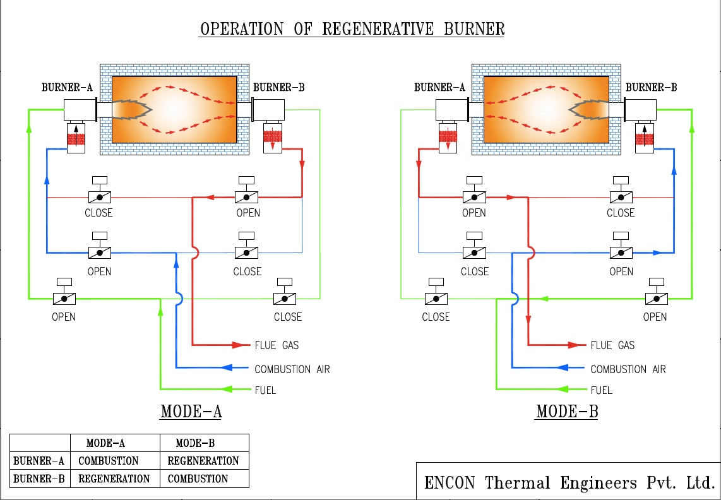
We are proposing to give REGEN Burners in the furnace, REGEN is a range of Low NOx Regenerative burners developed by ENCON.
REGEN BURNERS work in pairs. In Mode A, Burner A fires and Burner B act as a regenerator or heat sink, the flue gas is sucked through Burner B, the flue gas travels through the media box in the regenerator of Burner B, the flue gas from the burner are sucked through a fan to the chimney, The Media box or Regenerator is filled with Ceramic balls which absorbs up to 85% of the heat of the flue gases.

In Mode B, the process is reversed and Burner A act as the regenerator and Burner B fires, in this case combustion air passes through the hot media and we are able to achieve a Combustion air temperature which is approximately 300 °C below the process temperature, for example if the process temperature is 1100 °C we will be able to achieve a temperature of 800 °C for the combustion air. This cycle repeats itself; the cycle time varies from 30 seconds to 20 minutes depending on the application and temperatures.

ENERGY SAVING
The chart shows the Saving in natural gas in a furnace compared to a system with no recuperator, a system with a recuperator giving a preheat temperature of 400⁰C and with Regenerative burners operating with a preheat temperature of 1000⁰C.
Savings In NATURAL Gas
Furnace Temp °C | Recuperator vs Cold Air | REGEN vs Cold Air | REGEN vs Recuperator
1050 | 27.0% | 42.6% | 21.3%
1100 | 27.9% | 43.7% | 21.9%
1150 | 28.9% | 44.9% | 22.5%
1200 | 30.0% | 46.2% | 23.1%

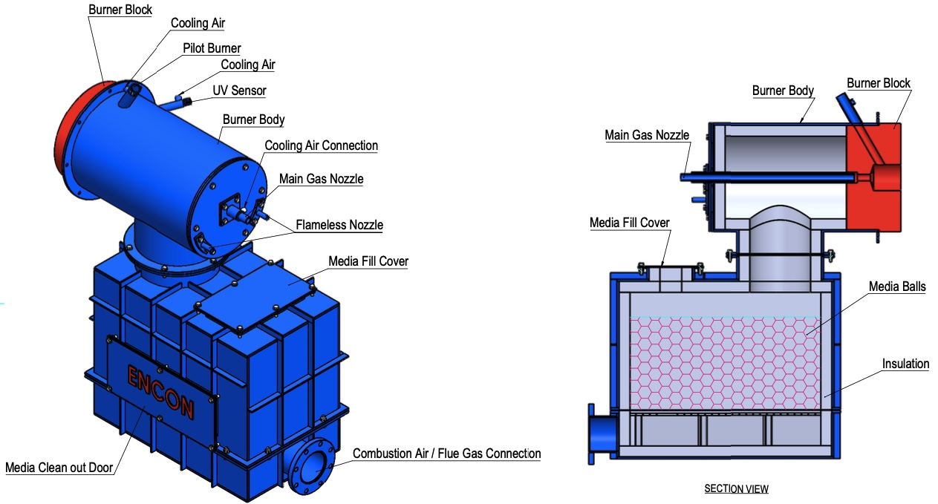
PART OR REGENERTAIVE BURNER (Flameless nozzle is not included)

ENCON REGENERATIVE {{ fuel_word }} BURNERS – {{ burner_count }}
We shall supply {{ qty_words }} of ENCON Regen Burners of {{ kw }} kW Capacity, the fuel used in these burners will be {{ fuel_name }}. Each regen burner is accompanied by an air-cooled pilot burner and UV Sensor.
PNG GAS TRAIN FOR MAIN BURNERS
We shall supply suitable capacity of gas train for PNG which supply the fuel to burners at desired flow and pressure. The gas train will be consisting of following main components: Pressure at TOP 2.1 bar and minimum pressure as 1 bar is considered.

- Ball valve
- Inlet Pressure Gauge with TNV
- Gas filter
- RPD Flowmeter with communication
- Slam Shut off Valve.
- Pressure Regulator/ Gas governor
- Safety Relief Valve
- Outlet Pressure Gauge with TNV
- High & low-pressure switches with manual valve
- Solenoid Valve
- Safety Solenoid Valve
- Ball Valve
GAS LINE FOR PILOT BURNER
The gas line for pilot burner shall be routed from main gas train and will be consisting of following main components: The tube of Pilot burner shall be SS – 304 We have supplied the same tube and it’s working well as per the requirement.
- Ball valve
- Pressure gauge with manual cock
- Pressure regulator
- Solenoid Valve
- Flexible Hoses
COMBUSTION AIR BLOWER
To supply the adequate quantity of combustion air to the above burners, we will be supplying one number centrifugal steel plate direct driven air blower of suitable capacity and Pressure and motor of standard make like Crompton, ABB, and BB.
SUCTION BLOWER FOR FLUE GAS
To suck the flue gases from furnace through the Regenerative Burners via regenerator, we will be supplying One centrifugal suction air blower of suitable capacity & pressure, max. temp 300⁰C and the motor of standard make like Crompton, ABB, GEC.

TEMPERATURE CONTROL
To control and maintain the temperature of furnace accurately, the furnace is governed through a control zone which is automated by PLC. The temperature control system will consist of the following main components:
- PLC S7 – 1200
- One Thermocouple with Temperature Transmitter
- One Orifice with DPT Volumetric flow meter for Air
- One Orifice with DPT Volumetric flow meter for Gas
- One Pneumatic Flow Air Control Valve
- One Pneumatic Flow Gas Control Valve
- One Pneumatic Flow Flue Control Valve

OPERATIONAL SEQUENCE
The Sequence of temperature of each zone in the furnace will be as following:
A thermocouple fitted in the furnace will sense the temperature, and give temperature feedback to the P.L.C.
- DPT on the airline and gas line will give a signal indicating the flow in the Air & Gas header.
- The Flow of Air & Gas entering to burner will be governed by the ratio set in the PLC.
- If the temperature needs to increase the PLC will give signal to increase the flow of Air by modulating the Air control valve. Once the Air control valve modulated the Gas control valve will open according to the ratio set on the PLC (the flow meters will continuously monitor the flow of air & gas), thus increasing the gas flow while maintaining the air to gas ratio in burner. Similarly, if the temperature has to reduce, the PLC will give a signal to reduce the flow of Air and flow of gas will be reduced accordingly maintaining air gas ratio as per set point.
FURNACE PRESSURE CONTROL SYSTEM
The furnace pressure control system will be consisting of the following main component:
- P.L.C S7 – 1200
- 1 Pressure Sensing Tube with Pressure Transmitter be installed in the furnace.
- 1 Damper type Flue control Valves
OPERATIONAL SEQUENCE
The Sequence of Pressure control in the furnace will be as following:
- The sensing tube fitted in the furnace, will give the Pressure differential and that will be sensed by the Pressure Transmitter
- The pressure transmitter will give a signal to the P.L.C indicating the furnace pressure.
- P.L.C will send a signal to the flue control valve fitted on the flue line to modulate according to the set pressure.

ELECTRICAL CONTROL PANEL
One No. Control panel would be supplied along with the system. All the electrical equipment shall be conforming to the Indian Electricity regulations for safety, earthing etc. and panel box to IP54 protection. The control panel will be fitted with the following main items:
Ampere meter & Voltmeter of suitable capacity | Indicating lamps and fuses
S7 1200 P.L.C with HMI | Safety relays and contactors
MCB of suitable capacity | Safety and interlocks
Overload relays – Solid state type  And fuses/switchgears for all motors. – Siemens Make. | Main Switch.

BILL OF MATERIAL
Description | Qty.
BURNER (complete set) Consist of:
Burner with Accessories | 2 Nos.
Burner with Regenerator | 2 Nos.
Pilot Burners | 2 Nos.
NG Burners | 2 Nos.
Burner Controller | 2 Nos.
Ignition Transformer | 2 Nos.
UV Sensor | 2 Nos.
For Pilot Burner
Pilot regulator | 2 Nos.
Pilot Solenoid Valve | 2 Nos.
Ball Valve | 2 Nos.
Pressure Gauge | 2 Nos.
Flexible Hose | 1 set
Pneumatic Shut Off Valve Air | 2 Nos.
Pneumatic Flow Control Valve – AIR | 1 Nos.
DPT With Orifice Plate - Air | 1 Nos.
Pressure Gauge | 2 Nos.
Pneumatic Shut Off Valve Flue Gas | 2 Nos.
Pneumatic Control Valve Flue Gas | 1 Nos.
Pneumatic Flow Control Valve -Gas | 1 Nos.
DPT With Orifice Plate- Gas | 1 Nos.
Thermocouple with TT (for burner) | 4 Nos.
Air, Fuel & Flue Gas Pipelines | 1 Lot
NATURAL GAS TRAIN – gas flow & consumption shall be shown in PLC directly.
Ball Valve | 01 No.
Pressure gauge with Isolation Valve | 01 No.
Gas Filter | 01 No.
Slam Shut off Valve | 01 No.
Pressure Regulator | 01 No.
Pressure Relief Valve with isolation valve | 01 No.
Safety Auto reset Solenoid Valve | 01 No.
Low Gas Pressure Switch with manual valve | 01 No.
High Gas Pressure Switch with manual valve | 01 No.
Solenoid Valve | 01 No.
Fitting for valves for pilot line | 01 No.
Solenoid Valve for Main Burners | 02 Nos.
Miscellaneous
PLC S7 – 1200 with HMI Siemens | 1 No.
Combustion Air Blower with Motor (IE3) | 1 No.
Flue gas Suction Blower with Motor. | 1 No.
Thermocouple with TT for Furnace | 1 No.
Pressure Sensing Tube | 1 No.
DPT for Pressure | 1 No.
Control Panel | 1 No.

EXCLUSIONS
All parts and services which are not specifically mentioned in “Scope of Supply Division”, with reference to the following:

S. No. | Description
1. | Civil foundations including civil shuttering drawings, foundation planning, reinforcement details, embedded conduits.
2. | Construction of instrumentation control room and electrical and air conditioning fittings for it.
3. | E.O.T. cranes, pulley blocks, lifting tackles and accessories.
4. | Fire alarm and firefighting systems.
5. | Utility piping beyond the specified battery limits.
6. | Potable water, generating and distribution.
7. | Track system, vehicles, forklift trucks and any other transportation equipment.
8. | Any arrangement for removal/disposal of scales.
9. | Covers for trenches, openings for equipment.
10. | Standard tools and tackles for operation and maintenance.
11. | First fill of lubricants and hydraulic oils, as required.
12. | All erection and commissioning spares.
13. | Compressor air for atomizing and pneumatic cylinder. (Pipeline up to furnace end)
14. | Power Cable, Cabling, and earthling materials complete with necessary auxiliaries like junction boxes, cable trays, clamps, etc.

MAKE LIST

ITEMS | MAKE
MS Material | Main/Jindal
Motor | ABB
Control Panel | Encon
Solenoid Valve | Madas
Flexible Pipe | BIL/Flexible/Bengal Engineers
Butterfly Valve | AUDCO/L&T
Burner controller unit, Ignition  Transformer, UV sensor | Linear/Cofi/Danfoss
Pilot Burner | Encon
Ball Valve | AUDCO/ L&T
Pipeline | Jindal/Tata
Pressure gauge | H-Guru
Pressure regulator | Madas
Pressure switch Low/High | Madas/Switzer
Regen Gas Burner (LPG/NG) | Encon
Contractor/MCB | ABB/Siemens/Schneider
Pneumatic Shut Off Valve | Dembla
Pneumatic Flow Control Valve | Dembla
NG/PNG Gas Train Components | Madas
Thermocouple | SB International
Temperature Transmitter | Honeywell
DPT | Honeywell/ ABB
Orifice Plate | Engineering Specialties
RPD Flowmeter | Honeywell/Madas
Combustion Air Blower | Encon
ID Fan – Suction Blower | Encon

PART – B
PRICE SCHEDULE

S. No. | Description | Price (INR)
1. | {{ price_line_desc }} | {{ price_inr }}
Total (Ex Works, Faridabad Price) |  | {{ price_inr }}
Price in Words: {{ price_in_words }}

SUPERVISION CHARGES FOR ERECTION & COMMISSIONING
- Mechanical & Instrumentation Supervisor: Rs.12,500/day/person, to & fro fare from Faridabad to destination plus Boarding & Lodging.
- PLC Supervisor: Rs.15,500/day/person, to & fro fare from Faridabad to destination (Air/Train 2nd AC) plus Boarding & lodging.

TERMS AND CONDITIONS
- All the material supplied by us will be received by your store for safe custody and storage. The material will be issued to us as and when required for installation.
- You will provide electricity and water free of charge for the erection work.
- You will provide crane facilities available in your works, free of charge.
- Delivery and Erection schedule:
  - We will prepare and submit drawings for the furnace within 5 weeks from the date of your confirmed order for the design work. After approval of the drawings from your end we will supply the items of our scope of supply within 15 weeks from the date of approval of your drawings.
  - We will mutually work out the erection schedule based on your scope of erection work.
  - We shall not be responsible for any delay in the completion of work due to the non-availability of fronts, delay in issue of work permits, safety clearances and other clearances, which fall in your preview.
- Transportation of all the materials from our factory to your work site shall be extra at actual and chargeable to you.
- Taxes and Duties will be extra at actuals.
- Payment terms:
  - 30% to be paid along with purchase order.
  - 70% of the value of the contract shall be paid against inspection of material at our work site.
- Packing 4% of the order value to be charged extra.
- Warranty/ Guarantee: 18 months from the date of the material supplied (any manufacturing defect) or 12 months from date of commissioning, whichever is earlier.

ROI
Furnace Size (Ton/Hr)
Present Fuel Consumption (Nm3/ton ) | 90.00
Fuel Consumption with regenerative burner (Nm3/ton ) | 63.00
Fuel Saving (Nm3/Ton ) | 27.00
Average Cost of Natural Gas (INR/Nm3) | 50.00
Cost of Electricity (Rs/Kw) | 8.00
Working Days | 330.00
Working Hours | 16.00
Retrofit Cost
Cost of Regnerative Burner System | 5,100,000.00
Saving
Savings in Fuel Cost per year (considering 330 days and 16 hrs of working) | 7,128,000.00
Total Saving | 7,128,000.00
Extra Costs
Electricity - Blower | 236,016.00
Maintainace Cost | 51,000.00
Spare Cost | 102,000.00
Additioanl Costs | 389,016.00
NET SAVINGS PER ANNUM (Rs.) | 6,738,984.00
NET SAVINGS PER DAY (Rs.) | 20,421.16
Approx. Pay Back Of Regenerative Burner (DAYS) | 250.00

Note:-
- There will be reduction in Dross Formation.
- Also the savings are calculated assuming that there is a recuperator which is Preheating combustion air to 350°C.
- This will lead to quicker payback.

