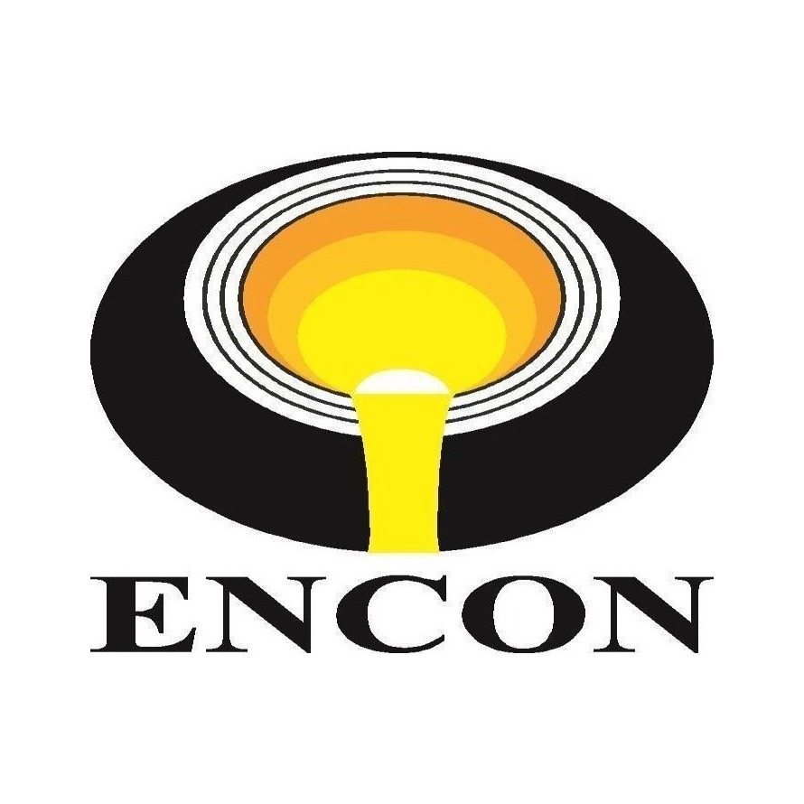
OFFER FOR
{{equipment_name}}
Project / Equipment | {{equipment_name}}
Client | {{company_name}}
Enquiry No. | {{enquiry_ref}}

ENCON Thermal Engineers (P) Ltd
Your Answer to the Continued Need for Energy Conservation
297, Sector‑21B • Faridabad – 121 001 • Haryana, India
Tel: +91 (129) 4047847, 2439458
sales@encon.co.in • www.encon.co.in

COVER LETTER
To,
{{company_name}}
Kind Attn: {{poc_name}} ({{poc_designation}})
{{company_address}}
Contact No.: {{mobile_no}}
Email: {{email}}

Subject: {{subject}}
Dear Sir,
This is with reference to your enquiry for {{project_name}} as per the technical specifications shared.
We are pleased to enclose herewith our most competitive and comprehensive offer for the same for your kind perusal.
Though we have endeavored to make the offer self-explanatory, please feel free to contact us should you require any clarification or additional information.
Regards,
{{technical_person}}
ENCON Thermal Engineers Pvt. Ltd.
Mob: {{technical_phone}}
Email: {{technical_email}} | www.encon.co.in

TABLE OF CONTENTS
S. No. | Section
1 | Company Profile
2 | About the Client
3 | Technical Specifications
4 | General Information

LIST OF ANNEXURES
Annexure No. | Item | Remarks
Annexure I | Scope of Supply | Attached
Annexure II | Price Schedule | Attached
Annexure III | Terms & Conditions | Attached

1. COMPANY PROFILE

ABOUT US
Founded during the energy crisis of 1978 in India, ENCON Thermal Engineers Pvt. Ltd. is a pioneer in industrial heating and energy conservation solutions. The name “ENCON” stands for Energy Conservation & Conversion, reflecting the company’s commitment to sustainable energy practices. With over four decades of industry experience, ENCON specializes in providing innovative, reliable, and cost-effective thermal systems and equipment for various industries, including iron and steel, automotive, foundries, aluminum, glass, cement, pharmaceutical, and more.
We are well known for designing, manufacturing, supplying, and commissioning fuel-efficient heating systems on a turnkey basis.

INDUSTRIES WE SERVE
Iron & Steel • Automotive • Foundries • Aluminium • Glass • Cement • Pharmaceutical • Heat Treatment

SOME OF OUR ESTEEMED CLIENTS
ENCON has built lasting partnerships with leading names across the steel, casting, and process industries.

RESEARCH & DEVELOPMENT
At ENCON, our dedicated R&D division plays a crucial role in driving innovation and new developments. Our team of experts is continuously engaged in research to improve existing products and develop new technologies that enhance energy efficiency and performance. This commitment to R&D allows us to offer cutting-edge solutions that meet the evolving needs of our clients.
Recent developments from our R&D team include advancements in self-recuperative and regenerative burners, which significantly improve thermal efficiency and reduce energy consumption in high-temperature applications. We are also exploring new materials and designs to further enhance the durability and effectiveness of our products.

OUR COMMITMENT
We have been committed to building long-term partnerships with our clients for the last 46 years — providing tailored solutions that meet specific needs and contributing to a sustainable future through energy conservation and innovation. ENCON’s dedication to excellence is reflected in our core values: integrity, quality, customer focus, and continuous improvement.
As a trusted name in the industry, ENCON has successfully executed numerous projects worldwide, earning a reputation for reliability and technical expertise. Our customer-centric approach ensures that we not only meet but exceed client expectations, offering support and guidance throughout the project lifecycle.

ENCON’S GLOBAL PRESENCE
With installations across India, the Middle East, and South-East Asia, ENCON serves a global customer base — backed by responsive after-sales support and a worldwide network of partners.


2. ABOUT THE CLIENT

CLIENT DETAILS
Company | {{company_name}}
Contact Person | {{poc_name}}
Designation | {{poc_designation}}
Contact No. | {{mobile_no}}
Email | {{email}}

MARKETING PERSON DETAILS
Name | {{marketing_person}}
Email | {{marketing_email}}
Contact No. | {{marketing_phone}}

3. TECHNICAL SPECIFICATIONS

COMBINED EQUIPMENT OFFER
Equipment | Specifications
{%tr for eq in equipments %}
{{ eq.name }} | {{ eq.specs }}
{%tr endfor %}

ANNEXURE I — PRICE SCHEDULE
The scope of supply covers design, engineering, manufacturing, supply, and supervision for erection and commissioning of the system, consisting of the following components:

ANNEXURE II — PRICE SCHEDULE
S. No. | Item Description | Qty | Unit Price (INR) | Total Price (INR)
{%tr for line in price_lines %}
{{ line.sno }} | {{ line.name }} | {{ line.qty }} | {{ line.unit_price }} | {{ line.total }}
{%tr endfor %}
 | GRAND TOTAL |  |  | {{ grand_total }}

ANNEXURE III — TERMS & CONDITIONS
Prices | {{ tnc_prices }}
Delivery | {{ tnc_delivery }}
GST | {{ tnc_gst }}
HSN Code | {{ tnc_hsn_code }}
PAN / GST No. | {{ tnc_pan_gst }}
Terms of Payment | {{ tnc_payment_terms }}
Packing & Forwarding | {{ tnc_packing_forwarding }}
Freight Charges | {{ tnc_freight }}
Transit Insurance | {{ tnc_transit_insurance }}
Validity | {{ tnc_validity }}
Inspection | {{ tnc_inspection }}
Guarantee | {{ tnc_guarantee }}

