CORN FRITTER: Corn fritters are fried cakes made with corn kernels held together by a batter, often savory, but can also be sweet. They can be served as a side dish or appetizer. Their origin is linked to Native American cuisine, and they are popular in the Southern United States and Indonesia.
In baking, a batter is a semi-liquid mixture of flour and liquid ingredients, often including eggs, fat, and sugar, that is thin enough to pour or drop. Batters are used for a variety of baked goods, such as cakes, pancakes, and waffles, and can also be used as a coating for fried foods like tempura.
Corn fritters
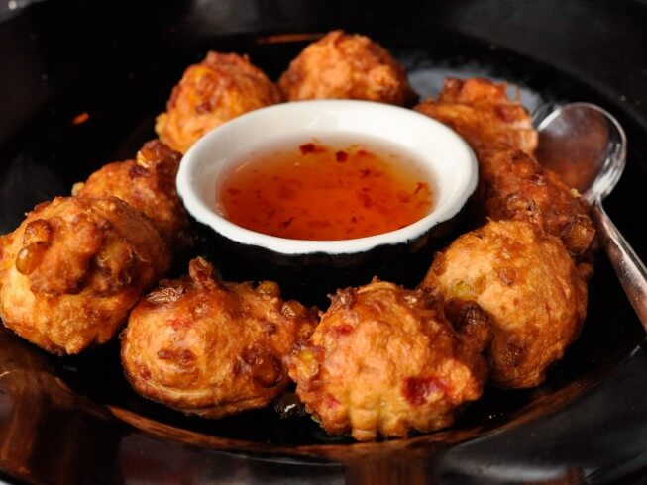

Ingredients:
oil
2 cups Bisquick baking mix
1/2 teaspoon salt
2/3 cup milk
1 egg, beaten
2 cups corn kernels
Directions:
Preheat oil to 365 degrees F in a deep skillet or deep fryer.
Combine the Bisquick, salt, milk, and egg in a bowl and mix well. Stir in the corn.
Drop the fritter batter by small teaspoonfuls into the hot oil. Turn to brown on all sides. Remove from the oil and let drain on paper toweling. Serve the Bisquick corn fritters warm.
recipe tips

For extra crunch, add a tablespoon of cornmeal to the batter.
If the batter seems too thick, add a little more milk to reach the desired consistency.
To test the oil temperature without a thermometer, drop a small amount of batter into the oil. If it sizzles and floats to the top, the oil is ready.
Placing the fried fritters on a wire rack over paper towels helps to drain excess oil while keeping them crispy.
Serve the fritters as a side dish with grilled meats or as an appetizer with your favorite dips.
For a sweet version, add a bit of sugar to the batter and serve with maple syrup or honey.
Using a cookie scoop can help create uniform fritter sizes for even cooking.
Adjust the seasoning according to taste, adding more salt if needed after frying a test fritter.

Types of corn celebrated in CA include:
Brentwood
Sugar & Butter

