**Assignment10.3:**

**Query 1:**

**Fetch date and temperature from temperature_data where zip code is greater than 300000 and less than 399999.**

SELECT date,temperature from temperature_data where zip_code>300000 AND zip_code<399999;

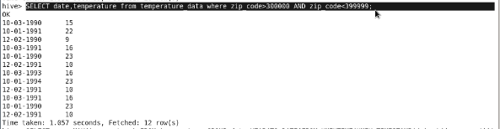

**Query 2:**

**Calculate maximum temperature corresponding to every year from temperature_data table.**

SELECT YEAR(FROM_UNIXTIME(UNIX_TIMESTAMP(date,'dd-mm-yyyy'))) as date, MAX(temperature) as max_temp FROM temperature_data GROUP BY YEAR(FROM_UNIXTIME(UNIX_TIMESTAMP(date,'dd-mm-yyyy')));

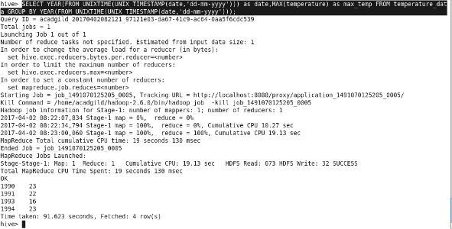

**Query3:**

**Calculate maximum temperature from temperature_data table corresponding to those years which have at least 2 entries in the table.**

SELECT YEAR(FROM_UNIXTIME(UNIX_TIMESTAMP(date,'dd-mm-yyyy'))) as date, MAX(temperature) as max_temp FROM temperature_data GROUP BY YEAR(FROM_UNIXTIME(UNIX_TIMESTAMP(date,'dd-mm-yyyy'))) HAVING COUNT(date)>=2;

