**Assignment11.1**

**Table Creation:**

CREATE TABLE IF NOT EXISTS olympic(athlete string,age int,country string,year string,closing\_date string,sport string,

gold int,silver int,bronze int,total int)

ROW FORMAT DELIMITED

FIELDS TERMINATED BY '\t'

STORED AS TEXTFILE;

**Loading Data:**

LOAD DATA LOCAL INPATH '/home/acadgild/Downloads/olympic\_data.csv' OVERWRITE INTO TABLE olympic;

**Query1:**

**Number of medals won by each country in swimming**

SELECT country,SUM(total) FROM olympic WHERE sport="Swimming" GROUP BY country;

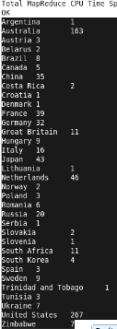

**Query2:**

**Number of medals that India won year wise**

SELECT year,SUM(total) from olympic WHERE COUNTRY=="India" GROUP BY year;

C:\Users\User\Downloads\A11.1-master\A11.1-master\output_query(2).PNG