load an input dataset from Pig to Hbase table and send the steps and screenshot of the final output

//HBASE TABLE CREATION

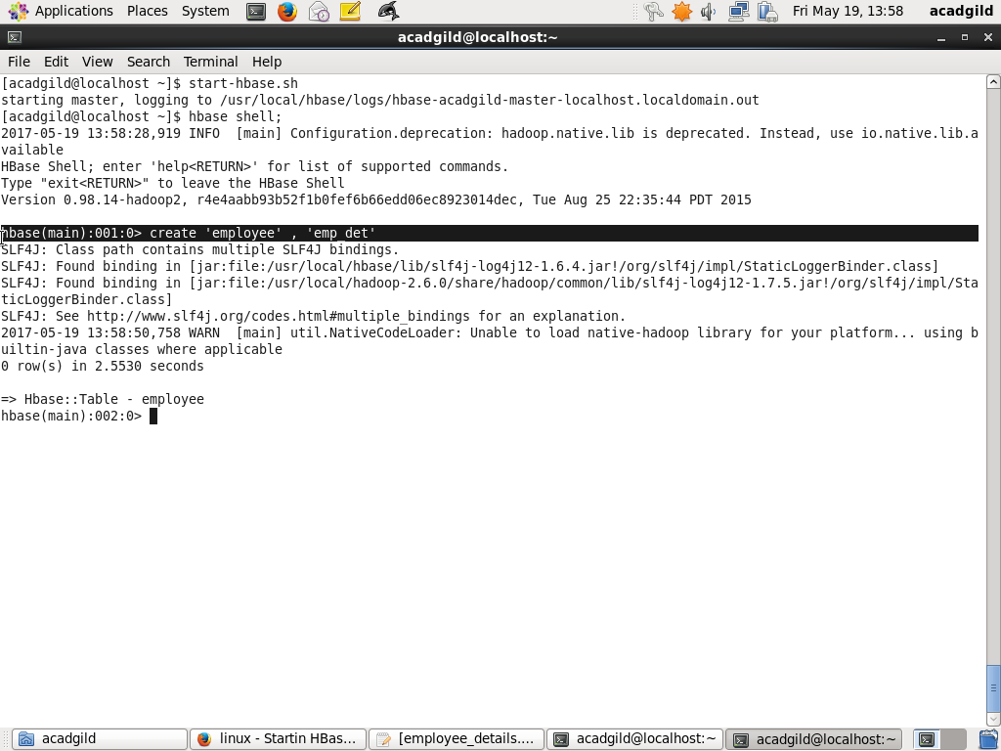

//DATA LOAD IN PIG

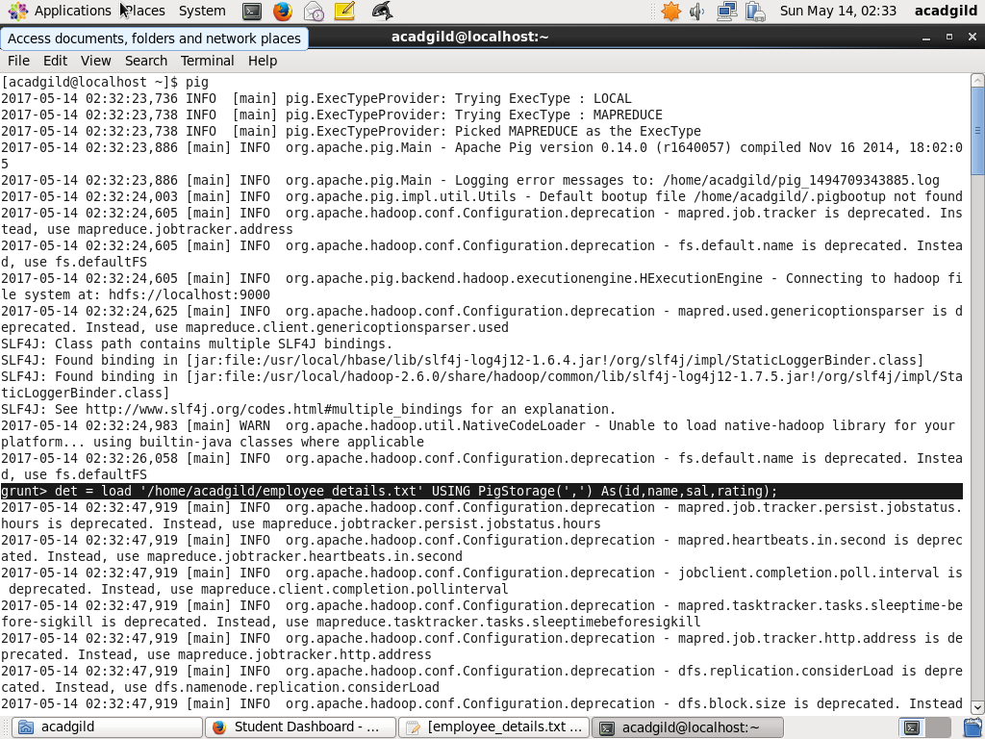

//HBASE DATA LOAD

