**Assignment15.2**

**CREATION OF MYSQL TABLE:**

create table details (id int,salary int);

**INSERTING VALUES INTO THE TABLE**

insert into details values (1,1),(2,2),(3,3),(4,4);

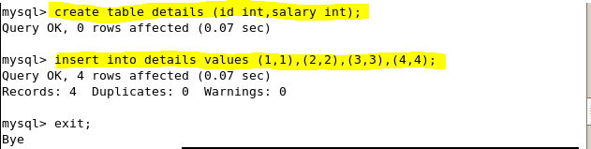

**SQOOP COMMAND WITH INCREMENTAL IMPORT**

sqoop job --create job incremental -- import --connect jdbc:mysql://localhost/employee --username root --table details --m 1 --incremental append --check-column id

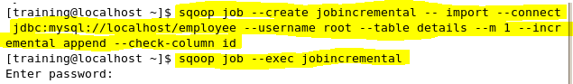

**IMPORTED TABLE IN HDFS**

hadoop fs –ls

