**ASSIGNMENT 15.5**

**INCREMENTAL IMPORT IN SQOOP**

**CREATION OF MYSQL TABLE AND INSERTION**

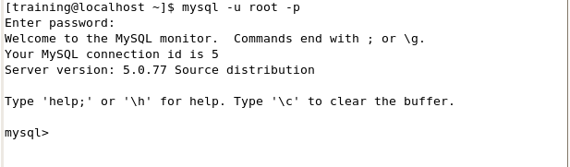

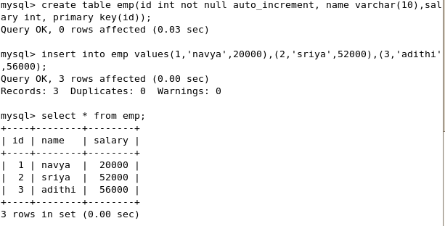

**SQOOP IMPORT**

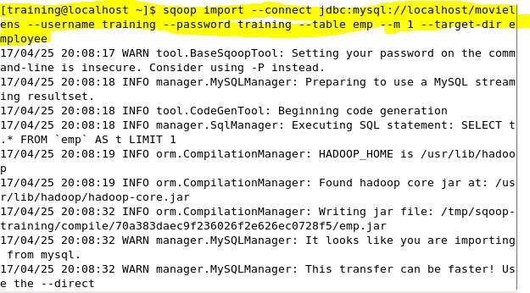

**DISPLAY THE HDFS DIRECTORY**

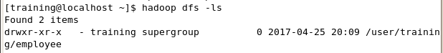

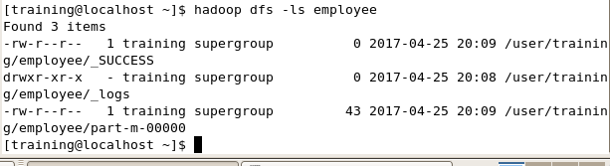

**DISPLAY CONTENTS IN EMPLOYEE DIRECTORY**

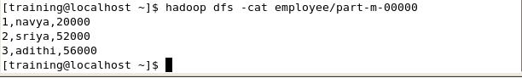

**ADD MORE DATA IN MYSQL**

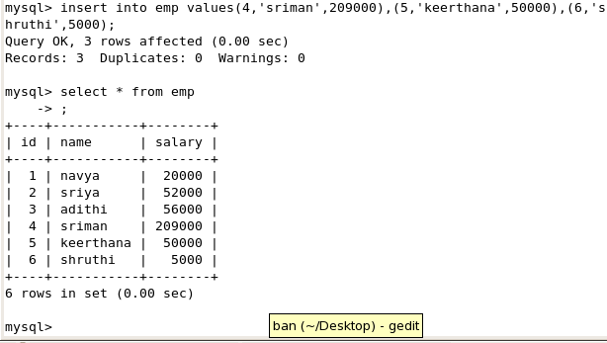

**EXECUTE THE INCREMENTAL APPEND COMMAND IN SQOOP**

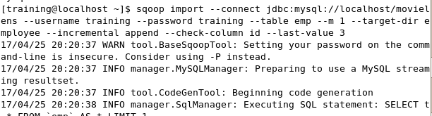

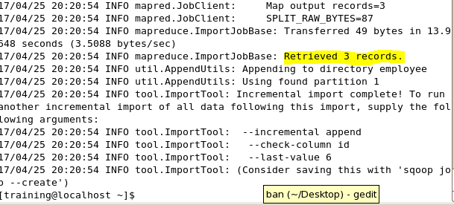

**DISPLAY THE DIRECTORY**

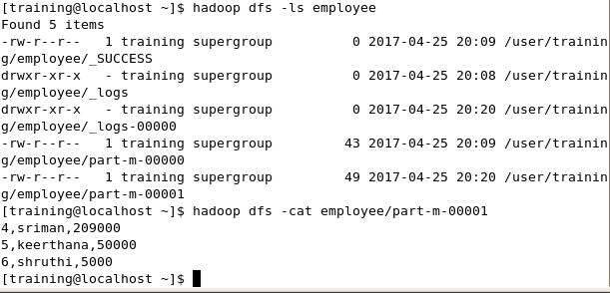

**DISPLAY THE CONTENTS**

