**Problem Statement**

We have a dataset of sales of different TV sets across different locations. Records look like:

Samsung|Optima|14|Madhya Pradesh|132401|14200 The fields are arranged like:

Company Name|ProductName|Size in inches|State|PinCode|PriceSales_differentTV:

There are some invalid records which contain 'NA' in either Company Name or Product Name. Sales of different TV

**Task 2: Write a MapReduce program to calculate the total units sold for each Company. Sales of different TV**

**Input:**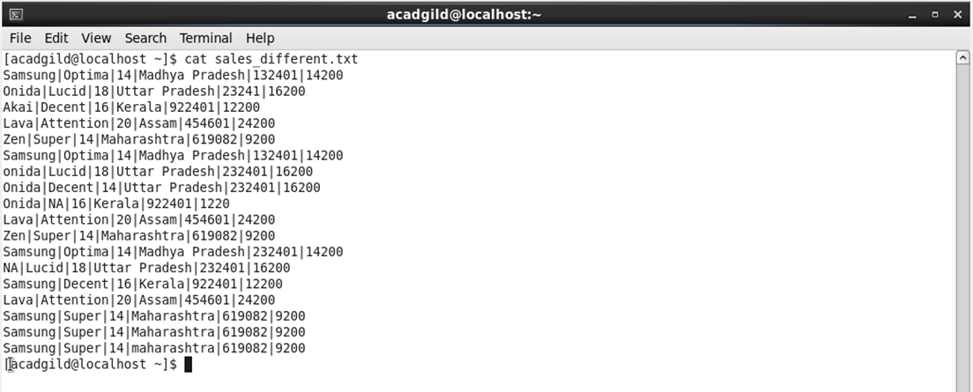

**Driver:**

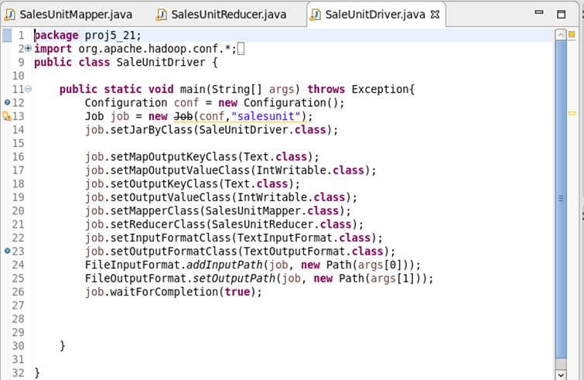

Mapper:

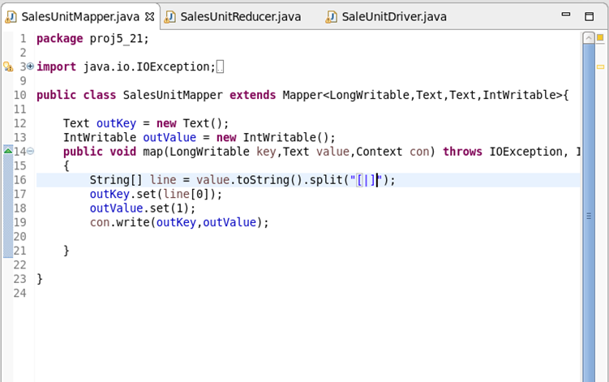

Reducer:

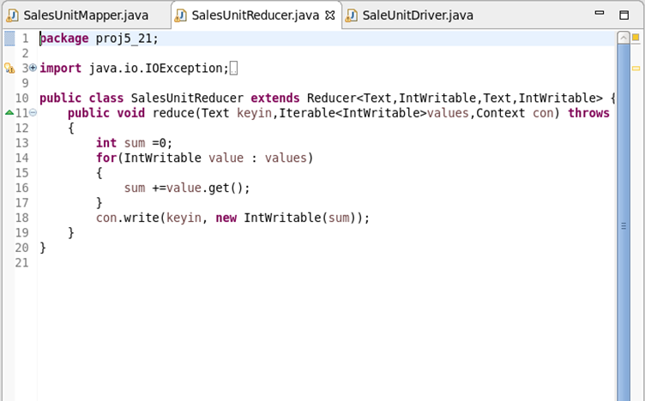

Output file:

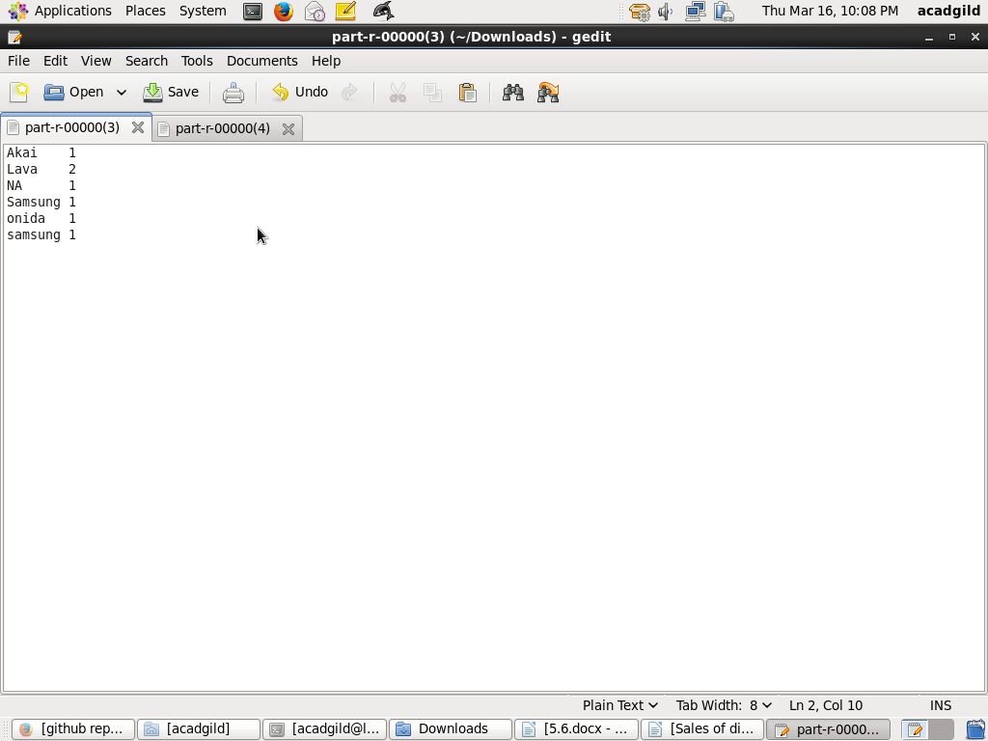

**Task 3: Write a MapReduce program to calculate the total units sold in each state for Onidacompany.**

Driver:

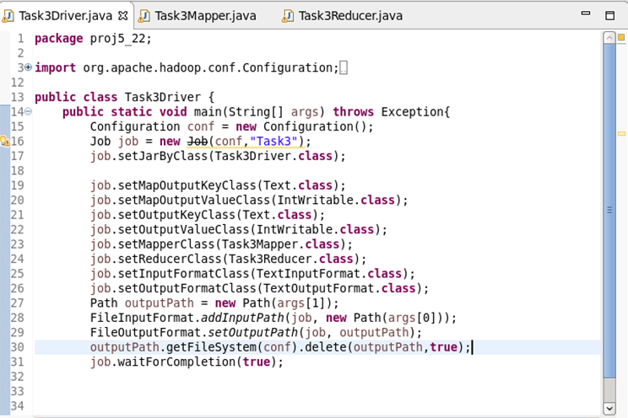

Mapper:

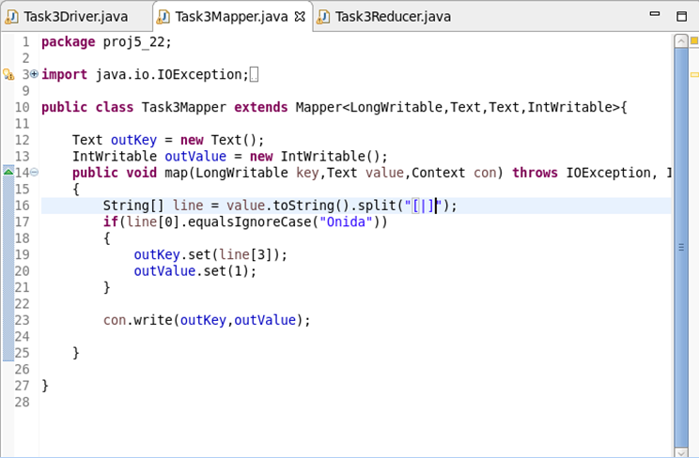

Reducer:

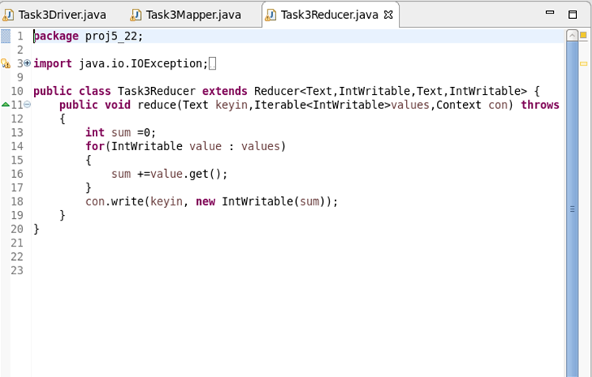

Output file:

