Assignment 4.6

Write a map reduce program to find the total number of people travelled in titanic. Download the Titanic data set from the below link https://drive.google.com/file/d/0ByJLBTmJojjzNmV0dk1EMmwwQ1U/view?usp=drive_web DATA SET DESCRIPTION Column 1 : PassengerId Column 2 : Survived (survived=0 & died=1) Column 3 : Pclass Column 4 : Name Column 5 : Sex Column 6 : Age Column 7 : SibSp Column 8 : Parch Column 9 : Ticket Column 10 : Fare Column 11 : Cabin Column 12 : Embarked

Main class:

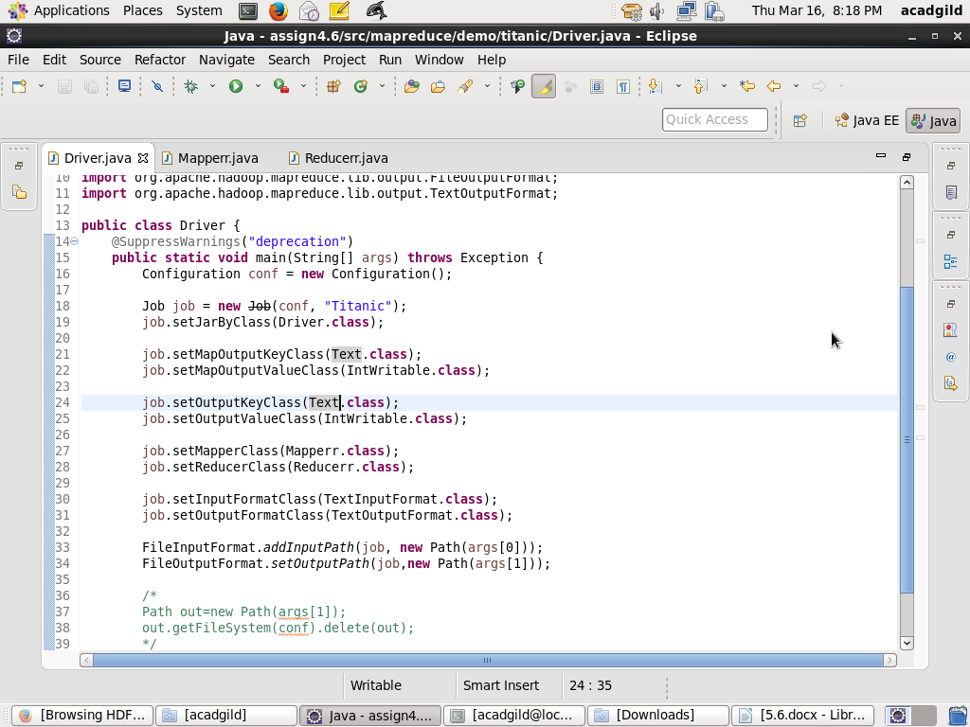

Mapper Class:

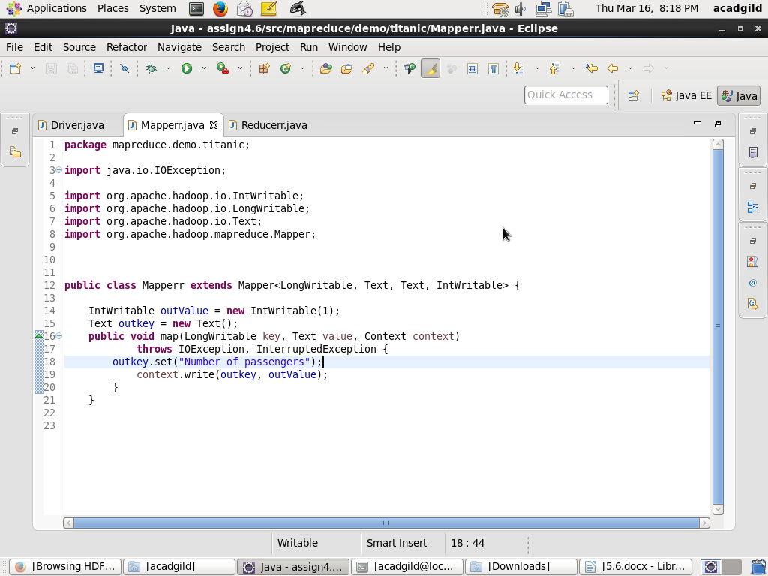

Reducer class:

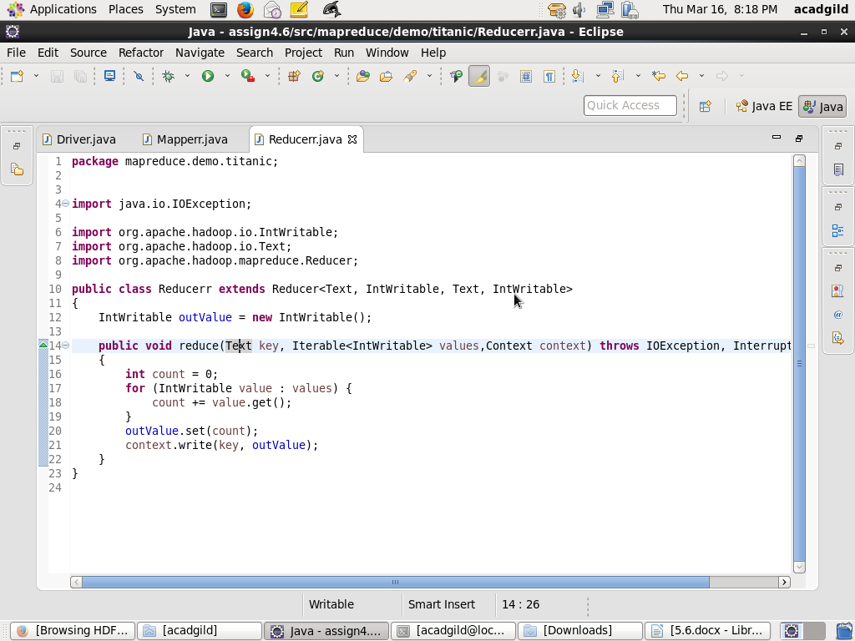

Running jar:

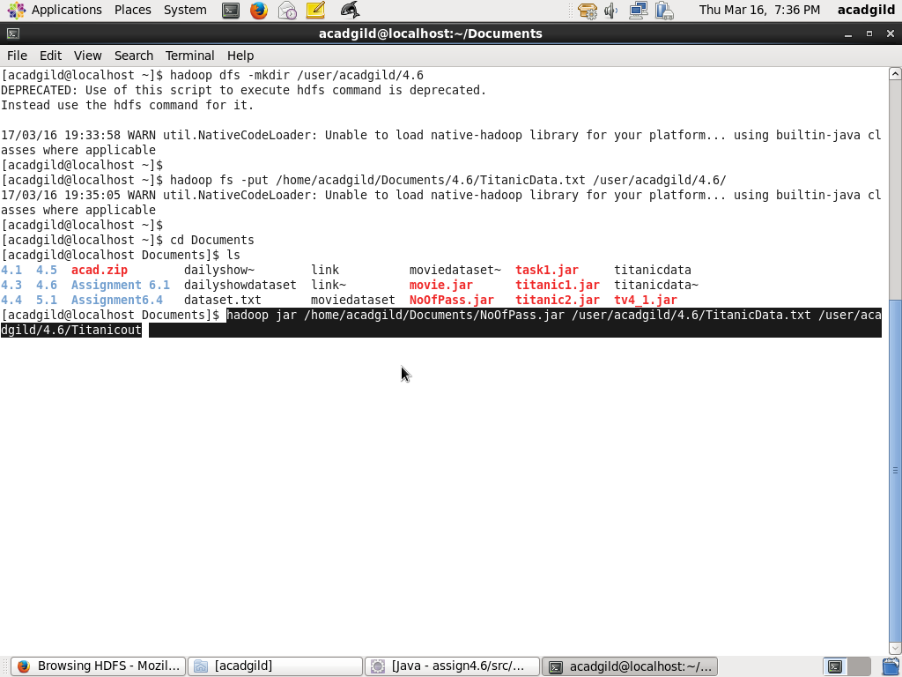

Completed succesfully:

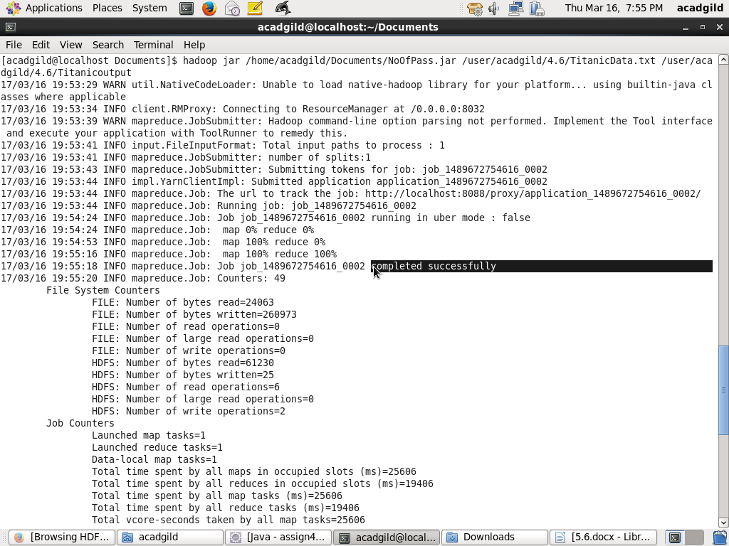

Output answer:

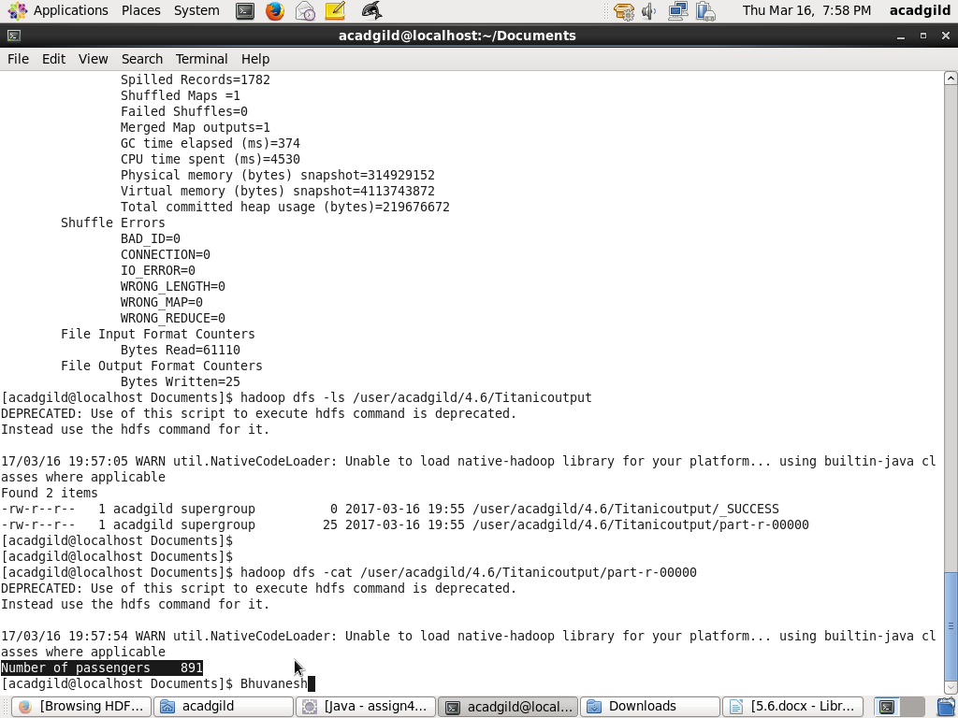

HDFS output:

