Write a Pig UDF To find the tweets posted by @realDonaldTrump from the given dataset.

Udf code is written to filter the realDonaldTrump tweets. It works as a filter application

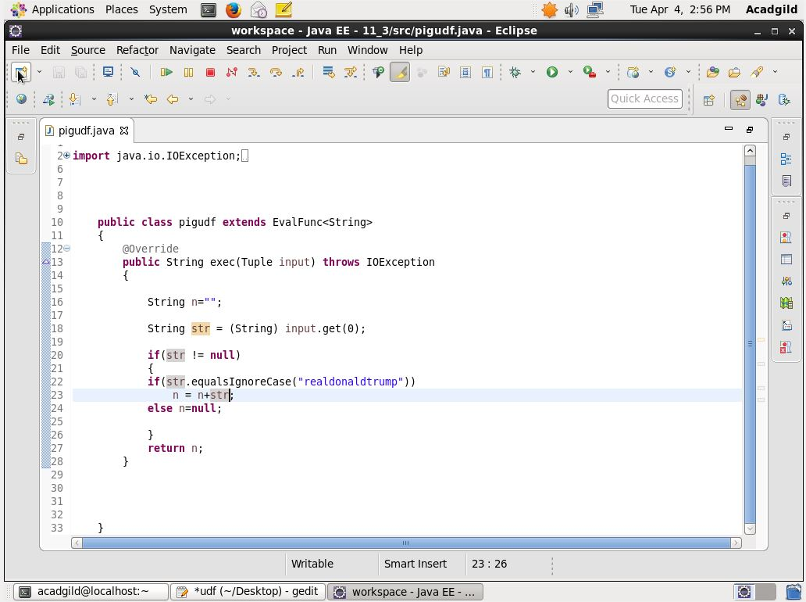

Then the pig scripts are used to filter the null values and to count the tweets

