Predicting Used-Car Prices in Sri Lanka with Ensemble Machine Learning
Applied Machine Learning — Assignment Report
Name: Lakshan B.D. Index: 269136C Date: 23 October 2026
Code and app: https://github.com/crazy-diya/ML_Assignment-269136C

1. Problem and data
Sri Lanka's car market is unusual: vehicle imports were restricted from 2020, pushing used-car prices up and making them opaque; many cars are "reconditioned" Japanese imports; and hybrids and EVs are growing quickly. Buyers and sellers need a fair-price estimate. This project predicts the asking price (LKR) of a car from its specification — a tabular regression problem.
Data were collected from ikman.lk, Sri Lanka's largest classifieds site, with a polite scraper (robots.txt respected, 1.5 s delay between requests). The dataset has 3,000 advertisements and 10 usable fields: brand, model, year, condition (Brand New / Used / Reconditioned / Import), transmission, body type, fuel type, engine capacity, mileage and location. Prices are asking prices, not final sale prices.

2. Data analysis and preprocessing
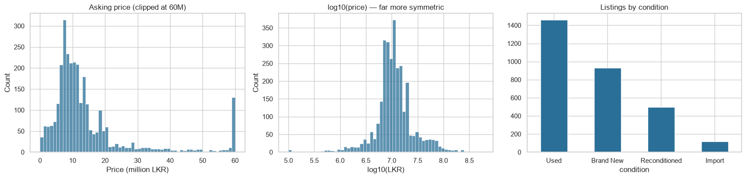
Figure 1 — Price is heavily right-skewed; log-price is near-symmetric.
- Skew: price skewness is extreme (a few LKR 200M+ cars), so models are trained on log(price), which also makes the objective a relative (percentage) error.
- Invalid values, not only nulls: placeholder prices (0, 106, 123456), a 595M-rupee BMW with a 1 cc "electric" engine, years after 2026, engines under 300 cc, mileage placeholders (1, 10, 123456) and "used" cars with under 500 km. 14 rows with impossible prices were dropped; invalid engine/mileage values were set to missing and imputed. Genuine vintage (Sunny, Lancer, Beetle) and luxury cars were kept because they are real parts of the local market.
- Imputation and features: engine size imputed from the median of the same car model; mileage from the median of the same condition; age and km-per-year engineered; rare models and locations grouped as "Other"; ordinal encoding for tree models, one-hot for the linear baseline, native categorical handling in CatBoost, and standard scaling of numeric columns. All steps are fitted on training data only.
- Key EDA findings: condition is the largest price divider (Brand New/Import above Reconditioned above Used); depreciation with age is non-linear; brand and model matter, with 351 distinct car models (a high-cardinality categorical problem); mileage is only moderately informative because it is confounded with age.

3. Models and hyper-parameter design
Two baselines ("existing approaches") — Ridge regression and a single decision tree — were compared with Random Forest, XGBoost, LightGBM, CatBoost and sklearn Gradient Boosting, plus Voting and Stacking ensembles. No default parameters were used: each algorithm received a search space designed from how it works and from the data size (about 2,400 training rows), tuned with 5-fold randomised search. Examples: boosters use shallow trees (depth 3–8) with low learning rates (0.02–0.15) and row/column subsampling to avoid over-fitting a small, noisy dataset; Random Forest uses deep trees (8–30) because bagging reduces variance; LightGBM's num_leaves is constrained to 15–63. The stacking meta-learner (Ridge) is trained on out-of-fold predictions of XGBoost, LightGBM and CatBoost. Random Forest was left out of the ensembles because the meta-learner gave it a weight of only about 0.01 and it made the saved model about 180 MB.

4. Results
Model | R² (LKR) | MAPE % | RMSE (log price) | MAE (LKR)
Stacking (XGB+LGBM+Cat → Ridge) | 0.914 | 12.6 | 0.225 | 2.00 M
CatBoost | 0.905 | 13.1 | 0.225 | 2.13 M
Voting (XGB+LGBM+Cat) | 0.914 | 12.8 | 0.231 | 1.94 M
XGBoost | 0.906 | 14.5 | 0.247 | 2.16 M
LightGBM | 0.901 | 14.0 | 0.250 | 2.12 M
Gradient Boosting (sklearn) | 0.893 | 14.7 | 0.255 | 2.26 M
Ridge (baseline) | 0.761 | 16.7 | 0.272 | 3.27 M
Random Forest | 0.858 | 15.9 | 0.273 | 2.40 M
Decision Tree (baseline) | 0.735 | 23.5 | 0.335 | 3.22 M

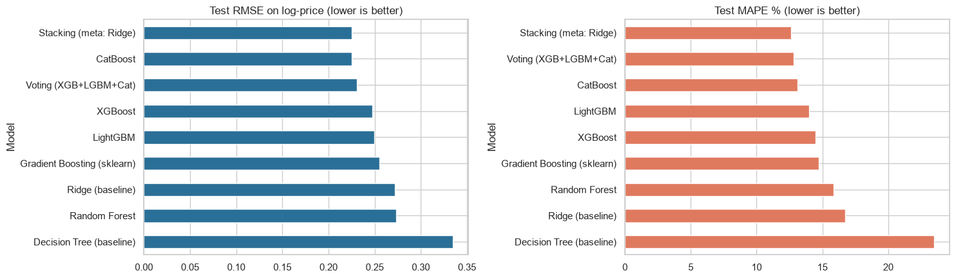
Figure 2 — Test error of every model (lower is better).
- Ensembles clearly beat the baselines: boosting cuts error from 23.5% (single tree) to about 13%, and R² in rupees rises from 0.74 to 0.91. Ridge is reasonable on the log scale but poor in rupees (R² 0.76) because it misprices the expensive tail where brand × age × engine interactions matter.
- CatBoost is the best single model, consistent with the data having many high-cardinality categorical features; the stacker gives it about 64% of the weight (XGBoost 24%, LightGBM 14%).
- Stacking and CatBoost are effectively tied on log-RMSE (0.2249 vs 0.2253); stacking's gain appears in R² and rupee error, so it is at least as good but not decisively better, at a higher complexity cost.
- Random Forest under-performed the boosters: it cannot extrapolate beyond the training price range, so luxury cars are under-priced, and it treats integer-coded categories as ordered.
- Cross-validation error (0.242 for stacking) is consistent with test error (0.225), so there is no sign of over-fitting. A typical error of about 13% is close to the natural noise of asking prices.

5. Strengths and limitations of the models
- Ridge — fast and transparent, but cannot capture non-linear depreciation or interactions.
- Decision tree — readable rules but high variance (weakest result).
- Random Forest — robust and low-tuning, but cannot extrapolate and produces large models.
- XGBoost / LightGBM — strong accuracy with regularisation and fast training; need careful tuning, and categoricals must be encoded by hand.
- CatBoost — native categorical handling and ordered boosting give the best single model; slowest to train.
- Voting / Stacking — combine different error patterns for the best accuracy; most complex and costly to explain.

6. Explainability: SHAP and LIME
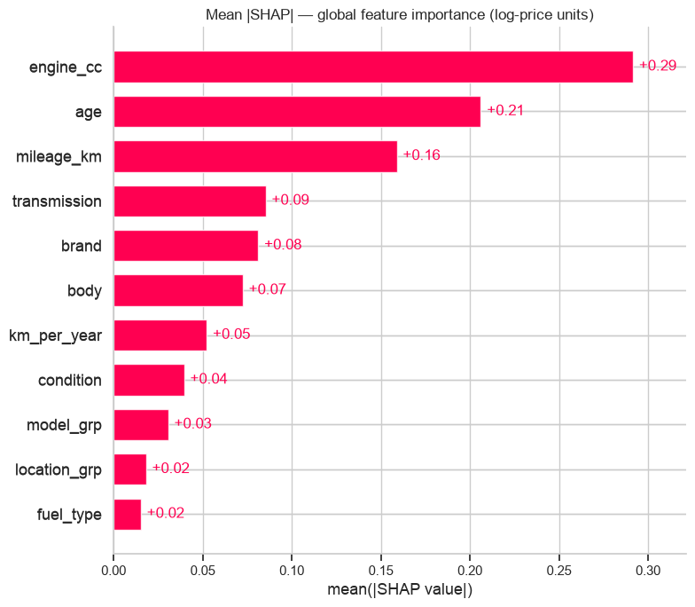
Figure 3 — SHAP global importance (XGBoost), in log-price units.
- SHAP: engine capacity, age and mileage dominate (mean |SHAP| about 0.29, 0.21, 0.16, i.e. roughly 29%, 21% and 16% average price effect). Newer, lower-mileage and larger-engine cars are predicted higher, which matches economic intuition. Engine size is partly a proxy for car class, so SHAP shows what the model uses, not what causes price.
- LIME (local): for a 2018 Suzuki Alto, the small engine and manual gearbox push the predicted price down. For a 2007 Hyundai Santa Fe (over-estimated by about 33%), LIME exposed a recorded mileage of only 0–15,000 km that is implausible for a 19-year-old car — a likely data-entry error — showing that explanations can also act as a data-quality check.

7. Inference and application
One car (a 2026 Daihatsu Mira) was kept out of training, tuning and testing. The exported model (model.pkl, 4 MB) predicted LKR 7.43 M against an actual asking price of LKR 7.48 M (−0.6%). A Streamlit front end (generated with GenAI assistance) loads the pickle, offers drop-downs and number fields for each input, and returns the estimated price with a ±13% range based on the model's average error.

8. Conclusion, limitations and future work
Tuned boosted-tree ensembles predict Sri Lankan car prices to within about 13% on average, far better than linear or single-tree baselines, and SHAP/LIME make the predictions explainable. Limitations: asking prices rather than sale prices; about 3,000 ads from one site at one time; no trim, photos or accident history; few comparables for vintage and supercars. Future work: collect data over time and add a time-series component for market drift, add Riyasewana data, use quantile regression for proper price intervals, and deploy with an MLOps pipeline (CI/CD and drift monitoring) for the bonus marks.
Data source: ikman.lk classified advertisements, collected for coursework purposes.

