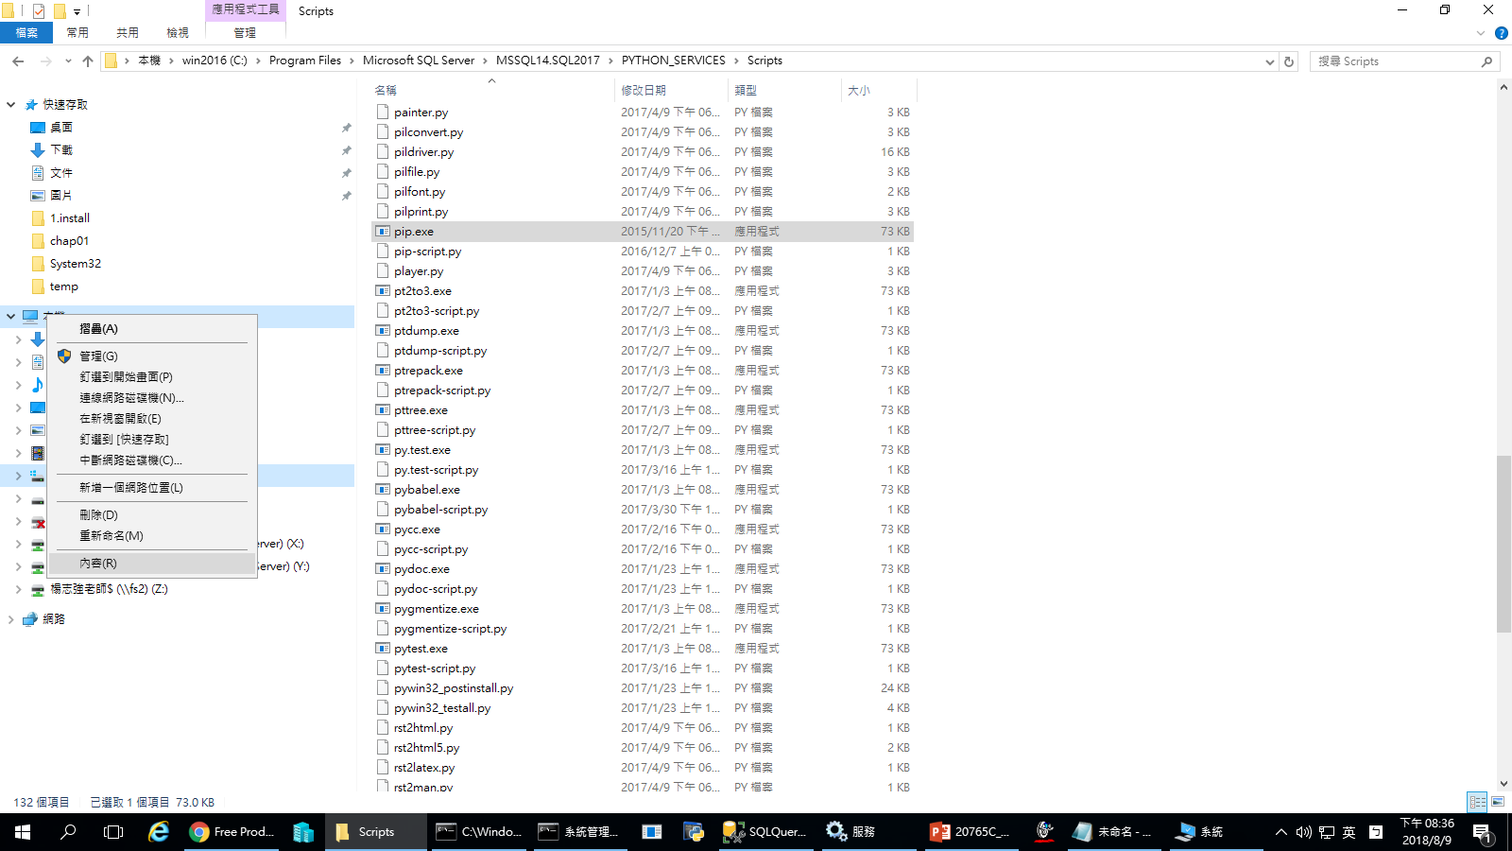

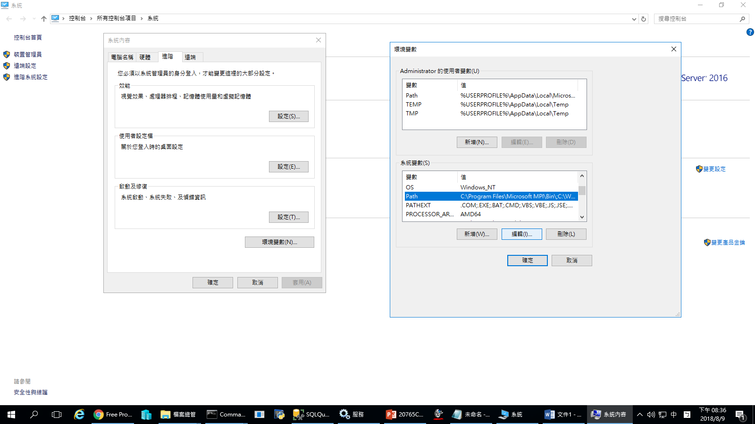

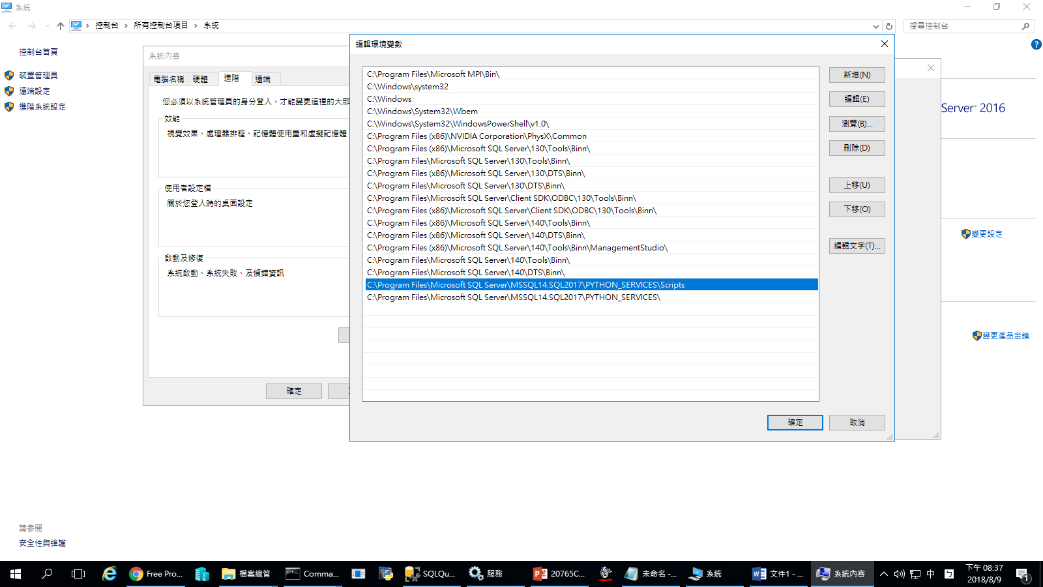

C:\Program Files\Microsoft SQL Server\MSSQL14.SQL2017\PYTHON_SERVICES\Scripts

C:\Program Files\Microsoft SQL Server\MSSQL14.SQL2017\PYTHON_SERVICES