LAB ASSIGNMENT – 9

**CISCO PACKET TRACER**

To begin using Packet Tracer and enter simulation mode, follow these steps:

* Open the Packet Tracer application and navigate to the simulation mode.
* To create the network topology, select the "End Devices" category and choose the "Generic Host" option.
* Add a total of 4 hosts to the network by clicking on them and placing them in the desired locations.

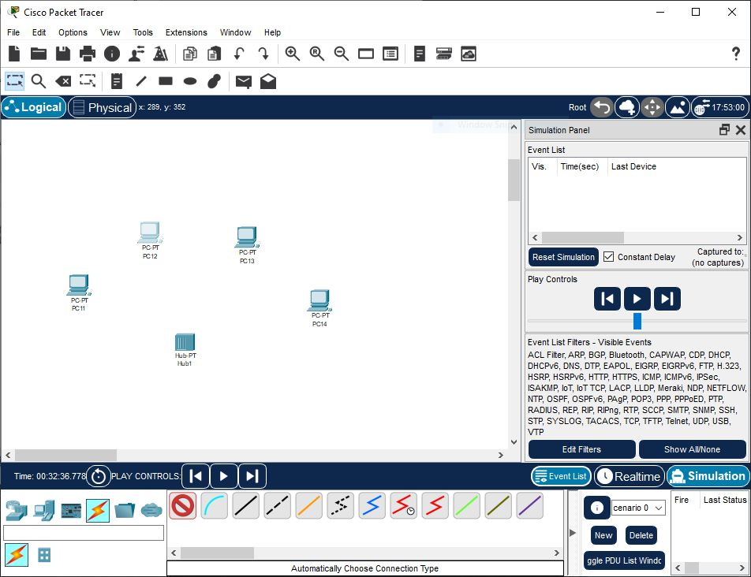By following these steps, you will successfully start Packet Tracer, enter simulation mode, and build the desired network topology with 4 Generic Hosts.

Select a hub, by clicking once on Hubs and once on a Generic hub. Place a Hub below PC-0 and PC-1.

1. To connect PC-0 to Hub-0 in Packet Tracer, follow these steps:
2. Click once on PC-0 to select it.
3. Choose "FastEthernet" as the interface for PC-0.
4. Drag the cursor from PC-0 to Hub-0.
5. Click once on Hub-0 and select "Port 0" as the connection point.
6. You will notice green link lights on both the PC-0 Ethernet NIC and the Hub-0 Port 0, indicating an active connection.

By following these steps, you will successfully connect PC-0 to Hub-0 in your network topology.

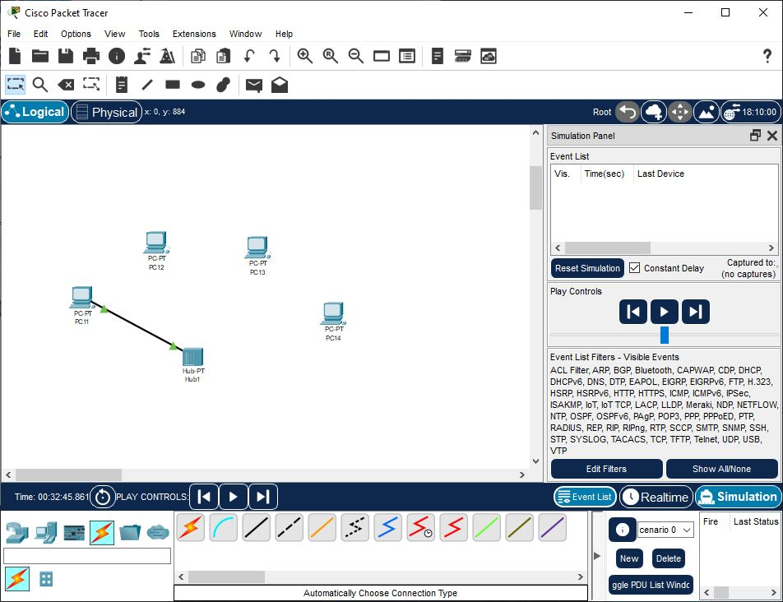Please note that the connection between PC-0 and Hub-0 is established using a Copper Straight through cable, which is selected from the Connections tab in Packet Tracer.

Repeat the same steps for connecting PC-1 to Hub-0 via Port 1

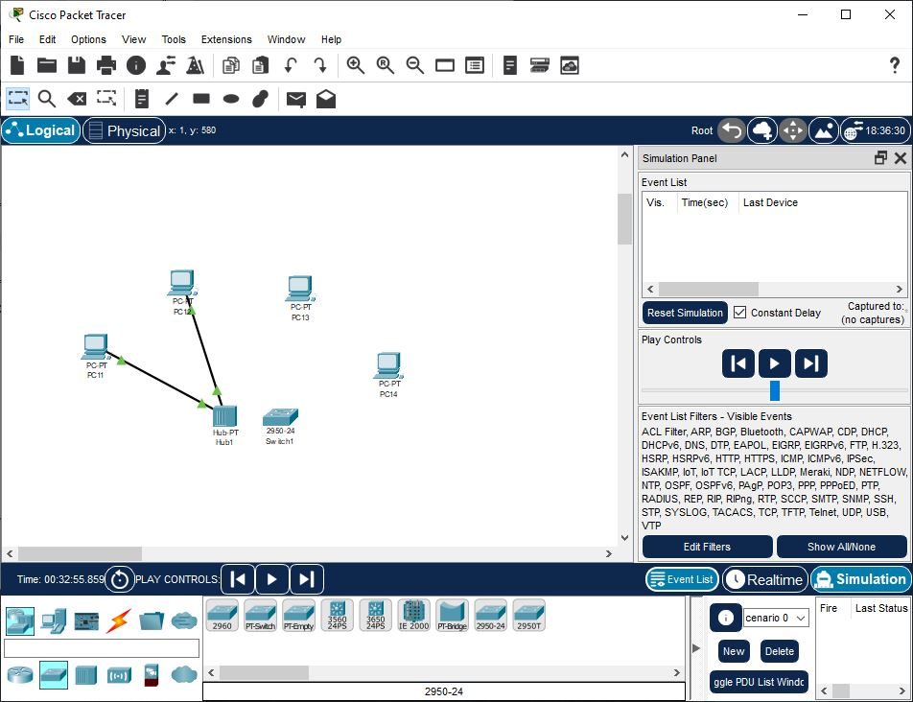Adding a Switch Select a switch, by clicking once on Switches and once on a 2950-24 switch

Connect PC-2 to Switch-0 by choosing Copper Straight through Cable from the Connections tab. Perform the following steps to connect PC2 to Switch0:

1. Click once on PC2

2. Choose FastEthernet

3. Drag the cursor to Switch0

4. Click once on Switch0 and choose FastEthernet0/1

5. Notice the green link lights on PC2 Ethernet NIC and amber light Switch0FastEthernet0/1 port.

6. After a about 30 seconds the amber light will change to green indicating that the port has entered the forwarding stage. Frames can now forwarded out the switch port.

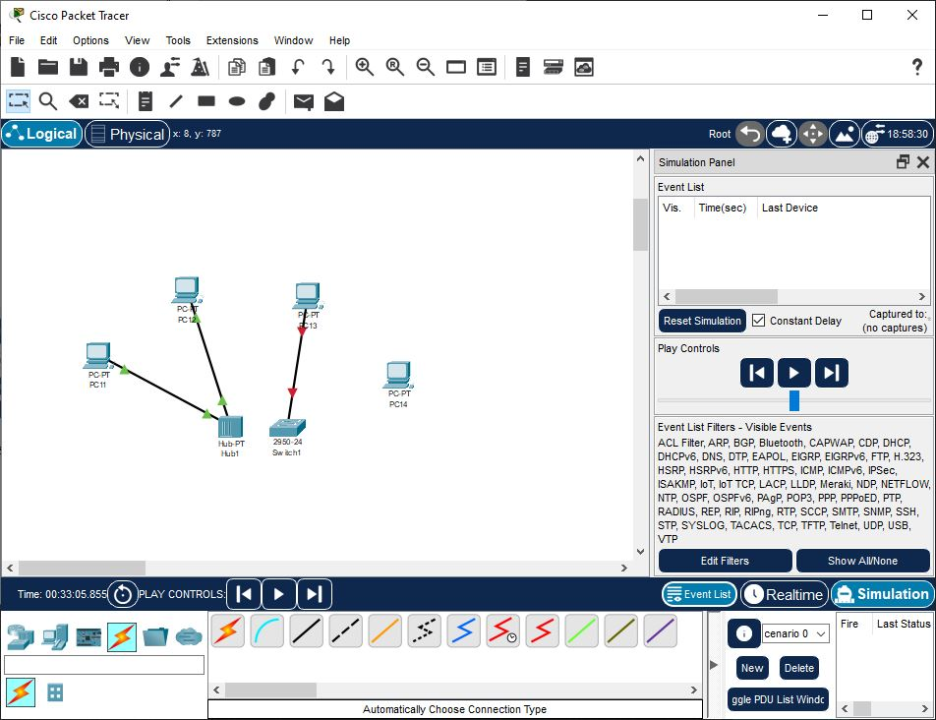

Repeat the above steps for connecting PC-3 to Switch-0 via Port-3 to FastEthernet 0/2

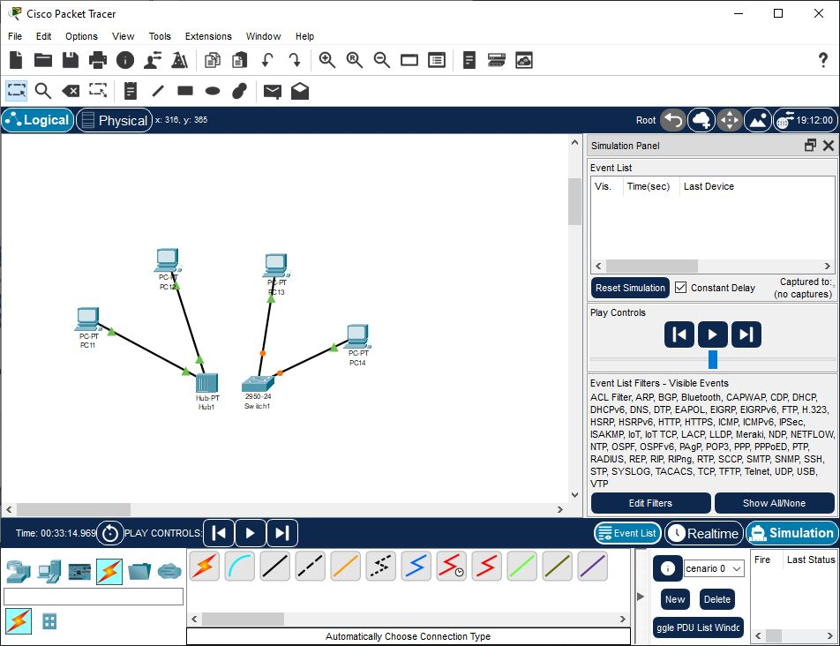

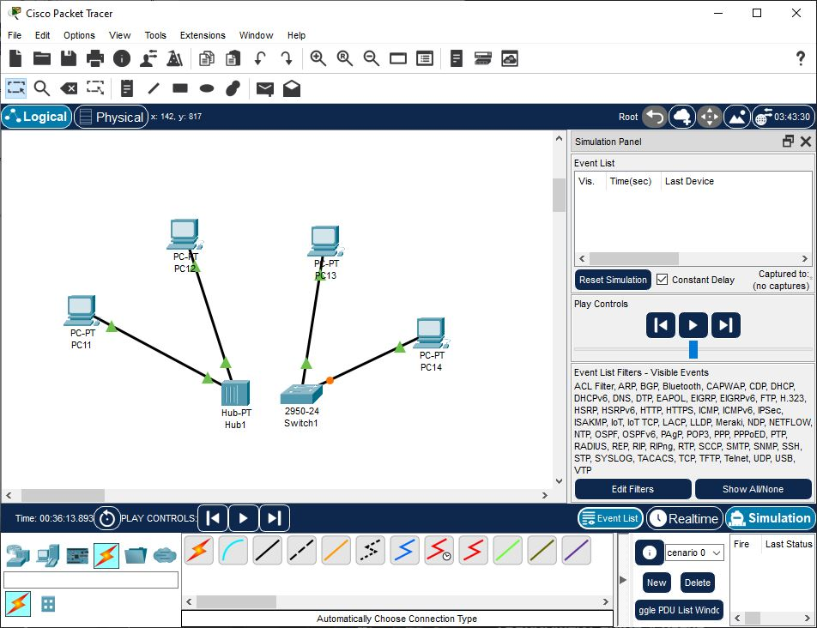The amber lights have changed to green indicating that the port has entered the forwarding stage. Trames can now be forwarded out of the switch port.

To configure IP addresses and subnet masks on the hosts in Packet Tracer, follow these steps:

1. Click on the respective host (e.g., PC-0).
2. Choose the "Config" tab to access the configuration settings.
3. Click on "FastEthernet" to select the interface.
4. Set the IP address for the host according to the following:
   * PC-0: 172.16.1.10
   * PC-1: 172.16.1.11
   * PC-2: 172.16.1.12
   * PC-3: 172.16.1.13
5. Set the subnet mask to 255.255.0.0 for all hosts.

By following these steps, you will successfully configure the IP addresses and subnet masks on the respective hosts in your network topology.

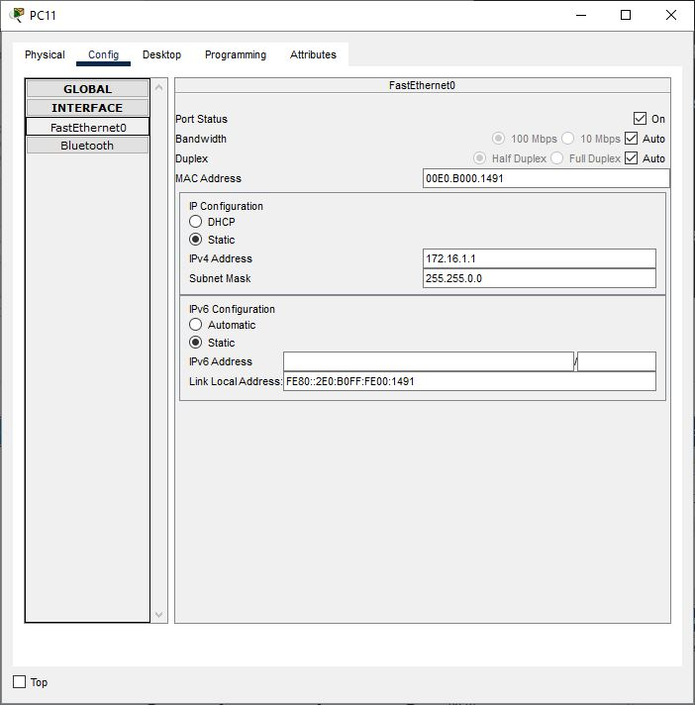

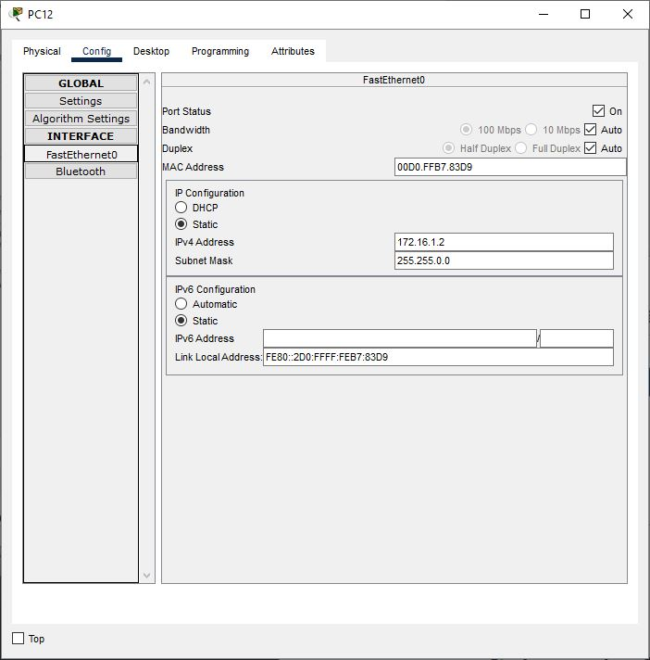

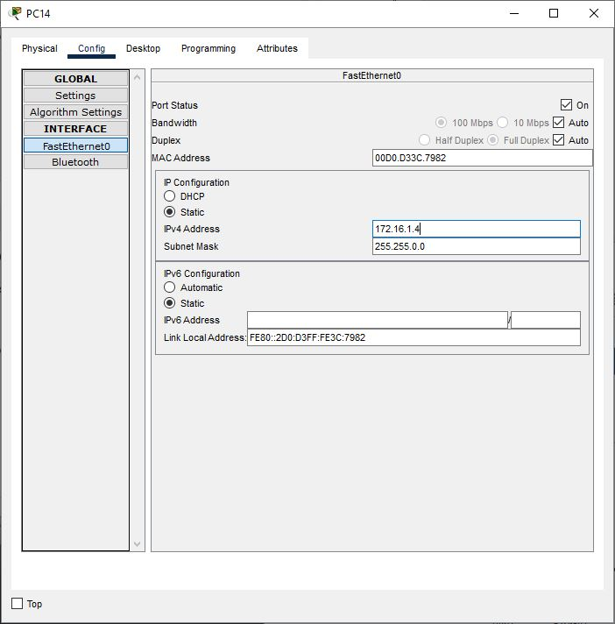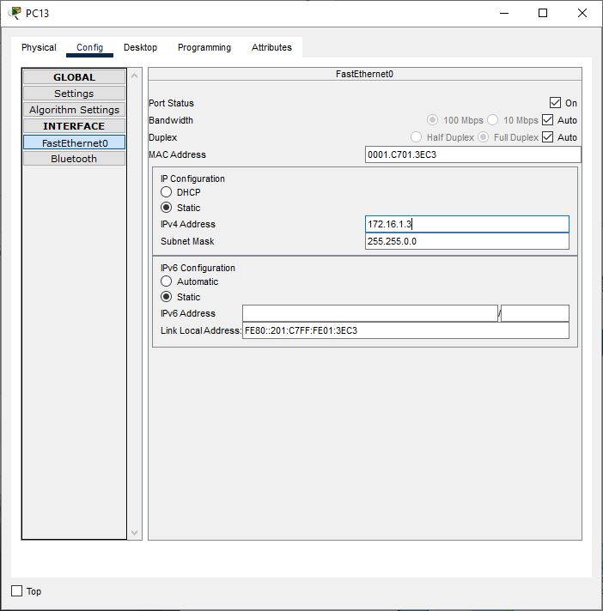

To connect Hub-0 to Switch-0 in Packet Tracer, follow these steps:

1. Use a crossover cable from the Connections tab to connect like-devices.
2. Click on Hub-0 and choose Port 5 as the connection point.
3. Connect the other end of the crossover cable to Switch-0.
4. Select "FastEthernet 0/4" on Switch-0 as the connection point.

By following these steps, you will successfully connect Hub-0 to Switch-0 in your network topology.

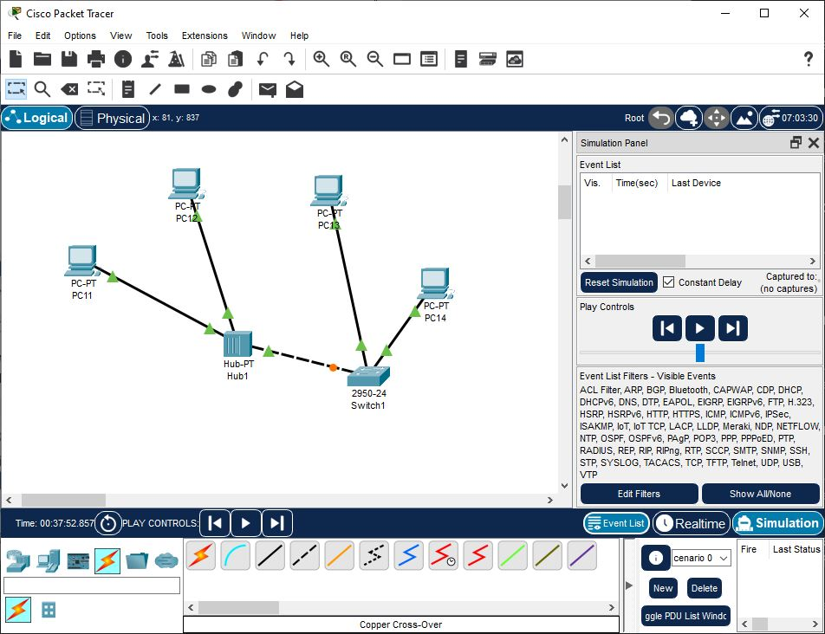

The link light for switch port FastEthernet0/4 will begin as amber and eventually change to green as the Spanning Tree Protocol transitions the port to forwarding.

