LAB ASSIGNMENT – 11

Topology using DHCP in Cisco Packet Tracer

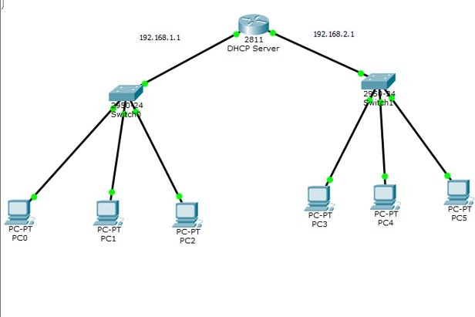Step-1 : Establish the network configuration with the devices, switches, and routers depicted as illustrated.

Step-2 : Execute the instructions to set up the IP addresses of the devices using the DHCP server.

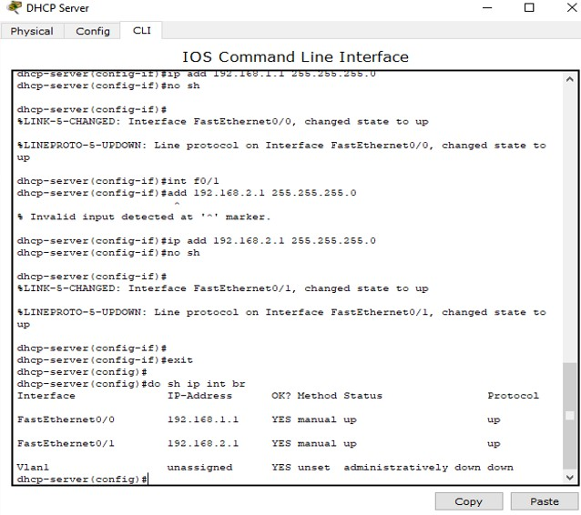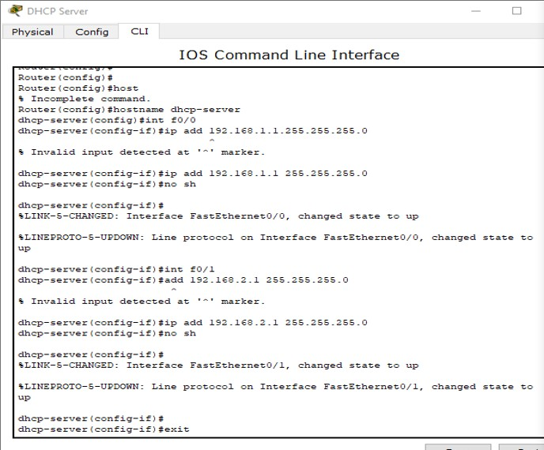

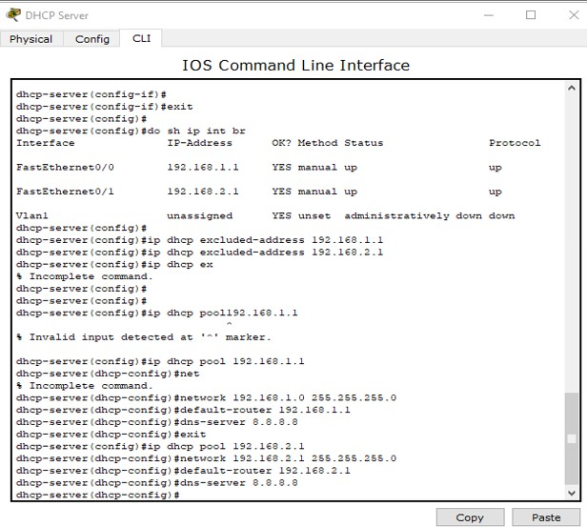

Step-3 : Verify the revised IP addresses on the devices (e.g., PC0 and PC3).

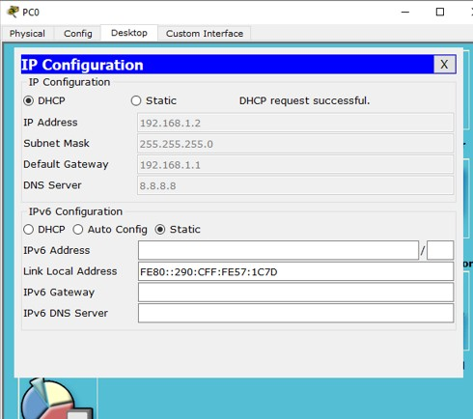

Step-4 : Assess the connectivity between the devices using the ping command.

