|  |
| --- |
| aChat  A Chat Application for Android  ­­­­­­Description: Kulogo new  System Analysis and Design Report  *Submitted By:* Kishor Raj Adhikari (03)  Shalil Awaley (04)  Subhechha Bista(08)  Sanshila Gurung(19)  Rabin Shrestha (44)  Milan Thapa (52)  *Submitted to:* Mr. Dhiraj Shrestha  **Department of Computer Science and Engineering**  **School of Engineering**  **Kathmandu University**  **February 1, 2012** |

# Acknowledgement

This academic project work has been made with suggestion, guidance & help from many individuals. We are deeply indebted to those who have contributed in this developmental study.

Forwarding the vote of thankfulness, we record our appreciation to our esteemed Kathmandu University for having involved us in practical based syllabus. We would like to sincerely thank our project supervisor Mr. Purosottam Kharel for providing his invaluable guidance and comments in every step of our project. Similarly we would like to acknowledge the efforts of our undergraduate program co-coordinator Mr. Manoj Shakya.

The support of our colleagues and others who helped us directly or indirectly in our project cannot be forgotten at this juncture.

# Abstract

This report has been drafted in order to fulfill the requirements of the course COMP 302 offered by the Department of Computer Science and Engineering, Kathmandu University.

With the consent of our group members, we are doing our project on a Chat Engine for Android OS. This project is currently in the building phase as we have completed the study phase and interface design.

We are doing this project for Android OS using Android Development Tools (ADT) in Java programming language. We strongly believe that by working on this project we will be able to learn the development process and different components of networking in widely used mobile based OS Android. We are also strongly willing in using as most features of networking and database management for Android platform. We are also hopeful that with the joint effort of the group members we will finish the project within the timeline as we have planned.

Contents

Acknowledgement i

Abstract ii

System Definition, Specification and Investigation 1

Introduction 1

Definition of the Problem 2

Requirement Specification 2

Investigation 2

Investigation of Required Component 4

System Analysis 7

Hardware and Software Requirements for Software Design 7

Hardware and Software Requirements for Software Implementation 7

Proposed Solution 7

Alternative Solutions 8

Advantages and Disadvantages of the proposed Solutions 9

Feasibility Report 9

System Design 12

Data Modeling 12

Process Design 12

Intended Benefits of Proposed System 17

Limitations of the System 17

Conclusion 18

Appendix A: Abbreviation 19

References 20

List Of Figures

Figure 1: Context Diagram 12

Figure 2:DataFlow Diagram 13

Figure 3: New user registration Figure 4: User login 14

Figure 5: Receive message Figure 6: Receive message 15

Figure 7: sending subscription request and verification 16

# System Definition, Specification and Investigation

## Introduction

### Background:

Android is quickly becoming one of the most popular tools for mobile application development. It easily provides a range of benefits for mobile application developers. It is easy to handle and implement. Moreover it is open-source based. The Software Development Kit facilitated by Android assists the developers to a great extent and one can start working on applications in an instant.

Mobile phones are now working as pocket fit PCs because of the advent of great user-friendly operating systems like the Google’s Android. This platform is based on Linux Kernel. Applications can be created for the smart phones without any hassle. There is usually a high ROI involved too. Hence many mobile phone application developers are coming to the fore and offering services at extremely affordable rates.

## Definition of the Problem

The desired application is supposed to run in an Android application. This application is intended to facilitate the Instant Messaging between and two Android users. The users should be able to share not only the normal chat messages and emoticons but Unicode messages as well. Also the users should be able to communicate with graphical messages created by their finger tips on the Android screen.

## Requirement Specification

There required specifications of the application to be developed are:

* Facilitate Registration of a new user through the application in desired internet domains.
* Support Login to open the user’s profile that is with the users particular contact list with the respective username.
* The users should be able to send instant messages to each other.
* The users should be able to set their status such as Available, Busy, Away, etc.
* This application should receive the messages instantly after being sent.
* This application should reflect the received messages and the new status of the other users immediately.
* The instant messages should support emoticons.
* The android users should be able to communicate with Unicode.
* The android users should be able to communicate with graphical messages created by their finger tips on the Android screen.
* This application should receive the graphical messages instantly after being sent.
* This application should reflect the received graphical messages instantly on the user Finger Paint screen.

## Investigation

### Basic Investigation on Android

Android has come a long way since the opening of its application store, the Android Market. Almost every major developer is releasing their applications for Android. Because of this, Android is catching up quickly and growing at a very fast rate. In addition, all the latest Smartphones are using the Android engine. This increases the number of Android user.

* More and more phones are using the Android operating system and many prefer Android because it allows many options for users.
* Android is open source. This allows Android app developers and users to customize Android to their liking.
* The distribution of applications flexible in the Android.
* Worldwide market of android OS in 2009 was only 3.9%, It becomes 22.7% in 2010 and rises to 38.5% in 2011.

This shows that Android is gaining more and more flame in these days and users and products are increasing every day.

### Investigation on Android App

Record shows that over 300,000 mobile apps have been developed in three years. Apps have been downloaded 10.9 billion times. And demand for download mobile apps is expected to peak in 2013.Here are some reasons for the surge in number of Android app development

* It is an open source platform which helps the developers to invest more in their time and understanding clientele needs.
* Performance stability and security is boosted as it is based on Linux Kernel. The OS is hence very smooth to operate and less chances of crashing down.
* In case of Android app development, the porting of the application becomes hassle free.
* The investment involved is comparatively low along with considerable reduction in time required for creating an application.
* Android is based on Linux which facilitates smooth accessibility to a rich development environment.
* Android facilitates swift information gathering and provides accurate information.  
  The development tools are very easy to use.
* The Google Android Application can be created with the help of a professional Android application development service provider or from some average application developer. But the professional can get better results for you. Hiring an average mobile app developer can backfire and lead to wastage of money, time and resources.

### Technical aspects of Android application development

The process of developing these Android applications is through JAVA programming. Android uses CDMA, GSM, Wi-Fi, EDGE, EV-DO, Bluetooth and UMTS to receive and send data on different platforms. 3D as well as 2D graphics can be utilized. There are various features which are included like the GPS, accelerometer, and video camera. All in all, the easy and sleek Android framework facilitates the professional developer to create innovative Android applications through Android application development strategies.

### Mobile and Internet Statistics of Nepal

* The number of mobile customers grew from 12.62 million in mid-October to 13.10 in November and penetration rate is over 50 at end of 2011.
* The country counted 3.75 million internet users in November, up from 3.59 million reported in mid-October and the penetration rate stood at 14.09 percent.
* Among 3.75 million, 3.44 million people connect to the internet using GPRS.
* The total number of internet users in the mountain nation of Nepal has grown by a significant 160% within a year, according to the latest report released by the regulator, the Nepal Telecom Authority (NTA).

These basic facts shows that mobile trending is increasing in these days and being the hilly and mountainous country mobile internet is the best suitable method to connect to the world. Mobile Service providers has come up with their attractive offer and are increasing their investment for the promotion of mobile and internet through mobile devices. Yet another fact is technology become cheap in these days and digital divide is decreasing.

To estimate the statistics of Nepali mobile user Mobile Social Networking has carried out the survey with the involvement of Student of Kathmandu University also. The survey was carried among 237 people and it shows that more than 20 percentages of people are using android phone for their purposes. Although this is not the excited result to work on android application development but it was satisfactory. As the economic status of the people increase the no. of android user will definitely increase. And the demand of technology is rising and needs are increasing everyday, peoples are going to use Android as their gadgets. Also the survey shows that 87 percentages of people are using any kind of mobile application. It shows the interest of people to the mobile app whatever the types of their mobile. And 69 percentages of people uses the communication based application which is highest among any applications and 62 percentages of them still want application for communication.

## Investigation of Required Component

### Protocol

Most IM systems were designed in isolation using closed networks and/or proprietary

Protocols, meaning each system can only exchange messages with users on the same IM network. Users on different IM net-works often can’t send or receive messages, or do so with drastically reduced features because the messages must be transported through “gateways” that use a least common denominator approach to message translation. The problem of isolated, proprietary networks in IM systems today is similar to email systems in the early days of computer networks. Fortunately for email, the IETF created early standards defining the protocols and data formats that should be used to

Exchange email. Email software vendors rapidly switched to the IETF standards to provide universal exchange of email among all email users on the Internet. Google introduced Google Talk, a service that uses XMPP as it’s underlying protocol. Google’s endorsement of the XMPP protocol has greatly increased the visibility and popularity of XMPP and helps pave the way for XMPP to become the Internet IM standard.

The XMPP protocol benefits from three primary features that appeal to administrators, end users and developers: an IETF open standard, XML data format, and simple extensions to the core protocol. These benefits combine to position XMPP as the most compelling IM protocol available for businesses, consumers, and organizations of any size.

### Networks

An XMPP network is composed of all the XMPP clients and servers that can reach each other on a single computer network. The biggest XMPP network is available on the Internet and connects public XMPP servers. However, people are free to create private XMPP networks within a single company’s internal LAN, on secure corporate virtual private networks, or even within a private network running in a person’s home. Within each XMPP network, each user is assigned a unique XMPP address.

### Data format

XML is one of the most popular data exchange formats in use today and has become a standard part of most software systems. As a modern protocol, XMPP uses the XML data format to transport data over standard TCP/IP sockets, making the protocol and its data easy to use and understand. Any developer familiar with XML can immediately work with XMPP as no special data format or other proprietary knowledge is needed. Existing tools for creating, reading, editing, and validating XML data can all be used with XMPP without significant modification. The XML foundation of XMPP greatly simplifies integration with existing environments and eases the movement of data to and from the XMPP network.

### Chat server

As we are using the XMPP protocol the server should able to operate on XMPP protocol. Server should able to handle the activates of different users. User information will kept in server which validates the user while login. Later on it receives the message from sender and passed to the respective receiver.

### Sqlite Server

Sqlite is database engine for cell phones, PDAs, MP3 players, set-top boxes, and other electronic gadgets. Most SQL database engines are implemented as a separate server process. Programs that want to access the database communicate with the server using some kind of intercrosses communication (typically TCP/IP) to send requests to the server and to receive back results. SQLite does not work this way. With SQLite, the process that wants to access the database reads and writes directly from the database files on disk. There is no intermediary server process. This can be used to save the chat history in users machine which gives the availability of previous message even in absent of network coverage.

### Findings from the Investigation

Taking the reference above describe facts it is relevant to develop the system for android which will definitely makes us able to compute with the trending market and there are lots of alternatives to develop the specific application but we are going to develop the chat system as most of the people spend their time on mobile using communication and social application.

Focusing on chat application there are many chat applications available for android phones in the market with different features and continuous improvement. Among which some are just for chatting on android phones like Fring, Viber, Nimbuzz, Whatsapp and others are just the very famous IM software we use such as Skype, MSN, Yahoo, Gtalk etc. these are the application which comes through the sequence of development with availability of different client processes. But still now there is no any chat application specially focusing Nepal. Hence the specialty of the new system will have special meaning to Nepal and it will achieve through implementing Nepali Unicode support in Android. As the technology is spreading people are using android mobile on rural area too. The trend here at Nepal is that people go to the foreign country to work and one thing they bring back to the country is smart phone. And among them many are poor in English hence we think of developing a system which can convert the roman English character to the Unicode Nepali Character. Although it is available on web but it is the complete new for the android. As the Nepali Unicode character are under Devanagari family it can equally support for the Hindi and other Devanagari based language and hence can be useful for the peoples of India where 59 percentage of them uses only the mobile web.

And yet another feature that will be unique to the system will the implementation of White board. It is just a blank white area where user can move their finger on screen and they can send their art to other user. It will make the system user friendly and attractive.

And definitely system will compose of basic feature of logging in, registration for new user, Availability status and status message, add new contact to buddies and text chat.s

# System Analysis

## Hardware and Software Requirements for Software Design

Following are the Hardware and Software requirement for designing the system

### Hardware Requirement

* An Intel Core Processor 1 GHZ or better with a compatible motherboard.
* 512 MB or more RAM.
* A hard disk to store and save the files, including the program
* A monitor to display the output.
* A mouse and a keyboard for entering the data into the system.

### Software Requirement

* A Windows XP/Windows Vista/ Windows 7/ Ubuntu 9.04 or above Operating System
* Android SDK manager
* Eclipse or NetBeans (version 6.9 or above)
* SDK Platform for suitable android version
* Android Virtual Devices (AVD)
* aSmack API for Android
* Openfire Server module

## Hardware and Software Requirements for Software Implementation

Following are the Hardware and Software requirement of the system

* An Android Phone
* Android operating system of version 2.0 or newer(3 or newer for Unicode support)

## Proposed Solution

The proposed solution is to design an Android application using a web service. The application is supposed to be installed in the Android phone. This application consumes the Xmpp based web service.

Extensible Messaging and Presence Protocol (XMPP) is an open-standard communications protocol for message-oriented middleware based on XML (Extensible Markup Language) The protocol is developed for near-real-time, extensible instant messaging (IM), presence information, and contact list maintenance.The application can establish connection to any general xmpp server. So user registration and login can be done to these servers using the xmpp protocol.

We planned to extend the instant messaging by adding Romanized Nepali conversion. Also we want to facilitate the graphical communication using finger paint messaging. Also a simple local database can maintain in the application which the user can clear any time. With this database facility the user can view the history without connecting to server, saving the cost of air time (Internet Connection).

## Alternative Solutions

### Alternative 1: JavaScript enabled WebPages

A possible solution could be to develop a site targeted for android users in which a user can register and login to chat with other users. A complete site with mater page should be created to facilitate registration, login, sending instant messages, maintaining contact list and adding and removing other users from the contact list.

JavaScript programming could be used for Romanized Nepali conversion. This would facilitate the communication between the users with Nepali Unicode.

Also by JavaScript programming we can facilitate the users with a white board and paint so that two users( or more ) can communicate graphically by painting on the white board with the finger tips.

A database needs to be implemented in the server to store the registration and logging of the user.

### Alternative 2: Android web application usingService Oriented Architecture (SOA)

An android chat application can be created using the Service Oriented Architecture. Here the SOAP (Simple Object Access Protocol) could be used as the protocol to connect the web application to the server. Here the protocol just provides the connection between the server and client application and the client can call any procedure in the server that is set to grant access.  
The Romanized Nepali conversion and graphical communication through Finger Paint technique can be implemented in the web application as well.

Again a database needs to be setup in the server to store the registration and logging of the user.

## Advantages and Disadvantages of the proposed Solutions

The main disadvantage of the first alternative is that opening the site results more data transfer from the Internet to the Client browser resulting higher expenses for air time (Internet Connection). The other disadvantage is the user has to open the browser every time as well as remember the site name. Also the designing of such project consumes more time than an android application.

The second alternative is better in the sense that the same chat can be done with fewer data transfer thus function well even in lower bandwidths. Also the cost of air time (Internet Connection) is cheaper as well.

Both these alternatives require development of servers. So, the users have to log in to the created domain only without an alternative. Also the code has to start from scratch resulting more development time period.

The proposed android web client application is supported by many xmpp server domains. Also the development time is shorter, for a new server is not required to be developed. In addition to this, the protocol implements serialization, encoding and security for effective communication. Moreover, the development does not need to start from scratch.

## Feasibility Report

### Technical Feasibility:

#### Programming Language

Android applications are developed using Java programming language with the support of Android SDK (Software Development Kit ).Java is a very popular programming languages developed by Sun Microsystems ( now owned by Oracle ).*Developed long after C and C++, Java incorporates many of the powerful features of those programming language while addressing some of its drawbacks.*

The other optional programming language is C++ with the support of Android NDK (Native Development Kit) for developing the application. This is also a strong language that has the advantages of fast execution and is a very good choice for designing games and other modules that require faster execution and give a better access to the resources of the Android device.

Java has been chosen for developing our project for the following reasons:

* It is easy to learn and understand.
* It is easy to program and debug a module.

The hardware requirements are Android phone of version 3 or newer. Only the android versions of 3 or higher support Unicode.

This software does not require installation of extra plugin.

This software does uses a maximum of 6 MB including the installation of package and use of local database. Any external storage is not required.

#### Android SDK

The android SDK supports all Packages required for building the project for Android. The SDK also features Android virtual devices of all verisons of operating system’s available with the Android operating system installed in each. It can be easily integrated with Eclipse IDE by installing Eclipse ADT-plugin to support android application building, testing and debugging.

### Operational Feasibility

* This application is very easy to use and any user with skills to run android or pc can use this application.
* There are many XMPP based free servers where this application can be connected.

### Economic Feasibility

* The Windows 7 OS required for development is available for Nepali student for free by Microsoft. And Ubuntu 11.10 is open source operating system that can be downloaded freely from the site <http://releases.ubuntu.com/11.10/> and other mirror sites.
* Also the Java Development Kit (JDK) is freely available for download at Oracle’s site <http://www.oracle.com/technetwork/java/index.html>
* Android SDK and API’s for the development of software can be downloaded free of cost from the site<http://developer.android.com/sdk/index.html>

### Scheduling Feasibility:

### Legal Feasibility:

* The system follows the rule of Data Capture Right of the country
* Copyrights of the system must be registered.

# System Design

## Data Modeling

A local database is maintained in the client to save the history. This database stores the message received and send by the logged user. We have used one table called chatmessage to save the chat historyof logged in users. This table contains the following fields:“_id” , “loggedin”, “seconduser”, “time”,”type”, “message”. The data is retrieved when the user opens the chat window that was exchanged earlier.

## Process Design

### Data Flow Diagram

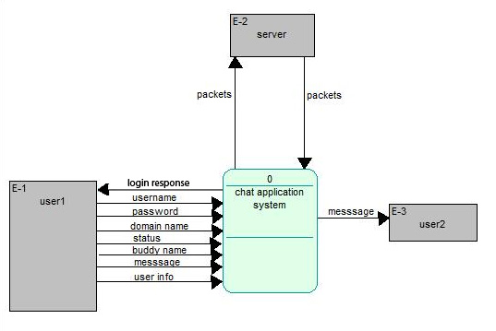

Figure : Context Diagram

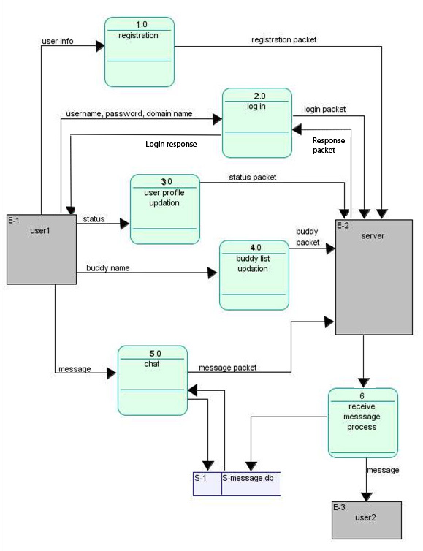

Figure :DataFlow Diagram

### System Flow Diagram

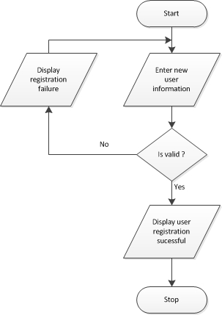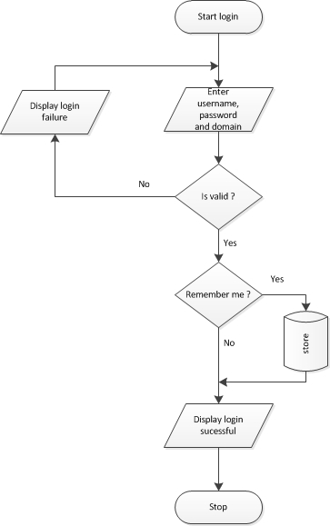

Figure : New user registration Figure : User login

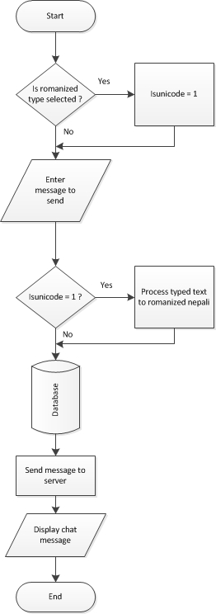 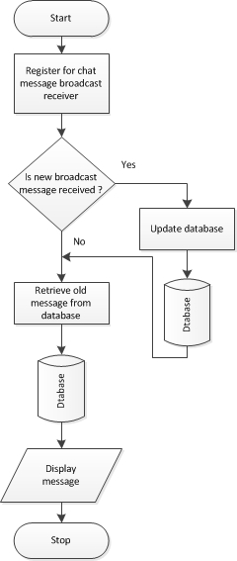

Figure : Receive message Figure : Receive message

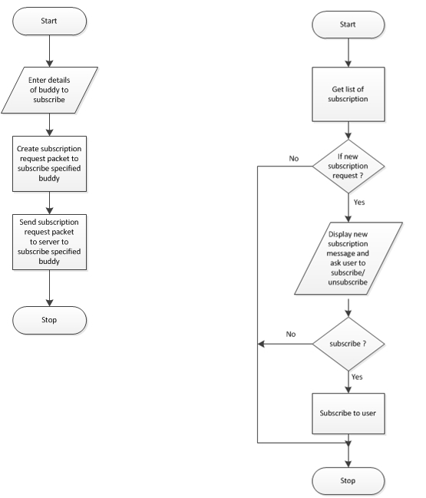

Figure : sending subscription request and verification

## Intended Benefits of Proposed System

* Less bandwidth consumption and fast connection.
* User doesn’t have to open browsers and go to specific site to login and chat.He/She can directly login through the application.
* Support for Romanized Unicode (Nepali devanagari) conversion.
* Supports graphical communication through finger paints.

## Limitations of the System

* Live voice or video messaging are not supported by the application.
* File Transfer is not supported.

# Conclusion

We have designed the requirement and system overview as the basic of project and we are clear about the need and requirement of our project. We have designed the user interface with facility to chat between the registered user which can be *(and has been) tested* using the Android virtual device. We have to extend this chat, with Romanized Unicode support for instant messaging in Nepali and also with graphical communication using Finger Paint technique. Design and user interface is ready. We are positive about the completion of the project within the specified time. Although some problems encountered have made us go behind schedule we have put in our best efforts to overcome them.

# Appendix A: Abbreviation

* App : Application
* IM : Instant messaging
* XMPP : extensive messaging and presence protocol
* SDK : software development kit
* API : Application package interface
* ROI : Return of investment
* CDMA : Code Division Multiple Access
* GSM : Global system for mobile communication
* GPS : Global positioning system
* EDGE: Enhanced Data Rules for GSM Evolutions
* UMTS: Universal Mobile Telecommunication System
* GPRS: General Packet Radio Service
* IETF: Internet Engineering Task force

# References

* Android Development, <http://www.developer.android.com>
* Mobile Nepal Networks, <http://www.mobilenepal.net>
* Open fire, <http://www.igniterealtime.org/projects/openfire/>
* Stack overflow, <http://stackoverflow.com>