Grass item (shrub) geometry definition
File format:

Line oriented text file.

The format is following:

Line 1: Name of a texture used for this shrub
Line 2: Count of Levels of Detail
Follow several lines for each Level of Detail (LoD). The count of lines depends on the content of the first line of each LoD:
CountOfSegmentsInX CountOfSegmentsInY – these values (natural numbers) define complexity of geometry for appropriate LoD. For each vertex of the geometry a single line follows which contains 4 real values:
X Y U V – X and Y are coordinates of the vertex and U and V are its texture coordinates.
There are (CountOfSegmentsInX + 1) * (CountOfSegmentsInY + 1) of these lines, starting with description of left down vertex. The order of vertices is shown on the picture below, which shows a shrub with CountOfSegmentsInX of 3 and CountOfSegmentsInY of 4.
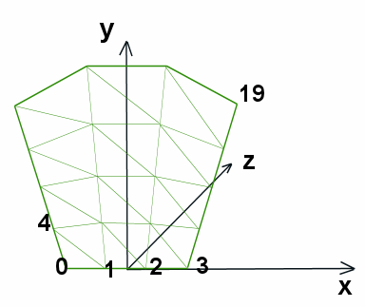
Shrub explanation:
Shrub file represents one shrub or tuft of grass and defines its geometry. The geometry is always planar, thus only X and Y coordinates are specified. You should not create too complex geometry (try keeping it under 20 triangles) since there could be thousands of shrubs in the game scene. On the other hand, it’s recommended to define several Levels of Detail for a shrub.

Example:
tuft2.png
2
1 1
-20 0 0.5 1
20 0 1 1
-30 60 0.5 0.5
30 60 1 0.5
3 1
-20 0 0.5 1
20 0 1 1
-23.33 20 0.5 0.8333
23.33 20 1 0.8333
-26.67 40 0.5 0.6667
26.67 40 1 0.6667
-30 60 0.5 0.5
30 60 1 0.5

