Database
Due to the teams knowledge and comfortability, the RAS application suite will be using a relational database for persisting application data. NoSQL databases such as CouchDB or MongoDB were discussed, but the team decided against it as our table structures will not be changing enough to require the need for such a flexible storage mechanism.

Figure 6-? Database Diagram (Note: Notifications have been left out as this section has not yet been discussed)
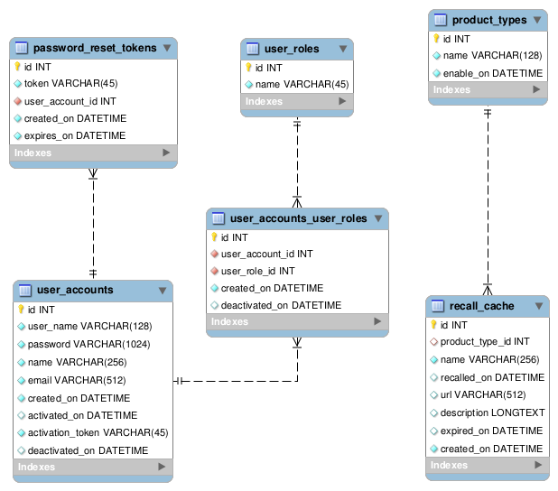

Tables
Tables in the system will be in all lowercase with words separated by underscores. Each database table is to have a surrogate key called id for quick referencing from the applications.
- user_accounts – this table will hold the membership information.
- user_roles – this is a system look up table that contains the role definitions for RAS.
- password_reset_tokens – holds the table of reset tokens that get generated when a member requests to reset their password either from the membership management page or the forgot password page.
- user_accounts_user_roles – because accounts can have many roles, this is purely a table to hold a many-to-many relationship between member accounts and system roles.
- product_types – a reference table that contains the product categories for the recalls in the system. The enable_on column is available to help with deployment.
- recall_cache – this table contains the list of product recalls that have been retrieved by the system. In the event that the SearchUSA application is down, the system will search the recall_cache.

