Recall Alert System
Design Document

Brian Chiasson
Brandon Small
Dan Buhrman
Table of Contents

1. Architecture 3
1.1 Layered Architectures Considered 3
1.1.1 3-tier architecture 3
1.1.2 Onion architecture 4
2. Database 5
2.1 Tables 5
3. SearchUSA Interface 6
4. Web Application 8
4.1 Web Application – Searching 9
4.2 Web Application – Membership 10
Appendix A References 11

Illustration Index

Illustration 1: Sample 3-tier architecture (Palermo, 2008) 4
Illustration 2: The onion architecture (Palermo, 2008)References 4
Illustration 3: Database Design 5
Illustration 4: SearchUSA Interface 8
Illustration 5: Web Application - Searching Design 9
Illustration 6: Web Application - Membership Design 10

1. Architecture
This section outlines the architectural decisions about the RAS application suite.

Goals:
- Extensible - the application architecture should permit the system to grow and support new features easily.
- Simple - the architecture should be simple as this helps to improve extensibility and maintenance.
- Testable - the architecture should be created in such a way that automated testing can be performed.
- UI Agnostic - the back-end system must be agnostic of any UI components as there is a need for multiple applications to utilize the business layers - Web Application and Notifications System.

Martin Fowler et al, in their book Patterns of Enterprise Application Architecture, points out that a layered architecture has the following benefits (2002):

- Because components are broken down into a single layer, the layer as a whole is easier to understand without having to know details about the other layers.
- Layers make it easy to substitute components without impacting the application as a whole.
- Layers can be used across different applications.

These benefits satisfy the extensibility goal, the simplicity goal, and the UI agnostic goal, therefore RAS will be implemented using a layered architecture.

1.1 Layered Architectures Considered

1.1.1 3-tier architecture
The traditional 3-tiered architecture breaks an application down into three layers - Presentation, Domain, and Data (Fowler et al, 2002). The Presentation layer is responsible for coordinating with the domain layer, displaying the UI and handling input from the UI. The Domain layer encapsulates the business rules and enforces the requirements of the system. The Data layer communicates with databases and other external data sources.

This architectural style benefits from most things listed above but has one large drawback in typical implementations - the Presentation and Domain layers are coupled to the Data layer. This means that the Data layer cannot change without impacting the majority of the application (Palermo, 2008). Due to the requirement that the RAS application suite be capable of working with multiple data sources (web services and the database) it will not use the traditional 3-tier architecture.
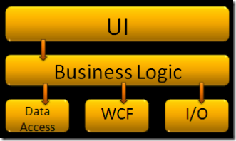Illustration 1: Sample 3-tier architecture (Palermo, 2008)

1.1.2 Onion architecture
The onion architecture, in a way, inverts the layers of a 3-tiered (or N-tiered) application. The Domain layer is at the center of the onion and only coupled to itself (Palermo, 2008). This means that the business rules can change and the external layers have to adjust. Additionally, it means that the data layer and presentation layers can change without the business layer being impacted (Palermo, 2008). This style of architecture will also allow us to share the business layer across applications should the Notifications system require the business rules. For this reason, we will be using this style of architecture for the RAS system.

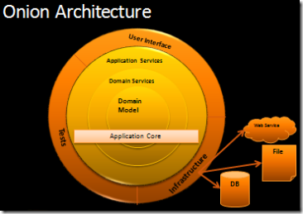Illustration 2: The onion architecture (Palermo, 2008)References

2. Database
Due to the teams knowledge and comfortability, the RAS application suite will be using a relational database for persisting application data. NoSQL databases such as CouchDB or MongoDB were discussed, but the team decided against it as our table structures will not be changing enough to require the need for such a flexible storage mechanism.

Figure 6-? Database Diagram (Note: Notifications have been left out as this section has not yet been discussed)
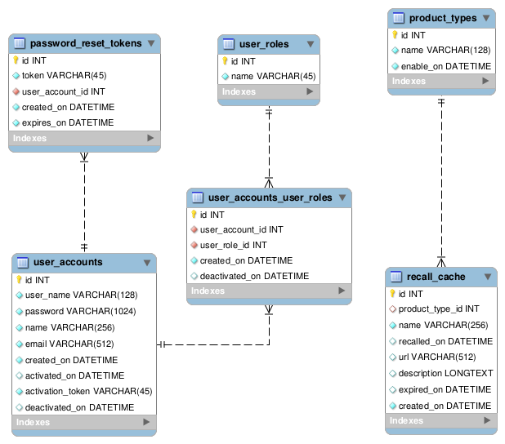Illustration 3: Database Design

2.1 Tables
Tables in the system will be in all lowercase with words separated by underscores. Each database table is to have a surrogate key called id for quick referencing from the applications.
- user_accounts – this table will hold the membership information.
- user_roles – this is a system look up table that contains the role definitions for RAS.
- password_reset_tokens – holds the table of reset tokens that get generated when a member requests to reset their password either from the membership management page or the forgot password page.
- user_accounts_user_roles – because accounts can have many roles, this is purely a table to hold a many-to-many relationship between member accounts and system roles.
- product_types – a reference table that contains the product categories for the recalls in the system. The enable_on column is available to help with deployment.
- recall_cache – this table contains the list of product recalls that have been retrieved by the system. In the event that the SearchUSA application is down, the system will search the recall_cache.

3. SearchUSA Interface
The SearchUSA component within the RAS applications will be responsible for returning product searches. The application services will use the following implementation when searching for recalls to keep the components decoupled from the service's API. This decoupling will allow us to swap in a cached repository should the service be unavailable for querying.
Figure 6 - ? Class Diagram
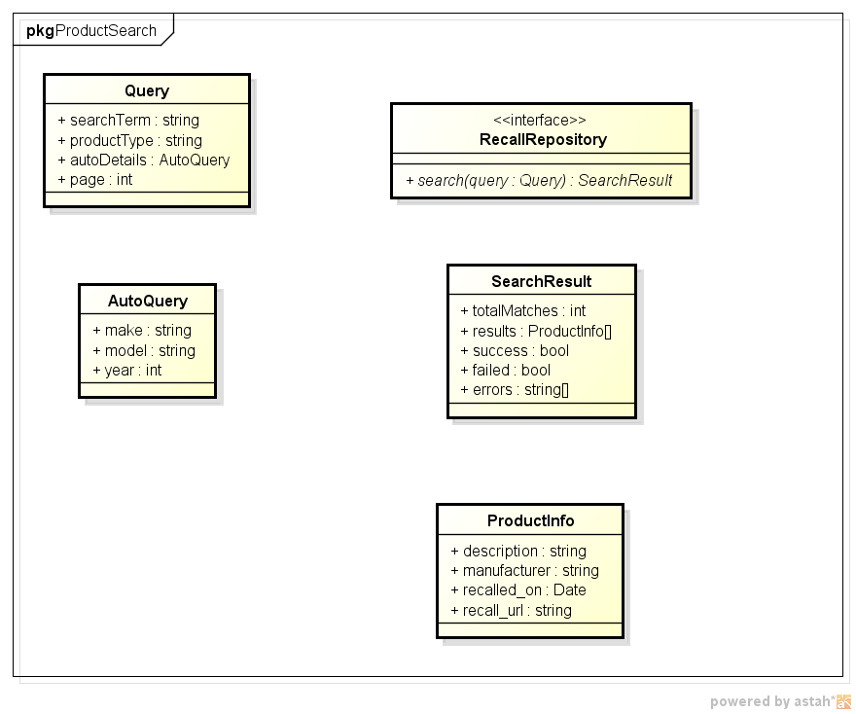Illustration 4: SearchUSA Interface

4. Web Application
The web application contains two main design entities for consideration: Searching and Membership.

4.1 Web Application – Searching
The searching entity searches for recalls based on user input. The Form interface is used to provide the basis for all search forms. Currently, the ProductForm and AutoForm are the only two forms. ProductForm allows users to search for recalls on food and consumer goods. AutoForm allows users to search for automobile recalls.
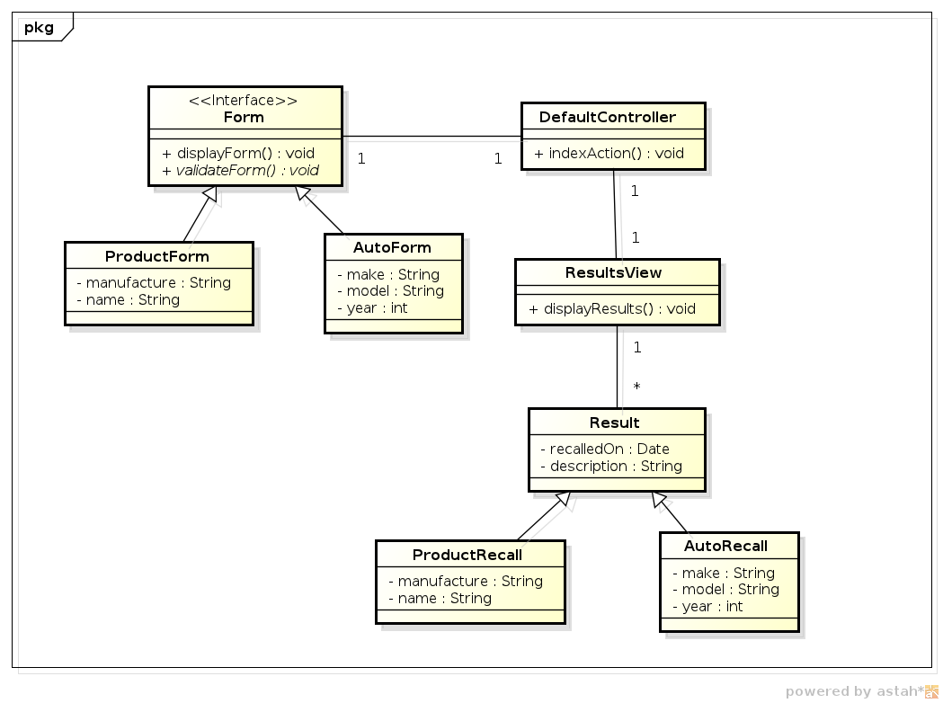Illustration 5: Web Application - Searching Design
The DefaultController is the entry point into this design entity. It provides the brain behind which form to display, searches based on form input (through the SearchUSA interface), and displays the results.
The results are stored in the Result class and displayed by the ResultView. There are two types of results, ProductRecall and AutoRecall. ProductRecall are search results on food and consumer goods, while AutoRecall are search results on automobiles. Each result contains the date the item was recalled and a description of the recall.

4.2 Web Application – Membership
The membership entity consists of two forms. The LoginForm to allow existing users to login and the RegistrationForm to allow new users to register. All actions go through the DefaultController and then through the DatabaseController which persists new users or verifies the information of existing users.
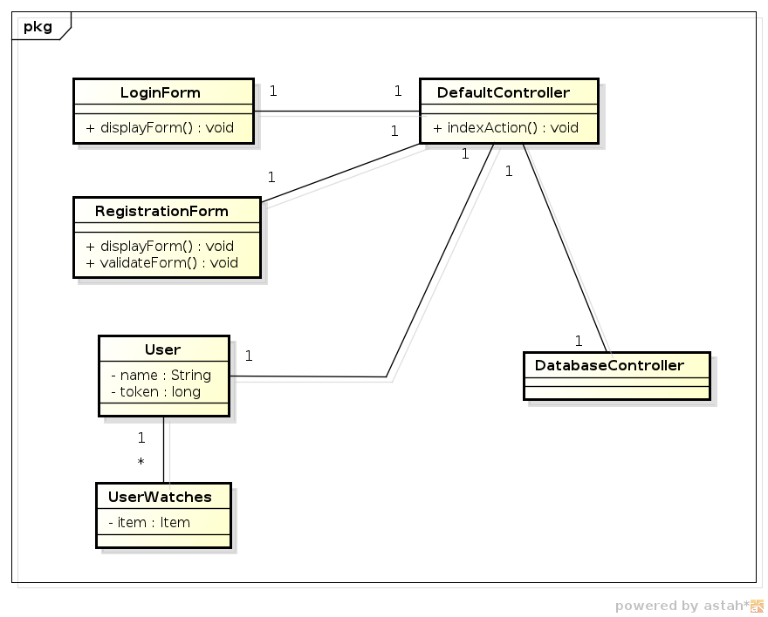Illustration 6: Web Application - Membership Design
Once validated or created, a user is then stored in the User class which contains the user's name and a security token to validate them against so they do not have to login everytime they click a link on the website. Each user can have several UserWatches which are essentially products they want to watch for recalls. When the Notifier entity is designed and developed, user's will be notified of recalls on their watched products.

Appendix A References
Fowler, Martin, Rice, David, Foemmel, Matthew, Hieatt, Edward, & Stafford, Randy (2002). Patterns of Enterprise Application Architecture. Boston: Addison-Wesley Professional.

Palermo, Jeffrey (2008, July 29). The Onion Architecture : part 1-3. Message posted to http://jeffreypalermo.com/blog.

