CMSC 495

Capstone Project

Final Report

Recall Alert System

Brian Chiasson

Dan Buhrman
Table of Contents
CMSC 495 1
Capstone Project 1
Final Report 1
Recall Alert System 1
Brian Chiasson 1
Dan Buhrman 1
1. Overview 1
2. Project Overview 1
2.1 Project Deliverables 2
2.2 Roles 4
3. Requirements 4
3.1 Purpose 4
3.2 Audience 4
3.3 Use Cases 5
3.3.1 Actors 5
3.3.2 UC – 1: Web Application – Search Recalls 5
3.3.3 UC – 2: Membership 6
3.3.4 UC – 3: Web Application – Membership Management 8
3.3.5 UC – 4: Notifier – Notifications 9
4. System Specification 11
4.1. Web Application 11
4.2 Notifier 12
4.3 Search USA 12
5. User Manual 12
5.1 User Interface 12
5.2 Search for Recalls 12
5.3 Login 12
5.4 Forgot Password 13
5.5 Search Results 13
5.6 Accounts Page 13
5.6.1 Change Account Info 13
5.6.2 Cancel Account 14
5.7 Administrative Section 14
5.7.1 Membership search 14
5.7.2 Membership admin 14
5.7.2.1 Password Reset 14
5.7.2.2 Deactivate Account 14
5.7.2.3 Activate an Account 15
5.7.3 Notifications Admin 15
5.7.3.1 Cancelling jobs 15
5.7.3.2 Running jobs 15
5.8 Membership Sign Up 15
6. Test Plan 16
6.1 Introduction & Scope 16
6.1.1 Introduction 16
6.1.2 Features to be tested 16
6.1.3 Features not to be tested 16
6.2 Testing Strategy 16
6.2.1 Approach 16
6.2.2 Item pass/fail criteria 17
6.3 Testing Tasks, Staff, and Environment 17
6.3.1 Testing tasks 17
6.3.2 Environmental needs 17
6.3.3 Responsibilities 17
6.4 Schedule and Risks 17
6.4.1 Schedule 17
6.4.2 Risks and contingencies 18
6.5 Test Case Specifications 18
6.5.1 Test Case <SearchAutoRecalls> 18
5.5.1.1 Test items 18
6.5.1.2 Input specifications 19
6.5.1.3 Output specifications 19
6.5.1.4 Environmental needs 19
6.5.1.5 Special procedural requirements 19
6.5.1.6 Intercase dependencies 19
6.5.2 Test Case <MembershipFeature> 19
6.5.2.1 Test items 19
6.5.2.2 Input specifications 19
6.5.2.3 Output specifications 19
6.5.2.4 Environmental needs 19
6.5.2.5 Special procedural requirements 19
6.5.2.6 Intercase dependencies 19
6.5.3 Test Case <SearchFoodRecalls> 20
6.5.3.1 Test items 20
6.5.3.2 Input specifications 20
6.5.3.3 Output specifications 20
6.5.3.4 Environmental needs 20
6.5.3.5 Special procedural requirements 20
6.5.3.6 Intercase dependencies 20
6.5.4 Test Case <SearchConsumerRecalls> 20
6.5.4.1 Test items 20
6.5.4.2 Input Specifications 20
6.5.4.3 Output Specifications 20
6.5.4.4 Environmental needs 20
6.5.4.5 Special procedural requirements 20
6.5.4.6 Intercase dependencies 20
6.5.5 Test Case <Notifier> 20
6.5.5.1 Test Items 21
6.5.5.2 Input Specifications 21
6.5.5.3 Output Specifications 21
6.5.5.4 Environmental needs 21
6.5.5.5 Special procedural requirements 21
6.5.5.6 Intercase dependencies 21
6.6 UI Tests 21
7. Architecture 21
7.1 Layered Architectures Considered 22
7.1.1 3-tier architecture 22
7.2 Database 23
7.2.1 Tables 23
7.3. SearchUSA Interface 24
7.4 Web Application 25
7.4.1 Web Application – Searching 26
7.4.2 Web Application – Membership 27
8 Conclusion 27
8.1 Lessons Learned 28
8.2 Future Improvements 28
Appendix A: References 30
Appendix B: Phase Summaries 31
B.1 Phase 1 Summary 31
B.1.1 Milestones 31
B.1.2 Item 1 Status – Development Environment 31
B.1.3 Item 2 Status – Web Server Setup 32
B.1.4 Item 3 Status – Website template 32
B.1.5 Item 4 Status – Search Form 32
B.1.6 Item 5 Status – Search Results 32
B.1.7 Item 6 Status – USA Search Rest API 33
B.2 Document Changes/Schedule Changes 33
B.2 RAS Application Suite: Phase 2 Summary 35
B.2.1 Milestones 35
B.2.2 Item 1 Status – Site Template 35
B.2.3 Item 2 Status – Create the registration form 36
B.2.4 Item 3 Status – Process Registration 40
B.2.5 Item 4 Status – Membership Activation Form 40
B.2.6 Item 5 Status – Membership Activation Script 41
B.2.7 Item 6 Status – Configuring the SMTP Server 41
B.2.8 Item 7 Status – Member Login form 41
B.2.9 Item 8 Status – Member login script 42
B.2.10 Document Changes/Schedule Changes 42
B.2.11 Retrospective 44
B.3 RAS Application Suite: Phase 3 Summary 44
B.3.1 Milestones 44
B.3.2 Item 1 Status – Member registration script 44
B.3.3 Item 2 Status – Complete script to process member activation 46
B.3.4 Item 3 Status – Configure SMTP server 46
B.3.5 Item 4 Status – Complete member login script 46
B.3.6 Item 5 Status – Add ability to search for food recall data 46
B.3.7 Document Changes/Schedule Changes 46
B.3.8 Retrospective 48
B.4 RAS Application Suite: Phase 4 Summary 48
B.4.1 Milestones 48
B.4.2 Item 1 Status – Member registration script 48
B.4.3 Item 2 Status – Complete script to process member activations 49
B.4.4 Item 3 Status – Configure SMTP server 50
B.4.5 Item 4 Status – Complete member login script 50
B.4.6 Item 5 Status – Complete Recall Search form 51
B.4.7 Document Changes/Schedule Changes 51
B.4.8 Retrospective 53
B.5 RAS Application Suite: Phase 5 Summary 53
B.5.1 Milestones 53
B.5.2 Item 1 – Consumer Goods Recalls 53
B.5.3 Item 2 – Final touches 54
B.5.3.1 Item 2.1 – Results Pagination 54
B.5.3.2 Item 2.2 – Better descriptions 55
B.5.4 Item 3 – Bug Fixes 55
B.5.5 Document Changes/Schedule Changes 56
B.5.6 Retrospective 58
Illustration Index
Illustration 1: Sample 3-tier architecture (Palermo, 2008) 22
Illustration 2: Database Design 23
Illustration 3: SearchUSA Interface Diagram 25
Illustration 4: Web Application Searching Design 26
Illustration 5: Web Application - Membership Design 27
Illustration 6: Screenshot of latest automated test execution (All tests) 31
Illustration 7: UI Screen capture of test run for the USA Search restul parser class 32
Illustration 8: Screen shot of site home page 36
Illustration 9: Registration form screen shot 39
Illustration 10: Screen capture of the required fields 40
Illustration 11: Membership activation form with field requirements 41
Illustration 12: Membership login screen with required field messages 42
Illustration 13: Screen of user_accounts table with record inserted from test 45
Illustration 14: Screen of the final page in the registration process complete. 49
Illustration 15: Screen shot of final page in membership activation 49
Illustration 16: Screen shot of error when email/token is not in system database. 50
Illustration 17: Screen shot of successful member logon. 50
Illustration 18: Message displayed when system can't authenticate user 51
Illustration 19: Search Form with Results 51
Illustration 20: Final Search Form 54
Illustration 21: Pagination 55
Illustration 22: No results 55
Index of Tables
Table 1: Project Deliverables 4
Table 2: Roles 4
Table 3: Testing Milestones 18
Table 4: Project Deliverables - Phase 1 Update 35
Table 5: Project Deliverables - Phase 2 Update 44
Table 6: Project Deliverables - Phase 3 Update 48
Table 7: Project Deliverables - Phase 4 Update 53
Table 8: Project Deliverables - Phase 5 Update 58

1. Overview
The project started with the idea of making it easier for users to find product recall information to fill a gap in the market. The success or failure of the project will be solely based on the public’s adoption of the web site and its features. The web site will be made publicly accessible at a domain to be determined.

Through the five development phases the following features were completed:

- Site layout
- Server configuration
- Product recall search form
- Membership registration (will become important when notifications are built)
- Membership activation
- Membership login

Both team members contributed to the documentation phases of the project and were key in the successful delivery of the completed features. The following credits are being given:

Dan Buhrman
- Web server configuration - SMTP, Apache, and MySQL
- Recall search form user interface and integration with backend wrappers around recall data source APIs.
- Database design
- Script troubleshooting
- Testing
Brian Chiasson
- Site layout
- Database design
- Backend wrapper around the USA Search REST APIs
- Membership registration UI and integration with database
- Membership activation UI and integration with database
- Membership login UI and integration with database
- Script troubleshooting
- Automated unit test scripts

2. Project Overview
The project will design, develop, and implement a Recall Alert System (RAS) that allows consumers to easily check for recalls on various products. The system will provide the functionality for users to search for various products, as well as receive notifications regarding different products or product categories. The main user interface will consist of a website. The website will interact with a back-end server that will data mine for recalls based on the input of the user.

2.1 Project Deliverables
Deliverable | Date
Project Plan | 6/19
Meeting Notes | 6/20
System & Software Specification | 6/26
Meeting Notes | 6/27
Test Plan & User Guide | 7/3
Meeting Notes | 7/4
Design | 7/10
Meeting Notes | 7/11
Hosted Website (Phase 1)  Provide a hosted webpage with the ability to search for automotive recall data. | 7/17
Meeting Notes | 7/18
Membership Feature (Phase 2)  Complete website template. Enhance the website by adding a membership feature. | 7/24
Meeting Notes | 7/25
Food Recalls (Phase 3)  Complete membership control scripting. Configure SMTP server. Enhance the website by adding the ability to search for food recall data. | 7/31
Meeting Notes | 8/1
Consumer Goods Recalls (Phase 4)  Finish member registration  Complete SMTP server setup  Complete membership activation  Complete membership login  Complete the recall search form  Enhance the website by adding the ability to search for consumer goods recall data. | 8/7
Meeting Notes | 8/8
Touch-ups (Phase 5)  Include any bug fixes, touch-ups, and any other enhancements agreed upon. | 8/14
Meeting Notes | 8/15
Final Report | 8/21
Table 1: Project Deliverables

2.2 Roles
Dan Buhrman | Brian Chiasson
- Documentation  - Webmaster  - Development (PHP, MySQL, HTML, JavaScript)  - Tester  - Infrastructure  - Architect/Designer | - Documentation  - SCM  - Development (PHP, MySQL, HTML, JavaScript)  - Tester  - Architect/Designer
Table 2: Roles

3. Requirements
This section outlines the high level requirements for the RAS application suite.

3.1 Purpose
It's daunting how difficult it is to find product recall information on the web. A simple Google search on“product recall alert services” yields search results for companies that assist other companies in the process of recalling products. The only service we were able to find is the government's website www.recall.gov. The website offers services for finding and being notified for recall information, but it lacks a unified interface and only offers rudimentary notification services.

The goal of the RAS application suite is to provide a unified interface into consumer product recall information. Initially the sutie will provide access to automotive, food and consumer good recall information available from the government's API. Future releases of the system will incorporate additional features and data sources.

3.2 Audience
The system is being built for everyday consumers in the US. Our target audience is familiar with web technologies and is assumed to use the Internet on a daily basis – for work, for research, or for leisure.

3.3 Use Cases
The following use cases outline the primary usage for the RAS application suite. The actors have been defined below to reduce the duplication of re-listing the definitions from within each use case.

3.3.1 Actors
The potential users of the RAS application suite.
- Web User – the primary audience for the web application. This user has access to an Internet connection and will uses a web browser that must be supported by the application.
- System Administrator – a system user that assists in maintaining the application suite and its infrastructure. The system administrator will use both the web browser and any supporting software that helps keep the system running.
- Notifier – the application responsible for delivering information to users and system administrators.
- SearchUSA – the back-end service responsible for parsing and logging the recall information.

3.3.2 UC – 1: Web Application – Search Recalls
The majority of the web application's functionality will be built around ensuring the best experience for the web user in finding recall information for the users' products. The Recall search form will be available in two places, the home page and a page dedicated to searching.

Scope
Web application, SearchUSA

Actors
Primary Actors: Web User
Supporting Actors: SearchUSA?

Stakeholders
Web User – is interested in obtaining safety recall information about a product
Company – wants the users to use the system and be able to obtain information successfully

Preconditions
- The application is published to the web at the Domain.
- The data sources for the recall data has been polled or is available to the system.

Post Conditions
- Success conditions
  - User can see the rendered home page in the browser
  - User can search for recall information without receiving an error
- Failure conditions
  - User receives an error when attempting to search
  - The website is unavailable

Primary Flow
- User arrives at the website's homepage.
- User clicks to select a product type on the search form.
- User clicks button to execute search.
- The information is sent to the web server in the form of a POST operation.
- The data is translated and sent as a request to the back-end API
- Data is returned from the API to the web server.
- The search results page is rendered and returned to the user.
- The user can repeat steps 2-7 at this point because the search form is at the top of the results page.

Alternate Flows
- At any time the user may cancel the operation
  - The user presses the cancel button.
  - The user is taken back to the home page.
- The user chooses to search without providing any input criteria
  - The user clicks search without entering any data.
  - The client-side technology determines that no input is selected and presents a message to the user indicating that input is required.
  - If the client-side technology is disabled than the server-side will perform the validation
- The user clicks search and the back-end system is not available.
  - The user clicks search.
  - The database is not available so the web server receives an error.
  - The user is taken to an error page indicating that a problem occurred.
  - The system notifies the administrator of the error.
- No search results are presented to the user
  - The back-end is unable to find any search results for the product.
  - The user is prompted to sign-up for the notifications system to be informed if recall information is ever collected.
  - Begin Membership UC later in this document.

Special Requirements
- The system should be available where possible. Hopefully the system is successful enough that there will be redundant servers and a single server being down will not cause an issue.
- If possible, any errors should be recorded and/or sent to administrative personnel.

Frequency of Occurrence
The main goal of the RAS suite it to provide recall information and the primary means for doing so will be the web application (initially). Therefore, this use case will be executed continuously.

Open Issues
- What if the database has not collected any information from the Recall data sources?
- Is there a way to reduce duplication of validation logic so we don't have to replicate validation in the client-side and server-side technologies?
- Can we support a “Google” style search for the future?

3.3.3 UC – 2: Membership
The web application will allow users to create memberships. Memberships will only require basic info and a means of contact (for notification purposes). Most of the information we will capture will be preferences on notifications (what to send, how often, where to send them).

Scope
Web application, Database

Actors
Primary Actors: Web users
Supporting Actors: System administrators

Stakeholders
Administrators – want account creation to be simple and straight forward, so they need not be involved
Web User – want a simple interface for creating an account
Company – wants a simple yet flexible account creation process so that users will actually create an account and use the alert service, instead of being scared away by a long creation process

Preconditions
The application is published to the web at the Domain.

Post Conditions
- Success conditions
  - User account has been created, alerts can be sent to the user.
- Failure conditions
  - User receives an error when performing any operations, thus account is not created
  - The website is unavailable

Primary Flow
- The Use-case begins when a user either wants to set up an alert, or wants to create an account, either way an account will be created.
- User clicks on “Create an account” link which navigates to the account creation screen.
- User fills out the membership form and submits.
- Account is created but not confirmed.
- User confirms account through the email contact or some other means of communication.
- Account is now confirmed and notifications can now be sent to the user based on their preferences.

Alternate Flows
- Admin chooses to add a member
  - The add button is clicked.
  - The membership form is presented.
  - The information is entered and the targeted account user is emailed the appropriate information
  - User takes over at Main Flow step 5 to complete membership
  - Admin is taken back to membership page and is presented with new user account in list.
- Error in account creation
  - User enters invalid information
  - User credentials haven’t been verified
  - The account will remain in the database but will be labeled inactive until confirmation

Special Requirements
User must provide and confirm a point of contact.

Frequency of Occurrence
Every user that wants to have notifications sent will have to create an account, so this will occur very frequently.

Open Issues
None for the moment.

3.3.4 UC – 3: Web Application – Membership Management
The web application will allow users to create memberships that will enable the future feature of notifications (Phase 5 if time permits). In an effort to support our members, system administrators need to be able to manage the web users.
Scope
Web application, Database

Actors
Primary Actors: System administrators
Supporting Actors: Web users

Stakeholders
Administrators – want a simple to interface for managing application users
Web User – may need support to reset account passwords, cancel accounts
Company – wants to ensure that business processes are followed for managing accounts. Does
not want admins using the database tools to by-pass processes.

Preconditions
The application is published to the web at the Domain.

Post Conditions
- Success conditions
  - Admin can login to find members, reset passwords, add members and disable members
- Failure conditions
  - Admin receives an error when performing any operations
  - The website is unavailable

Primary Flow
- Admin navigates to membership login.
- System recognizes user as admin and presents a new link to the admin portal.
- Admin clicks on portal and is presented with options for finding members.
- Admin locates member using membership search form
- Admin is presented with a list of options for disabling the account or resetting the password.

Alternate Flows
- Admin chooses to add a member
  - The add button is clicked.
  - The membership form is presented.
  - The information is entered and the targeted account user is emailed the appropriate information
  - UC Membership step takes over from here for member to complete membership
  - Admin is taken back to membership page and is presented with new user account in list.
- Admin finds a member and elects to disable account.
  - The disable button is clicked.
  - A confirmation is posted warning the admin about the ramifications
  - Admin chooses:
    - Ok Chosen
      - Account is disabled in the back-end and the user is notified of the account being disables
      - Admin is taken back to membership admin home page and is notified that account is disabled.
    - Cancel
      - Account is not disabled.
      - Admin stays on the member's administrative page.
- Admin finds a member and elects to reset the password
  - Admin clicks the reset password button.
  - The back-end system regenerates a password reset token.
  - The token is emailed to the member.
  - UC Membership password reset step takes over from here.
  - Admin stays on members’ admin page.
- The admin is not recognized by the system
  - The admin attempts to login.
  - The credentials are not recognized
  - An error message states that the membership information is not recognized
- User attempts to navigate directly to admin section.
  - User inputs admin URL into browser locator bar.
  - User is directed to access denied page that contains the membership form.
- The member is not found
  - The admin searches for a member that is not in the system
  - The system presents a message that says user is not found

Special Requirements
- Per membership section, failed login attempts should not disable the account, they should create a login attempt window that increase exponentially with each failed login attempt per security recommendations.
- Administrators should never be able to set the password or see the account password.
- Administrators should never be permitted to remove an account, accounts must be disabled.

Frequency of Occurrence
Admins will fairly frequently visit this section, hopefully to add members or help with password resets, not cancellations.

Open Issues
None for the moment.

3.3.5 UC – 4: Notifier – Notifications
This use case is being added as a nice to have for Phase 5 of the RAS application suite. It is perhaps the most complex feature and should require the most attention as it involves emailing users about recall information based on preferences.

Scope
Notifier, Web application, Database, SMTP Server

Actors
Primary Actors: Notifier service
Supporting Actors: Web users, System administrators

Stakeholders
Web Users – want to be notified when a recall is detected by the system
Company – wants to ensure that users are not being spammed.
Administrators – need to be able to kick off notifications, check notification process, and stop it if necessary

Preconditions
- The application is published to the web at the Domain.
- At least one user has elected to receive notifications

Post Conditions
- Success conditions
  - Member receives email regarding the notification that was found.
  - Administrators can see the number of emails that were sent.
- Failure conditions
  - Admin receives an error that the notification process hasn't finished
  - The website is unavailable
  - The email server is down.

Primary Flow
- Notifier polls the database for recall information that is new and members preferences to determine who needs to be notified.
- Records have been found so the notifier kicks off threads to send out emails to members
- Processing is done to create the emails from templates and sent to the SMTP server to be delivered.
- Processing marks the member as being notified.
- When all threads have completed the notifier sleeps until the polling interval has elapsed.

Alternate Flows
- No one needs to be notified
  - No results are returned.
  - Notifier sleeps waiting for the next interval
- The SMTP server is unavailable
  - The thread determines that the SMTP server is not available.
  - The Notifier cancels the remaining threads and logs the error.
  - The memberships are not marked notified so that the next run will pick them up again.
- Admin chooses to cancel notifications
  - Administrator, using the admin portal cancels notification in process and provides a reason.
  - The SMTP server is sent a stop command.
  - The Notifier is sent a stop command.
  - The system logs the cancellation.
  - The memberships are not marked notified so that the next run will pick them up again.
- Notifier determines that too many messages are going out
  - Notifier determines that too many messages are being sent out.
  - Notifier cancels the run.
  - Notifier emails the system administrator that the run has been canceled due to the number of notifications that might be sent out.
- Admin forces a notification run
  - Admin forces a notification run from the admin portal
  - SMTP server is sent start command (in case it was stopped)
  - Notifier is sent command to begin.
  - Notifier may not halt the process due to number of notifications because of admin override.
  - Main flow takes over from here.

Special Requirements
- To avoid being black-listed, we must ensure that we do not SPAM our users. We must be careful when implementing the email feature so that we are not notifying our users too much.
- The notifier should be multi-threaded so that it can send out multiple emails at a time and be able to get through a notification cycle pretty quickly.

Frequency of Occurrence
The notification interval will be daily or twice daily to ensure that our users are kept informed of recalls. The administrator should rarely have to intervene.

Open Issues
- We need to figure out a performant way identifying who needs to be notified.
- We must ensure that the notifier is not bogging down the network or the database too much.
- How will users register for notifications? Send all? Send ones based on product type? User enters in manufacturer information? User has options to do any or all of them?
- What will we send? The notifications embedded in the email? An email that says a notification has been found for something the user is interested in?

4. System Specification
This section outlines the supporting infrastructure for the RAS application suite.

4.1. Web Application
The web application is the primary focus for the RAS application suite. It will be constructed and deployed using a LAMP stack.
- Linux server operating system (actual distribution to be determined by host)
- Apache 2
- PHP 5
- MySQL
- HTML/JavaScript

4.2 Notifier
The notifier, should time permit, will be constructed for processing membership notifications when recalls are entered into the system.
- Linux server operating system (actual distribution to be determined)
- SMTP
- Java

4.3 Search USA
This portion of the system is responsible for querying the recall data providing services.
- Linux server operating system (actual distribution to be determined)
- Java
- HTTP

5. User Manual

5.1 User Interface
The RAS application suite will be managed via the website as much as possible. Both web users and administrative users will utilize the website to login and perform the various tasks that are determined by roles within the system. The entry point into the website application will be the home page. From the homepage, the following items may be performed:

- Search for product recalls.
- Login to the members’ section/admin section.
- Sign up for membership.
- Learn about the site and its purpose.

5.2 Search for Recalls
The main focus of the homepage, and the site will be to allow users to quickly find product recalls. In order to find out about a product’s recall information the following steps must be performed:

- Required: Select a product type from the list of available product types (Figure 1-1).
- Optional: Select the brand name from the list that is populated.
- Required: Provide a search term in the provided text box.
- Click the search button (or hit the Enter key) to perform the search.
- View the results page that is displayed to find your product (Figure 1-2).

Unfortunately, the RAS application is reliant upon third party data that may not be updated in real-time. Should the search results not yield anything for the user, an option will be made available for the user to sign up for notifications (see section 4 for details).

5.3 Login
Users may want to quickly sign up for notifications, change their account information or cancel their account. Administrators will have their own tasks to accomplish. Users must log in to gain access to these secured features. Log in by performing the following:

- Click the Login link at the top of the homepage.
- Required: Enter the username that was chosen during sign up.
- Required: Enter the account’s password.
- Click the Log in button (or hit the Enter key) to login.
- Choose from the available options on the account screen.

5.4 Forgot Password
The forgotten password feature will be available for regular site users only. This feature seems complex for a simple thing, however, for better security the RAS system does not store passwords in reversible form - this means that passwords cannot be retrieved for any users. From the login page, click the Forgot my password link.

- Required: Enter the username.
- Click the button (or press the Enter key).
- Open up your email account.
- Open up the email sent to you from our system.
- Copy the password reset token into your clipboard (password reset tokens have an expiration on them, if the time expires start the process over).
- Navigate to the website URL indicated (e.g. domain.com/PasswordReset)
- Required: Enter the token into the text field provided.
- Click the button (or press the Enter key) to be presented with the password reset dialog.
- Required: Enter the account’s username.
- Required: Enter the new password.
- Required: Confirm the new password.
- Click the reset button (or press the Enter key)

When complete, you will be directed to the login page an asked to login again.

Note: For security reasons, this page will not inform the user if the account was found or not. Additionally, the email will not provide any links to our site.

5.5 Search Results
Users will be redirected to this page when a product search is performed. From this page users will be able to view their results, perform additional searches, login to the website and sign up for account membership.

5.6 Accounts Page
The section of this site will allow users to manage their account. Users will be able to change their email address, reset their password, change their notification preferences, and cancel their account.

5.6.1 Change Account Info
This link will present a form that allows the user to change the account’s email address and password.

- Required: Email address
- New password field - required if input. Note: your password will not change if you do not enter a value here.
- Confirm password field - required if New password entered.
- Click update (or hit the Enter key)
- Enter the current account password to confirm the changes.

5.6.2 Cancel Account
Users can cancel their account by clicking the cancel account link.

- Click the link to cancel the account.
- Enter the account’s password when prompted to confirm account cancellation.
- Click cancel to quit the account cancellation process.

5.7 Administrative Section
When administrators log in they will be redirected to the admin portion of the RAS website where they will be able to perform the following:

- Administer user accounts.
- Administer notifications

5.7.1 Membership search
Find members using the account search form.

- Required: Search field - put in account username, account email or account holder’s name.
- Click the search button (or press the Enter key)
- Select an action for the user from the list, or click to open up the account details page.

5.7.2 Membership admin
From the account details screen (or the membership search) admins can do the following.

5.7.2.1 Password Reset
Admins can generate account password reset tokens using this feature.

- Click “Reset Password”
- Click Ok to confirm or Cancel to exit.
- The password token will be generated and emailed to the user.

5.7.2.2 Deactivate Account
Admins can disable an account.

- Click “Deactivate”
- Required: Enter a deactivation reason
- Click Ok to confirm or Cancel to exit.

5.7.2.3 Activate an Account
Admins can enable an account.

- Click “Activate”
- Click Ok to confirm or Cancel to exit.

5.7.3 Notifications Admin
Admins can force a notification run or cancel a notification run from this section.

Note: The page will contain the list of the last 5 successful notification runs, but there are no actions available for these items.

5.7.3.1 Cancelling jobs
Admins can cancel running or pending jobs.

- Click the notifications link.
- The page will display the list of the last 10 jobs - cancelled, failed, running and pending.
- Click the Cancel button next to the run you would like to cancel.
- Required: Enter a cancellation reason.
- Click Ok or Cancel to exit.

5.7.3.2 Running jobs
Admins can re-run cancelled jobs or failed jobs.

- Click the notifications link.
- The page will display the list of the last 10 jobs - cancelled, failed, running and pending.
- Click the KickOff button next to the run you would like to start.
- Click Ok to confirm or Cancel to exit.

Note: Jobs can only be started if no others are currently executing.

5.8 Membership Sign Up
Users may sign up from the home page or the search results page.

- Required: Enter a Name
- Required: Enter a Username - this value must be unique.
- Required: Enter an email address - this is required for account activation and notifications.
- Click Create (or press the Enter key) to create the account.
- Check the email address’s inbox for an account activation email.
- Copy the URL into the browser and hit enter.
- The account is now active

6. Test Plan

6.1 Introduction & Scope

6.1.1 Introduction
The goal of testing is to ensure the majority of bugs have been found and resolved before release. This is handled by a 4-tier approach: (1) White-box testing, (2) Black-box testing, (3) Integration Testing, and (4) UI Testing. The white-box testing is done often during development to ensure the business logic of the code is sound. Black-box testing occurs after a phase has been developed to ensure the code meets the business requirements. Integration testing is done in an identical environment to the production environment to ensure the new code integrates completely with the old code. The last tier, UI testing, ensures all user interfaces interactions match the use-cases specified in the Software Requirements Specification Document.

6.1.2 Features to be tested
All features of the project are subject to testing, per this test plan. The project currently consists of 5 phases, each introducing a new feature. Each feature will be tested during development (for logic testing), during integration (for integration testing), and after release (for UI testing).

6.1.3 Features not to be tested
Apache, MySQL, PHP, SearchUSA, and Symfony (including any 3rd party Symfony libraries) will not be tested. All of these components provide a functionality layer to the application, and will be assumed as production-worthy applications.

6.2 Testing Strategy

6.2.1 Approach
Several approaches will be used for testing. All tests will be conducted by someone with a significant knowledge of the system.

During each development phase, a white-box approach will be used to frequently test the logic of the component being developed. An agile development approach will be followed where small portions of code (typically a single class) will be tested and verified before continuing development of that component.

After the component has been developed, and logic verified, a black-box approach will be utilized to ensure the component has met the requirement specification. At this point, integration tests will be performed to verify the component integrates with the rest of the system. Finally, user interface tests will be performed to ensure the component matches the scenario described in the functional requirement.

These combined testing approaches will ensure the highest quality software will be produced while verifying the functional requirements are still met.

6.2.2 Item pass/fail criteria
All testing will pass if the expected output matches the actual output.

6.3 Testing Tasks, Staff, and Environment

6.3.1 Testing tasks
To successfully conduct testing, each tester will need to have a fully functioning development environment as described in section 3.2 of this document. Also, a functioning test environment will need to be setup that is identical to the live environment. Each tester will need access to the test environment.

6.3.2 Environmental needs
There are two main environments required for testing: the development environment, and the testing environment.

The development environment consists of any computer with the latest versions of Apache, MySQL, and PHP installed. In addition, the Symfony framework will be installed and configured. All unit testing will be conducted through Symfony's third party library PHPUnit.

6.3.3 Responsibilities
All developers will be responsible for each stage of testing.

6.4 Schedule and Risks

6.4.1 Schedule

Milestone | Date | Testing Task
Hosted Website (Phase 1) | 7/12 – 7/17 | White-box Tests  Black-box Tests  Integration Tests  UI Tests
Membership Feature (Phase 2) | 7/18/ - 7/24 | Black-box Tests  Integration Tests  UI Tests  Security Tests
Food Recalls (Phase 3) | 7/25 – 7/31 | White-box Tests  Black-box Tests  Integration Tests  UI Tests
Consumer Goods Recalls (Phase 4) | 8/1 – 8/7 | White-box Tests  Black-box Tests  Integration Tests  UI Tests
Phase 5 (TBD) | 8/8 – 8/14 | TBD
Table 3: Testing Milestones

6.4.2 Risks and contingencies
All white-box tests are at the developers discretion. This poses the risk of too little, or no testing to be performed during development, increasing the chances of latter tests to fail, or bugs to surface after deployment. If this is the case, the time spent on the project will increase.

There are no security concerns for testing. All information is public domain, and all code open source, with the exception to user account information, which is not a concern during the testing period.

6.5 Test Case Specifications
White-box Tests
Because of the agile nature of the development process, all white-box tests will be conducted during development. The goal is to code small and test the logic continuously during development using Symfony's PHPUnit plugin. All white-box tests will be included in the final report, and will include the test data, test logs, and test reports.

Black-box Tests
All black-box tests will be conducted after a development phase completion. These tests aim to ensure the project requirements for that phase have been met, per the Software Requirements Document.

6.5.1 Test Case <SearchAutoRecalls>

5.5.1.1 Test items
Several examples will be used to verify the website is correctly receiving, parsing, and displaying the data from SearchUSA.

6.5.1.2 Input specifications
Three specific searches, three moderately specific, and three generic searches will be conducted. The specific searches will consist of a search knowing the specific car. The moderately specific searches will consist of a search knowing the year and make of the car. The three generic searches will consist of a search knowing the make of the car.

6.5.1.3 Output specifications
The expected output is that returned from SearchUSA, in the format described in the Software Requirements Specification Document.

6.5.1.4 Environmental needs
None.

6.5.1.5 Special procedural requirements
None.

6.5.1.6 Intercase dependencies
None.

6.5.2 Test Case <MembershipFeature>
The membership feature allows users to register with the website.

6.5.2.1 Test items
This test will verify a new registration is published to the database, and can be retrieved and authenticated against correctly.

6.5.2.2 Input specifications
Sample user data.

6.5.2.3 Output specifications
A cookie that authenticates the user.

6.5.2.4 Environmental needs
None.

6.5.2.5 Special procedural requirements
None.

6.5.2.6 Intercase dependencies
SearchAutoRecalls

6.5.3 Test Case <SearchFoodRecalls>

6.5.3.1 Test items
This feature allows users to search for recalls on food.

6.5.3.2 Input specifications
9 different types of food products will be picked at random.

6.5.3.3 Output specifications
The expected output is that returned from SearchUSA, in the format described in the Software Requirements Specification Document.

6.5.3.4 Environmental needs
None.

6.5.3.5 Special procedural requirements
None.

6.5.3.6 Intercase dependencies
SeachAutoRecalls, MembershipFeature

6.5.4 Test Case <SearchConsumerRecalls>

6.5.4.1 Test items
This feature allows users to search for recalls on consumer goods.

6.5.4.2 Input Specifications
9 different types of consumer goods products will be picked at random.

6.5.4.3 Output Specifications
The expected output is that returned from SearchUSA, in the format described in the Software Requirements Specification Document.

6.5.4.4 Environmental needs
None.

6.5.4.5 Special procedural requirements
None.

6.5.4.6 Intercase dependencies
SearchAutoRecalls, MembershipFeature, SearchFoodRecalls

6.5.5 Test Case <Notifier>
This feature will be implemented in phase 5, and only if time allows.

6.5.5.1 Test Items
This feature allows members of the site to be notified via email of any recall information on a product they have specified.

6.5.5.2 Input Specifications
Twenty-seven products will be “watched” by various dummy users. Fake recall information will be “detected” by the system.

6.5.5.3 Output Specifications
An email containing the recall information to the various email addresses of the dummy users.

6.5.5.4 Environmental needs
Special email addresses will need to be created. An SMTP server must be present on the test machine.

6.5.5.5 Special procedural requirements
A special data source will need to be created for this test so it appears the information is coming from a valid source. This will ensure the notifier is checking for information on-time, and it detects the correct information.

6.5.5.6 Intercase dependencies
SearchAutoRecalls, MembershipFeature, SearchFoodRecalls, SearchConsumerRecalls

6.6 UI Tests
All UI tests are specified by the use-cases in the Software Requirements Specification Document. The tester will follow the use-case and ensure all UI displays match those specified.

7. Architecture
This section outlines the architectural decisions about the RAS application suite.

Goals:
- Extensible - the application architecture should permit the system to grow and support new features easily.
- Simple - the architecture should be simple as this helps to improve extensibility and maintenance.
- Testable - the architecture should be created in such a way that automated testing can be performed.
- UI Agnostic - the back-end system must be agnostic of any UI components as there is a need for multiple applications to utilize the business layers - Web Application and Notifications System.

Martin Fowler et al, in their book Patterns of Enterprise Application Architecture, points out that a layered architecture has the following benefits (2002):

- Because components are broken down into a single layer, the layer as a whole is easier to understand without having to know details about the other layers.
- Layers make it easy to substitute components without impacting the application as a whole.
- Layers can be used across different applications.

These benefits satisfy the extensibility goal, the simplicity goal, and the UI agnostic goal, therefore RAS will be implemented using a layered architecture.

7.1 Layered Architectures Considered

7.1.1 3-tier architecture
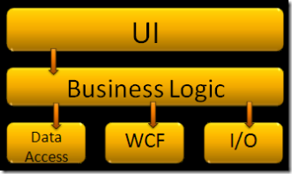Illustration 1: Sample 3-tier architecture (Palermo, 2008)
The traditional 3-tiered architecture breaks an application down into three layers - Presentation, Domain, and Data (Fowler et al, 2002). The Presentation layer is responsible for coordinating with the domain layer, displaying the UI and handling input from the UI. The Domain layer encapsulates the business rules and enforces the requirements of the system. The Data layer communicates with databases and other external data sources.

This architectural style benefits from most things listed above but has one large drawback in typical implementations - the Presentation and Domain layers are coupled to the Data layer. This means that the Data layer cannot change without impacting the majority of the application (Palermo, 2008). Due to the requirement that the RAS application suite be capable of working with multiple data sources (web services and the database) it will not use the traditional 3-tier architecture.

7.2 Database
Due to the teams knowledge and comfortability, the RAS application suite will be using a relational database for persisting application data. NoSQL databases such as CouchDB or MongoDB were discussed, but the team decided against it as our table structures will not be changing enough to require the need for such a flexible storage mechanism.
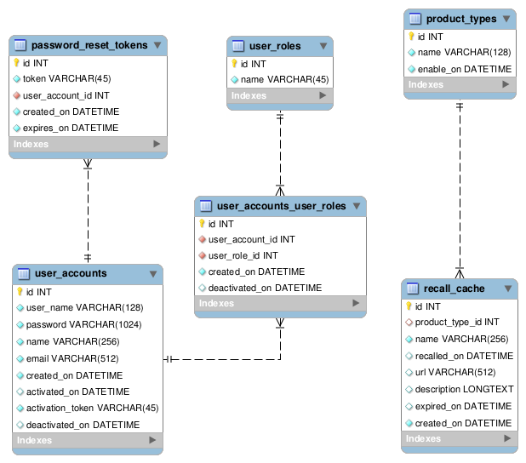Illustration 2: Database Design

7.2.1 Tables
Tables in the system will be in all lowercase with words separated by underscores. Each database table is to have a surrogate key called id for quick referencing from the applications.
- user_accounts – this table will hold the membership information.
- user_roles – this is a system look up table that contains the role definitions for RAS.
- password_reset_tokens – holds the table of reset tokens that get generated when a member requests to reset their password either from the membership management page or the forgot password page.
- user_accounts_user_roles – because accounts can have many roles, this is purely a table to hold a many-to-many relationship between member accounts and system roles.
- product_types – a reference table that contains the product categories for the recalls in the system. The enable_on column is available to help with deployment.
- recall_cache – this table contains the list of product recalls that have been retrieved by the system. In the event that the SearchUSA application is down, the system will search the recall_cache.

7.3. SearchUSA Interface
The SearchUSA component within the RAS applications will be responsible for returning product searches. The application services will use the following implementation when searching for recalls to keep the components decoupled from the service's API. This decoupling will allow us to swap in a cached repository should the service be unavailable for querying.
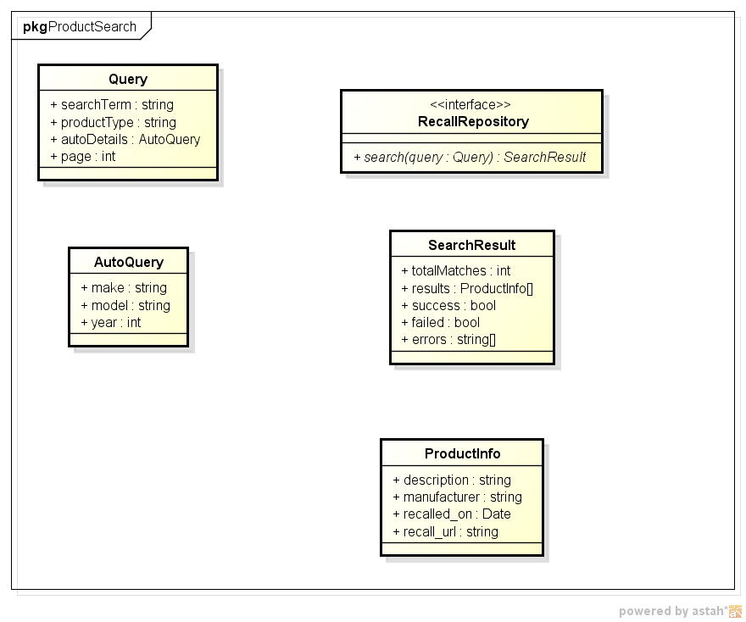Illustration 3: SearchUSA Interface Diagram

7.4 Web Application
The web application contains two main design entities for consideration: Searching and Membership.

7.4.1 Web Application – Searching
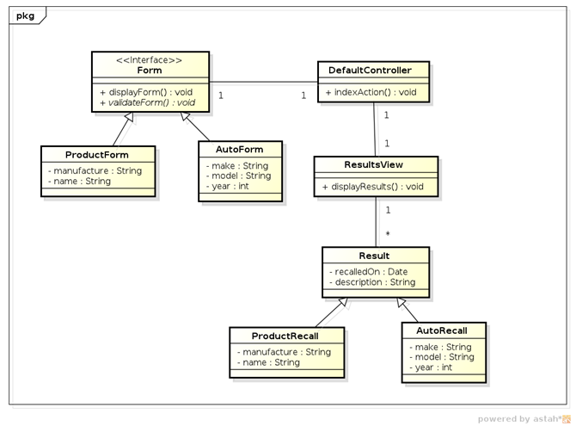Illustration 4: Web Application Searching Design
The searching entity searches for recalls based on user input. The Form interface is used to provide the basis for all search forms. Currently, the ProductForm and AutoForm are the only two forms. ProductForm allows users to search for recalls on food and consumer goods. AutoForm allows users to search for automobile recalls.

The DefaultController is the entry point into this design entity. It provides the brain behind which form to display, searches based on form input (through the SearchUSA interface), and displays the results.

The results are stored in the Result class and displayed by the ResultView. There are two types of results, ProductRecall and AutoRecall. ProductRecall are search results on food and consumer goods, while AutoRecall are search results on automobiles. Each result contains the date the item was recalled and a description of the recall.

7.4.2 Web Application – Membership
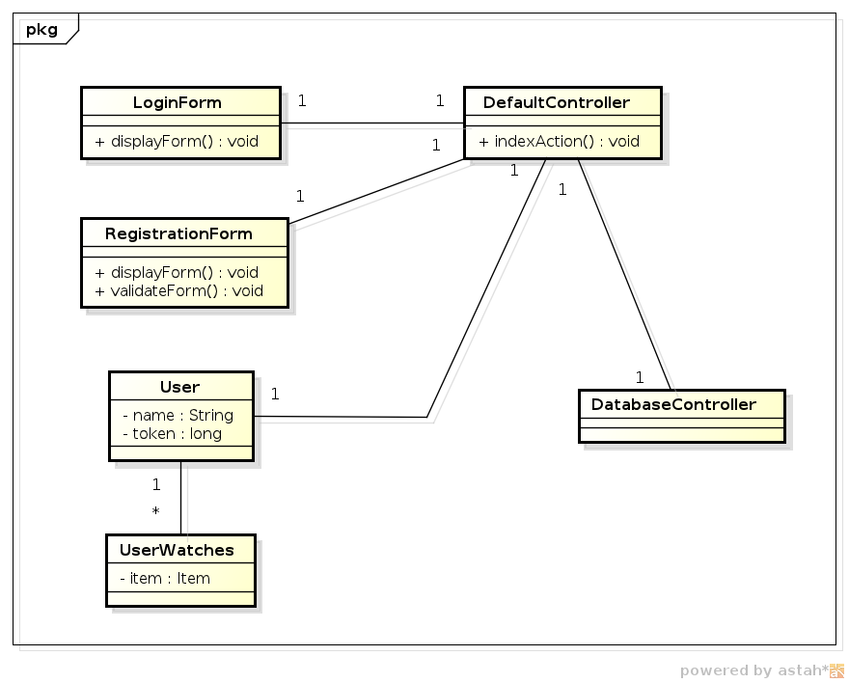Illustration 5: Web Application - Membership Design
The membership entity consists of two forms. The LoginForm to allow existing users to login and the RegistrationForm to allow new users to register. All actions go through the DefaultController and then through the DatabaseController which persists new users or verifies the information of existing users.

Once validated or created, a user is then stored in the User class which contains the user's name and a security token to validate them against so they do not have to login everytime they click a link on the website. Each user can have several UserWatches which are essentially products they want to watch for recalls. When the Notifier entity is designed and developed, user's will be notified of recalls on their watched products.

8 Conclusion
Like most software projects, the development of the RAS web site has been a roller coaster ride of unexpected twists and turns. The varying availability of developer resources as well as development members’ inexperience with the technologies caused the schedule to slip from day one of Phase 1 all the way through Phase 5.

8.1 Lessons Learned
The development team has learned quite a bit about PHP throughout the development of the RAS web site.
- Don’t reinvent the wheel - Because PHP is an open-source platform, there are opportunities to take advantage of the community. Too often the development team did not spend the time looking for open source libraries that can improve productivity, are tested, and are well documented.
- Dependencies - PHP’s script management is a bit problematic. Managing the include and require statements in the scripts is error prone and challenging. More research should be done to evaluate solutions to the problem.
- Distributed development is hard - Dealing with distributed teams is hard on the development group. Communication is much more important for distributed teams and email is not the proper communication means. The team used IM, phones, email, and conference meeting tools to facilitate team coordination.
- Frameworks - The team spent some time researching PHP frameworks for use before beginning development. The team dismissed the toolset thinking that there would be too much of a learning curve for the short development cycle. It seems that the team may have benefited from one of these frameworks - CakePHP, Symfony - and future developers should consider switching to one of these frameworks before developing new features.

8.2 Future Improvements
The site will likely grow and adapt to the users’ feature requests. But the following recommendations should be considered for future product releases:
- Security testing/tightening - The developers did their best to account for cross-site scripting attacks, but has not been secured from cross-site request forgery (CSRF) attempts. Further security testing should be done to ensure that the site is guarded from cross-site scripting attacks. Forms need to be updated with mechanisms to prevent CSRF attacks from being successful.
- Notifications - The biggest feature improvement that will likely help in the adoption of the RAS product is recall notifications. This is a complex system that needs to be fleshed out well. The idea is that users will be able to sign up for notifications regarding recalls for the products they own. The notifications should adhere to the principles outlined by the original use case.
- Database indexing - No attention to database performance has been given through the phases of development. Care should be taken to apply the correct database indexes on tables for maximum performance.
- Continuous integration - A build server should be set up to run all automated tests whenever code changes are committed to the SCM repository. Continuous integration helps to track down regressions and provides both developers and stakeholder visibility into the health of the system.
- Application logging - Logging mechanisms should be put into place for tracking and debugging purposes. The stakeholders should carefully consider the features that they want to track as logging causes application overhead.
- Forgot password - This feature is likely to be high priority when the notification system becomes available.
- Be mindful of Session data - The application is taking advantage of PHP’s built in session mechanism to store data between form posts and form redirects. The session ID is being stored in cookies - which users can turn off - and the session data is tied to the server. Should the site need to scale, these limitations will have to be addressed.
- Data Source Expansion – Currently, the website utilizes a single data source for all recall information. This was done for simplicity sake; however, future improvements should include expanding to more data sources, while minimizing or eliminating duplicate results.

Appendix A: References
Fowler, Martin, Rice, David, Foemmel, Matthew, Hieatt, Edward, & Stafford, Randy (2002). Patterns of Enterprise Application Architecture. Boston: Addison-Wesley Professional.

Palermo, Jeffrey (2008, July 29). The Onion Architecture : part 1-3. Message posted to http://jeffreypalermo.com/blog

Appendix B: Phase Summaries

B.1 Phase 1 Summary
This document provides a summary of the development activities for Phase 1 of the RAS development process. The document also outlines any changes to the previous project documentation as well as any new challenges that have arisen.

B.1.1 Milestones
The goal for Phase 1, as outlined by the Project Plan document, is to provide a hosted web page that will allow anonymous users to search for automotive recall data. The plan outlined the following tasks for completion:
- Set up the development environment and SCM.
- Set up the web application server.
- Develop a website template for the application design to be used on all pages of the website.
- Add the search form to the RAS homepage and integrate the search form with the USA Search service.
- Create the search results web page that maintained the state of the automotive search from the home page screen and presented the search results from the USA Search REST API.
- Build out the REST API component for interfacing with the USA Search REST service.

B.1.2 Item 1 Status – Development Environment
The team needed to setup the development environment on each workstation before beginning development. Eclipse has been chosen as the IDE of choice for developing the application and has been installed and configured for PHP on each workstation. Additionally, the team decided on using the open source library known as SimpleTest for building automated tests of important features of the site.
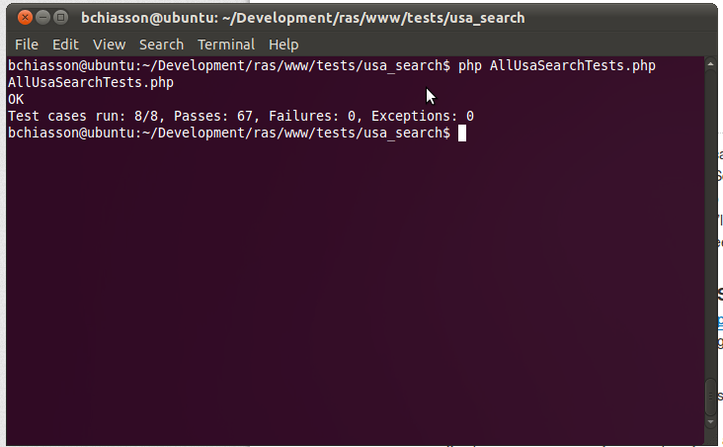Illustration 6: Screenshot of latest automated test execution (All tests)
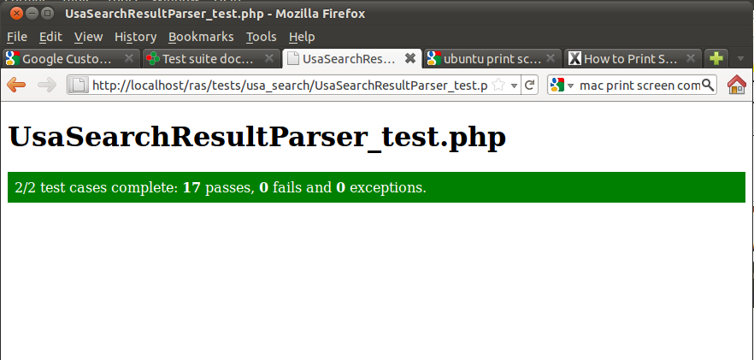Illustration 7: UI Screen capture of test run for the USA Search restul parser class
For SCM, the team decided to use the centralized, public collaboration features of github. Github allows the team to work in a distributed and disconnected manner. Developers can make local changes to a copy of the code base. When finished, a developer can choose to commit back to the central repository or create a branch for review before changes are integrated into the mainline repository. The only challenge thus far, is that github does not work well with Office documents – it treats them as binary. As a result, it is difficult to work collaboratively on the same document.

B.1.3 Item 2 Status – Web Server Setup
The production web server has been setup on a shared hosting plan with Dreamhost. Currently, the production server is a sub-domain of an existing domain name we own, however, this will change when the site is ready to be live.

B.1.4 Item 3 Status – Website template
The website template was to be the simpler tasks for this phase of the development cycle. Due to the simplicity, it was deemed low risk and the development team decided to leave this task for the end of the development cycle. Unfortunately, due to loss in development resources and other tasks taking longer than anticipated, this task is being pushed to Phase II of development. However, this task will be top priority as we begin Phase 2 of development.

B.1.5 Item 4 Status – Search Form
The Search Form that allows users to search for automobile recalls has been developed and is currently in a testing phase. The form allows text field input for make, model, and year of the car and submits using the GET action.

B.1.6 Item 5 Status – Search Results
The search results portion has also been developed and is currently in a testing phase. Once a user submits the search form, the form values are converted to a Query and passed on to the USA Search API. Once the results are parsed, they are displayed under the search form.

B.1.7 Item 6 Status – USA Search Rest API
RAS is not responsible for maintaining a centralized database of all recall data. The system relies on third party data stores to provide the recall information that is displayed to the RAS users. For the initial development of the application suite, RAS will be taking advantage of the USASearch API offered by Search.USA.gov. The goal for this task was to build out the classes that are responsible for interfacing with this REST API.

The REST API is exposed via the HTTP protocol through GET requests. Search parameters are provided as query string inputs (e.g. make=Subaru&model=Legacy) and the returned data is sent back using JSON (). To facilitate interaction using HTTP, the development team had two choices within the PHP environment – 1) curl and 2) the PHP HTTP Functions. The team decided to use curl based on the recommendation of a post on the well-respected help site: http://stackoverflow.com/questions/869927/php-difference-between-curl-and-httprequest. Deciding to use curl turned out to be the right decision as interfacing with it is simple and results were returned quickly.

B.2 Document Changes/Schedule Changes
We have adjusted the Project Plan's deliverables to reflect the move of the website template to the Phase 2. The updated chart is displayed below. It should be noted that pushing the website template to Phase 2 does not impact the schedule.
Deliverable | Date
Project Plan | 6/19
Meeting Notes | 6/20
System & Software Specification | 6/26
Meeting Notes | 6/27
Test Plan & User Guide | 7/3
Meeting Notes | 7/4
Design | 7/10
Meeting Notes | 7/11
Hosted Website (Phase 1)  Provide a hosted webpage with the ability to search for automotive recall data. | 7/17
Meeting Notes | 7/18
Membership Feature (Phase 2)  Complete website template. Enhance the website by adding a membership feature. | 7/24
Meeting Notes | 7/25
Food Recalls (Phase 3)  Enhance the website by adding the ability to search for food recall data. | 7/31
Meeting Notes | 8/1
Consumer Goods Recalls (Phase 4)  Enhance the website by adding the ability to search for consumer goods recall data. | 8/7
Meeting Notes | 8/8
Touch-ups (Phase 5)  Include any bug fixes, touch-ups, and any other enhancements agreed upon. | 8/14
Meeting Notes | 8/15
Final Report | 8/21
Table 4: Project Deliverables - Phase 1 Update

B.2 RAS Application Suite: Phase 2 Summary
This document provides a summary of the development activities for Phase 2 of the RAS development process. The document also outlines any changes to the previous project documentation as well as any new challenges that have arisen.

B.2.1 Milestones
The goal for Phase 2, as outlined by the Project Plan document, is to get the site template set up and to provide the application users with a mechanism for registering with our membership system. The plan outlined the following tasks for completion:

- Create the site template.
- Create the registration form.
- Create the script to process the registration.
- Create the form to activate registrations.
- Create the script to activate registrations.
- Configure an SMTP server for sending emails for registration confirmation.
- Create a member log in form.
- Create the script for processing member logins.

B.2.2 Item 1 Status – Site Template
As laid out in the Phase 1 summary, the site template task was put off until Phase 2 of the project. The site template was chosen and has been completed.
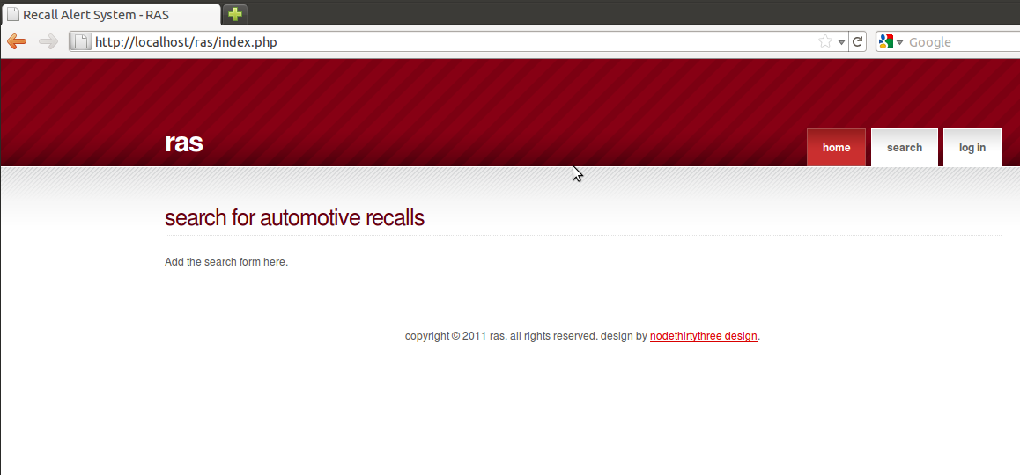Illustration 8: Screen shot of site home page

B.2.3 Item 2 Status – Create the registration form
In order to allow users to use the notifications system they must register as members of the site. This task was to create the UI for users to register with the site. The following fields and attributes were required for completion:

- Name – required, no more than 256 characters
- Email – required, must be email address, no more than 256 characters
- Password – required, no more than 256 characters
- Confirm Password – not required, must match Password field
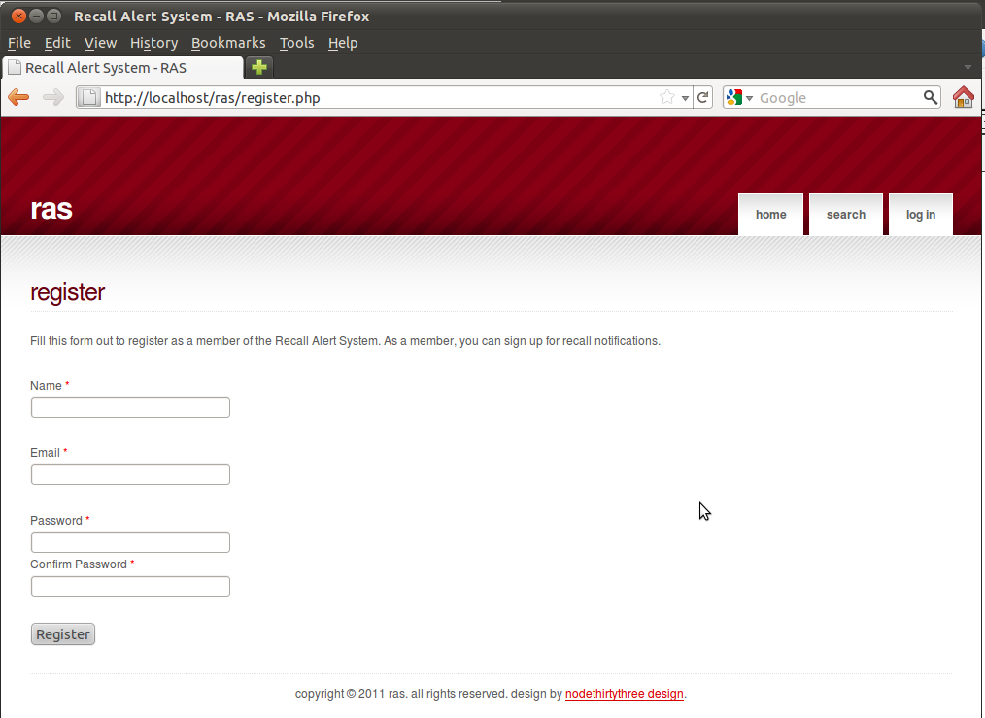Illustration 9: Registration form screen shot

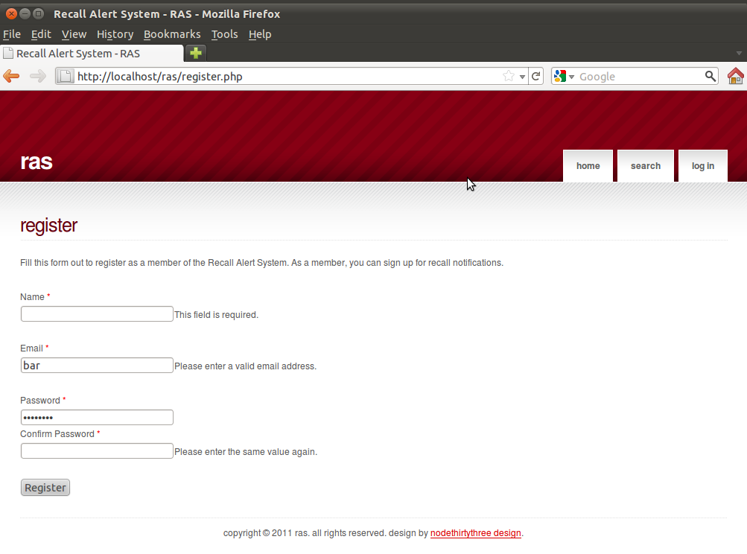Illustration 10: Screen capture of the required fields

B.2.4 Item 3 Status – Process Registration
The goal for this task was to create the controller script for handling the request to create memberships. Due to the amount of effort in setting up the plumbing for building site forms and the site template, this task has been moved to Phase 3. (See Devlierables chart in the Document Changes section)

B.2.5 Item 4 Status – Membership Activation Form
This page should contain a form to allow members to enter the information sent to them via email from the process registration script. The form should have the following form fields.
- Token – required, maximum of 256 characters
- Password – required – the member password used during registration
- Confirm password – must match Password
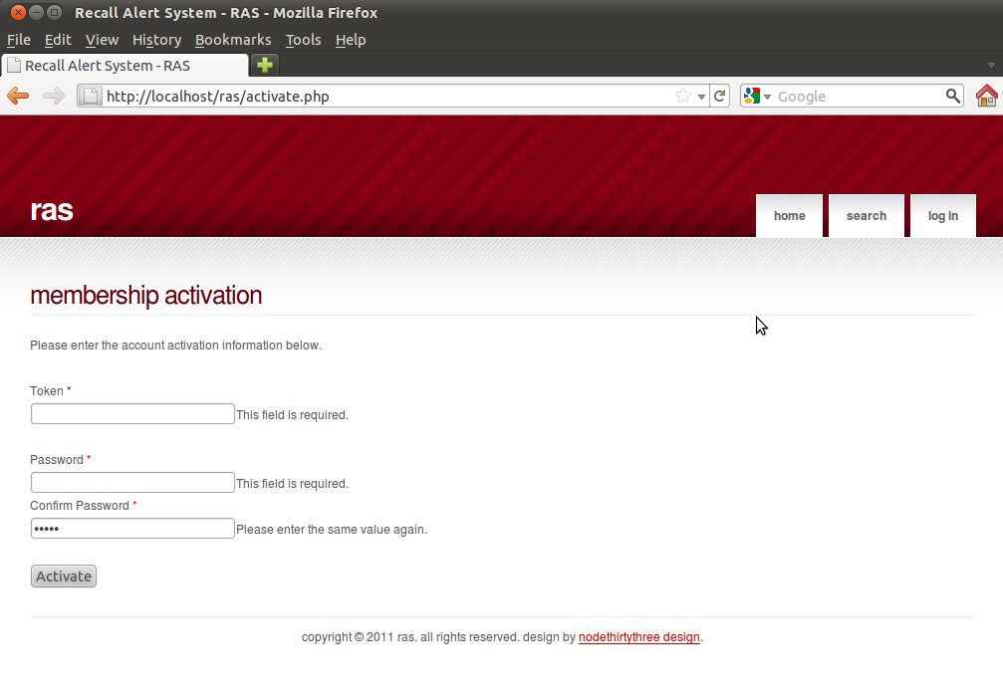Illustration 11: Membership activation form with field requirements

B.2.6 Item 5 Status – Membership Activation Script
The task here was to create the controller script for processing the membership activation form input. Due to the amount of effort in setting up the plumbing for building site forms and the site template, this task has been moved to Phase 3. (See Devlierables chart in the Document Changes section)

B.2.7 Item 6 Status – Configuring the SMTP Server
An email server is needed to facilitate the membership activation. The task here is to identify the appropriate server for sending email to the members and configure it for use with the application. This includes setting up the site scripts for communicating with the server.
Due to the amount of effort in setting up the plumbing for building site forms and the site template, this task has been moved to Phase 3. (See Devlierables chart in the Document Changes section)

B.2.8 Item 7 Status – Member Login form
A login form is needed to allow users to register for notifications. The form for authenticating users should have the following form fields.
- User Name – required (this is the user's email address).
- Password – required
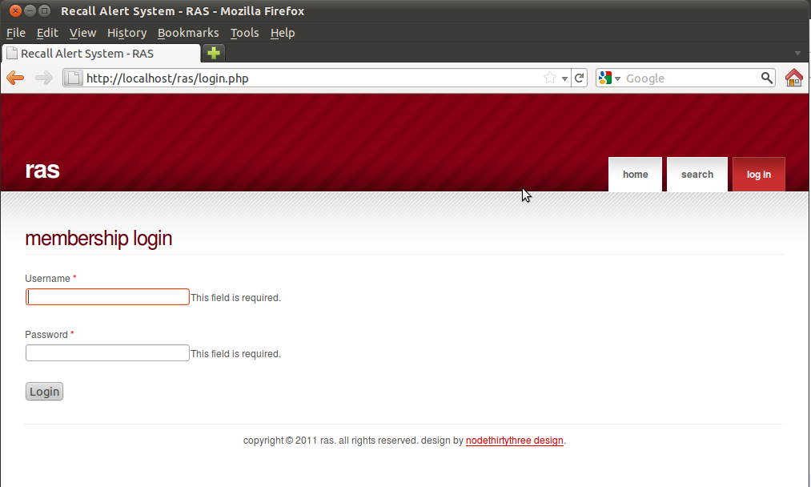Illustration 12: Membership login screen with required field messages

B.2.9 Item 8 Status – Member login script
The goal for this task was to create the controller script for handling the request to login to the member section. Due to the amount of effort in setting up the plumbing for building site forms and the site template, this task has been moved to Phase 3. (See Devlierables chart in the Document Changes section)

B.2.10 Document Changes/Schedule Changes
We have adjusted the Project Plan's deliverables to reflect the move of the membership scripting to Phase 3. The updated chart is displayed below. It should be noted that pushing the scripting to Phase 3 may have an impact on the schedule for Phase 3 items.

Deliverable | Date
Project Plan | 6/19
Meeting Notes | 6/20
System & Software Specification | 6/26
Meeting Notes | 6/27
Test Plan & User Guide | 7/3
Meeting Notes | 7/4
Design | 7/10
Meeting Notes | 7/11
Hosted Website (Phase 1)  Provide a hosted webpage with the ability to search for automotive recall data. | 7/17
Meeting Notes | 7/18
Membership Feature (Phase 2)  Complete website template. Enhance the website by adding a membership feature. | 7/24
Meeting Notes | 7/25
Food Recalls (Phase 3)  Complete membership control scripting. Configure SMTP server. Enhance the website by adding the ability to search for food recall data. | 7/31
Meeting Notes | 8/1
Consumer Goods Recalls (Phase 4)  Enhance the website by adding the ability to search for consumer goods recall data. | 8/7
Meeting Notes | 8/8
Touch-ups (Phase 5)  Include any bug fixes, touch-ups, and any other enhancements agreed upon. | 8/14
Meeting Notes | 8/15
Final Report | 8/21
Table 5: Project Deliverables - Phase 2 Update

B.2.11 Retrospective
Due to the perceived simplicity of the RAS system, the developers decided to forgo bringing in an MVC framework such as CakePHP or Symfony. The downside to this decision was realized in Phase 2 when unforeseen development was needed to facilitate common form building tasks. This forced the team to shift away from working on the scripting that would have provided more visible functionality to focus on plumbing tasks.
Additionally, it would have been prudent for the development team to spend some time researching available Open-source alternatives instead of reinventing the wheel for form building. This lesson will be kept in mind for future phases.

B.3 RAS Application Suite: Phase 3 Summary
Brian Chiasson

This document provides a summary of the development activities for Phase 3 of the RAS development process. The document also outlines any changes to the previous project documentation as well as any new challenges that have arisen.

B.3.1 Milestones
The goal for Phase 3, as outlined by the Project Plan document, is to complete the membership features of the application and enable the food recall search. Unfortunately development has been hindered by an extreme lack of developer resources. As a result, the feature delivery for Phase 3 is significantly reduced. The plan outlined the following tasks for completion:

- Complete script to process the member registrations.
- Complete script to process the member activations.
- Configure an SMTP server for sending emails for registration (and in the future, notifications).
- Complete the script for member login.
- Ensure that the recall search can return food recall data.

B.3.2 Item 1 Status – Member registration script
The membership registration form was completed in Phase 2 but was not functional. The script that handles the registration of members needed to be completed. This included setting up the database to persist member data, creating the script to process the form input, and creating a class for interfacing with the email server. The following items have been completed for this task:
- The script for registering members is complete, but has not been wired up to the form. This will be completed first thing in Phase 4 (see Figure 1-1 for test output).
- Set up the user account table and complete the database setup. This is complete (see Figure 1-2).
- Creating a class for interfacing with the email server. This is complete, but the email server is not ready to deliver emails.
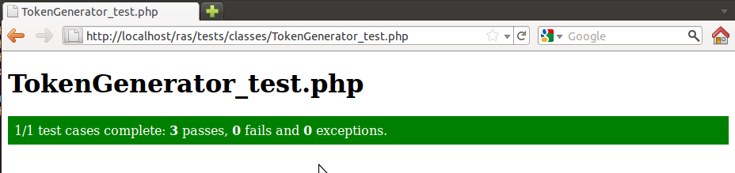
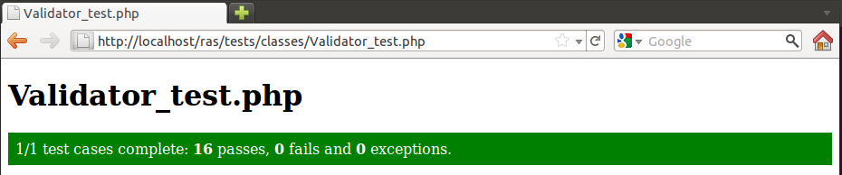
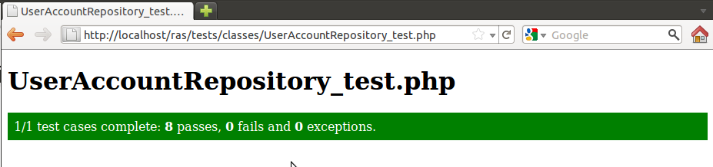
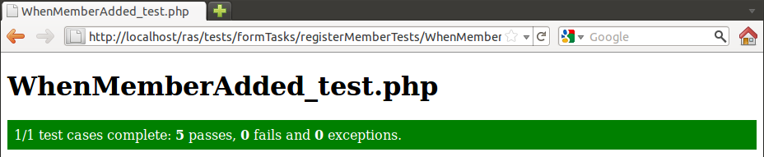
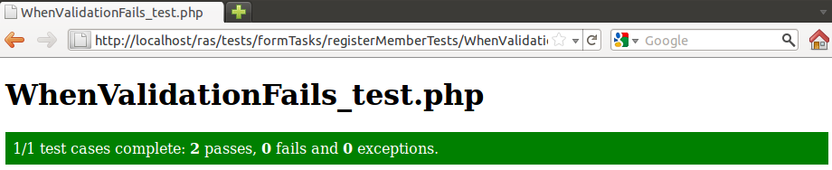

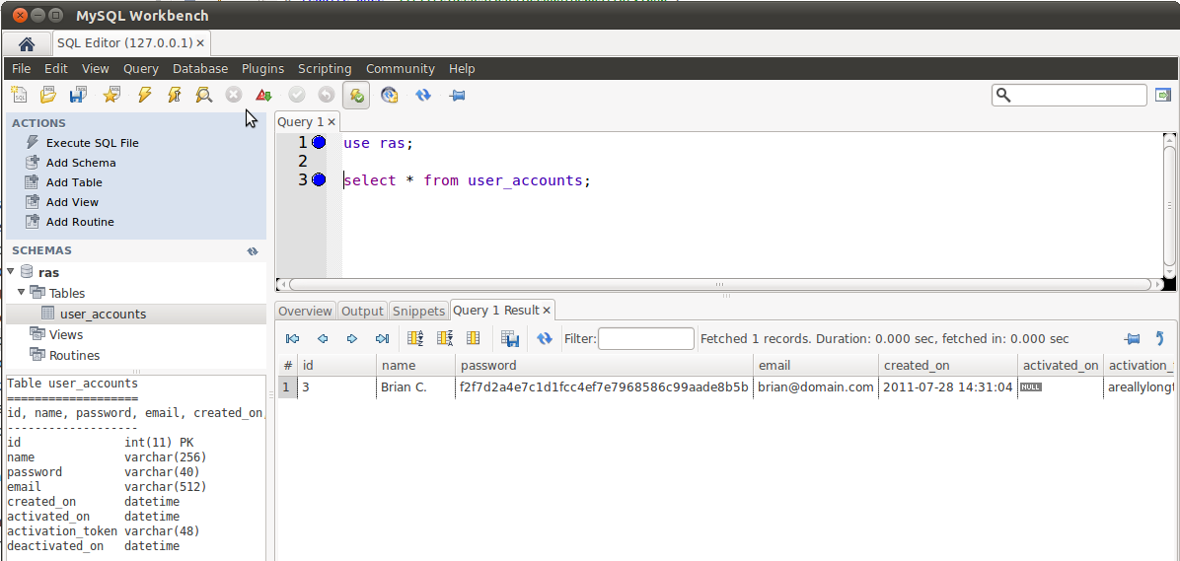Illustration 13: Screen of user_accounts table with record inserted from test

B.3.3 Item 2 Status – Complete script to process member activation
The task here was to create the controller script for processing the membership activation form input. This task is being moved to Phase 4 as developer participation in Phase 3 stressed the team's resources. (See Devlierables chart in the Document Changes section)

B.3.4 Item 3 Status – Configure SMTP server
This task turned out to be a huge time sink and is plaguing the development team at the moment. The SMTP server has been installed but is not relaying email. Per the recommended research, the team is attempting to use the open source email system SendMail, but configuration turns out to be a challenging task. The team hopes to complete this step in Phase 4.

B.3.5 Item 4 Status – Complete member login script
The task here was to create the controller script for processing the membership logins. This task is being moved to Phase 4 as developer participation in Phase 3 stressed the team's resources. (See Devlierables chart in the Document Changes section)

B.3.6 Item 5 Status – Add ability to search for food recall data
The task here was to enable food recall searching capabilities on the recall form. This task is being moved to Phase 4 as developer participation in Phase 3 stressed the team's resources. (See Devlierables chart in the Document Changes section)

B.3.7 Document Changes/Schedule Changes
We have adjusted the Project Plan's deliverables to reflect the move of the membership scripting to Phase 4. The updated chart is displayed below. It should be noted that pushing the scripting to Phase 4 has impacted Phase 5 and makes it official that the development team will not be able to get to the notifications system.
Deliverable | Date
Project Plan | 6/19
Meeting Notes | 6/20
System & Software Specification | 6/26
Meeting Notes | 6/27
Test Plan & User Guide | 7/3
Meeting Notes | 7/4
Design | 7/10
Meeting Notes | 7/11
Hosted Website (Phase 1)  Provide a hosted webpage with the ability to search for automotive recall data. | 7/17
Meeting Notes | 7/18
Membership Feature (Phase 2)  Complete website template. Enhance the website by adding a membership feature. | 7/24
Meeting Notes | 7/25
Food Recalls (Phase 3)  Complete membership control scripting. Configure SMTP server. Enhance the website by adding the ability to search for food recall data. | 7/31
Meeting Notes | 8/1
Consumer Goods Recalls (Phase 4)  Finish member registration  Complete SMTP server setup  Complete membership activation  Complete membership login  Complete the recall search form  Enhance the website by adding the ability to search for consumer goods recall data. | 8/7
Meeting Notes | 8/8
Touch-ups (Phase 5)  Include any bug fixes, touch-ups, and any other enhancements agreed upon. | 8/14
Meeting Notes | 8/15
Final Report | 8/21
Table 6: Project Deliverables - Phase 3 Update

B.3.8 Retrospective
The open source community is ripe with tools and products to assist in making development of products simpler so that developers can focus their efforts on the product and less so on the plumbing. The open source model falls down when products are selected that are difficult to configure with little to no documentation. This isn't a problem if the team isn't constrained by time as the open source community is full of participants that are willing to assist. However, because we are in a time crunch, the development team has to come up to speed quickly on a product, which doesn't always work out. This is why the SMTP server was so much trouble for the team.

B.4 RAS Application Suite: Phase 4 Summary
Brian Chiasson and Dan Buhrman
This document provides a summary of the development activities for Phase 4 of the RAS development process. The document also outlines any changes to the previous project documentation as well as any new challenges that have arisen.

B.4.1 Milestones
The goal for Phase 4, as outlined by the Project Plan document, is to complete the membership features of the application and complete the recall search form. Development has gotten back on track a little, but we are still behind the original plan. As a result, the feature delivery for Phase 5 is significantly reduced. The plan outlined the following tasks for completion:

- Complete script to process the member registrations.
- Complete script to process the member activations.
- Configure an SMTP server for sending emails for registration (and in the future, notifications).
- Complete the script for member login.
- Complete the recall search form.

B.4.2 Item 1 Status – Member registration script
The membership registration form has been completed in Phase 4. The script is handling input validation (sever-side and client-side), activation token generation, and inserting the records into the database.
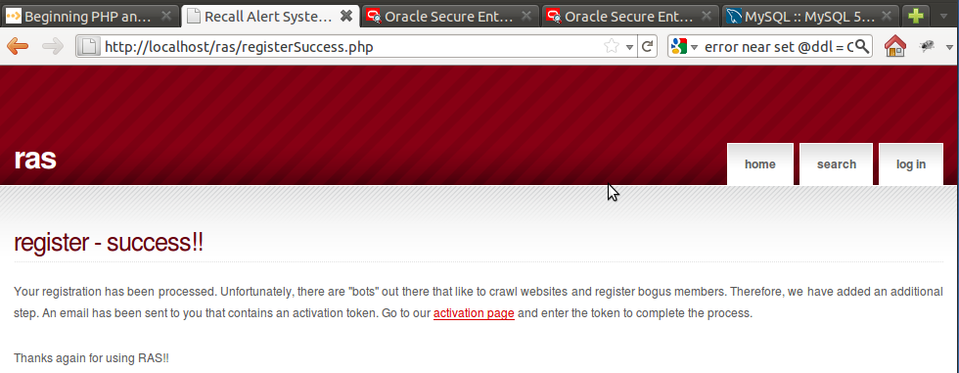Illustration 14: Screen of the final page in the registration process complete.

B.4.3 Item 2 Status – Complete script to process member activations
The task here was to create the controller script for processing the membership activation form input. This task has been completed in this phase. The members can now complete the activation. We did change the requirements of the form page to have the user submit their email address in conjunction with the activation token.
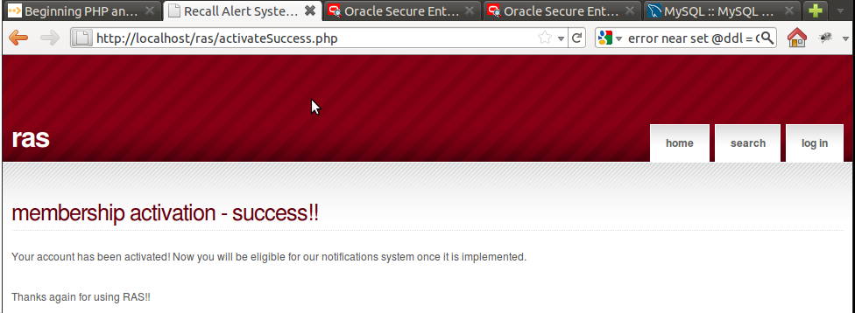Illustration 15: Screen shot of final page in membership activation

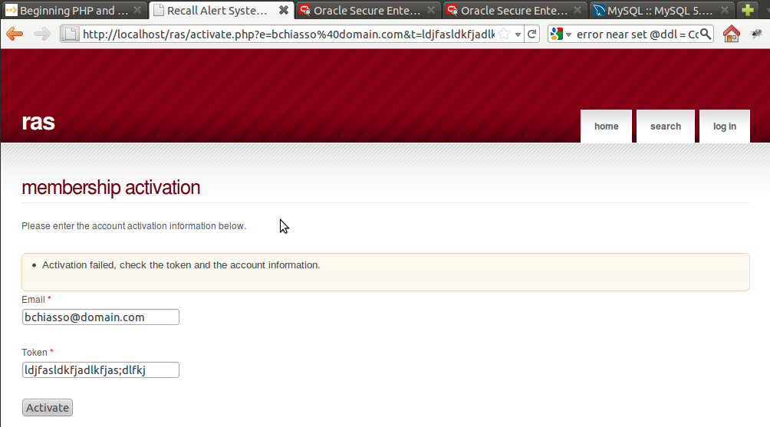Illustration 16: Screen shot of error when email/token is not in system database.

B.4.4 Item 3 Status – Configure SMTP server
The SMTP server has been installed and configured according to documentation but is still not sending out emails. The team is confident that the email server in production is functioning and the service has been built so this functionality will be tested when the site is placed online, but not made active.

B.4.5 Item 4 Status – Complete member login script
The member login script is complete. The feature is logging the date and time that the user logs in. If the authentication fails, the user is presented with a message that just says we cannot authenticate the user.

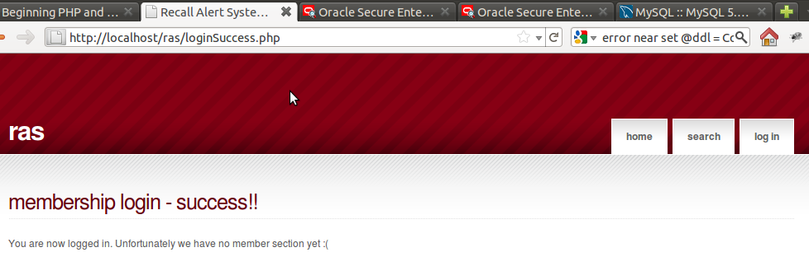Illustration 17: Screen shot of successful member logon.
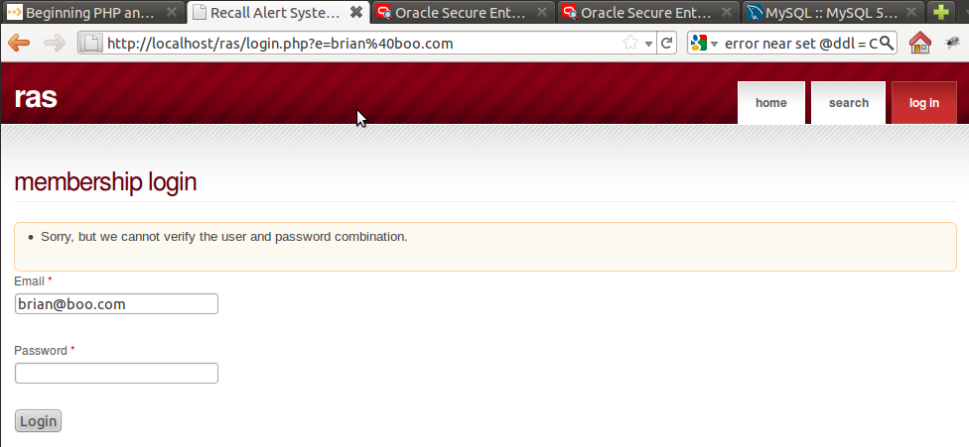Illustration 18: Message displayed when system can't authenticate user

B.4.6 Item 5 Status – Complete Recall Search form
The search form now searches for automobiles by make, model, year, or a combination of the three. If there are any recalls based on the information entered, they are displayed with a description, manufacturer, the date of the recall, and a source URL (if available).
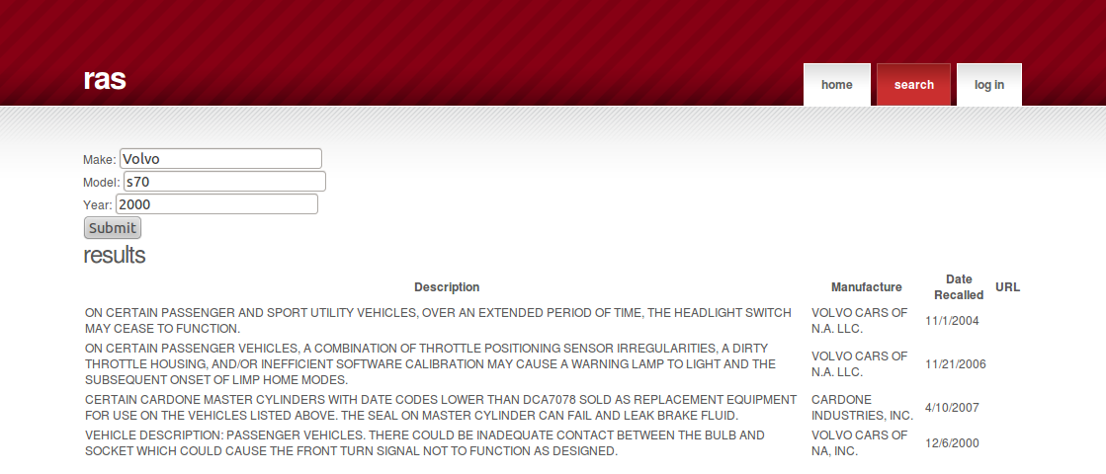Illustration 19: Search Form with Results

B.4.7 Document Changes/Schedule Changes
We have adjusted the Project Plan's deliverables to reflect the move of the membership scripting to Phase 4. The updated chart is displayed below. It should be noted that pushing the scripting to Phase 4 has impacted Phase 5 and makes it official that the development team will not be able to get to the notifications system.
Deliverable | Date
Project Plan | 6/19
Meeting Notes | 6/20
System & Software Specification | 6/26
Meeting Notes | 6/27
Test Plan & User Guide | 7/3
Meeting Notes | 7/4
Design | 7/10
Meeting Notes | 7/11
Hosted Website (Phase 1)  Provide a hosted webpage with the ability to search for automotive recall data. | 7/17
Meeting Notes | 7/18
Membership Feature (Phase 2)  Complete website template. Enhance the website by adding a membership feature. | 7/24
Meeting Notes | 7/25
Food Recalls (Phase 3)  Complete membership control scripting. Configure SMTP server. Enhance the website by adding the ability to search for food recall data. | 7/31
Meeting Notes | 8/1
Consumer Goods Recalls (Phase 4)  Finish member registration  Complete SMTP server setup  Complete membership activation  Complete membership login  Complete the recall search form  Enhance the website by adding the ability to search for consumer goods recall data. | 8/7
Meeting Notes | 8/8
Touch-ups (Phase 5)  Include any bug fixes, touch-ups, and any other enhancements agreed upon. | 8/14
Meeting Notes | 8/15
Final Report | 8/21
Table 7: Project Deliverables - Phase 4 Update

B.4.8 Retrospective
There are quite a few bows left to tie on some of the features developed. Little things like unique constraints to ensure that users don't register multiple times, and the login page should probably redirect the user back to the referring that made them log in. These items will be addressed in Phase 5 and any unresolved items will be outlined in the final project documentation.

B.5 RAS Application Suite: Phase 5 Summary
This document provides a summary of the development activities for Phase 5 of the RAS development process. The document also outlines any changes to the previous project documentation as well as any new challenges that have arisen.

B.5.1 Milestones
The goal for Phase 5, as outlined by the Project Plan document, and carried over from previous phases are:
- Add ability to search for consumer goods recalls.
- Add any final touches.
- Fix any bugs.

B.5.2 Item 1 – Consumer Goods Recalls
The field to add a generic search term was added. This enables the user to search for pretty much anything, however, is still limited to Search USA's data.
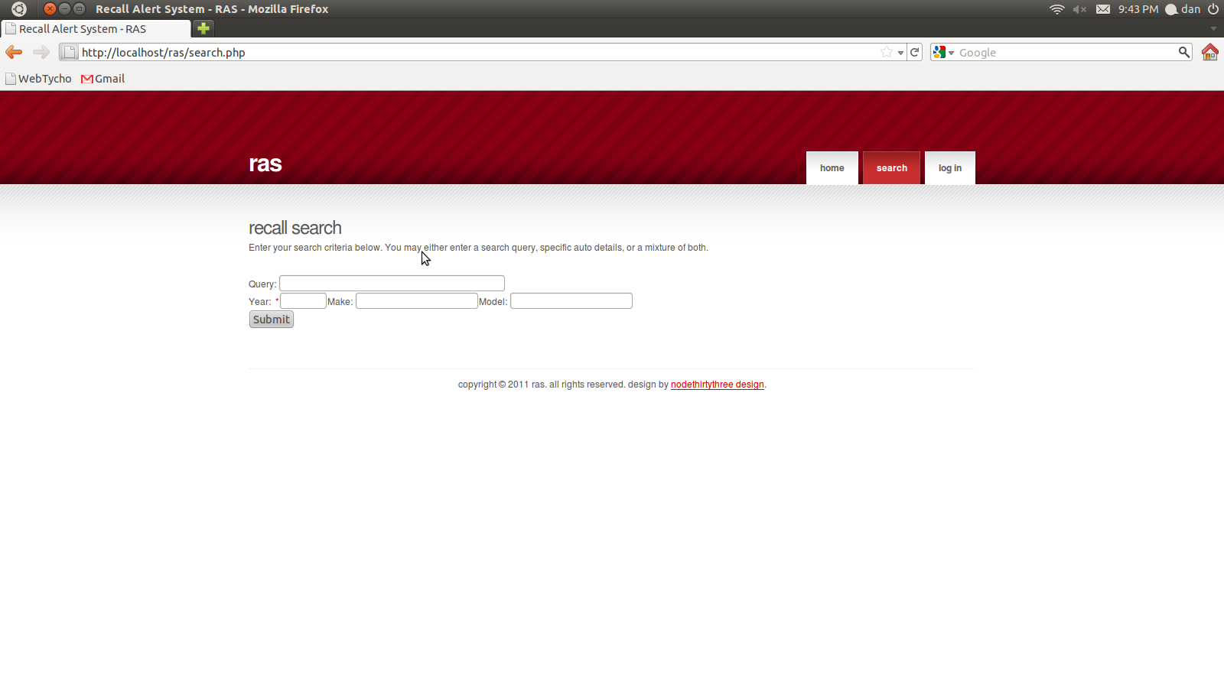Illustration 20: Final Search Form

B.5.3 Item 2 – Final touches

B.5.3.1 Item 2.1 – Results Pagination
Until this point, only the first 10 results where displayed to the user. This is due to a limitation with Search USA's API, in which only 10 results at a time can be returned. To remedy this, the search results are now paged in groups of 10, and allow the user to move from page to page, running a new query with each page turn.
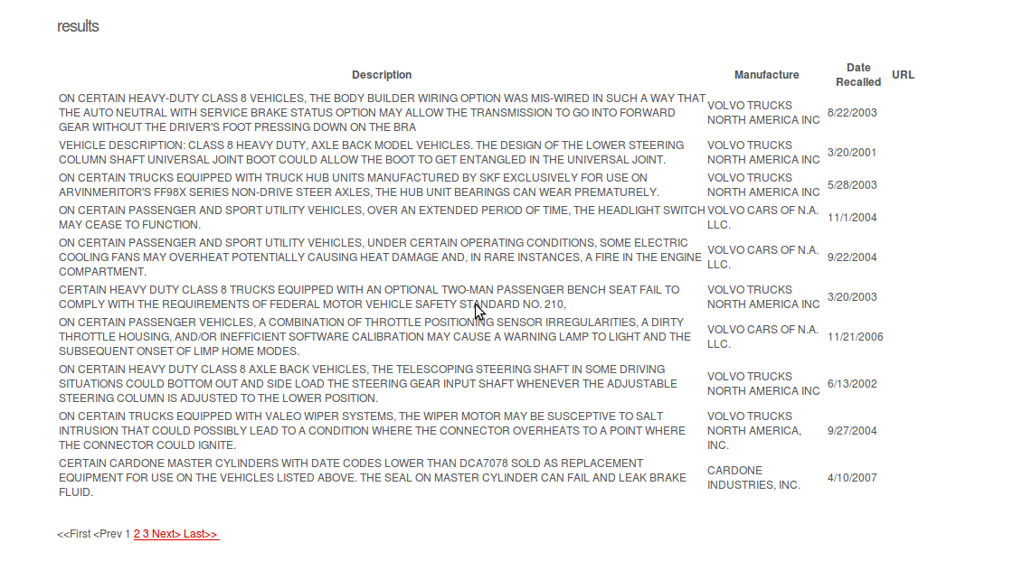Illustration 21: Pagination

B.5.3.2 Item 2.2 – Better descriptions
More interesting descriptions where added to the search form and results. There is now a brief explanation on how to use the search form at the top (see Illustration 20). Also, if no search results are returned, an explanation of possible reasons is listed. (see Illustration 22)

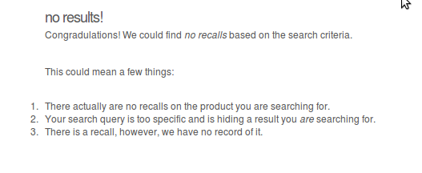Illustration 22: No results

B.5.4 Item 3 – Bug Fixes
Although there where no bugs to fix, a bug was discovered in the 11th hour of Phase 5: Only search queries with a year render results. If a phase 6 existed, this would definitely be fixed in the next phase, and most definitely will be fixed if the site ever goes live to the public, however, a quick and dirty remedy was applied for now: the year field is now required.

B.5.5 Document Changes/Schedule Changes
We have adjusted the Project Plan's deliverables to reflect the move of the membership scripting to Phase 4. The updated chart is displayed below. It should be noted that pushing the scripting to Phase 4 has impacted Phase 5 and makes it official that the development team will not be able to get to the notifications system.
Deliverable | Date
Project Plan | 6/19
Meeting Notes | 6/20
System & Software Specification | 6/26
Meeting Notes | 6/27
Test Plan & User Guide | 7/3
Meeting Notes | 7/4
Design | 7/10
Meeting Notes | 7/11
Hosted Website (Phase 1)  Provide a hosted webpage with the ability to search for automotive recall data. | 7/17
Meeting Notes | 7/18
Membership Feature (Phase 2)  Complete website template. Enhance the website by adding a membership feature. | 7/24
Meeting Notes | 7/25
Food Recalls (Phase 3)  Complete membership control scripting. Configure SMTP server. Enhance the website by adding the ability to search for food recall data. | 7/31
Meeting Notes | 8/1
Consumer Goods Recalls (Phase 4)  Finish member registration  Complete SMTP server setup  Complete membership activation  Complete membership login  Complete the recall search form  Enhance the website by adding the ability to search for consumer goods recall data. | 8/7
Meeting Notes | 8/8
Touch-ups (Phase 5)  Enhance the website by adding the ability to search for consumer goods recall data.  Include any bug fixes, touch-ups, and any other enhancements agreed upon. | 8/14
Meeting Notes | 8/15
Final Report | 8/21
Table 8: Project Deliverables - Phase 5 Update

B.5.6 Retrospective
Overall, I think it is safe to say this project put a lot of stress on all team members. As one kept dropping off the map, and adding stress to others to complete the work assigned to said team member. We would hope in a real work environment, this would result in disciplinary action of some kind, and push the project back. However, in a classroom environment, 13 weeks is all the time allocated, and therefore creates the difficulty of dealing with such issues.
Also, 5 weeks of development is kind of short to take on a project of the magnitude we originally envisioned.
Overall, it was a satisfying journey, and a relief to have the burden of tight schedules ended.

