Cover Page

COMPSCI 345 Human-Computer Interaction

Assignment Three: Realizing a Design

**Student Name:** Tien Nguyen Khac

Student ID: 756505860

Student UPI: tngu281

____________________________________________________________________

Note: To ensure a fair playing field for all students in the class the University of Auckland will not tolerate cheating or assisting others to cheat, and views cheating in coursework as a serious academic offence.

Student Declaration:

* I declare that this work is my own work and reflects my own learning.
* I declare that where work from other sources (including sources on the world-wide web) has been used, it has been properly acknowledged and referenced.
* I understand that my assessed work may be reviewed against electronic source material using computerised detection mechanisms.

Place this page in the front as the first page of your document that you are submitting to Canvas

Table of Contents

Context 3

Domain/Sub-domain 3

User 3

John 3

Kane 3

Tangelo (viewpoint user) 3

Moment 3

Walkthrough 4

Assignment 4

Chat 5

Peer review/discussions 5

Prototype scope 6

Design decision 7

Colour scheme 7

Border scheme 7

Fonts Scheme 9

On MacOS 9

On Windows 9

Fall-back 9

Resources used 10

Font and icons 10

Images 10

Bootstrap v4 component 10

# Context

## Domain/Sub-domain

Domain: Art History

Sub-domain: Movement of modern art from Renaissance to Contemporary Art.

## User

### John

Location: Auckland, New Zealand

Education: Secondary student at ACG senior

### Kane

Location: Auckland, New Zealand

Education: Secondary student at ACG senior

### Tangelo (viewpoint user)

Location: Auckland, New Zealand

Education: Secondary student at ACG senior

## Moment

Tangelo (the view point user) and her group peers (Kane and John) are currently doing their Art history assignment 1 titled “Movement of modern art from Renaissance to Contemporary Art”. They all have a version of their ongoing work posted on the discussion page for peer reviewing and are actively exchanging ideas on the group chat.

## Walkthrough

### Assignment

The user Tangelo can do her assignment by clicking on the assignments tab button on the sidebar, which take her to the assignment page. She can read the assignment specifications and cycle through questions using the “previous” and “next” button.

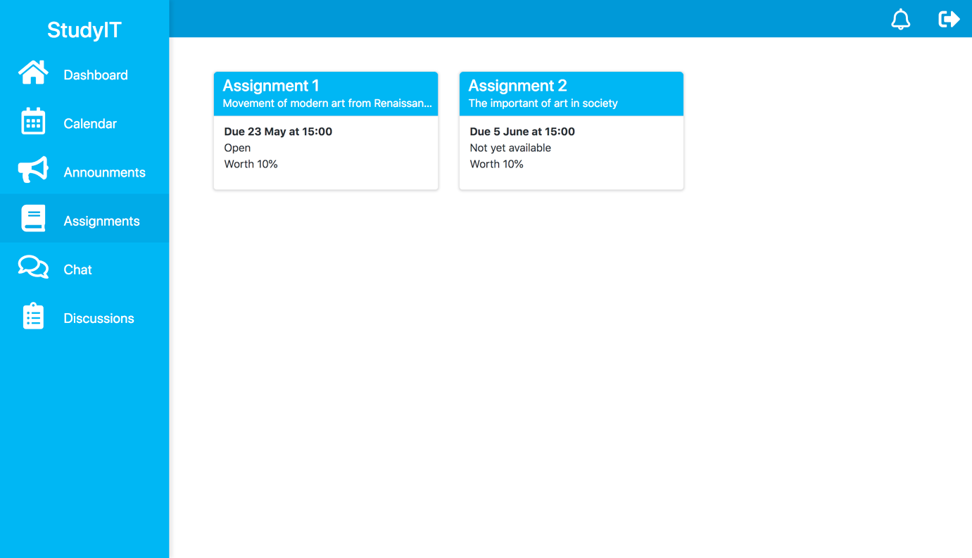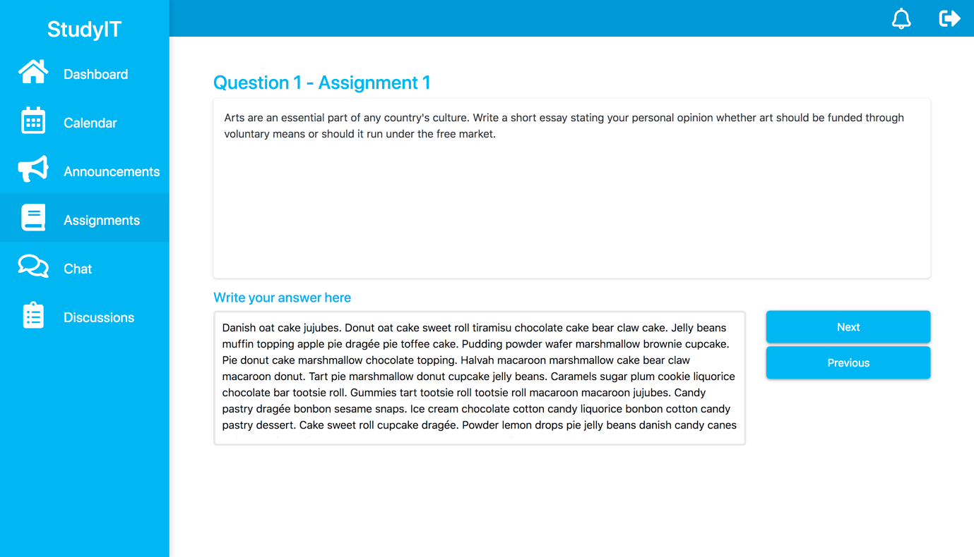

### Chat

If help is needed, she can go to the group chat by clicking on the chat button and leave a message on the appropriate chat thread.

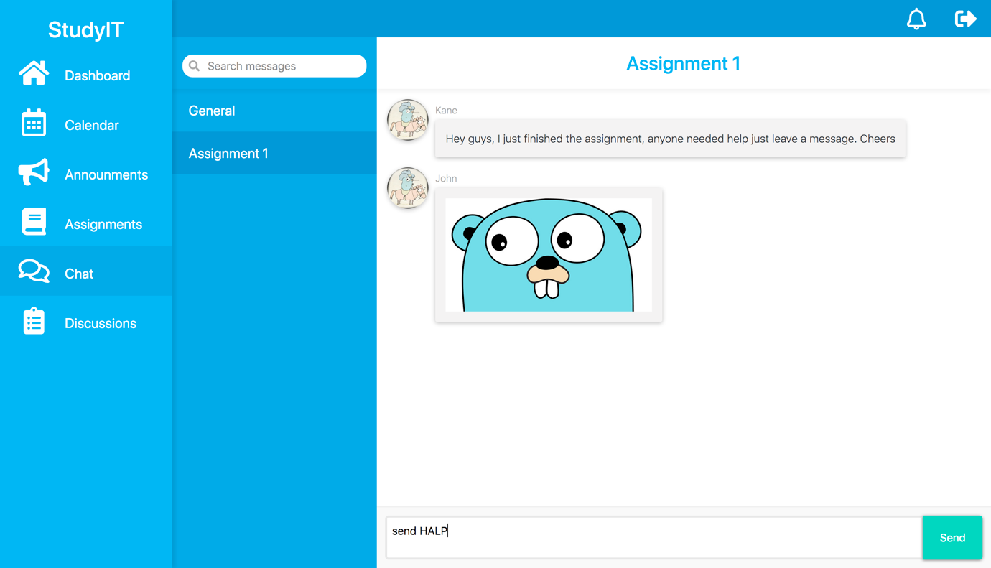

### Peer review/discussions

Tangelo can review her peers work by going to the discussion page, here she can select the question that she wants to review, switch between her peers’ work and leave a comment as well as upvote or down vote the others comments. 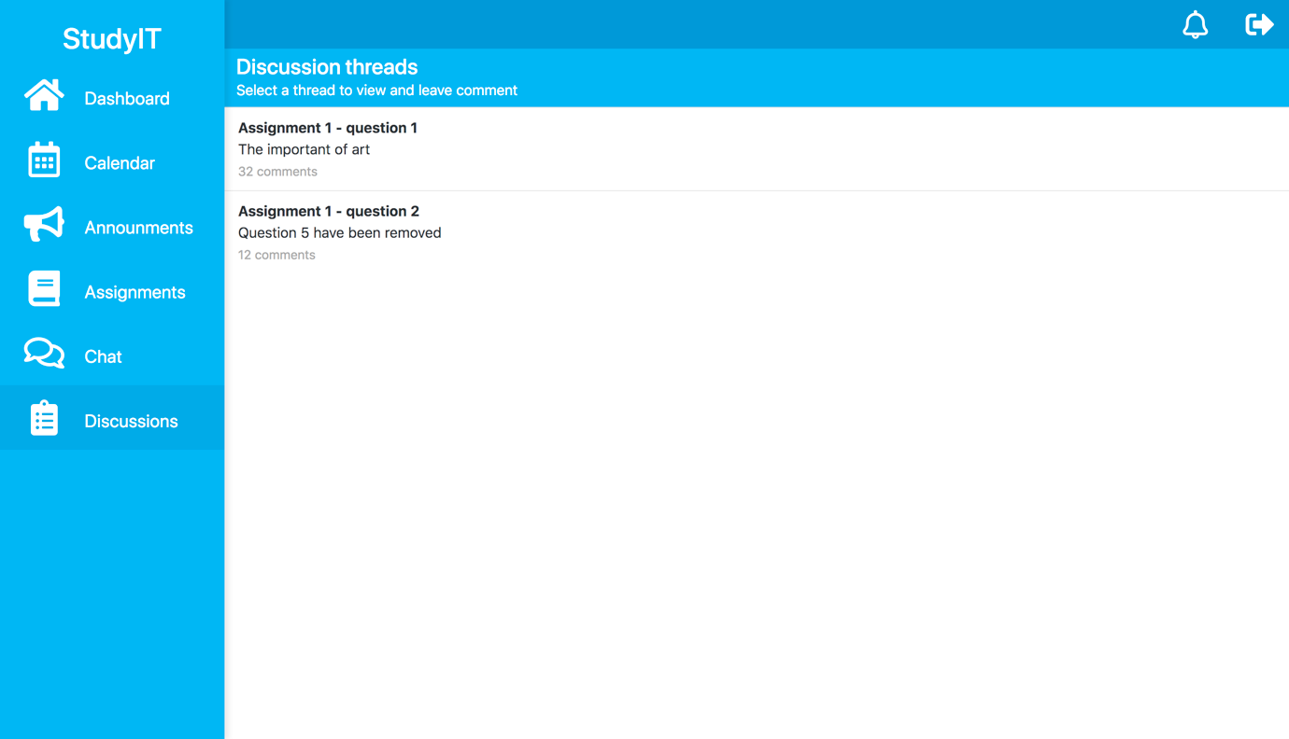

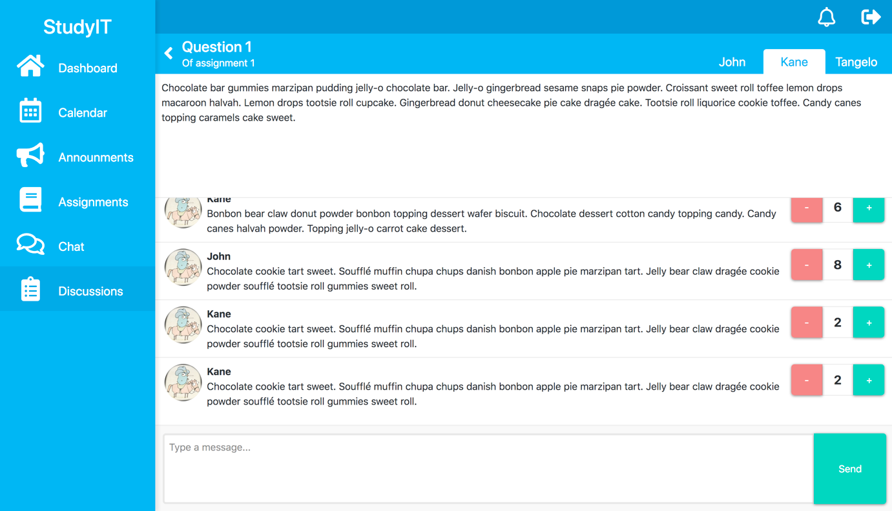

### Prototype scope

As this is only a prototype there are out of scope functionalities that will not be implemented. Pages for calendar, announcements and the top bar icon for showing notifications will not be implemented as they are not covered by the domain and serve no purpose in this walkthrough. The viewpoint user submission (for peer review) is already included in the dummy data and will not be updated when completing assignment in the walkthrough.

# Design decision

## Colour scheme

|  |  |  |
| --- | --- | --- |
| **colour** | **Rgb(x,y,y) value** | **Description** |
|  | rgb( 3,169,244) | Sidebar, panel header background, header font colour, default button |
|  | rgb( 3,155,229) | Sidebar active/hover, Sub menu side bar |
|  | rgb( 2,136,209) | Top navigation bar, Sub menu side bar active/hover |
|  | rgb( 2,209,178) | Confirmation button, positive button, outgoing chat message |
|  | rgb(238,110,115) | Critical highlight, negative button |
|  | rgb(255,241,118) | Important highlight |
|  | rgb(241,240,240) | Incoming chat message |
|  | rgb(247,247,247) | Textarea input background |
|  | rgb(255,255,255) | Navigation panel text, panel header font colour |

## Border scheme

Relevant information is categorised and organized into section of panels. A panel consist of a header which either use a distinctive background colour (*figure 2.2.1*) or font colour (*figure 2.2.2*) to separate it from the content body. A thin border is used with raised shadow effect to make the panel pop out, further capturing user attention.

|  |  |
| --- | --- |
| **Default style** | **Alternative style** |
| Figure 2.2.1 | Figure 2.2.2 |

The design employs a consistent use of subtle colours differences and soft shadow to define border between elements (*figure 2.2.3*). The combination of which give users the perception of working on tactile surfaces (*figure 2.2.4*). The number of surfaces is limited to 2 levels of elevation (with few exceptions) as anymore will likely cause confusion and confliction with the subtleness of the design language. Element will employ a flat design (*figure 2.2.5*) if raising it violate the previous rule.

|  |  |
| --- | --- |
| **Intersection** | **Pushable element** |
| Figure 2.2.3 | Figure 2.2.4 |
| **Flat design** | |
| Figure 2.2.5 | |

## Fonts Scheme

The design use default system font of the viewing OS with “Helvetica” as the fall-back font.

### On MacOS

|  |  |  |  |
| --- | --- | --- | --- |
| **Font Name** | **Font Style** | **Example** | **Description** |
| San Francisco | Default 16px | General | General text |
| Bold 16px | **Question 1** | Text heading |
| Default 20px | chat | Menu/sidebar item |
| Bold 24px | **Reading list** | Section/panel Heading |
| Default 16px | something | Sub heading |
| Bold 32px | Study | Logo |
| Regular 14px | 16 comments | Footer and note |

### On Windows

|  |  |  |  |
| --- | --- | --- | --- |
| **Font Name** | **Font Style** | **Example** | **Description** |
| Segoe UI | Default 16px | General | General text |
| Bold 16px | **Question 1** | Text heading |
| Default 20px | chat | Menu/sidebar item |
| Bold 24px | **Reading list** | Section/panel Heading |
| Default 16px | something | Sub heading |
| Bold 32px | Study | Logo |
| Regular 14px | 16 comments | Footer and note |

### Fall-back

|  |  |  |  |
| --- | --- | --- | --- |
| **Font Name** | **Font Style** | **Example** | **Description** |
| Helvetica | Default 16px | General | General text |
| Bold 16px | **Question 1** | Text heading |
| Default 20px | chat | Menu/sidebar item |
| Bold 24px | **Reading list** | Section/panel Heading |
| Default 16px | something | Sub heading |
| Bold 32px | Study | Logo |
| Regular 14px | 16 comments | Footer and note |

# Resources used

## Font and icons

Font awesome: <https://use.fontawesome.com/releases/v5.0.13/css/all.css>

## Images

Dummy user image: <http://ipengineer.net/wp-content/uploads/2016/07/gophercloud.png>

Dummy chat image: <https://pilsniak.com/wp-content/uploads/2017/04/golang.jpg>

## Bootstrap v4 component

Container

Row

Column