Project Title
StuDyIo - Turn your student experience into a portfolio worth sharing.

Project Description
StuDyIo helps students turn their education, skills, projects, work experience and contact details into a shareable portfolio. Account holders can save their information, choose one of three designs, preview the result, and manage their portfolios.

Technologies Used
Laravel 13, PHP 8.4, Blade, Tailwind CSS 4, Vite 8, PostgreSQL on Supabase, Supabase Storage, Brevo transactional email over HTTPS, Docker, Render and GitHub.

Database Platform
Supabase PostgreSQL, project StuDyIo.

Hosting/Deployment Platform
Render Web Service, deployed with Docker.

Database Structure
The PostgreSQL schema contains 16 tables. Each table lists its columns, database types, keys or defaults, and nullability.
users
Column | PostgreSQL type | Key / default | Nullable
id | bigserial | Primary key; Generated | No
name | varchar(255) |  | No
email | varchar(255) | Unique | No
email_verified_at | timestamp without time zone |  | Yes
password | varchar(255) |  | No
remember_token | varchar(100) |  | Yes
created_at | timestamp without time zone |  | Yes
updated_at | timestamp without time zone |  | Yes

templates
Column | PostgreSQL type | Key / default | Nullable
id | bigserial | Primary key; Generated | No
slug | varchar(40) | Unique | No
name | varchar(80) |  | No
description | text |  | No
sort_order | smallint | Default 0 | No
created_at | timestamptz |  | Yes
updated_at | timestamptz |  | Yes

portfolios
Column | PostgreSQL type | Key / default | Nullable
id | bigserial | Primary key; Generated | No
user_id | bigint | FK to users.id; ON DELETE CASCADE | Yes
full_name | varchar(160) |  | No
profile_picture_path | varchar(1024) |  | Yes
email | varchar(255) |  | No
contact_number | varchar(60) |  | Yes
address | text |  | Yes
about_me | text |  | Yes
template_id | bigint | FK to templates.id; ON DELETE SET NULL | Yes
created_at | timestamptz |  | Yes
updated_at | timestamptz |  | Yes

education
Column | PostgreSQL type | Key / default | Nullable
id | bigserial | Primary key; Generated | No
portfolio_id | bigint | FK to portfolios.id; ON DELETE CASCADE | No
institution | varchar(180) |  | Yes
qualification | varchar(180) |  | Yes
field_of_study | varchar(180) |  | Yes
start_date | date |  | Yes
end_date | date |  | Yes
description | text |  | Yes
sort_order | smallint | Default 0 | No
created_at | timestamptz |  | Yes
updated_at | timestamptz |  | Yes

skills
Column | PostgreSQL type | Key / default | Nullable
id | bigserial | Primary key; Generated | No
portfolio_id | bigint | FK to portfolios.id; ON DELETE CASCADE | No
name | varchar(120) |  | No
proficiency | varchar(60) |  | Yes
sort_order | smallint | Default 0 | No
created_at | timestamptz |  | Yes
updated_at | timestamptz |  | Yes

projects
Column | PostgreSQL type | Key / default | Nullable
id | bigserial | Primary key; Generated | No
portfolio_id | bigint | FK to portfolios.id; ON DELETE CASCADE | No
title | varchar(180) |  | No
description | text |  | Yes
project_url | varchar(2048) |  | Yes
screenshot_path | varchar(1024) |  | Yes
sort_order | smallint | Default 0 | No
created_at | timestamptz |  | Yes
updated_at | timestamptz |  | Yes
tags | json |  | Yes

work_experience
Column | PostgreSQL type | Key / default | Nullable
id | bigserial | Primary key; Generated | No
portfolio_id | bigint | FK to portfolios.id; ON DELETE CASCADE | No
company | varchar(180) |  | Yes
role | varchar(180) |  | Yes
start_date | date |  | Yes
end_date | date |  | Yes
description | text |  | Yes
sort_order | smallint | Default 0 | No
created_at | timestamptz |  | Yes
updated_at | timestamptz |  | Yes

social_links
Column | PostgreSQL type | Key / default | Nullable
id | bigserial | Primary key; Generated | No
portfolio_id | bigint | FK to portfolios.id; ON DELETE CASCADE | No
platform | varchar(80) |  | Yes
label | varchar(120) |  | Yes
url | varchar(2048) |  | No
sort_order | smallint | Default 0 | No
created_at | timestamptz |  | Yes
updated_at | timestamptz |  | Yes

password_reset_tokens
Column | PostgreSQL type | Key / default | Nullable
email | varchar(255) | Primary key | No
token | varchar(255) |  | No
created_at | timestamp without time zone |  | Yes

sessions
Column | PostgreSQL type | Key / default | Nullable
id | varchar(255) | Primary key | No
user_id | bigint | Index | Yes
ip_address | varchar(45) |  | Yes
user_agent | text |  | Yes
payload | text |  | No
last_activity | integer | Index | No

cache
Column | PostgreSQL type | Key / default | Nullable
key | varchar(255) | Primary key | No
value | text |  | No
expiration | bigint | Index | No

cache_locks
Column | PostgreSQL type | Key / default | Nullable
key | varchar(255) | Primary key | No
owner | varchar(255) |  | No
expiration | bigint | Index | No

jobs
Column | PostgreSQL type | Key / default | Nullable
id | bigserial | Primary key; Generated | No
queue | varchar(255) | Index | No
payload | text |  | No
attempts | smallint |  | No
reserved_at | integer |  | Yes
available_at | integer |  | No
created_at | integer |  | No

job_batches
Column | PostgreSQL type | Key / default | Nullable
id | varchar(255) | Primary key | No
name | varchar(255) |  | No
total_jobs | integer |  | No
pending_jobs | integer |  | No
failed_jobs | integer |  | No
failed_job_ids | text |  | No
options | text |  | Yes
cancelled_at | integer |  | Yes
created_at | integer |  | No
finished_at | integer |  | Yes

failed_jobs
Column | PostgreSQL type | Key / default | Nullable
id | bigserial | Primary key; Generated | No
uuid | varchar(255) | Unique | No
connection | varchar(255) | Composite index | No
queue | varchar(255) | Composite index | No
payload | text |  | No
exception | text |  | No
failed_at | timestamp without time zone | Default CURRENT_TIMESTAMP; Composite index | No

migrations
Column | PostgreSQL type | Key / default | Nullable
id | bigserial | Primary key; Generated | No
migration | varchar(255) |  | No
batch | integer |  | No

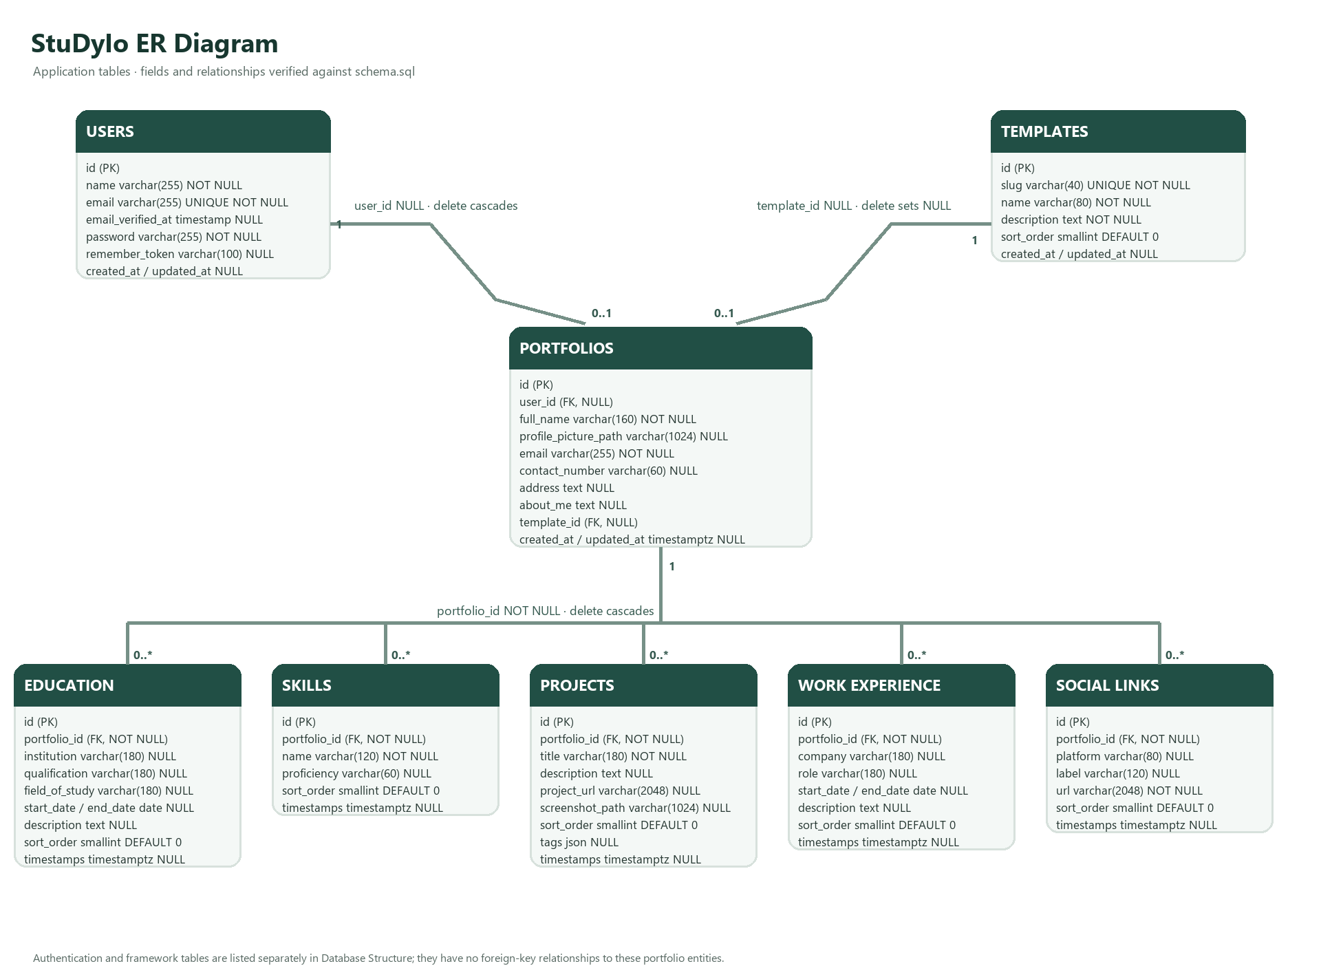
ER diagram - application tables

Screenshots of the System
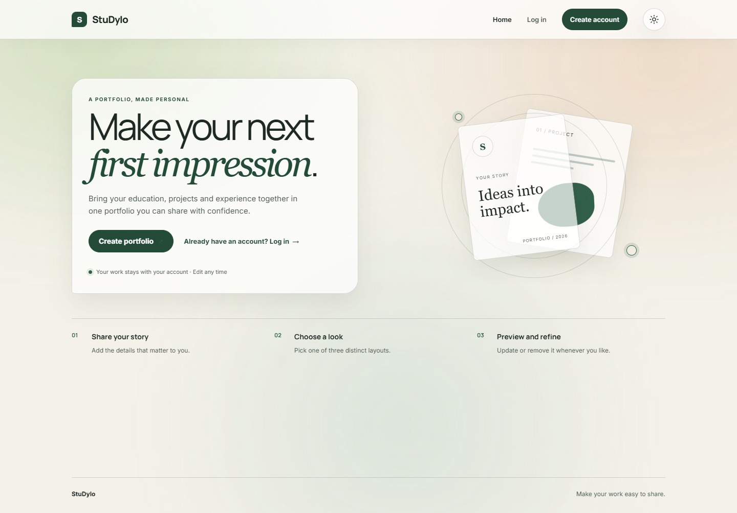  Home page | 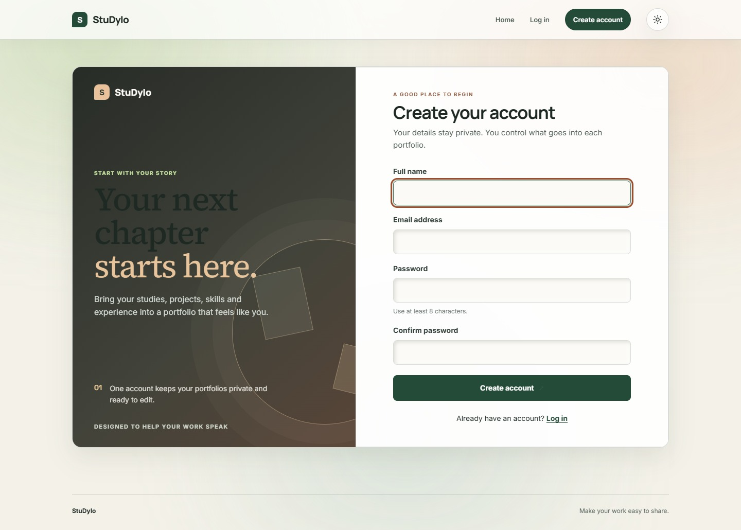  Register
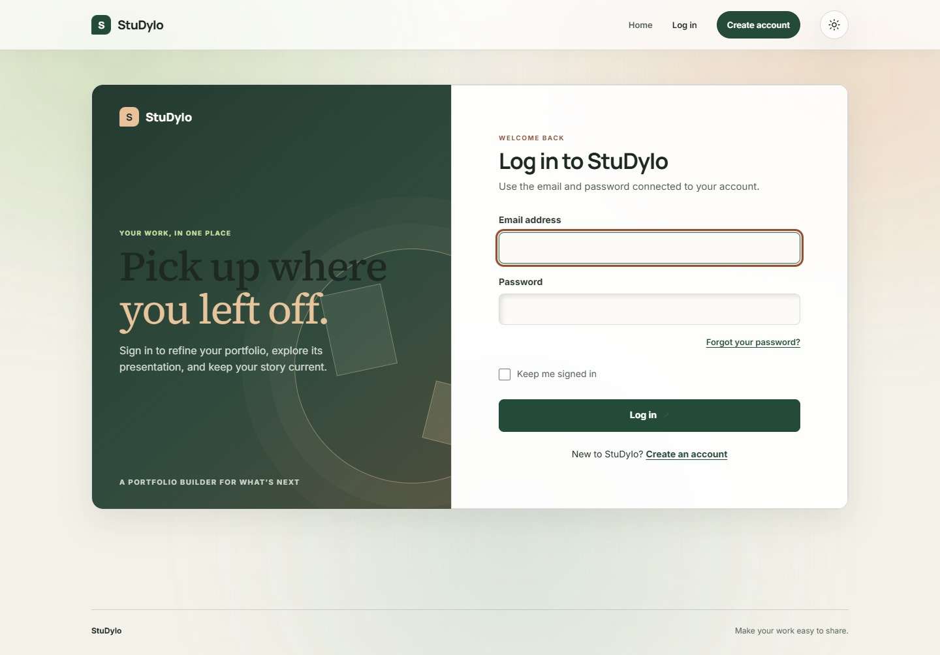  Login | 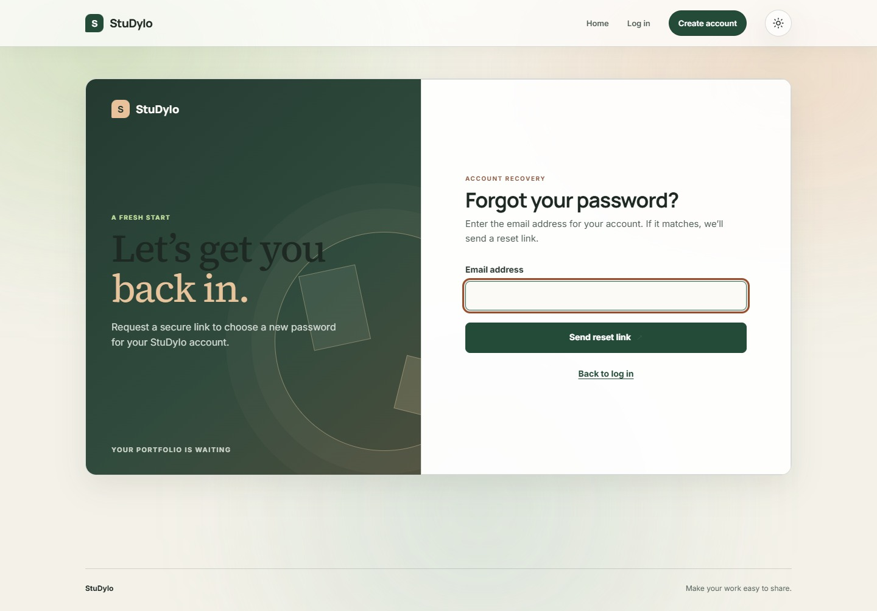  Forgot Password
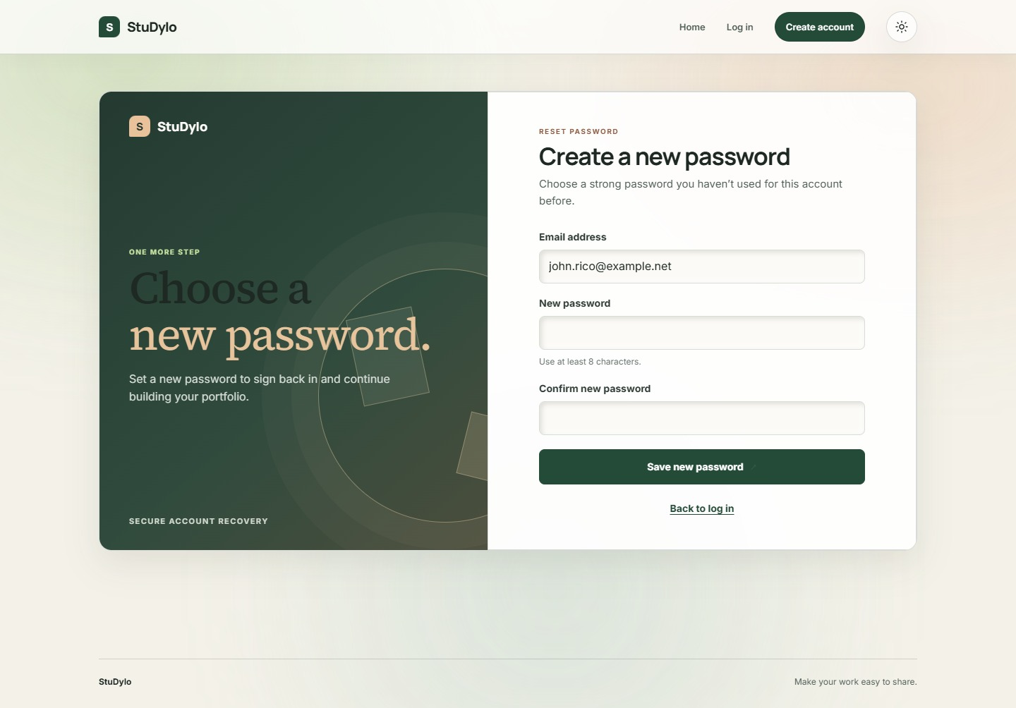  Reset Password | 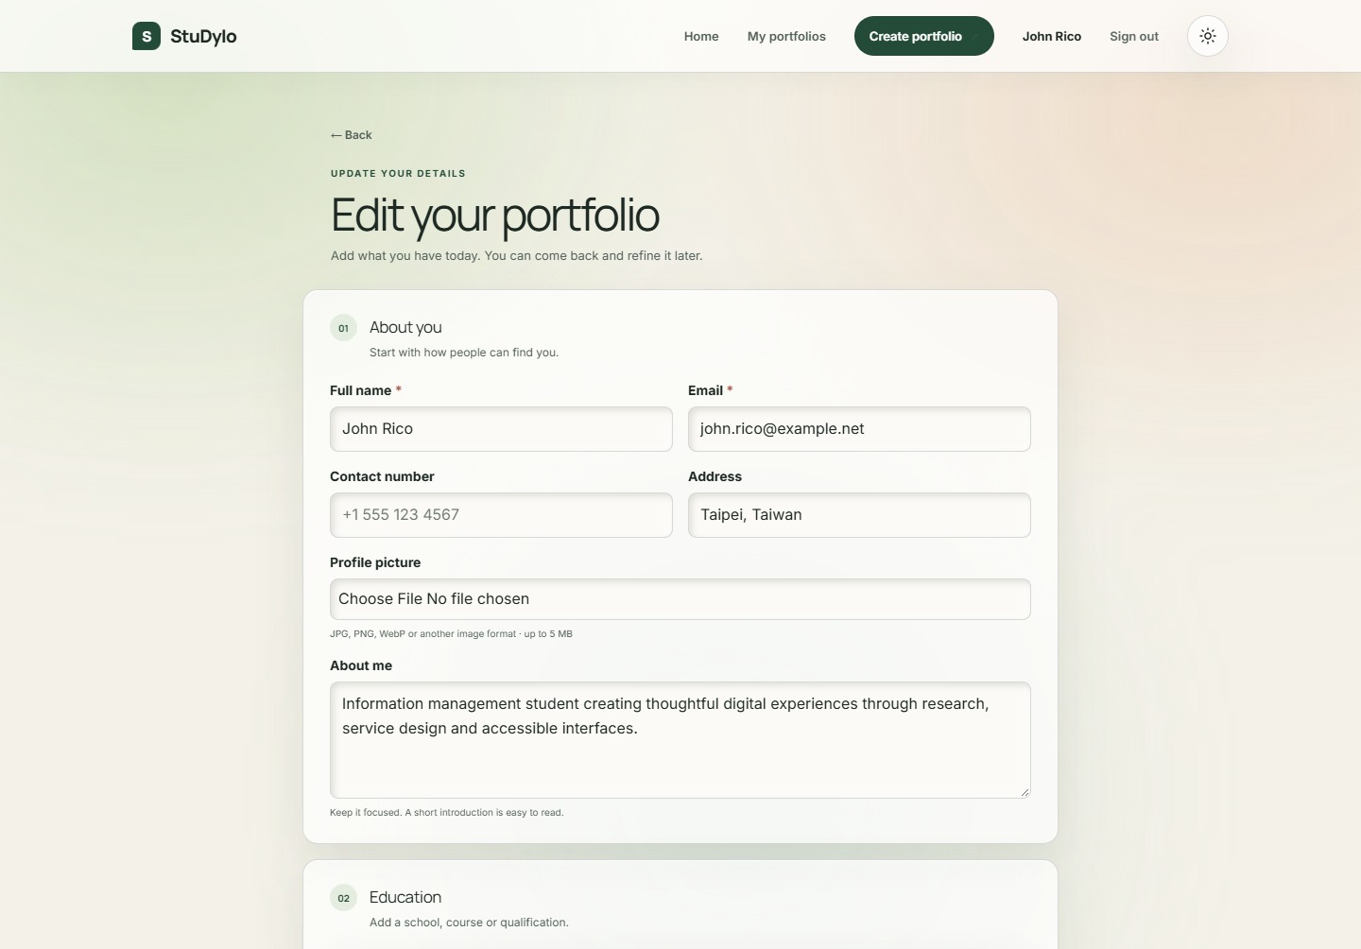  Portfolio information form

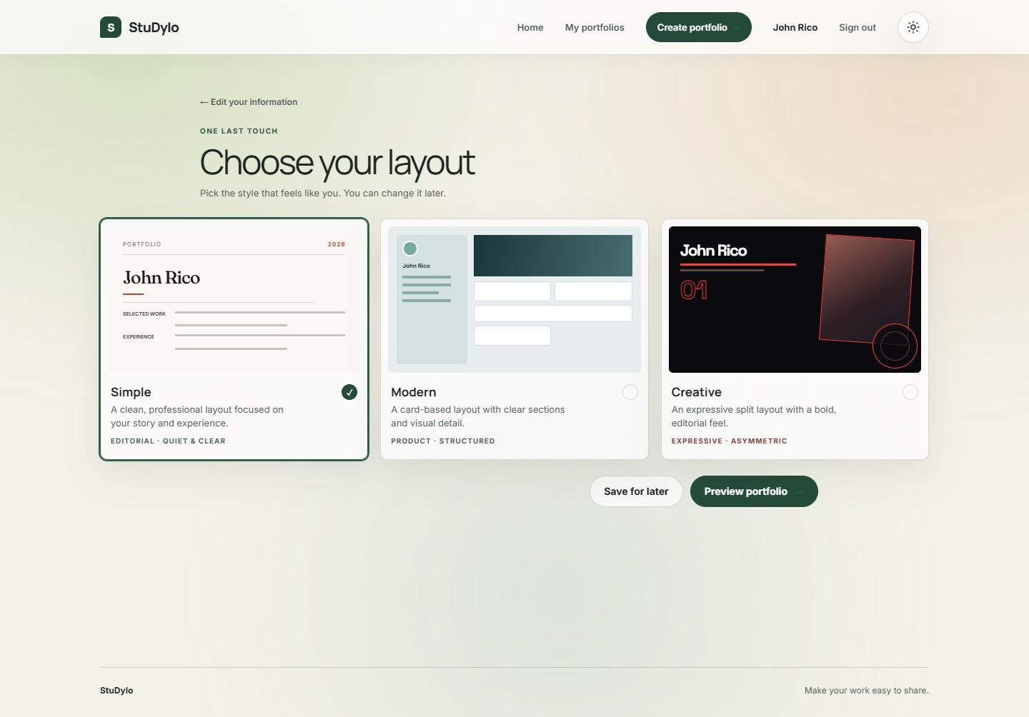  Template selection | 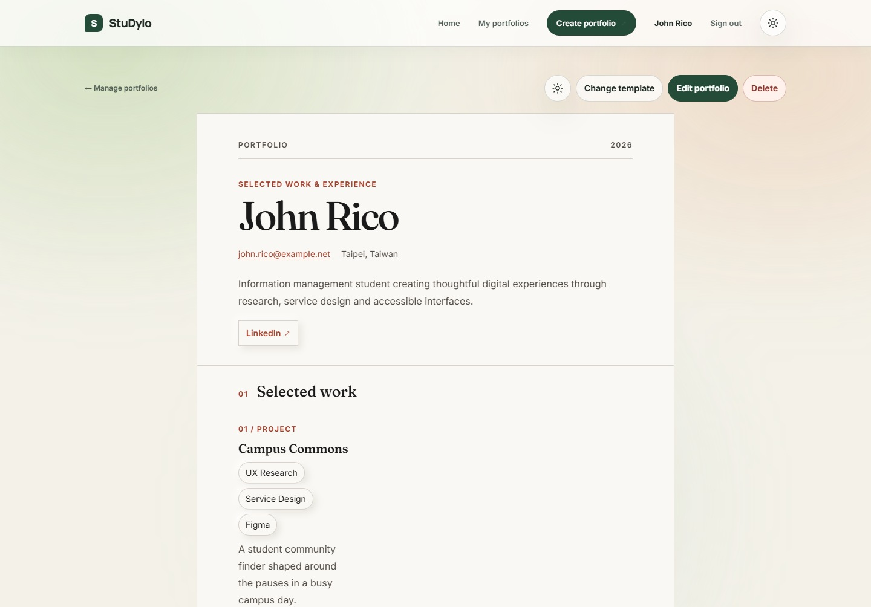  Portfolio preview
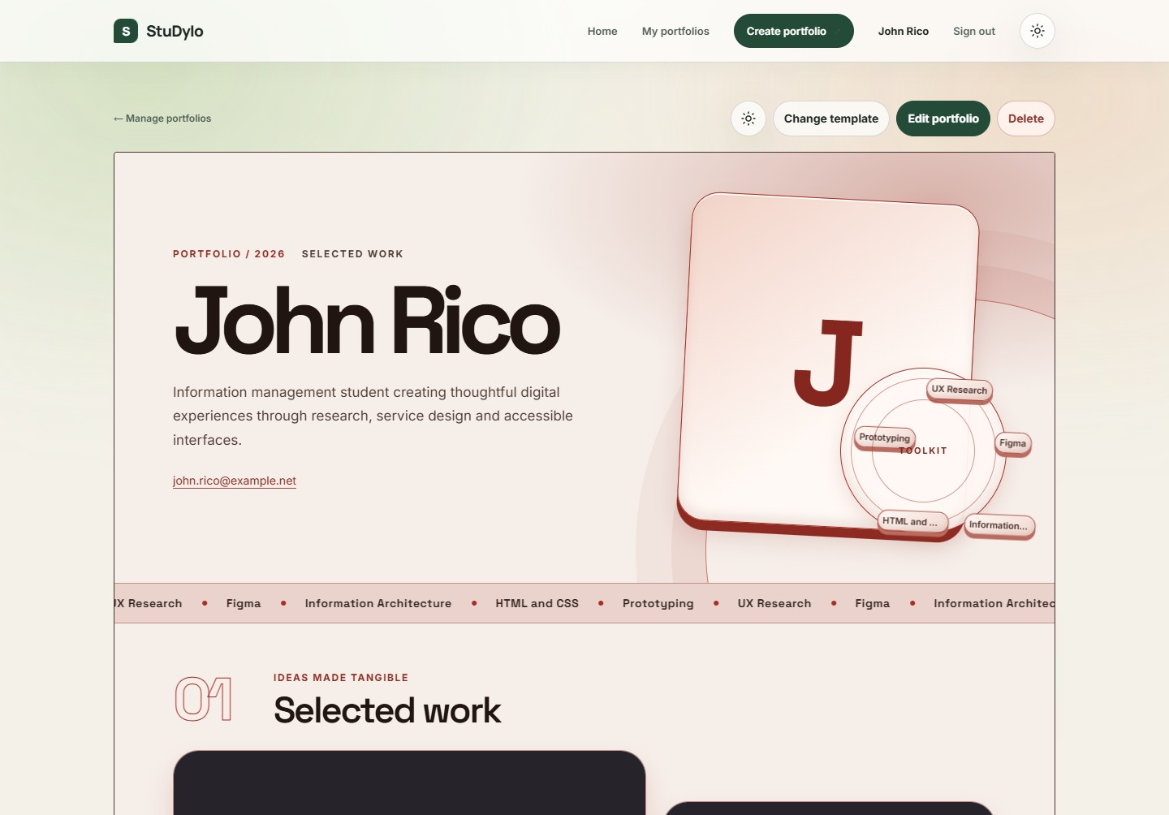  Manage portfolio | 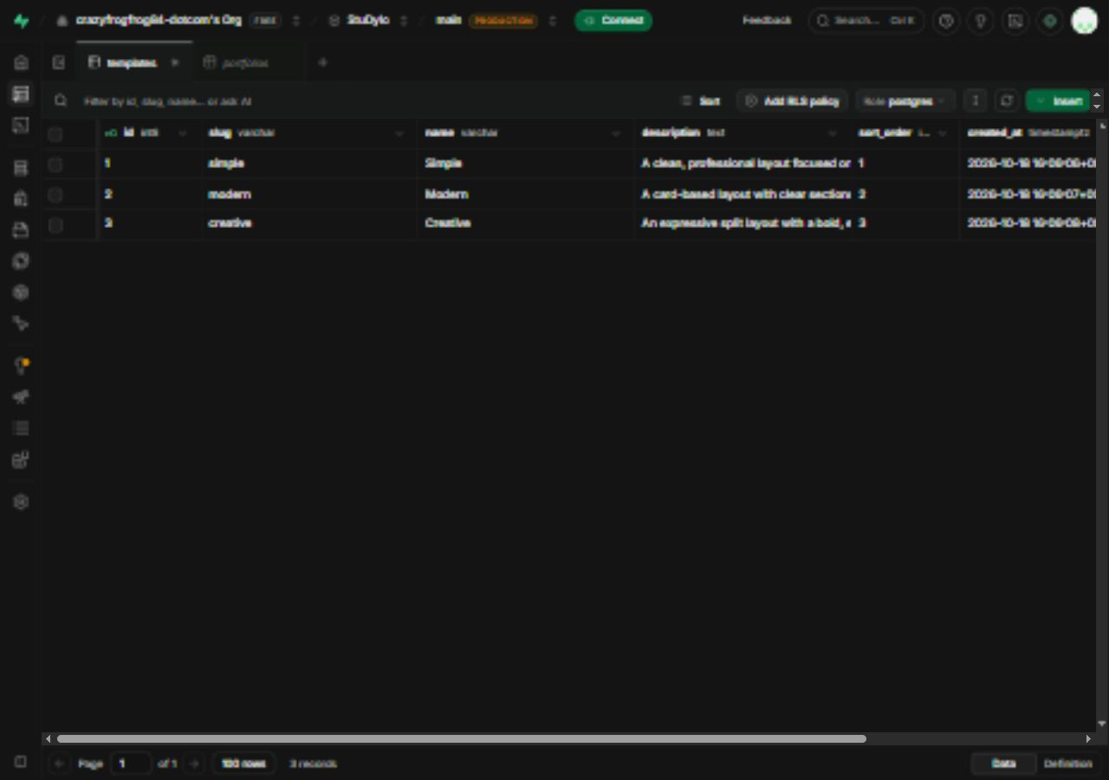  Supabase Table Editor - public.templates rows

Screenshots of the 3 Templates
Simple - Light mode | 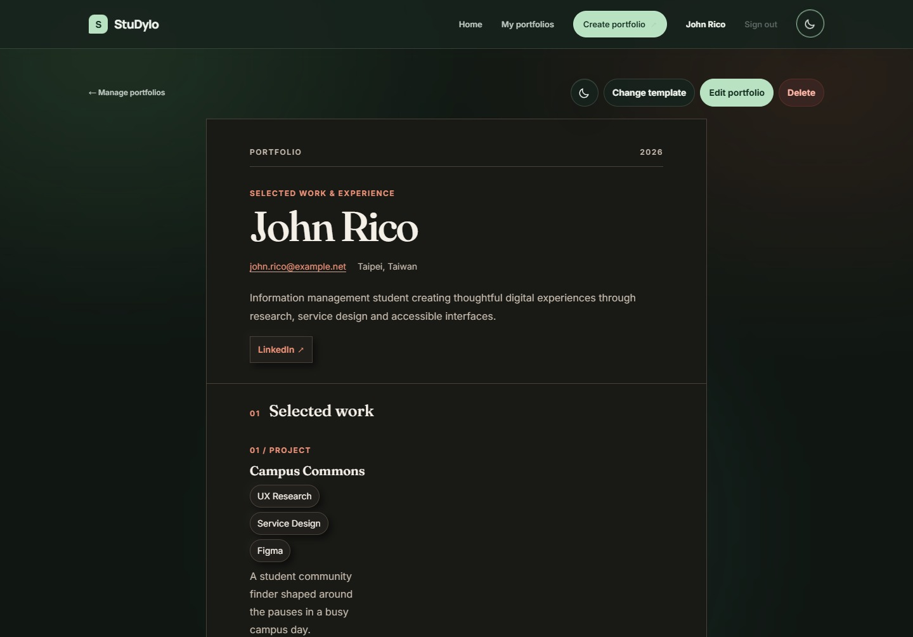  Simple - Dark mode
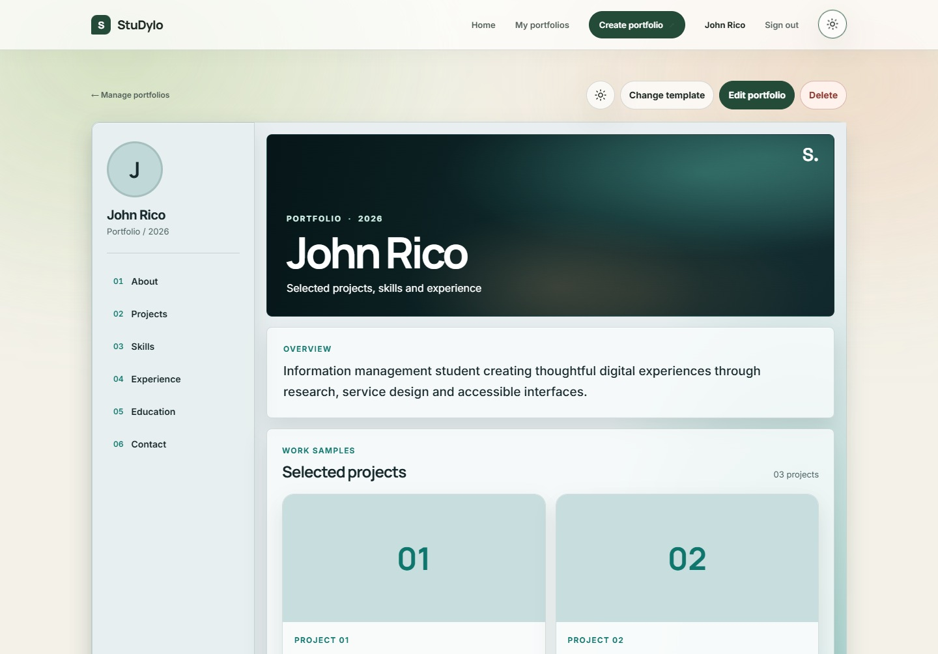  Modern - Light mode | 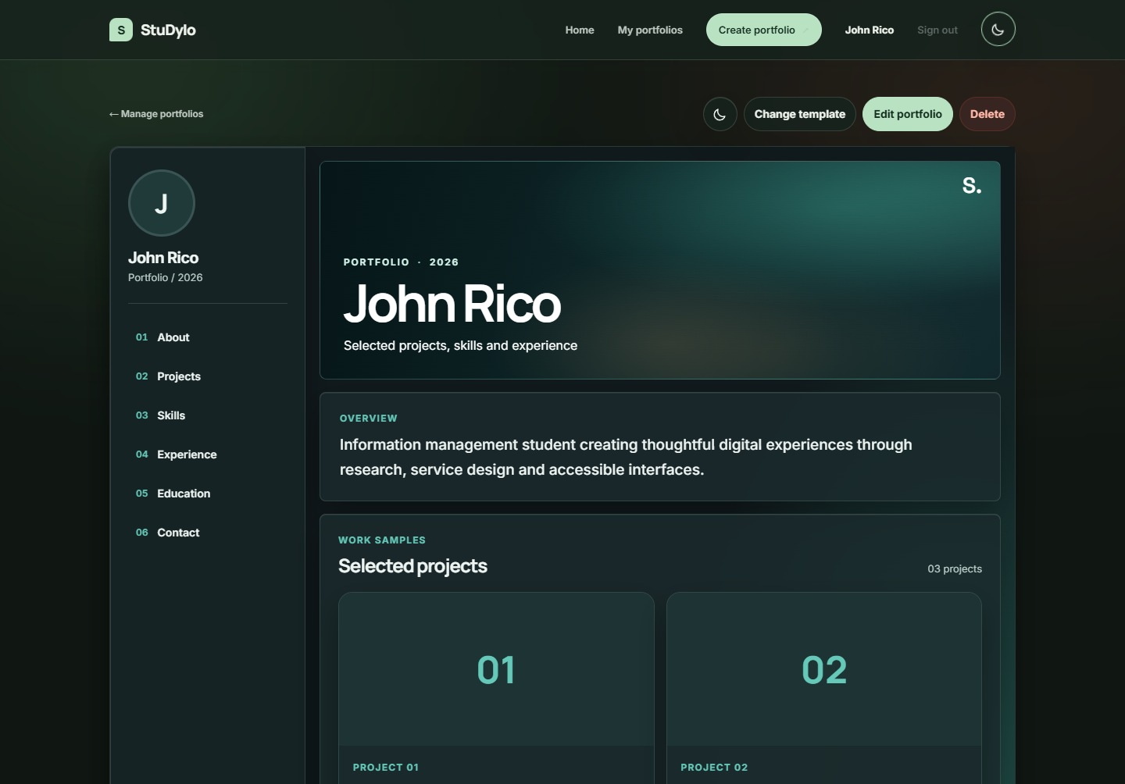  Modern - Dark mode
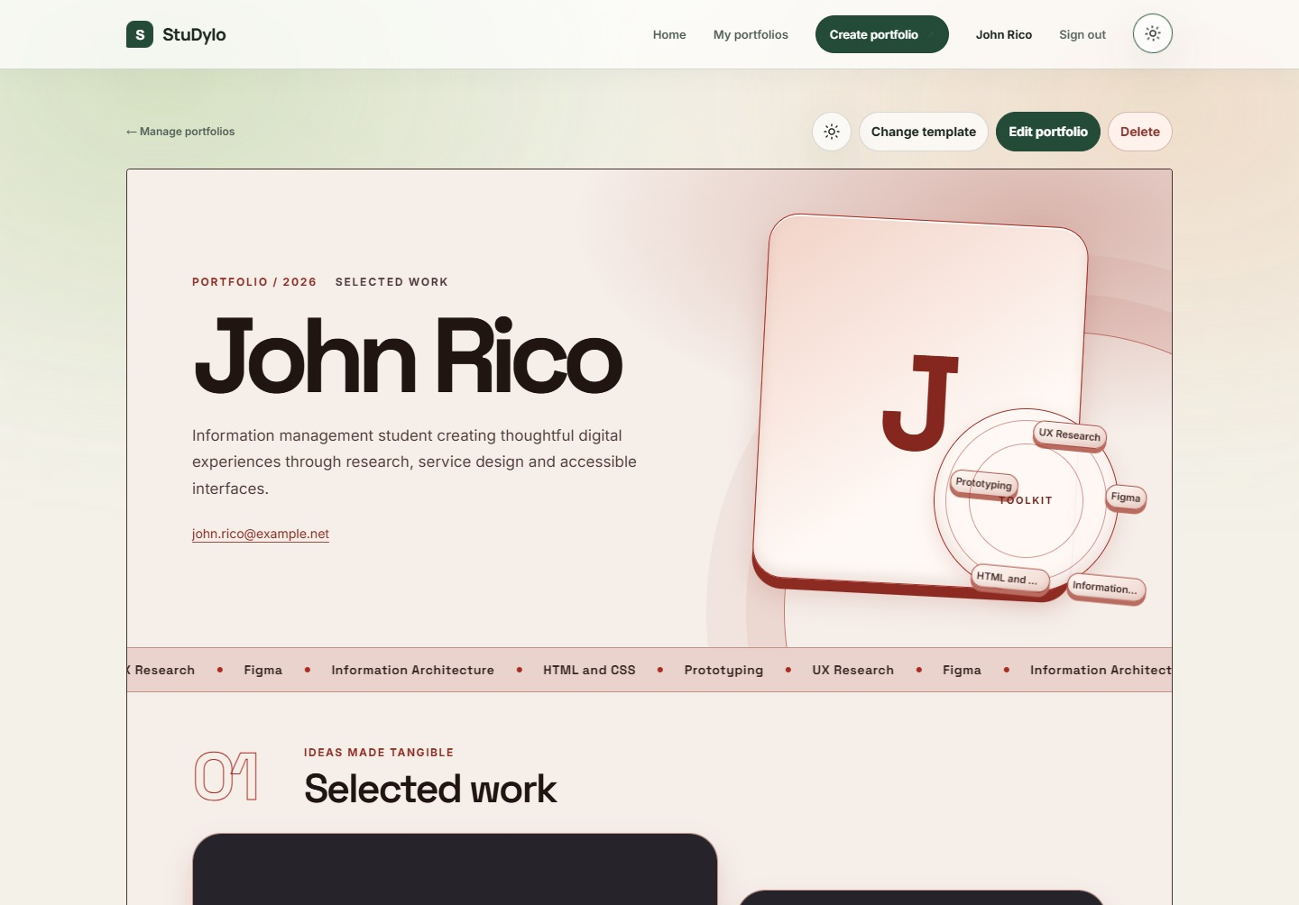  Creative - Light mode | 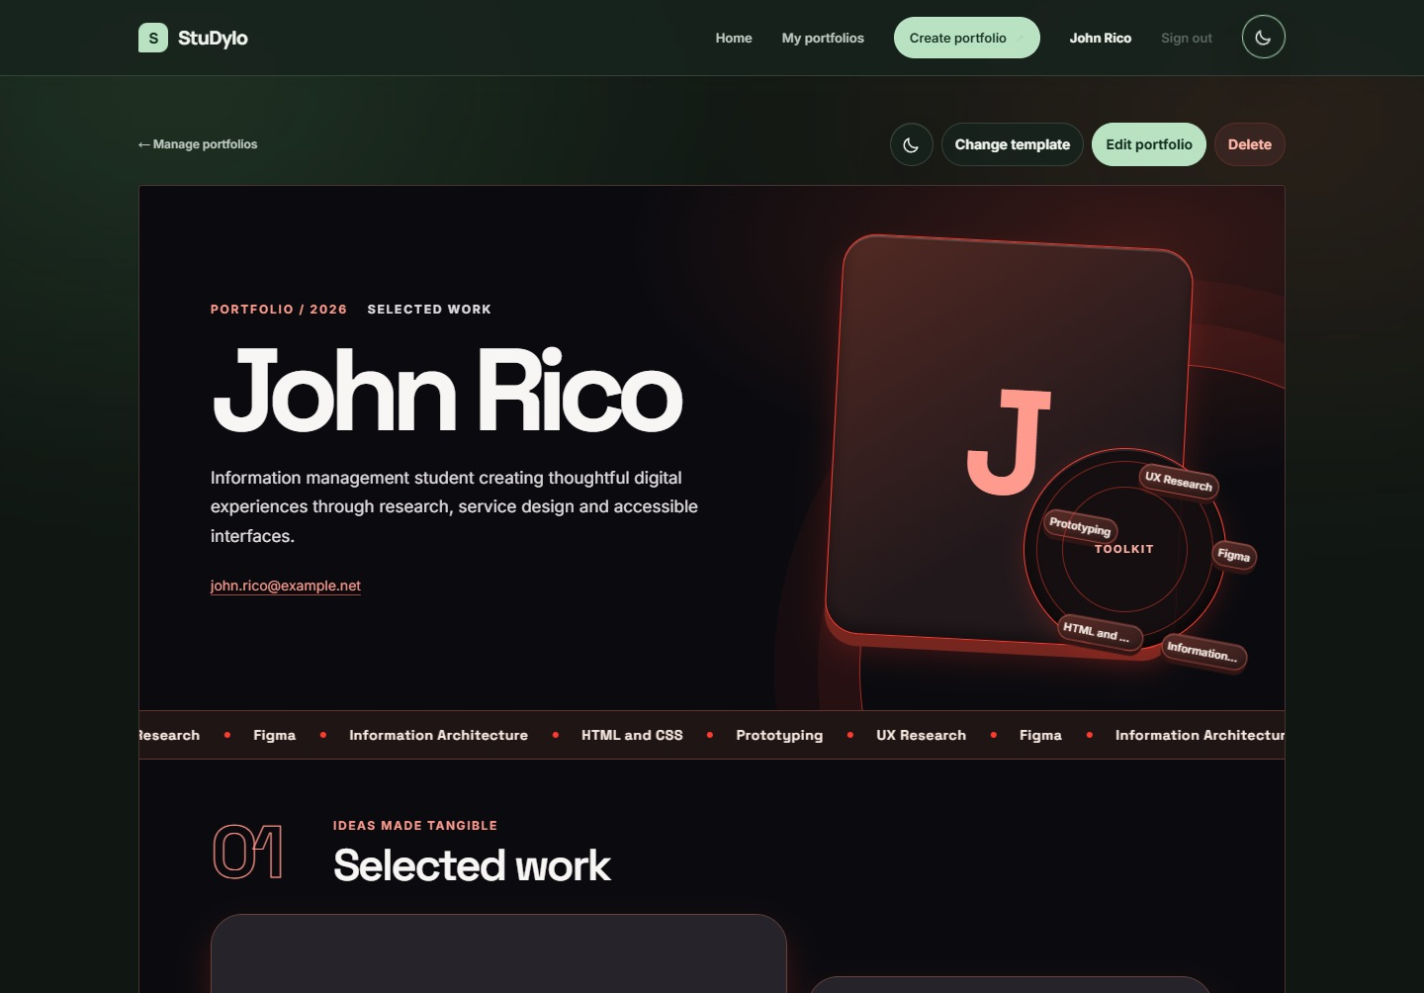  Creative - Dark mode

Published Website URL
https://studyio-portfolio.onrender.com

