
PROGRAMME: B.Tech COMPUTER SCINCE AND ENGINEERING
MINI PROJECT REPORT
Object Oriented Programming Using Java (2nd Semester)
- Student name: | - Guthi Leela Harsha | - Subject Name & Code: | - Object-Oriented Programming Using Java
- USN: | - 25BTRPW042 | - Faculty Name: | - Mrs.Shruti Hiregoudar
- Class/Section  - : | - CSE – PwC – A | - Date of Demo: | - 01 – 04 - 2026
- Project uploaded  - Github link |  | - Date of Report  - Submission: | - 02 – 04 - 2026

- Problem Statement:
Managing hotel customer records manually is slow, difficult, and often leads to data entry errors and billing mistakes. Staff may face problems in finding customer details quickly, updating records, or maintaining accuracy.
There is a need for a simple and reliable software system that can:
- Store customer information properly
- Calculate bills automatically
- Allow quick search and management of records
This project aims to develop a Hotel Management System using Java and Object-Oriented Programming (OOP) to make the process faster, easier, and error-free.
- Project Description:
The Hotel Management System is a Java-based application designed to manage guest stays efficiently. The system allows a user to perform basic management tasks through a simple menu.
- Add Customer: Register new guests with their ID, name, room number, and stay duration.
- View Records: List of all current guests and their staying details.
- Search/Delete: Find specific guests by their unique ID or remove them upon checkout.
- Automated Billing: The program automatically calculates the total cost based on the number of days stayed.
By automating these essential tasks, the application reduces manual effort, minimizes errors, and enhances overall accuracy in hotel operations.
- Concepts Used in the Program:
- Classes and Objects:
A class is a blueprint, and an object is its real example. In the program, the Customer class is used to create different customer objects using new Customer(), where each object stores separate customer details.
- Variables (Data Members):
Variables like id, name, roomNo, days, and bill are used to store customer information. Each object has its own values, so data does not mix.
- Constructor:
The constructor Customer(int id, String name, int roomNo, int days) is used to initialize customer details when an object is created. It also calls calculateBill() automatically.
- Methods:
Methods define the actions of the program, such as calculateBill() to compute the total bill and display() to show customer details.
- ArrayList:
ArrayList is used to store multiple customers. It can grow or shrink, so it is better than a fixed array.
- Scanner Class:
The Scanner class is used to take input from the user like ID, name, and days.
- Loop (do-while):
The do-while loop keeps the program running again and again until the user chooses to exit.
- Switch Case:
The switch statement is used to display menu options and perform actions like add, view, search, delete, and exit.
- Conditional Statements:
if conditions are used to check things like invalid input (days ≤ 0) and to verify if a customer exists.
- Lambda Expression (removeIf):
removeIf(c -> c.id == deleteId) is used to delete a customer easily without writing long code.

- Program Code
  - import java.util.ArrayList;
  - import java.util.Scanner;

  - class Customer {
  - int id;
  - String name;
  - int roomNo;
  - int days;
  - double bill;

  - // Constructor
  - Customer(int id, String name, int roomNo, int days) {
  - this.id = id;
  - this.name = name;
  - this.roomNo = roomNo;
  - this.days = days;
  - calculateBill();
  - }

  - // Method to calculate bill
  - void calculateBill() {
  - bill = days * 1000; // ₹1000 per day
  - }

  - // Display customer details
  - void display() {
  - System.out.println("ID: " + id);
  - System.out.println("Name: " + name);
  - System.out.println("Room No: " + roomNo);
  - System.out.println("Days: " + days);
  - System.out.println("Bill: ₹" + bill);
  - System.out.println("----------------------");
  - }
  - }

  - public class HotelManagement {
  - public static void main(String[] args) {

  - Scanner sc = new Scanner(System.in);
  - ArrayList<Customer> list = new ArrayList<>();
  - int choice;

  - do {
  - System.out.println("\n--- HOTEL MANAGEMENT SYSTEM ---");
  - System.out.println("1. Add Customer");
  - System.out.println("2. View Customers");
  - System.out.println("3. Search Customer");
  - System.out.println("4. Delete Customer");
  - System.out.println("5. Exit");
  - System.out.print("Enter choice: ");

  - choice = sc.nextInt();

  - switch (choice) {

  - case 1:
  - System.out.print("Enter ID: ");
  - int id = sc.nextInt();
  - sc.nextLine(); // clear buffer

  - System.out.print("Enter Name: ");
  - String name = sc.nextLine();

  - System.out.print("Enter Room No: ");
  - int roomNo = sc.nextInt();

  - System.out.print("Enter Days Stayed: ");
  - int days = sc.nextInt();

  - if (days <= 0) {
  - System.out.println("Invalid days!");
  - break;
  - }

  - list.add(new Customer(id, name, roomNo, days));
  - System.out.println("Customer Added Successfully!");
  - break;

  - case 2:
  - if (list.isEmpty()) {
  - System.out.println("No customers found.");
  - } else {
  - for (Customer c : list) {
  - c.display();
  - }
  - }
  - break;

  - case 3:
  - System.out.print("Enter Customer ID: ");
  - int searchId = sc.nextInt();
  - boolean found = false;

  - for (Customer c : list) {
  - if (c.id == searchId) {
  - c.display();
  - found = true;
  - break;
  - }
  - }

  - if (!found) {
  - System.out.println("Customer not found.");
  - }
  - break;

  - case 4:
  - System.out.print("Enter Customer ID to delete: ");
  - int deleteId = sc.nextInt();
  - boolean removed = list.removeIf(c -> c.id == deleteId);

  - if (removed) {
  - System.out.println("Customer deleted successfully!");
  - } else {
  - System.out.println("Customer not found.");
  - }
  - break;

  - case 5:
  - System.out.println("Thank you!");
  - break;

  - default:
  - System.out.println("Invalid choice!");
  - }

  - } while (choice != 5);

  - sc.close();
  - }
  - }
- Output Screenshots
  - Add Customer:
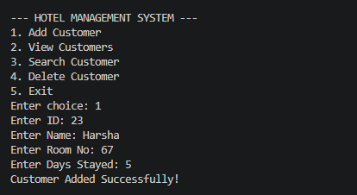
  - View Customer:
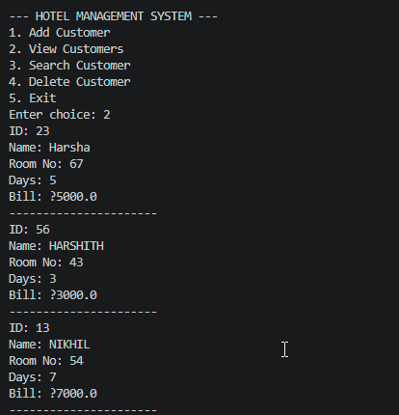
  - Search Customer:
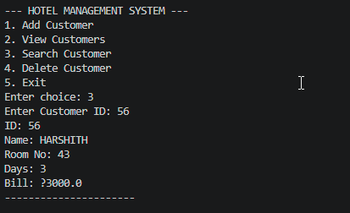
  - Delete Customer:
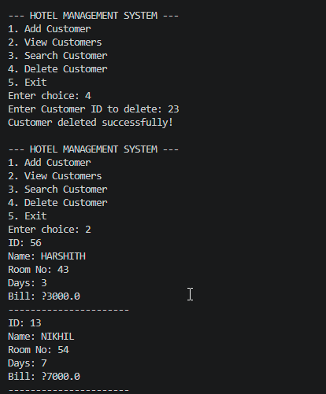
  - Exit:
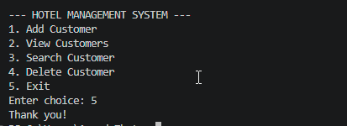
- Conclusion
  - The Hotel Management System successfully automates customer record management by allowing users to add, view, search, and delete customer details efficiently. It uses Object-Oriented Programming concepts to create a structured and easy-to-understand program, reducing manual work and improving accuracy in hotel operations.

