**Physics 121 Notebook**

**Fall 2015**

**Author:** Gabriel Nava

**Group members:** Will Coburn

**Project Name:** Wave Tank Wave Generator

**Table of Contents**

|  |  |
| --- | --- |
| **Description** | **Page** |
| List of figures | 3 |
| Project proposal | 4 |
| Week 1 | 6 |
| Week 2 | 7 |
| Week 3 | 10 |
| Week 4 | 11 |
| Week 5 | 12 |
| Week 6 | 15 |
| Week 7 | 17 |
| Week 8 | 19 |
| Week 9 | 20 |
| Week 10 | 21 |
| Week 11 | 23 |
| Week 12 | 24 |
| Week 13 | 26 |
| Operation Instructions | 27 |
| Outreach 1 | 28 |
| Outreach 2 | 30 |
| Reflections | 32 |
| Time Estimate | 33 |

**List of figures**

|  |  |
| --- | --- |
| **Figure Description** | **Page** |
| Figure 1 - current sliding functionality | 5 |
| Figure 2 – Rack and pinion | 8 |
| Figure 3 – Sample Arduino board with Stepper Driver and Motor | 9 |
| Figure 4 - Initial UI for Wave Tank Application | 13 |
| Figure 5 - Raspberry Pi and PASCO DC motor | 14 |
| Figure 6 - four states of coils which control motor steps | 16 |
| Figure 7 - Crude Java GUI for controlling Arduino scripts | 18 |
| Figure 8: Wave tank without water, but fully assembled | 22 |
| Figure 9 -TCP communications between GUI and Raspberry PI which controls motor | 25 |
| Figure 10 – Logic Level Converter | 26 |
| Figure 11 - Tank at Discovery Museum Night | 29 |
| Figure 12 – Resonant rings at Los Alamos | 31 |
| Table 2 – Time Estimate | 33 |
|  |  |
|  |  |
|  |  |
|  |  |
|  |  |
|  |  |
|  |  |

**Project Proposal**

A tsunami tank was presented during Friday Night Science 2015 by Will Coburn. This wave flume consisted of three segmented acrylic tank sections, a large volume of colored water, a model of a coastline, and an acrylic paddle.

The current method of generating waves involves physically generating a pulse by pushing an acrylic paddle sitting atop the tank in a forward and-back-linear motion. It was proposed to automate wave generation through the use of a stepper motor which drives a rack-and-pinion slide to move the acrylic paddle. The motor can be driven by a stepper driver. This driver can then be regulated by an Arduino board and controlled through a GUI interface in a tablet or smartphone.

The GUI will consist of touch buttons or sliders to control wave frequency and amplitude. This GUI can be written in JavaScript for platform independence. The device that loads the GUI will need to communicate with the Arduino board through Wi-Fi, Bluetooth, or USB.

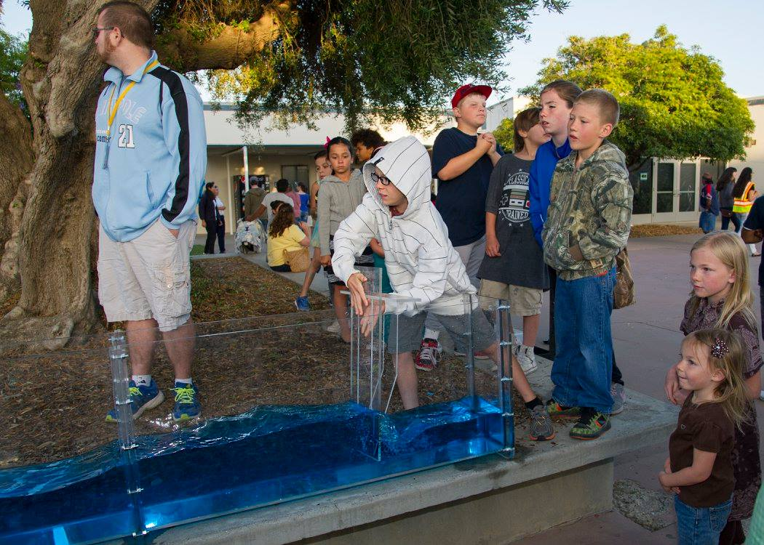

Figure 1 – A wave is generated in a tsunami wave tank by physically sliding an acrylic paddle across the anti-shore end.

**Week 1 (08-21-15)**

Week 1 Goals:

1. Familiarize self with current design of tsunami wave tank.
2. Gabriel will get in contact with Will and see where he can help through coding.

Week 1 Activities:

Since the tsunami tank was Will Coburn’s spring project, professor Jorstad called Will, who is now at Cal Poly, and left a message introducing Gabriel, who will try to help with the programming side of the project.

Researched about different tools and materials, including acrylic glass which is used in the tsunami wave tank.

Inspected the current wave tank and noticed that it consisted of several acrylic panes welded together to form rectangular-like segments. To build the tank, these segments were screwed together at their ends.

During the week Gabriel will review Will’s email to Professor Dunham, which outlines the exact requirements of the proposed automatized wave generation.

**Week 2 (08-28-15)**

Week 2 Goals:

1. Help in cleaning out old tank water-proofing material and adhesive.
2. Meet up with Will and introduce self.
3. Test waterproofing membranes for leaks.
4. Researched components of proposed automated mechanism.

Week 2 Activities:

Waterproofing foam laid in between the tsunami tank segments to stop leaks. This material was glued to the acrylic sheets. While the foam part of the material was really easy to take off, the left-over adhesive took over an hour to remove. Angus and Gabriel used WD40, paper towels, and straight edges to remove the leftover adhesive. We opted out of using acetone or nail polish because it would have burned into the acrylic.

Existing waterproofing membranes would allow for easier assembly and disassembly of the tank during demonstrations. Will and Gabriel tested two membranes and found that they still leaked water. It was proposed to look for a new material for the waterproofing membranes.

Gabriel reviewed watched existing wave tank videos at several universities which used motors to automate the generation of waves:

<https://youtu.be/SmZe_LjvfK0>  
<https://youtu.be/b3GXNPCsT3s>

The different components of the proposed mechanism were researched. For example, the following figure clarified the rack-and-pinion slide:

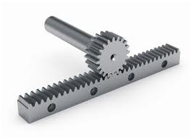

Figure 2 – A rack and pinion slide can be seen above. The stepper motor will allow for high-precision micro-steps which will move the linear slide in a back and forth motion.

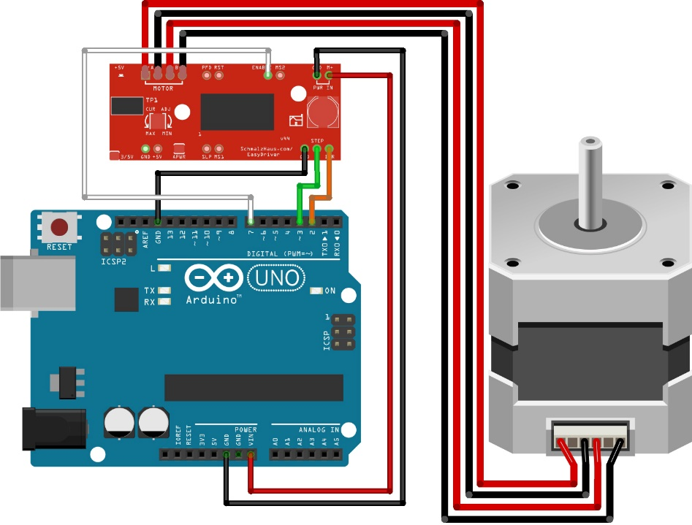

Figure 3 – Sample Arduino board with Stepper Driver and Motor.

**Week 3 (09-11-15)**

No meeting due to Labor Day weekend.

**Week 4 (09-11-15)**

Week 4 Goals:

1. Research Arduino stepper motor libraries and analyze functions.
2. Research communication interfaces between tablets and the Arduino board.
3. Test Arduino Simulator.

Week 4 Activities:

Water was leaking in two places through the acrylic welds at the bottom of the tsunami tank. Professor Jorstad added silicon on the insides. Angus and Gabriel duct taped a hair dryer and heat gun over the tank to speed up the curing of the silicon.

Gabriel coordinated with Will over email on GUI requirements. We could not meet during class due to schedule differences. Gabriel suggested we use a web app interface over a platform-dependent app interface for better software portability.

Will confirmed on the parts being ordered.

Installed an Arduino board simulator and began researching existing Arduino libraries for communication and motor control.

**Week 5 (09-18-15)**

Week 5 Goals:

1. Create simple proof-of-concept GUI and present to Will.

Week 5 Activities:

Gabriel used the Fluid UI application to draft the initial wave tank application. The focus was to control the speed via a slider and output possible amplitude and period.

With Prof. Jorstad’s help, a model was made using a Gaussian function in a form similar to:

where V is the voltage, t is the time, T is period, A amplitude, and w is the width of the waveform. Gabriel borrowed a Raspberry Pi and motor to attempt to test this waveform and to find valid values. From an email to Will on Sept 20, it was found out that stepper motors were not controlled through voltage alone. Added research on stepper motors for next week’s list of tasks.

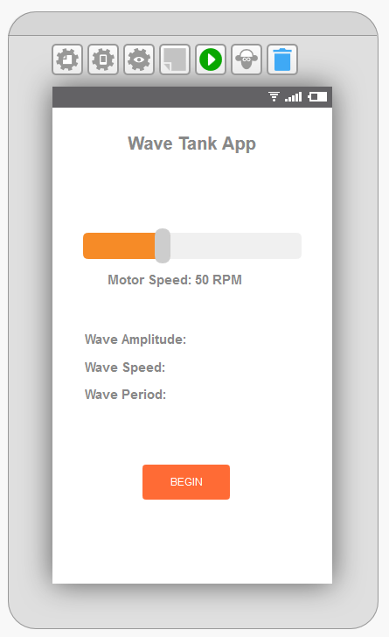

Figure 4: Initial UI for Wave Tank Application.

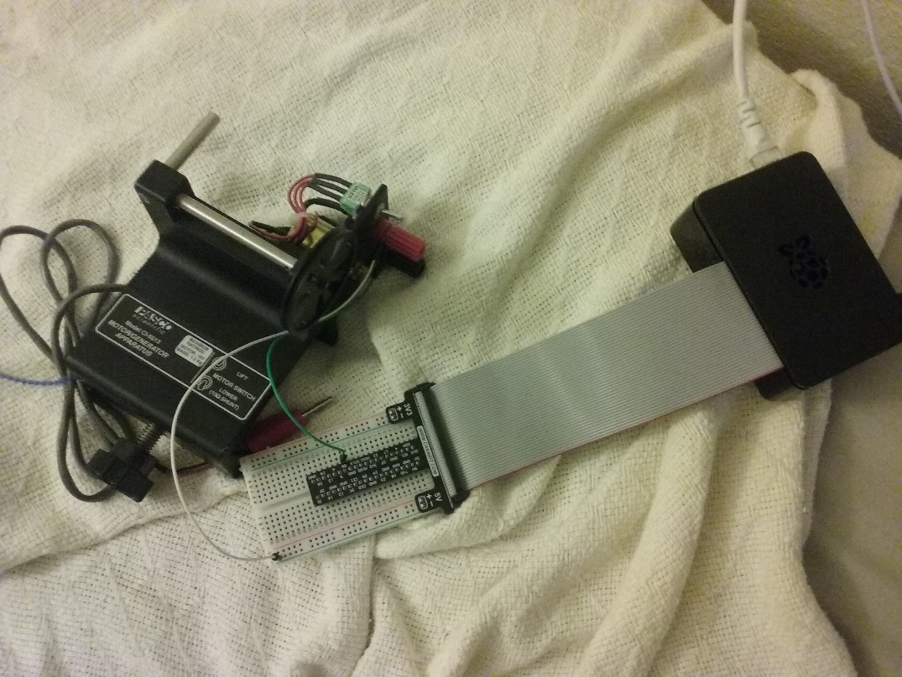

Figure 5: Raspberry Pi and PASCO DC motor. SSH’d into Raspberry Pi to load Java jar.

**Week 6 (09-25-15)**

Week 6 Goals:

1. Learn Raspberry Pi GPIO library and see if it can offer possible alternative for the Arduino.

Week 6 Activities:

Gabriel began researching stepper libraries for the Raspberry Pi and found the Pi4J library. Within the example packages a StepperMotorGpio.class already had implementation for a stepper motor. However, it was not compatible with our current setup. This library required four wires to control the four electromagnets:

Step C0 C1 C2 C3

1 1 0 1 0

2 0 1 1 0

3 0 1 0 1

4 1 0 0 1

Will had already received the motor and stepper and had configured the Arduino to use only two wires. It was decided to stick to his existing setup for the demo at the Discovery Museum. Gabriel added modifying the Raspberry Pi’s incompatible Stepper Motor GPIO library to his future list of tasks.

 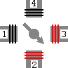 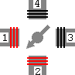 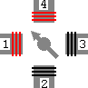

Step 1 Step 2 Step 3 Step 4

Figure 6: Demonstrates four states of coils which control motor steps. Only 2 bits are required (2 cables), where 01 encodes step 1, where 11 encodes step 2, where 10 encodes step 3, and where 00 encodes step 4.

**Week 7 (10-02-15)**

Week 7 Goals:

1. Work with Will to prepare tank for Santa Maria Discovery Museum.
2. Research photogate for detecting collisions.

Week 7 Activities:

Since the Arduino requires code to be manually uploaded one script at a time, Gabriel worked on putting together a crude Java display to do so automatically through the tablet at the discovery museum. The application used the Arduino IDE’s command line options. For example: arduino --upload C:/steady_wave_small/steady_wave_small.ino would load, compile, and upload the code for a small steady wave form into the Arduino. This command was bound to a button.

Will and friend mounted motor to a track and electronics to an acrylic board. They made the frame for the track to sit on and for the paddle to attach to. Gabriel helped screw covers on and created video for Stanford. We decided not to use a photogate for the demo.

On this week’s Saturday, Gabriel met with Prof. Jorstad to move tank section to Discovery Museum. Gabriel went one hour early before the event started to put everything together.

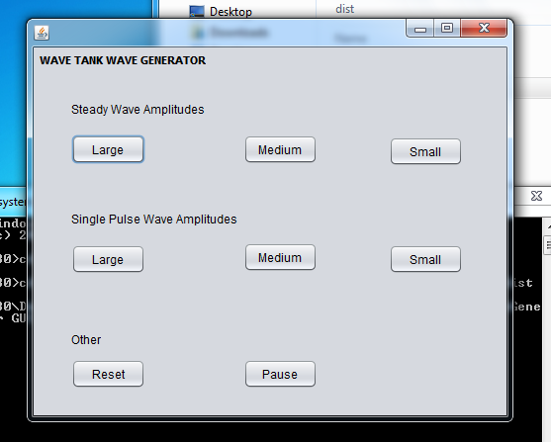

Figure 7: Crude Java GUI for controlling Arduino scripts.

**Week 8 (10-09-15)**

Week 8 Goals:

1. Work on redesigning paddle.

Week 8 Activities:

It was noticed during the demo of the wave tank at the Discovery Museum that the paddle bent considerably and at certain times caused slippage and stress on the motor. Prof. Jorstad suggested adding reinforcement brackets to the current paddle. The paddle would also be flipped to reduce the load on the interface of the paddle and track. The paddle would now “push” instead of “drag”. With Prof. Jorstad’s help, Gabriel found new brackets and prepared new design.

No time as left to drill holes on paddle because Gabriel had to go to work, but after calling Will, it was suggested to use stronger materials with a higher Young’s modulus such as aluminum (6GPa vs. Acrylic 3.2 GPa).

**Week 9 (10-16-15)**

Week 9 Goals:

1. Waterproof all sections of the tank with silicon.

Week 9 Activities:

The tank was leaking at various places. It was decided to apply silicon around inner welds. This involved removing all current silicon so new silicon could attach. This task was tedious because some silicon could only be removed with a rough sponge and/or razor.

After class Gabriel stopped by Home Depot and purchased 5 bottles of silicon and 1 roll of weather stripping.

On this week’s Saturday, Gabriel added the piece of weather stripping to one end of the tank, replacing the plastic gasket currently being used. Then silicon was added to all sides of three tank sections. A piece of wood was used to flatten the silicon.

**Week 10 (10-23-15)**

Week 10 Goals:

1. Assemble all three sections of the tank in preparation for demo to Chris from the Discovery Museum.

Week 10 Activities:

Gabriel placed all three sections of the tank on bricks (Figure 9), assembled the now “sealed” tank together, and filled tank with water. The foam “coast” was weighted down with lead bars. Then an attempt was made to mount the motor on the tank’s frame. It was noticed, however, that the motor’s gear was at the wrong side. The screw that held the gear ended up being stripped beyond repair. A new screw was found, but unfortunately too late for the demo to the Santa Maria Discovery Museum representatives. Instead the paddle was physically controlled as it was during Friday Night Science.

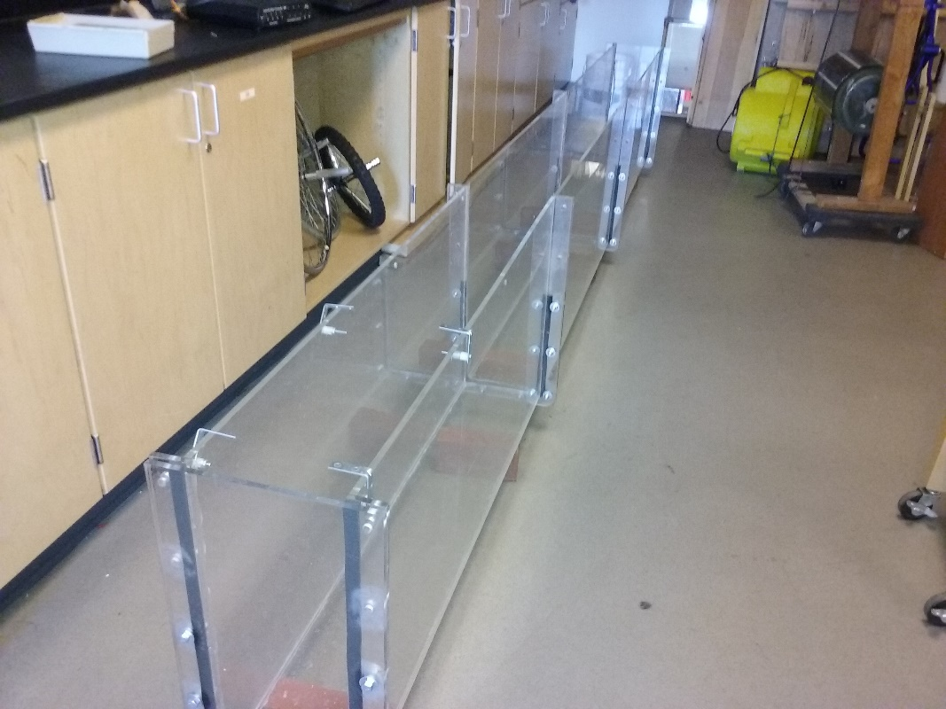

Figure 8: Wave tank without water, but fully assembled.

**Week 11 (10-30-15)**

Week 11 Goals:

1. Work on Journal

Week 11 Activities:

Having completed all hours required for the Project Lab, Gabriel decided to work on the journal.

**Week 12 (11-06-15)**

Week 12 Goals:

1. Work on Raspberry Pi networking.

Week 12 Activities:

Gabriel configured the java application that will run on the Raspberry to listen on TCP port 9999 for communications from a handheld device GUI. The handheld device will communicate as follows:

BEGIN – Begins communications.

DIR N – Set direction of the motor, where 0 is backwards and 1 is forwards.

SPEED N – Set speed of the motor where n is milliseconds between steps.

STARTMOTOR – Starts motor.

STOPMOTOR – Stops motor.

END - End communications.

.More variables can be added as needed to enable further control. The reason TCP is used is because of a planned wireless configuration between the handheld device and Raspberry Pi.

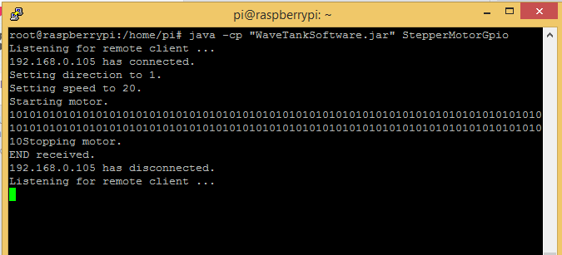

Figure 9 – TCP communications between GUI and Raspberry PI which controls motor.

**Week 13 (11-13-15)**

Week 13 Goals:

1. Work on hardware.

Week 13 Activities:

Gabriel decided to stop using Arduino due to variance in analog reads of Raspberry Pi digital signals and instead ordered 2 x 4-channel I2C-safe Bi-directional Logic Level Converters. These will allow the Raspberry Pi which can only output up to 3v signals to interface to the stepper motor, which expects 5v signals.

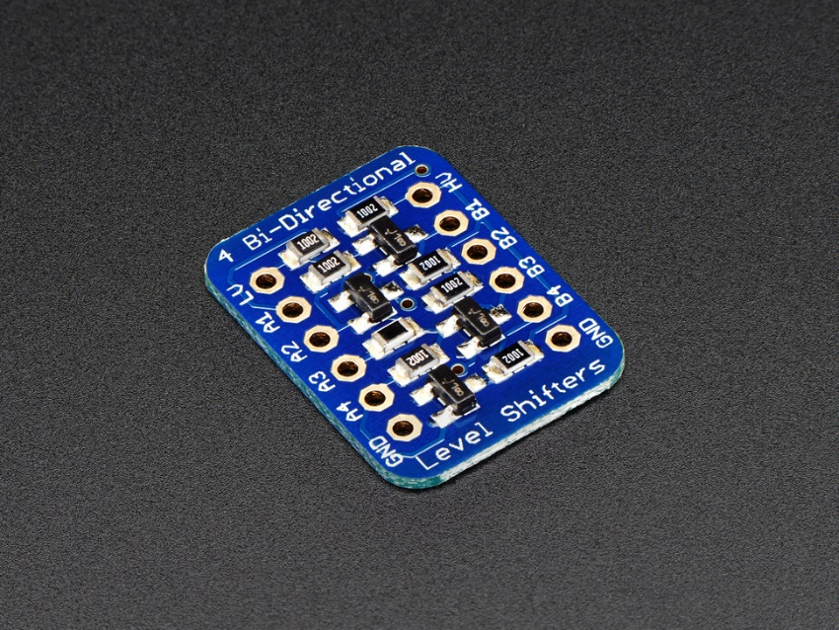

Figure 10 – Logic Level Converter

**Operation instructions & presentation notes draft (11/27/2015)**

To assemble the wave tank: Align two bricks per wave tank segment in parallel in a single-file line. Each brick should be about 1/3 from the end of the wave tank segment. Do this for all the wave tank segments. Place each wave tank segment on top of the bricks. Bolt a side cover onto each of the outer wave tank segments. Then bolt the middle two connections. Make sure to tighten every third nut/bolt to minimize stress on the acrylic. Add the coast foam on the side of the tank that has no paddle/motor bracket mounts. Add sufficient lead blocks on top of the foam to weight it down. Add water to the tank. Add food coloring to the tank.

To connect the electronics (W.I.P.): Plug the Arduino MEGA to the tablet via USB. Launch the Arduino IDE on the tablet and load either the single wave pulse .ino file or the steady waveform .ino file. Upload and compile the code. Move the paddle back to the starting position then connect the power-supply to an outlet. The paddle should start moving back and forth. To switch mode, run the empty loop program (reset .ino), move back the paddle to the starting position, and upload the new program. You can also use the standalone java program with buttons to do all of this loading, uploading, and compiling for you. The jar file should be located on the C: drive of the tablet. You can run the Crude Java GUI for controlling Arduino scripts.as follows from the windows command line:

cd C:\WaveTankArduinoScriptLauncher\

javaw.exe Launcher.jar GUI

**Outreach 1 for Gabriel Nava**

**Where:** Santa Maria Discovery Museum

**When:** 10/03/2015 7:00 – 10:00pm

**Who**: Adults

**Demo:** The Wave Tank

**The science:** The wave tank demonstrates the behavior of steady waveforms and a single pulse wave. By configuring the motor to do a steady but single long push, a large wave is generated. By watching the paddle, an idea can be made of the amount of energy required to create such a large wave. By configuring the motor to do rapid, back-and-forth motions, pulsating waves hit the shore. Energy distribution can be seen as the pulsating waves hit the different areas of the coastline.

**What worked:** Since the model was still very much a prototype, the steady waveforms seemed to work much better, especially since only one section of the tank had been set up. Having the wave tank on a table seemed to work well.

**What didn’t:** The tablet was very slow, so changing in between modes (single wave and stead waveform) took some time. Also, because the paddle had been cut too much one side, it was creating turbulence that affected the waveforms.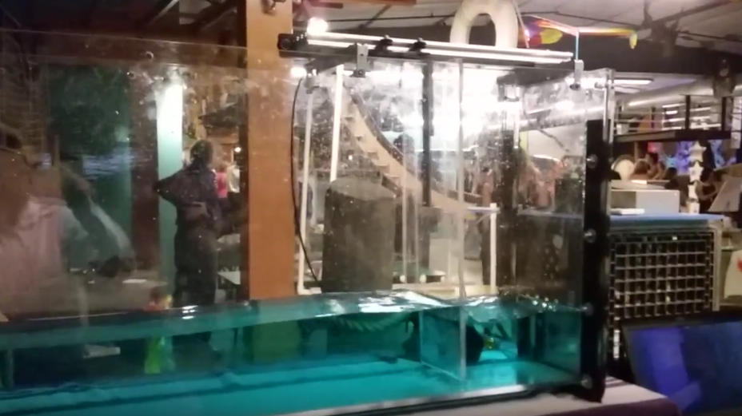

Figure 11: Tank at Discovery Museum Night.

**Outreach 2 for Gabriel Nava**

**Where:** Los Alamos

**When:** 10/16/2015 6:30 pm-8:00 pm

**Who**: About 30 Elementary Children

**Demo:** Resonant Rings

**The science:** A function generator produces tones powered by a speaker. This causes different rings to resonate. According to the Exploratorium, these resonant frequencies are determined by the ring’s mass and stiffness. Bigger rings resonated at lower frequencies and smaller rings resonated at higher frequencies.

**What worked:** Kids seemed to like changing the frequency themselves and seeing the results. The sound of the waves also allowed them to listen to the change in frequency and they were able to compare that visually to the resonating rings.

**What didn’t:** Higher frequencies created loud-high pitched sounds that annoyed others, so I kept the frequencies low.

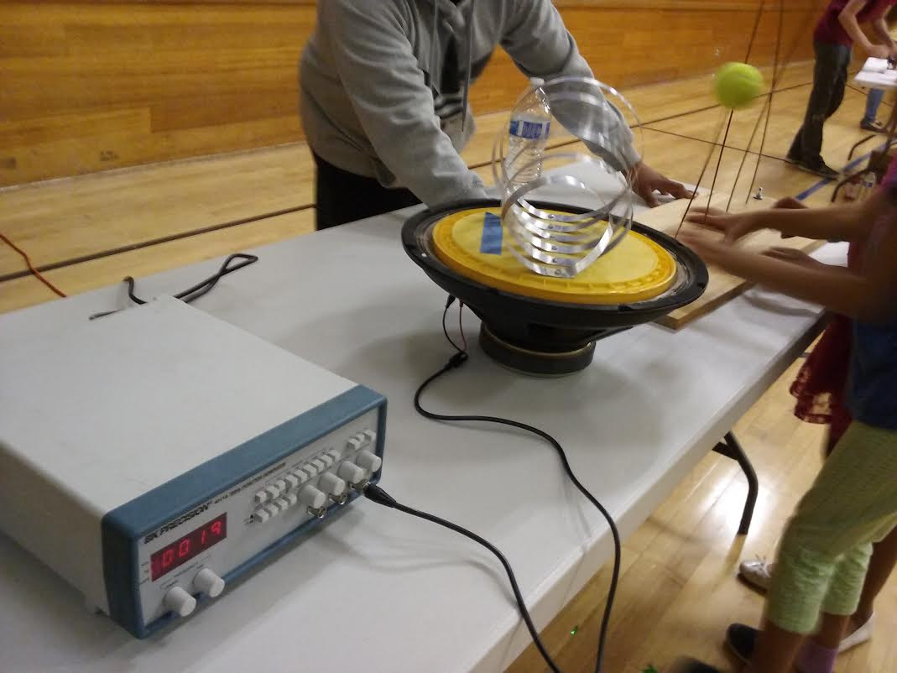

Figure 12 – Resonant rings at Los Alamos.

**Reflections (12/04/15)**

1. What did I do well this semester? What were my strengths in this course? I was timely with deadlines. For example, I was able to demo the Wave Tank at the Discovery Night Museum without any major hiccups. I was also able to seal the wave tank in time for Chris’ visit to Hancock.
2. What did I do poorly? What were my weaknesses in this course? I wish I had learned to use more power tools and learned more about different materials. When Will visited, I felt kind of helpless not being able to help him make the bracket mounts and base for the motor. I also wish I had decided to update my workplace schedule much sooner to get more Friday time in at the start of the semester.
3. What specific skills did I learn/improve this semester? I learned how to use the Arduino IDE. I learned to control the Arduino’s analog and digital pins. I learned how to control GPIO pins on the Raspberry Pi. I learned how to setup adhoc mode on the Raspberry Pi. I learned how to control a stepper motor. I learned how to seal leaks with silicon.
4. What did I learn about myself, my learning style, and my ability to work with others in this course? It was fun doing some of the non-technical work, and the idea of just getting stuff done really stuck with me. I’ve noticed that this has made me procrastinate a bit less since I try less to find an excuse to not do something right away.
5. In general, assess your ability to create and achieve weekly goals. How could you improve on this? Overall I think I remained fairly consistent on staying on track with my goals. If I wasn’t able to complete some of the week’s tasks in class, I would finish them on that following Saturday/Sunday. There was a lot of experimentation with different microcontrollers and programs as the semester progressed. While this at times required changing my goals unexpectedly, I did not let it hinder my overall progress.

**Time Estimate**

Table 1 – Estimate of time spent on various activities.

|  |  |  |
| --- | --- | --- |
| **Activity** | **Time Taken** | **Date** |
| Week 1 Class | 1 | 08/21/2015 |
| Reviewed requirements from Will’s email to Prof. Dunham | .5 | 08/23/2015 |
| Week 2 Class | 3 | 08/28/2015 |
| Reviewed videos of automated wave tanks at several universities | .5 | 08/29/2015 |
| Installed/Configure Arduino simulator. | 2 | 09/11/2015 |
| Week 4 Class | 1 | 09/11/2015 |
| Analyze Arduino IDE / Stepper Libraries | 2 | 09/12/2015 |
| Week 5 Class | 2 | 09/18/2015 |
| Tested waveform on Raspberry Pi and DC Motor | 3 | 09/22/2015 |
| Week 6 Class | 3 | 09/25/2015 |
| Research on stepper motors | 2.5 | 09/25/2015 |
| Week 7 Class | 7 | 10/02/2015 |
| Journal Write-Up | 2 | 09/30/2015 |
| Outreach Prep | 3 | 10/03/2015 |
| Week 8 Class | 2 | 10/09/2015 |
| Week 9 Class | 1 | 10/16/2015 |
| Silicon cleanup and application to all three sections of tank | 4.5 | 10/17/2015 |
| Week 10 Class (Including demo to Chris) | 5 | 10/23/2015 |
| Outreach 1 | 3 | 10/03/2015 |
| Outreach 2 | 3 | 10/16/2015 |
| Week 12 – TCP comms | 2 | 11/06/2015 |
| Week 13 – Pi/Arduino comms | 2 | 11/13/2015 |
| **Total Time Spent** | **55** |  |