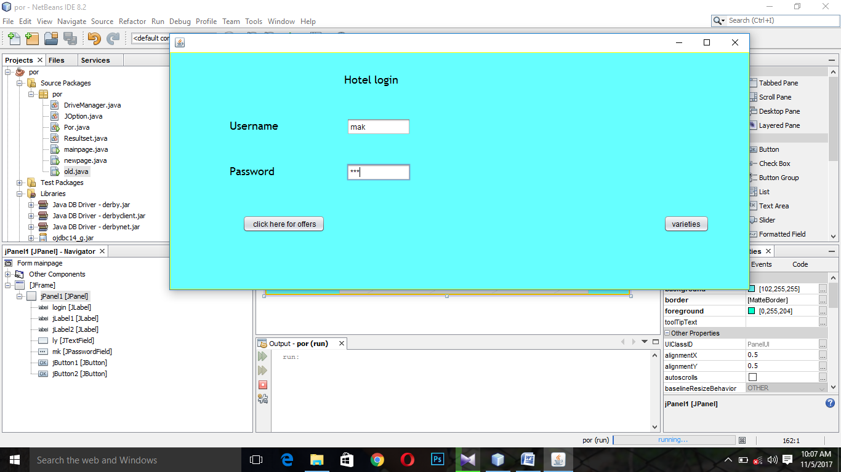

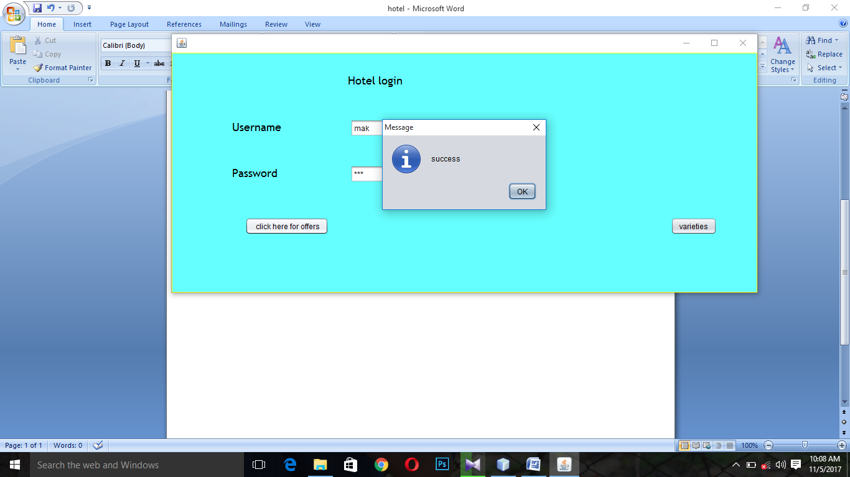

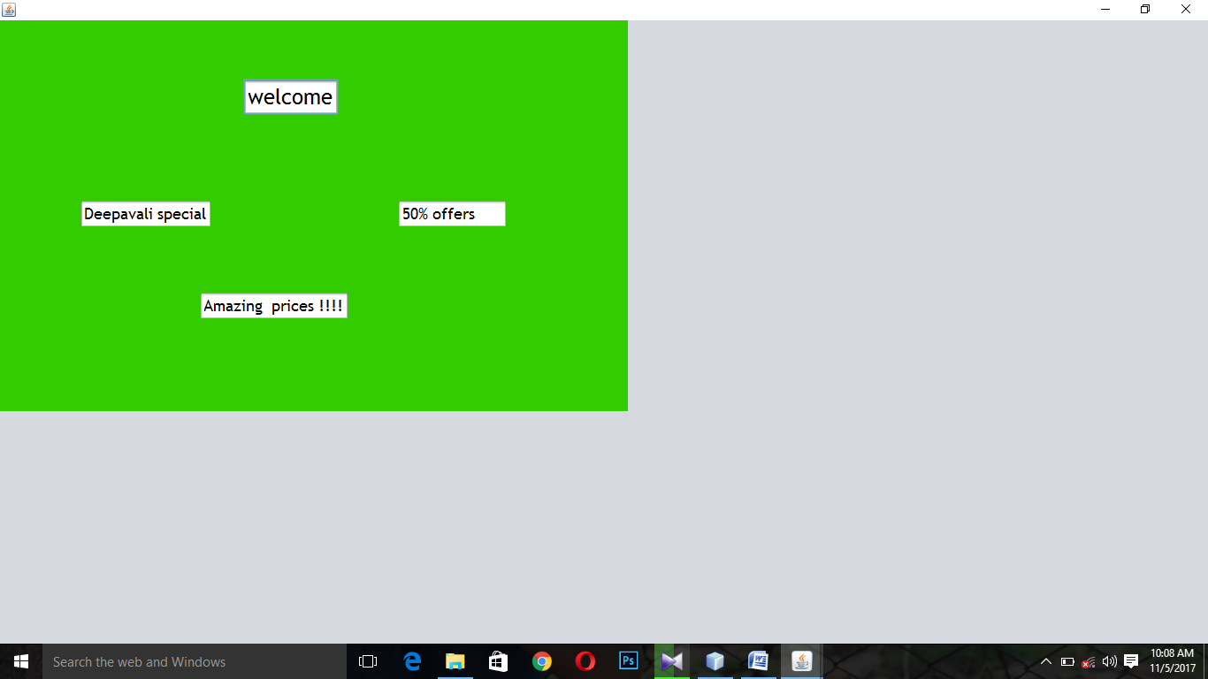

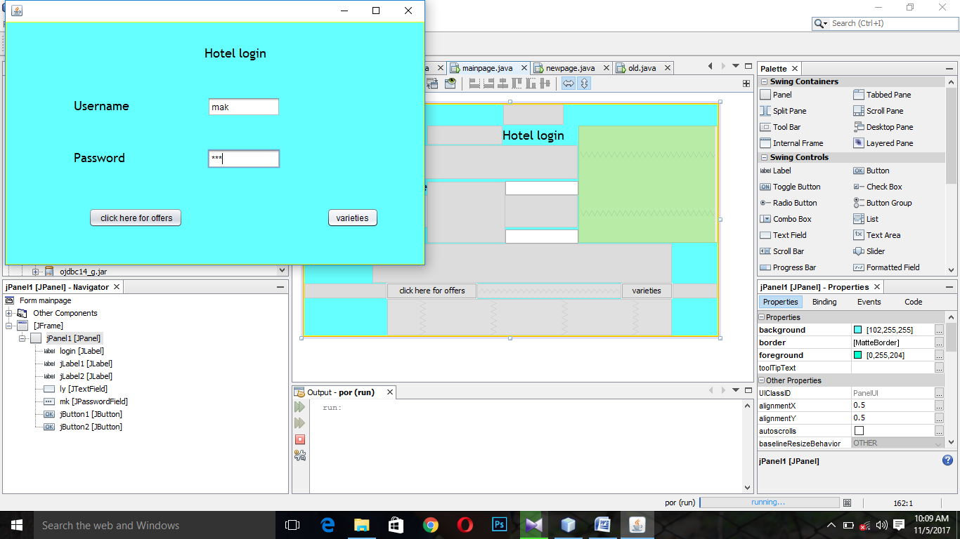

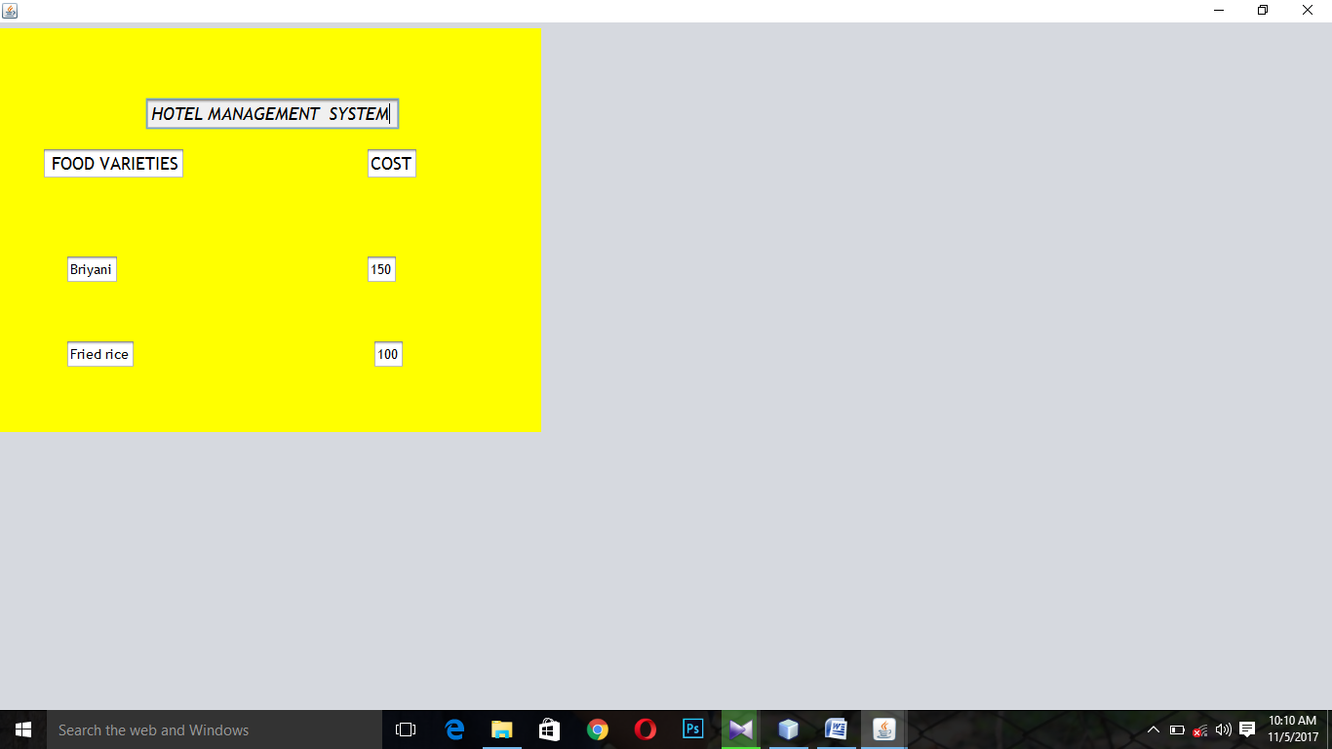

For hotel login page

/*

* To change this license header, choose License Headers in Project Properties.

* To change this template file, choose Tools | Templates

* and open the template in the editor.

*/

package por;

import javax.swing.JOptionPane;

/**

*

* @author makesh7

*/

public class mainpage extends javax.swing.JFrame {

private String user;

/**

* Creates new form mainpage

*/

public mainpage() {

initComponents();

}

/**

* This method is called from within the constructor to initialize the form.

* WARNING: Do NOT modify this code. The content of this method is always

* regenerated by the Form Editor.

*/

@SuppressWarnings("unchecked")

// <editor-fold defaultstate="collapsed" desc="Generated Code">

private void initComponents() {

jRadioButton1 = new javax.swing.JRadioButton();

jPanel1 = new javax.swing.JPanel();

login = new javax.swing.JLabel();

jLabel1 = new javax.swing.JLabel();

jLabel2 = new javax.swing.JLabel();

ly = new javax.swing.JTextField();

mk = new javax.swing.JPasswordField();

jButton1 = new javax.swing.JButton();

jButton2 = new javax.swing.JButton();

jRadioButton1.setText("jRadioButton1");

setDefaultCloseOperation(javax.swing.WindowConstants.EXIT_ON_CLOSE);

jPanel1.setBackground(new java.awt.Color(102, 255, 255));

jPanel1.setBorder(javax.swing.BorderFactory.createMatteBorder(1, 1, 1, 1, new java.awt.Color(255, 255, 0)));

jPanel1.setForeground(new java.awt.Color(0, 255, 204));

login.setFont(new java.awt.Font("Trebuchet MS", 0, 18)); // NOI18N

login.setText("Hotel login");

jLabel1.setFont(new java.awt.Font("Trebuchet MS", 0, 18)); // NOI18N

jLabel1.setText("Username");

jLabel2.setFont(new java.awt.Font("Trebuchet MS", 0, 18)); // NOI18N

jLabel2.setText("Password");

ly.addActionListener(new java.awt.event.ActionListener() {

public void actionPerformed(java.awt.event.ActionEvent evt) {

lyActionPerformed(evt);

}

});

mk.addActionListener(new java.awt.event.ActionListener() {

public void actionPerformed(java.awt.event.ActionEvent evt) {

mkActionPerformed(evt);

}

});

jButton1.setText(" click here for offers");

jButton1.addActionListener(new java.awt.event.ActionListener() {

public void actionPerformed(java.awt.event.ActionEvent evt) {

jButton1ActionPerformed(evt);

}

});

jButton2.setText("varieties");

jButton2.addActionListener(new java.awt.event.ActionListener() {

public void actionPerformed(java.awt.event.ActionEvent evt) {

jButton2ActionPerformed(evt);

}

});

javax.swing.GroupLayout jPanel1Layout = new javax.swing.GroupLayout(jPanel1);

jPanel1.setLayout(jPanel1Layout);

jPanel1Layout.setHorizontalGroup(

jPanel1Layout.createParallelGroup(javax.swing.GroupLayout.Alignment.LEADING)

.addGroup(jPanel1Layout.createSequentialGroup()

.addGap(117, 117, 117)

.addComponent(jButton1)

.addPreferredGap(javax.swing.LayoutStyle.ComponentPlacement.RELATED, 205, Short.MAX_VALUE)

.addComponent(jButton2)

.addGap(64, 64, 64))

.addGroup(jPanel1Layout.createSequentialGroup()

.addGap(96, 96, 96)

.addGroup(jPanel1Layout.createParallelGroup(javax.swing.GroupLayout.Alignment.LEADING)

.addComponent(jLabel2)

.addComponent(jLabel1))

.addGroup(jPanel1Layout.createParallelGroup(javax.swing.GroupLayout.Alignment.LEADING)

.addGroup(jPanel1Layout.createSequentialGroup()

.addGap(107, 107, 107)

.addComponent(login))

.addGroup(jPanel1Layout.createSequentialGroup()

.addGap(111, 111, 111)

.addGroup(jPanel1Layout.createParallelGroup(javax.swing.GroupLayout.Alignment.LEADING, false)

.addComponent(ly, javax.swing.GroupLayout.DEFAULT_SIZE, 104, Short.MAX_VALUE)

.addComponent(mk))))

.addContainerGap(javax.swing.GroupLayout.DEFAULT_SIZE, Short.MAX_VALUE))

);

jPanel1Layout.setVerticalGroup(

jPanel1Layout.createParallelGroup(javax.swing.GroupLayout.Alignment.LEADING)

.addGroup(jPanel1Layout.createSequentialGroup()

.addGap(29, 29, 29)

.addComponent(login, javax.swing.GroupLayout.PREFERRED_SIZE, 29, javax.swing.GroupLayout.PREFERRED_SIZE)

.addGap(48, 48, 48)

.addGroup(jPanel1Layout.createParallelGroup(javax.swing.GroupLayout.Alignment.BASELINE)

.addComponent(jLabel1)

.addComponent(ly, javax.swing.GroupLayout.PREFERRED_SIZE, javax.swing.GroupLayout.DEFAULT_SIZE, javax.swing.GroupLayout.PREFERRED_SIZE))

.addGap(46, 46, 46)

.addGroup(jPanel1Layout.createParallelGroup(javax.swing.GroupLayout.Alignment.BASELINE)

.addComponent(jLabel2)

.addComponent(mk, javax.swing.GroupLayout.PREFERRED_SIZE, javax.swing.GroupLayout.DEFAULT_SIZE, javax.swing.GroupLayout.PREFERRED_SIZE))

.addGap(56, 56, 56)

.addGroup(jPanel1Layout.createParallelGroup(javax.swing.GroupLayout.Alignment.BASELINE)

.addComponent(jButton1)

.addComponent(jButton2))

.addContainerGap(52, Short.MAX_VALUE))

);

javax.swing.GroupLayout layout = new javax.swing.GroupLayout(getContentPane());

getContentPane().setLayout(layout);

layout.setHorizontalGroup(

layout.createParallelGroup(javax.swing.GroupLayout.Alignment.LEADING)

.addComponent(jPanel1, javax.swing.GroupLayout.DEFAULT_SIZE, javax.swing.GroupLayout.DEFAULT_SIZE, Short.MAX_VALUE)

);

layout.setVerticalGroup(

layout.createParallelGroup(javax.swing.GroupLayout.Alignment.LEADING)

.addComponent(jPanel1, javax.swing.GroupLayout.DEFAULT_SIZE, javax.swing.GroupLayout.DEFAULT_SIZE, Short.MAX_VALUE)

);

pack();

}// </editor-fold>

private void jButton1ActionPerformed(java.awt.event.ActionEvent evt) {

String user=ly.getText();

String pwd=mk.getText();

if(user.equals("mak")&&pwd.equals("123"))

{

JOptionPane.showMessageDialog(this,"success");

new newpage().setVisible(true);

}

}

private void mkActionPerformed(java.awt.event.ActionEvent evt) {

// TODO add your handling code here:

}

private void lyActionPerformed(java.awt.event.ActionEvent evt) {

// TODO add your handling code here:

}

private void jButton2ActionPerformed(java.awt.event.ActionEvent evt) {

String user;

user = ly.getText();

String pwd=mk.getText();

if(user.equals("mak")&&pwd.equals("123"))

{

JOptionPane.showMessageDialog(this,"success");

new old().setVisible(true);

}

// TODO add your handling code here:

}

/**

* @param args the command line arguments

*/

public static void main(String args[]) {

/* Set the Nimbus look and feel */

//<editor-fold defaultstate="collapsed" desc=" Look and feel setting code (optional) ">

/* If Nimbus (introduced in Java SE 6) is not available, stay with the default look and feel.

* For details see http://download.oracle.com/javase/tutorial/uiswing/lookandfeel/plaf.html

*/

try {

for (javax.swing.UIManager.LookAndFeelInfo info : javax.swing.UIManager.getInstalledLookAndFeels()) {

if ("Nimbus".equals(info.getName())) {

javax.swing.UIManager.setLookAndFeel(info.getClassName());

break;

}

}

} catch (ClassNotFoundException ex) {

java.util.logging.Logger.getLogger(mainpage.class.getName()).log(java.util.logging.Level.SEVERE, null, ex);

} catch (InstantiationException ex) {

java.util.logging.Logger.getLogger(mainpage.class.getName()).log(java.util.logging.Level.SEVERE, null, ex);

} catch (IllegalAccessException ex) {

java.util.logging.Logger.getLogger(mainpage.class.getName()).log(java.util.logging.Level.SEVERE, null, ex);

} catch (javax.swing.UnsupportedLookAndFeelException ex) {

java.util.logging.Logger.getLogger(mainpage.class.getName()).log(java.util.logging.Level.SEVERE, null, ex);

}

//</editor-fold>

/* Create and display the form */

java.awt.EventQueue.invokeLater(new Runnable() {

public void run() {

new mainpage().setVisible(true);

}

});

}

// Variables declaration - do not modify

private javax.swing.JButton jButton1;

private javax.swing.JButton jButton2;

private javax.swing.JLabel jLabel1;

private javax.swing.JLabel jLabel2;

private javax.swing.JPanel jPanel1;

private javax.swing.JRadioButton jRadioButton1;

private javax.swing.JLabel login;

private javax.swing.JTextField ly;

private javax.swing.JPasswordField mk;

// End of variables declaration

private void ShowMessageDialog(mainpage aThis, String success) {

throw new UnsupportedOperationException("Not supported yet."); //To change body of generated methods, choose Tools | Templates.

}

private void visible(boolean b) {

throw new UnsupportedOperationException("Not supported yet."); //To change body of generated methods, choose Tools | Templates.

}

private static class newPage {

public newPage() {

}

}

}

For offers page

/*

* To change this license header, choose License Headers in Project Properties.

* To change this template file, choose Tools | Templates

* and open the template in the editor.

*/

package por;

/**

*

* @author makesh7

*/

public class newpage extends javax.swing.JFrame {

/**

* Creates new form newpage

*/

public newpage() {

initComponents();

}

/**

* This method is called from within the constructor to initialize the form.

* WARNING: Do NOT modify this code. The content of this method is always

* regenerated by the Form Editor.

*/

@SuppressWarnings("unchecked")

// <editor-fold defaultstate="collapsed" desc="Generated Code">

private void initComponents() {

jPanel1 = new javax.swing.JPanel();

jTextField1 = new javax.swing.JTextField();

jTextField2 = new javax.swing.JTextField();

jTextField3 = new javax.swing.JTextField();

jTextField4 = new javax.swing.JTextField();

setDefaultCloseOperation(javax.swing.WindowConstants.EXIT_ON_CLOSE);

jPanel1.setBackground(new java.awt.Color(51, 204, 0));

jTextField1.setFont(new java.awt.Font("Trebuchet MS", 0, 24)); // NOI18N

jTextField1.setText("welcome");

jTextField1.addActionListener(new java.awt.event.ActionListener() {

public void actionPerformed(java.awt.event.ActionEvent evt) {

jTextField1ActionPerformed(evt);

}

});

jTextField2.setFont(new java.awt.Font("Trebuchet MS", 0, 18)); // NOI18N

jTextField2.setText("Deepavali special");

jTextField3.setFont(new java.awt.Font("Trebuchet MS", 0, 18)); // NOI18N

jTextField3.setText("50% offers");

jTextField4.setFont(new java.awt.Font("Trebuchet MS", 0, 18)); // NOI18N

jTextField4.setText("Amazing prices !!!!");

jTextField4.addActionListener(new java.awt.event.ActionListener() {

public void actionPerformed(java.awt.event.ActionEvent evt) {

jTextField4ActionPerformed(evt);

}

});

javax.swing.GroupLayout jPanel1Layout = new javax.swing.GroupLayout(jPanel1);

jPanel1.setLayout(jPanel1Layout);

jPanel1Layout.setHorizontalGroup(

jPanel1Layout.createParallelGroup(javax.swing.GroupLayout.Alignment.LEADING)

.addGroup(jPanel1Layout.createSequentialGroup()

.addGap(90, 90, 90)

.addComponent(jTextField2, javax.swing.GroupLayout.PREFERRED_SIZE, javax.swing.GroupLayout.DEFAULT_SIZE, javax.swing.GroupLayout.PREFERRED_SIZE)

.addPreferredGap(javax.swing.LayoutStyle.ComponentPlacement.RELATED, 209, Short.MAX_VALUE)

.addComponent(jTextField3, javax.swing.GroupLayout.PREFERRED_SIZE, 125, javax.swing.GroupLayout.PREFERRED_SIZE)

.addGap(136, 136, 136))

.addGroup(jPanel1Layout.createSequentialGroup()

.addGroup(jPanel1Layout.createParallelGroup(javax.swing.GroupLayout.Alignment.LEADING)

.addGroup(jPanel1Layout.createSequentialGroup()

.addGap(275, 275, 275)

.addComponent(jTextField1, javax.swing.GroupLayout.PREFERRED_SIZE, javax.swing.GroupLayout.DEFAULT_SIZE, javax.swing.GroupLayout.PREFERRED_SIZE))

.addGroup(jPanel1Layout.createSequentialGroup()

.addGap(225, 225, 225)

.addComponent(jTextField4, javax.swing.GroupLayout.PREFERRED_SIZE, javax.swing.GroupLayout.DEFAULT_SIZE, javax.swing.GroupLayout.PREFERRED_SIZE)))

.addContainerGap(javax.swing.GroupLayout.DEFAULT_SIZE, Short.MAX_VALUE))

);

jPanel1Layout.setVerticalGroup(

jPanel1Layout.createParallelGroup(javax.swing.GroupLayout.Alignment.LEADING)

.addGroup(jPanel1Layout.createSequentialGroup()

.addGap(66, 66, 66)

.addComponent(jTextField1, javax.swing.GroupLayout.PREFERRED_SIZE, javax.swing.GroupLayout.DEFAULT_SIZE, javax.swing.GroupLayout.PREFERRED_SIZE)

.addGap(95, 95, 95)

.addGroup(jPanel1Layout.createParallelGroup(javax.swing.GroupLayout.Alignment.BASELINE)

.addComponent(jTextField2, javax.swing.GroupLayout.PREFERRED_SIZE, javax.swing.GroupLayout.DEFAULT_SIZE, javax.swing.GroupLayout.PREFERRED_SIZE)

.addComponent(jTextField3, javax.swing.GroupLayout.PREFERRED_SIZE, javax.swing.GroupLayout.DEFAULT_SIZE, javax.swing.GroupLayout.PREFERRED_SIZE))

.addPreferredGap(javax.swing.LayoutStyle.ComponentPlacement.RELATED, 71, Short.MAX_VALUE)

.addComponent(jTextField4, javax.swing.GroupLayout.PREFERRED_SIZE, javax.swing.GroupLayout.DEFAULT_SIZE, javax.swing.GroupLayout.PREFERRED_SIZE)

.addGap(103, 103, 103))

);

javax.swing.GroupLayout layout = new javax.swing.GroupLayout(getContentPane());

getContentPane().setLayout(layout);

layout.setHorizontalGroup(

layout.createParallelGroup(javax.swing.GroupLayout.Alignment.LEADING)

.addGroup(layout.createSequentialGroup()

.addComponent(jPanel1, javax.swing.GroupLayout.PREFERRED_SIZE, javax.swing.GroupLayout.DEFAULT_SIZE, javax.swing.GroupLayout.PREFERRED_SIZE)

.addGap(0, 0, Short.MAX_VALUE))

);

layout.setVerticalGroup(

layout.createParallelGroup(javax.swing.GroupLayout.Alignment.LEADING)

.addGroup(layout.createSequentialGroup()

.addComponent(jPanel1, javax.swing.GroupLayout.PREFERRED_SIZE, javax.swing.GroupLayout.DEFAULT_SIZE, javax.swing.GroupLayout.PREFERRED_SIZE)

.addGap(0, 328, Short.MAX_VALUE))

);

pack();

}// </editor-fold>

private void jTextField1ActionPerformed(java.awt.event.ActionEvent evt) {

// TODO add your handling code here:

}

private void jTextField4ActionPerformed(java.awt.event.ActionEvent evt) {

// TODO add your handling code here:

}

/**

* @param args the command line arguments

*/

public static void main(String args[]) {

/* Set the Nimbus look and feel */

//<editor-fold defaultstate="collapsed" desc=" Look and feel setting code (optional) ">

/* If Nimbus (introduced in Java SE 6) is not available, stay with the default look and feel.

* For details see http://download.oracle.com/javase/tutorial/uiswing/lookandfeel/plaf.html

*/

try {

for (javax.swing.UIManager.LookAndFeelInfo info : javax.swing.UIManager.getInstalledLookAndFeels()) {

if ("Nimbus".equals(info.getName())) {

javax.swing.UIManager.setLookAndFeel(info.getClassName());

break;

}

}

} catch (ClassNotFoundException ex) {

java.util.logging.Logger.getLogger(newpage.class.getName()).log(java.util.logging.Level.SEVERE, null, ex);

} catch (InstantiationException ex) {

java.util.logging.Logger.getLogger(newpage.class.getName()).log(java.util.logging.Level.SEVERE, null, ex);

} catch (IllegalAccessException ex) {

java.util.logging.Logger.getLogger(newpage.class.getName()).log(java.util.logging.Level.SEVERE, null, ex);

} catch (javax.swing.UnsupportedLookAndFeelException ex) {

java.util.logging.Logger.getLogger(newpage.class.getName()).log(java.util.logging.Level.SEVERE, null, ex);

}

//</editor-fold>

/* Create and display the form */

java.awt.EventQueue.invokeLater(new Runnable() {

public void run() {

new newpage().setVisible(true);

}

});

}

// Variables declaration - do not modify

private javax.swing.JPanel jPanel1;

private javax.swing.JTextField jTextField1;

private javax.swing.JTextField jTextField2;

private javax.swing.JTextField jTextField3;

private javax.swing.JTextField jTextField4;

// End of variables declaration

}

For food varieties page

/*

* To change this license header, choose License Headers in Project Properties.

* To change this template file, choose Tools | Templates

* and open the template in the editor.

*/

package por;

/**

*

* @author makesh7

*/

public class old extends javax.swing.JFrame {

/**

* Creates new form old

*/

public old() {

initComponents();

}

/**

* This method is called from within the constructor to initialize the form.

* WARNING: Do NOT modify this code. The content of this method is always

* regenerated by the Form Editor.

*/

@SuppressWarnings("unchecked")

// <editor-fold defaultstate="collapsed" desc="Generated Code">

private void initComponents() {

jPanel1 = new javax.swing.JPanel();

jPanel2 = new javax.swing.JPanel();

jTextField1 = new javax.swing.JTextField();

jTextField2 = new javax.swing.JTextField();

jTextField3 = new javax.swing.JTextField();

jTextField4 = new javax.swing.JTextField();

jTextField5 = new javax.swing.JTextField();

jTextField6 = new javax.swing.JTextField();

jTextField7 = new javax.swing.JTextField();

setDefaultCloseOperation(javax.swing.WindowConstants.EXIT_ON_CLOSE);

jPanel2.setBackground(new java.awt.Color(255, 255, 0));

jTextField1.setBackground(new java.awt.Color(240, 240, 240));

jTextField1.setFont(new java.awt.Font("Trebuchet MS", 2, 18)); // NOI18N

jTextField1.setText("HOTEL MANAGEMENT SYSTEM");

jTextField1.addActionListener(new java.awt.event.ActionListener() {

public void actionPerformed(java.awt.event.ActionEvent evt) {

jTextField1ActionPerformed(evt);

}

});

jTextField2.setFont(new java.awt.Font("Trebuchet MS", 0, 18)); // NOI18N

jTextField2.setText(" FOOD VARIETIES");

jTextField2.addActionListener(new java.awt.event.ActionListener() {

public void actionPerformed(java.awt.event.ActionEvent evt) {

jTextField2ActionPerformed(evt);

}

});

jTextField3.setFont(new java.awt.Font("Trebuchet MS", 0, 18)); // NOI18N

jTextField3.setText("COST");

jTextField4.setFont(new java.awt.Font("Trebuchet MS", 0, 14)); // NOI18N

jTextField4.setText("Briyani");

jTextField5.setFont(new java.awt.Font("Trebuchet MS", 0, 14)); // NOI18N

jTextField5.setText("Fried rice");

jTextField6.setFont(new java.awt.Font("Trebuchet MS", 0, 14)); // NOI18N

jTextField6.setText("150");

jTextField7.setFont(new java.awt.Font("Trebuchet MS", 0, 14)); // NOI18N

jTextField7.setText("100");

jTextField7.addActionListener(new java.awt.event.ActionListener() {

public void actionPerformed(java.awt.event.ActionEvent evt) {

jTextField7ActionPerformed(evt);

}

});

javax.swing.GroupLayout jPanel2Layout = new javax.swing.GroupLayout(jPanel2);

jPanel2.setLayout(jPanel2Layout);

jPanel2Layout.setHorizontalGroup(

jPanel2Layout.createParallelGroup(javax.swing.GroupLayout.Alignment.LEADING)

.addGroup(jPanel2Layout.createSequentialGroup()

.addGroup(jPanel2Layout.createParallelGroup(javax.swing.GroupLayout.Alignment.LEADING)

.addGroup(jPanel2Layout.createSequentialGroup()

.addGap(149, 149, 149)

.addComponent(jTextField1, javax.swing.GroupLayout.PREFERRED_SIZE, 261, javax.swing.GroupLayout.PREFERRED_SIZE))

.addGroup(jPanel2Layout.createSequentialGroup()

.addGap(67, 67, 67)

.addGroup(jPanel2Layout.createParallelGroup(javax.swing.GroupLayout.Alignment.LEADING)

.addComponent(jTextField4, javax.swing.GroupLayout.PREFERRED_SIZE, javax.swing.GroupLayout.DEFAULT_SIZE, javax.swing.GroupLayout.PREFERRED_SIZE)

.addComponent(jTextField5, javax.swing.GroupLayout.PREFERRED_SIZE, javax.swing.GroupLayout.DEFAULT_SIZE, javax.swing.GroupLayout.PREFERRED_SIZE))

.addGap(243, 243, 243)

.addComponent(jTextField7, javax.swing.GroupLayout.PREFERRED_SIZE, javax.swing.GroupLayout.DEFAULT_SIZE, javax.swing.GroupLayout.PREFERRED_SIZE)))

.addContainerGap(140, Short.MAX_VALUE))

.addGroup(javax.swing.GroupLayout.Alignment.TRAILING, jPanel2Layout.createSequentialGroup()

.addGap(43, 43, 43)

.addComponent(jTextField2, javax.swing.GroupLayout.PREFERRED_SIZE, javax.swing.GroupLayout.DEFAULT_SIZE, javax.swing.GroupLayout.PREFERRED_SIZE)

.addPreferredGap(javax.swing.LayoutStyle.ComponentPlacement.RELATED, javax.swing.GroupLayout.DEFAULT_SIZE, Short.MAX_VALUE)

.addGroup(jPanel2Layout.createParallelGroup(javax.swing.GroupLayout.Alignment.LEADING)

.addComponent(jTextField6, javax.swing.GroupLayout.PREFERRED_SIZE, javax.swing.GroupLayout.DEFAULT_SIZE, javax.swing.GroupLayout.PREFERRED_SIZE)

.addComponent(jTextField3, javax.swing.GroupLayout.PREFERRED_SIZE, javax.swing.GroupLayout.DEFAULT_SIZE, javax.swing.GroupLayout.PREFERRED_SIZE))

.addGap(126, 126, 126))

);

jPanel2Layout.setVerticalGroup(

jPanel2Layout.createParallelGroup(javax.swing.GroupLayout.Alignment.LEADING)

.addGroup(jPanel2Layout.createSequentialGroup()

.addGap(71, 71, 71)

.addComponent(jTextField1, javax.swing.GroupLayout.PREFERRED_SIZE, javax.swing.GroupLayout.DEFAULT_SIZE, javax.swing.GroupLayout.PREFERRED_SIZE)

.addGap(18, 18, 18)

.addGroup(jPanel2Layout.createParallelGroup(javax.swing.GroupLayout.Alignment.LEADING)

.addComponent(jTextField2, javax.swing.GroupLayout.PREFERRED_SIZE, javax.swing.GroupLayout.DEFAULT_SIZE, javax.swing.GroupLayout.PREFERRED_SIZE)

.addComponent(jTextField3, javax.swing.GroupLayout.PREFERRED_SIZE, javax.swing.GroupLayout.DEFAULT_SIZE, javax.swing.GroupLayout.PREFERRED_SIZE))

.addGap(77, 77, 77)

.addGroup(jPanel2Layout.createParallelGroup(javax.swing.GroupLayout.Alignment.BASELINE)

.addComponent(jTextField4, javax.swing.GroupLayout.PREFERRED_SIZE, javax.swing.GroupLayout.DEFAULT_SIZE, javax.swing.GroupLayout.PREFERRED_SIZE)

.addComponent(jTextField6, javax.swing.GroupLayout.PREFERRED_SIZE, javax.swing.GroupLayout.DEFAULT_SIZE, javax.swing.GroupLayout.PREFERRED_SIZE))

.addGap(57, 57, 57)

.addGroup(jPanel2Layout.createParallelGroup(javax.swing.GroupLayout.Alignment.BASELINE)

.addComponent(jTextField5, javax.swing.GroupLayout.PREFERRED_SIZE, javax.swing.GroupLayout.DEFAULT_SIZE, javax.swing.GroupLayout.PREFERRED_SIZE)

.addComponent(jTextField7, javax.swing.GroupLayout.PREFERRED_SIZE, javax.swing.GroupLayout.DEFAULT_SIZE, javax.swing.GroupLayout.PREFERRED_SIZE))

.addContainerGap(65, Short.MAX_VALUE))

);

javax.swing.GroupLayout jPanel1Layout = new javax.swing.GroupLayout(jPanel1);

jPanel1.setLayout(jPanel1Layout);

jPanel1Layout.setHorizontalGroup(

jPanel1Layout.createParallelGroup(javax.swing.GroupLayout.Alignment.LEADING)

.addGroup(jPanel1Layout.createSequentialGroup()

.addComponent(jPanel2, javax.swing.GroupLayout.PREFERRED_SIZE, javax.swing.GroupLayout.DEFAULT_SIZE, javax.swing.GroupLayout.PREFERRED_SIZE)

.addContainerGap(188, Short.MAX_VALUE))

);

jPanel1Layout.setVerticalGroup(

jPanel1Layout.createParallelGroup(javax.swing.GroupLayout.Alignment.LEADING)

.addGroup(jPanel1Layout.createSequentialGroup()

.addContainerGap()

.addComponent(jPanel2, javax.swing.GroupLayout.PREFERRED_SIZE, javax.swing.GroupLayout.DEFAULT_SIZE, javax.swing.GroupLayout.PREFERRED_SIZE)

.addContainerGap(javax.swing.GroupLayout.DEFAULT_SIZE, Short.MAX_VALUE))

);

javax.swing.GroupLayout layout = new javax.swing.GroupLayout(getContentPane());

getContentPane().setLayout(layout);

layout.setHorizontalGroup(

layout.createParallelGroup(javax.swing.GroupLayout.Alignment.LEADING)

.addGroup(layout.createSequentialGroup()

.addComponent(jPanel1, javax.swing.GroupLayout.PREFERRED_SIZE, javax.swing.GroupLayout.DEFAULT_SIZE, javax.swing.GroupLayout.PREFERRED_SIZE)

.addGap(0, 257, Short.MAX_VALUE))

);

layout.setVerticalGroup(

layout.createParallelGroup(javax.swing.GroupLayout.Alignment.LEADING)

.addGroup(layout.createSequentialGroup()

.addComponent(jPanel1, javax.swing.GroupLayout.PREFERRED_SIZE, javax.swing.GroupLayout.DEFAULT_SIZE, javax.swing.GroupLayout.PREFERRED_SIZE)

.addGap(0, 0, Short.MAX_VALUE))

);

pack();

}// </editor-fold>

private void jTextField1ActionPerformed(java.awt.event.ActionEvent evt) {

// TODO add your handling code here:

}

private void jTextField2ActionPerformed(java.awt.event.ActionEvent evt) {

// TODO add your handling code here:

}

private void jTextField7ActionPerformed(java.awt.event.ActionEvent evt) {

// TODO add your handling code here:

}

/**

* @param args the command line arguments

*/

public static void main(String args[]) {

/* Set the Nimbus look and feel */

//<editor-fold defaultstate="collapsed" desc=" Look and feel setting code (optional) ">

/* If Nimbus (introduced in Java SE 6) is not available, stay with the default look and feel.

* For details see http://download.oracle.com/javase/tutorial/uiswing/lookandfeel/plaf.html

*/

try {

for (javax.swing.UIManager.LookAndFeelInfo info : javax.swing.UIManager.getInstalledLookAndFeels()) {

if ("Nimbus".equals(info.getName())) {

javax.swing.UIManager.setLookAndFeel(info.getClassName());

break;

}

}

} catch (ClassNotFoundException ex) {

java.util.logging.Logger.getLogger(old.class.getName()).log(java.util.logging.Level.SEVERE, null, ex);

} catch (InstantiationException ex) {

java.util.logging.Logger.getLogger(old.class.getName()).log(java.util.logging.Level.SEVERE, null, ex);

} catch (IllegalAccessException ex) {

java.util.logging.Logger.getLogger(old.class.getName()).log(java.util.logging.Level.SEVERE, null, ex);

} catch (javax.swing.UnsupportedLookAndFeelException ex) {

java.util.logging.Logger.getLogger(old.class.getName()).log(java.util.logging.Level.SEVERE, null, ex);

}

//</editor-fold>

/* Create and display the form */

java.awt.EventQueue.invokeLater(new Runnable() {

public void run() {

new old().setVisible(true);

}

});

}

// Variables declaration - do not modify

private javax.swing.JPanel jPanel1;

private javax.swing.JPanel jPanel2;

private javax.swing.JTextField jTextField1;

private javax.swing.JTextField jTextField2;

private javax.swing.JTextField jTextField3;

private javax.swing.JTextField jTextField4;

private javax.swing.JTextField jTextField5;

private javax.swing.JTextField jTextField6;

private javax.swing.JTextField jTextField7;

// End of variables declaration

}