Report

**Car Sales System**

Object Oriented Programming Course Project

By Group 5, Batch 3, ET-B

**Group Members:**

1. Omkar Kulkarni, Roll No. 57, PRN 12010457
2. Parth Kunte, Roll No. 59, PRN 12011108
3. Nakul Kasar, Roll No. 46, PRN 12011421

# **Introduction**

As the world is developing at the fastest pace ever, technological advancement in performing all basic tasks we do can add more to the overall technological advancement. Making the world digital is an important aspect of this notion. Replacing all works of keeping records in paper format by digital storing of records can play an important role not only in technological advancement but also help in the conservation of the environment. It will significantly reduce the mass paper waste produced. Even in terms of security and reliability digitally storing any information proves to be very advantageous. We can have authentication for accessing any piece of information and backup of information as a precaution.

All local level shops of varieties can play a major role in making the world digital. This includes all types of shops like grocery stores, general-purpose stores, medical stores, clothing shops, car sales shops, etc. They can switch to digital ways over traditional ways for managing all information related to their shops. This way it will be easy for them to store information and to keep track of it. Also, it will increase the reach of digital technology in semi-urban areas thus exposing the technology to people.

Car sales shops are a part of these varieties of shops that can implement digital technology in their shops. A car sales system is an attempt at creating a system application that fulfills the needs of a car sales shop for managing and keeping records. It should perform all basic tasks like adding car details, altering details, selling a car, etc.

# **Problem Statement**

It is hectic to manage and keep records of a car sales shop in paper format.

# **Objectives**

The primary objectives of the car sales system are:

1. Storing car details
2. Obtaining the details as needed
3. Alter the details stored
4. An easy-to-use platform
5. Security for access

# **Tools Used**

Majorly used tools in development of the car sales system are Java programming language, MySQL, and IntelliJ IDEA.

1. **JAVA**

Java is used for programming the application. Various concepts of object-oriented programming have been implemented throughout the application. Inheritance and abstraction are majorly used.

1. **MySQL**

MySQL is used for storing the data in ROM. The data is stored in tabular format in a database. One table is used to store details of the cars available in the shop whereas another table is used to store details of sold cars.

1. **IntelliJ IDEA**

The entire program was programmed in IntelliJ IDEA IDE. The IDE is an easy-to-use platform for coding in java. Various tools provided by IDE proved to be very helpful.

# **Packages Used**

1. **java.awt**

AWT stands for Abstract Window Tools. This package is used for developing Graphical User Interface or a windows-based application in Java. It contains all classes and abstracts necessary for creating user interfaces and for painting graphics and images.

Frames for different pages in the application are created with help of this package. A message box for popups is also created by extending a class from this package. Buttons, labels, and other features used are by the grace of this package.

1. **java.sql**

This package provides an API for processing and accessing data stored in a data source, usually a database, using Java. It is used to access the MySQL database that is used to store car details, through the application.

# **Methodology**

At first, we created a list of tasks the application should be able to perform. Authenticating users, adding data, accessing stored data, altering data, removing data, selling a car, etc were some of the tasks we thought of as most important and basic.

Secondly, we designed a Graphical User Interface that should be compatible with this list of tasks to be performed. Also, the user point of view was considered designing GUI for providing ease at handling the application for the user.

At last, the logical part of the programming was done by adding it in the action to be performed after any action is performed by the user. For example, code for adding a car will run on clicking the button. Also, part of coding for database connectivity was done in this.

# **Results**

A graphical user interface was designed that met the application's basic requirements. Database connectivity was established between the java application and MySQL with the help of a MySQL connector .jar file. Different frame classes were created for different tasks by inheriting the frame class of java.awt package. The application can perform all basic tasks such as adding, removing, searching car details. A login page with a username and password is created for authenticating the user.

Below are some of the screenshots of the application.

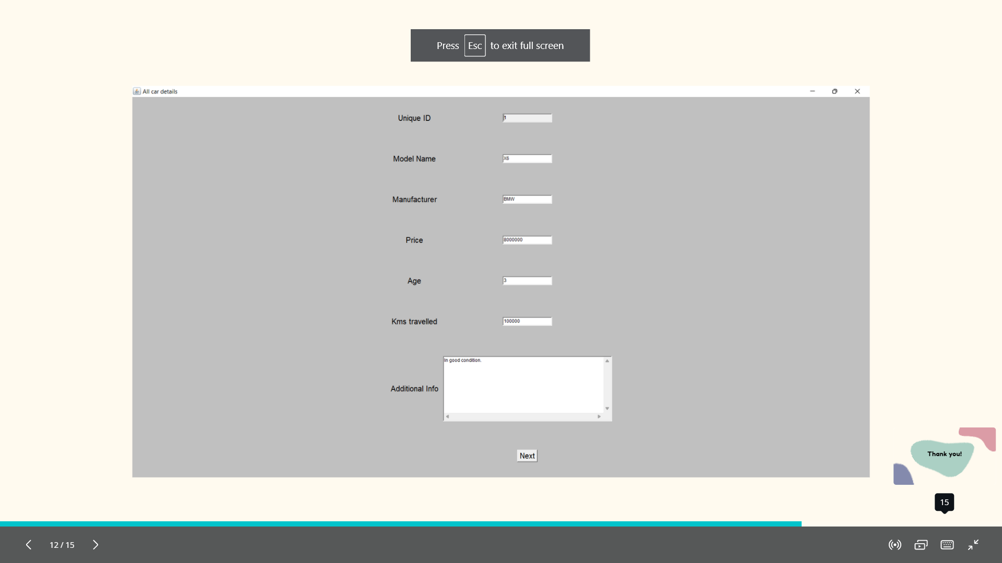

# **Conclusion**

The car sales system is a system to provide an application for managing data of a car sales shop. It consists of two major components those are Java application and MySQL database. The java application is used for providing user interfacing and another programming. On the other hand, MySQL is used for storing the data provided by the user. The system application has a graphical user interface (GUI) that helps make it even easier for the user to operate on the application. The GUI is a very simple one with a few labels, buttons, text fields, and text areas.

The car sales system can discard the hectic job of keeping and searching records and managing a car sales shop in the traditional way of paper format. With the use of this system, one can keep records and digitally manage the shop. It will not only reduce the hecticness of writing and storing data in paper format but also reduce the chances of losing data. As one can have a backup of data stored in computers regularly if the hard disk loses data, one can easily retrieve it back through its backup available on the cloud. The system also provides security for access. One can do not access the system without being authenticated user. This way it is for sure more secure than the traditional way.

# **Future Scope**

A more interactive graphical user interface can be implemented for the system. Customer details while selling a car can be taken as input from the user and be stored in the database as it can be helpful in the future. Also, the application can be added with more tasks to be performed like updating an entry. With help of data science technology, recorded information data can be analyzed to increase profit by providing a better model for the business.

# **References**

1. <https://docs.oracle.com/javase/8/docs/api/java/sql/package-summary.html>)
2. <https://www.marcobehler.com/guides/java-databases>
3. <https://www.wikihow.com/Close-a-Window-in-Java>
4. https://stackoverflow.com/questions/5258207/how-to-maximize-a-jframe-through-code