The “Extra Thumb” Brainstorming Task

We don't think this is very likely to happen, but imagine for a moment what would happen if everyone born after the year 2020 had an extra thumb on each hand. This extra thumb will be built just as the present one is, but located on the other side of the hand. It faces inward, so that it can press against the fingers, just as the regular thumb does now. Here is a picture to help you see how it looks like.

Now the question is: What practical benefits or difficulties will arise when people start having this extra thumb? You have 15 minutes to brainstorm on the question. Please consider following these brainstorming rules:

- the more ideas the better
- the wilder ideas the better
- improvement and combination of proposed ideas are sought
- do not be evaluative when generating ideas

The “Extra Eye” Brainstorming Task

We don’t think this is very likely to happen, but imagine for a moment what would happen if everyone born after the year 2020 had a single extra eye at the back of the head. This extra eye will function as same as regular eyes, but it will be located on the other side of the head, so that people may see things from the back. Here is a picture to help you see how it will be.
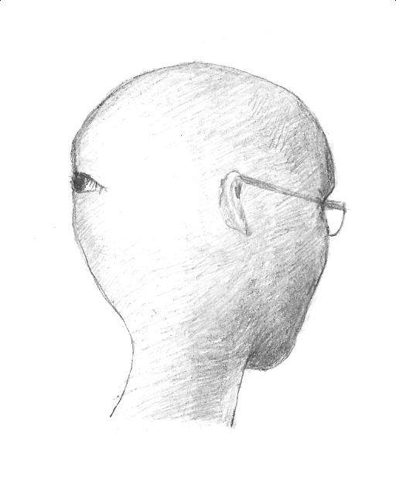

Now the question is: What practical benefits or difficulties will arise when people start having this extra eye? You have 15 minutes to brainstorm on the question. Please consider following these brainstorming rules:

- the more ideas the better
- the wilder ideas the better
- improvement and combination of proposed ideas are sought
- do not be evaluative when generating ideas

The “Having Wings” Brainstorming Task

We don’t think this is very likely to happen, but imagine for a moment what would happen if everyone born after the year 2020 had a pair of wings on the back. Here is a picture to help you see how it will be.

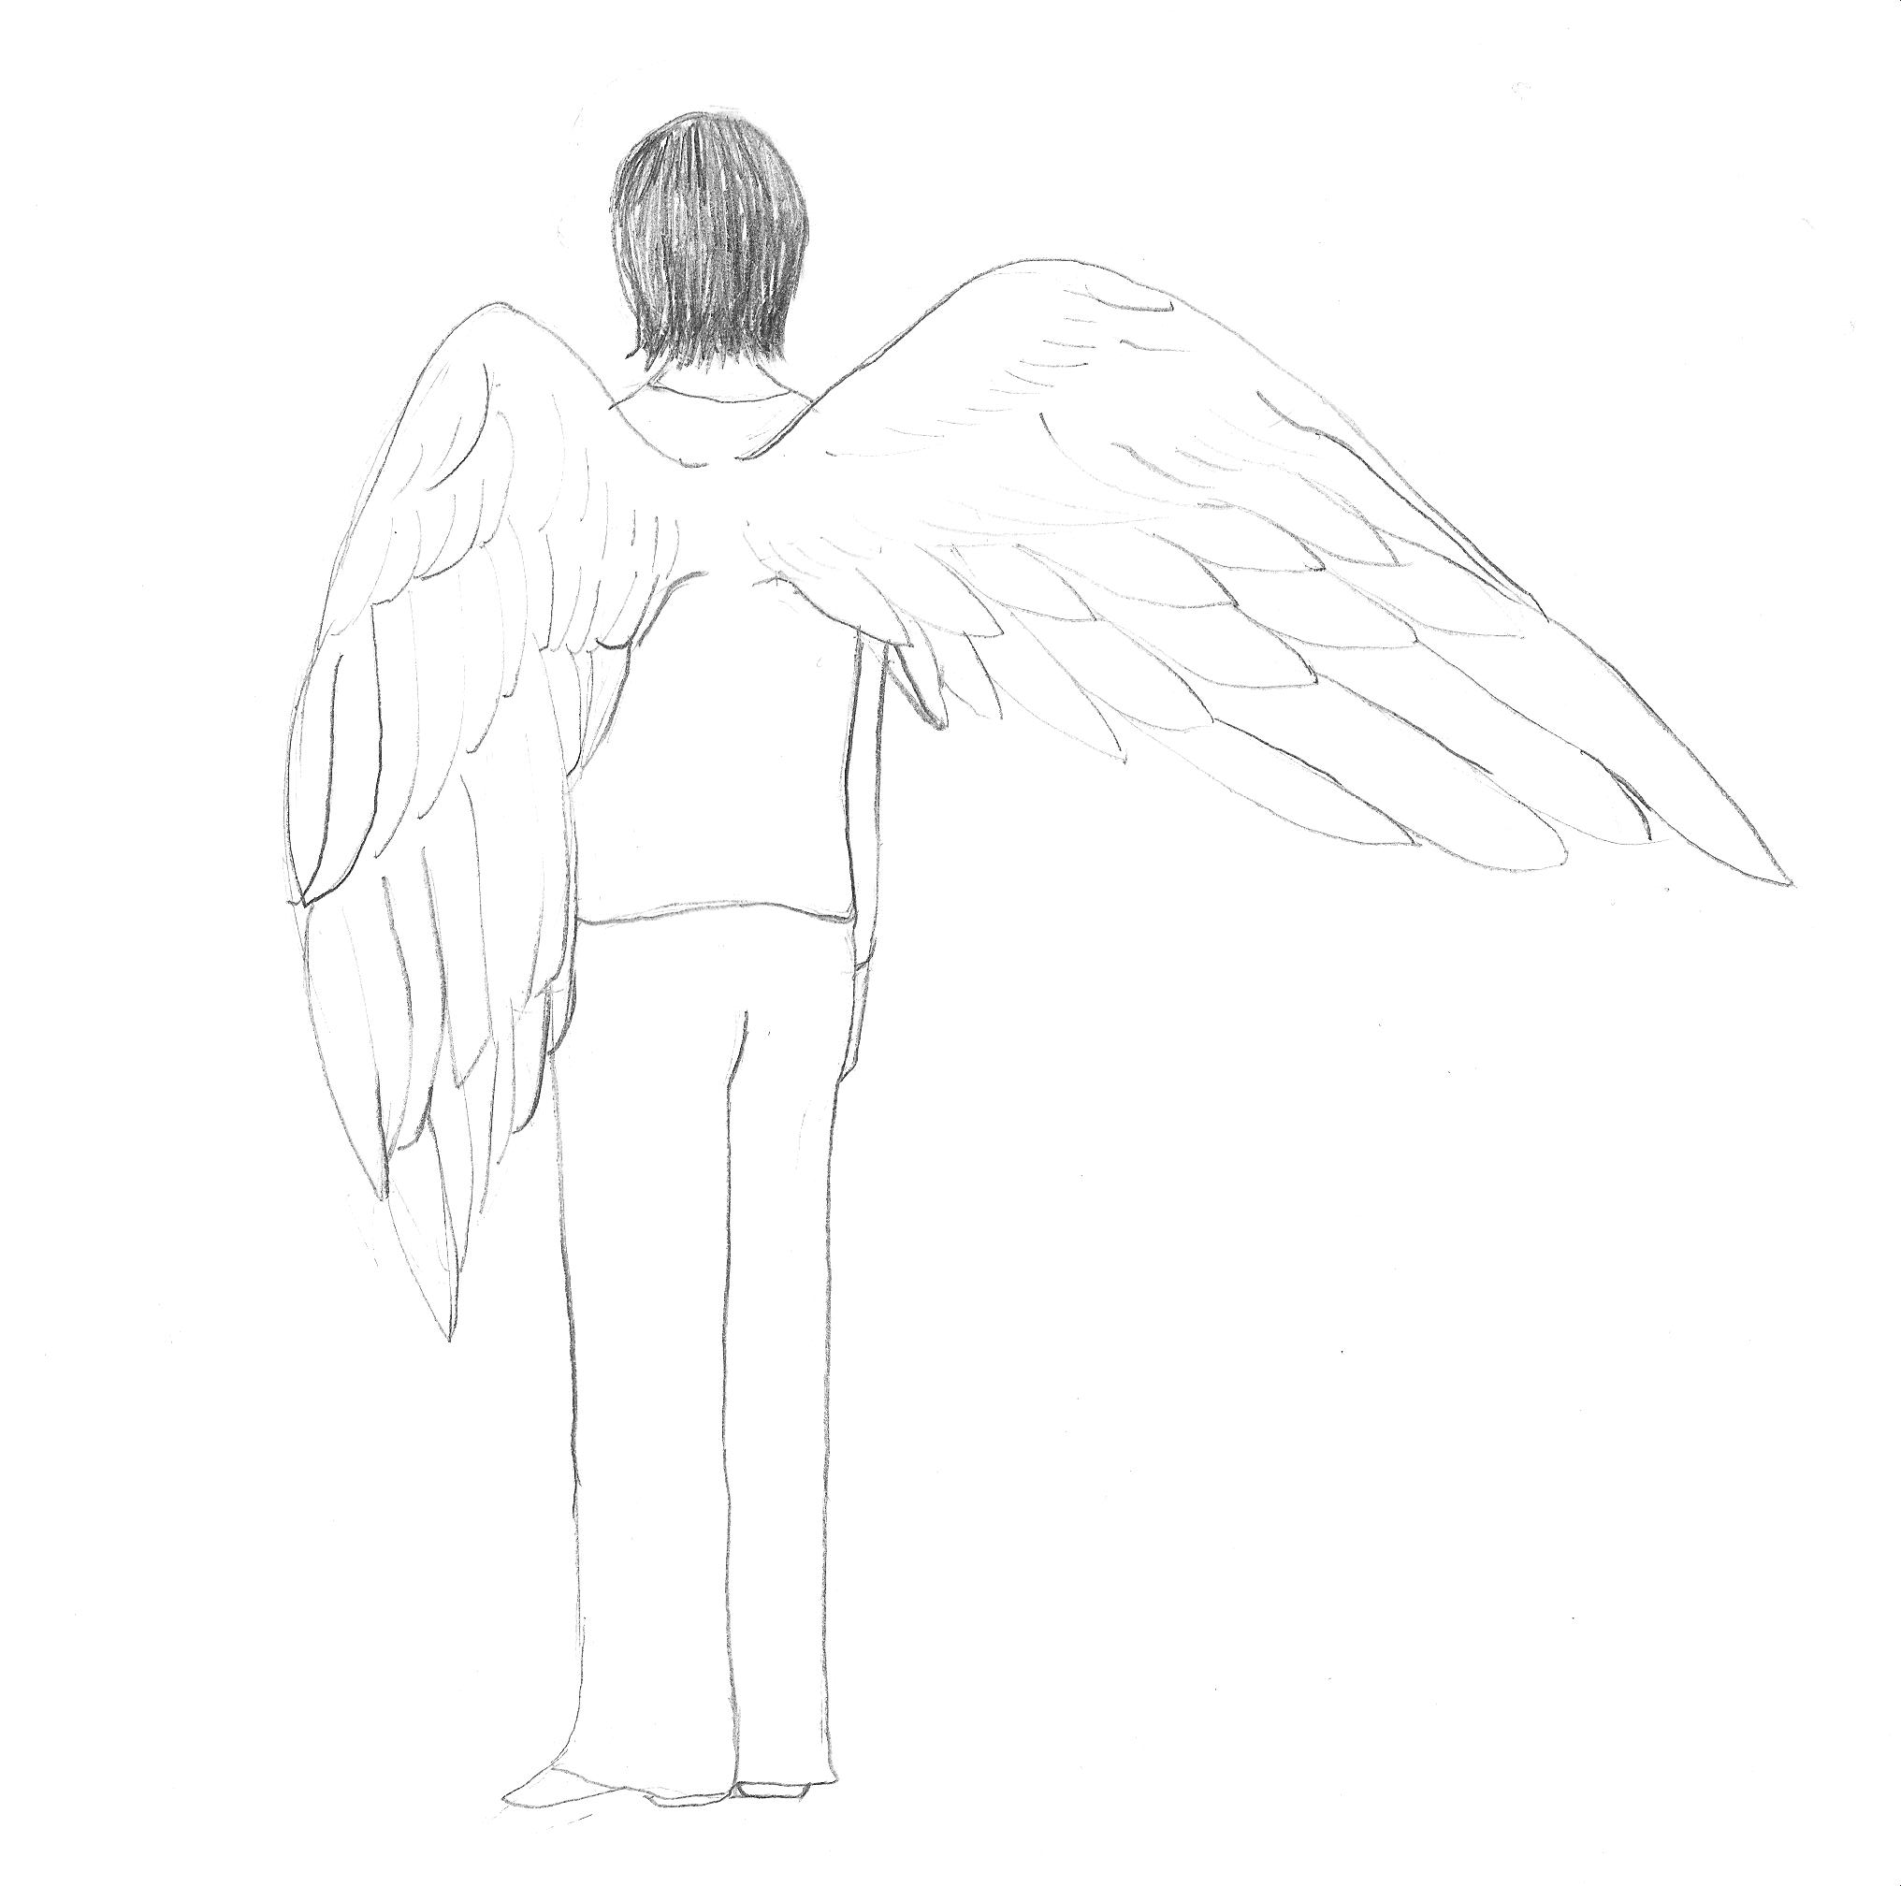

Now the question is: What practical benefits or difficulties will arise when people start having wings? You have 15 minutes to brainstorm on the question. Please consider following these brainstorming rules:

- the more ideas the better
- the wilder ideas the better
- improvement and combination of proposed ideas are sought
- do not be evaluative when generating ideas

