datahash

 bootstrap dropdown-toggle data-toggle=

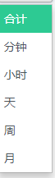 bootstrap dropdown-menu

 bootstrap icon-refresh

 icon-edit

icon-envelope

 icon-add

icon-date-picker

data-calendar-status-refresh-time

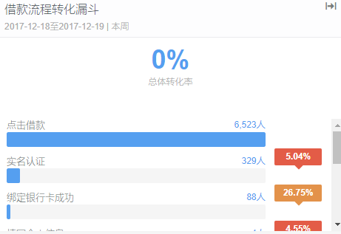dashboard-widget

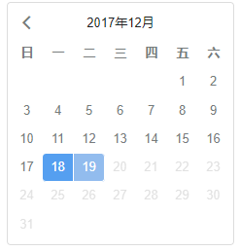 calendar

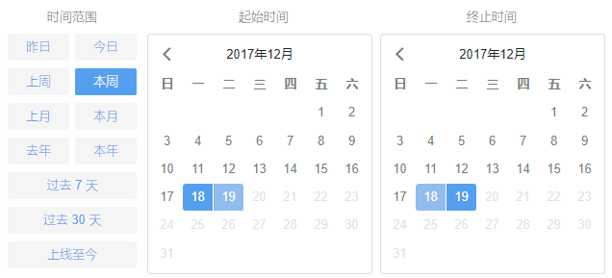daterangepicker dropdown-menu opensright show-calendar

sa-checkbox

cancelBtn applyBtn

progressbar

indicator-funnel-sec-convert

icon-date-limit

glyphicon glyphicon-trash

modal-dialog 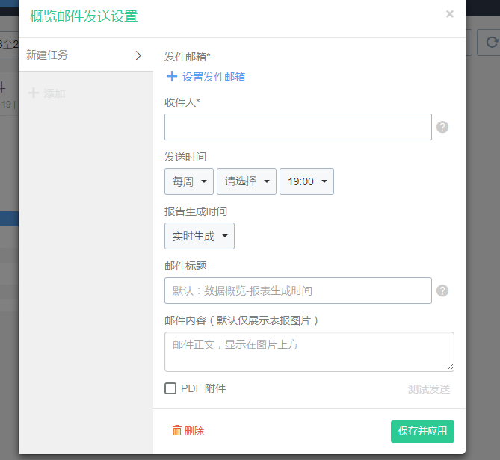

icon-help

bootstrap-tagsinput

sa-checkbox

dashboard-add-indicators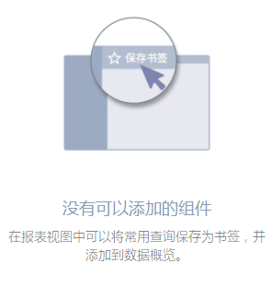

用户分群

icon-cheveron-right 

Bootstrap Form-grouphttp://www.runoob.com/bootstrap/bootstrap-forms.html

icon-card 

icon-collapse-up-single

profile-rules-add 

icon-remove 

glyphicon glyphicon-play-circle 

最后一部分

open-dialog glyphicon glyphicon-star-empty 

icon-user-property 

Echarts 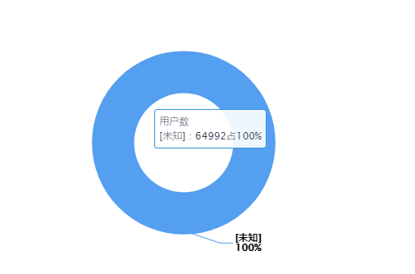

icon-search 