Lab 2

Step1:

Initial step is to choose any four services out of Time, GPS, Acceleration, Temperature, Humidity, Signal Strength, Gyroscope, Pressure, etc. As taken from the blackboard app1-app3-SensorTag which is a mixed version of first and third apps, I used the same for current application and have chosen humidity as an extra added feature.

There after edit the code as needed looking into the <http://www.ti.com/> for more info of the Sensor Tag features. Collecting the necessary information into a text file by running the service in an android device(Nexsus-7).

Save the text file on to the system.

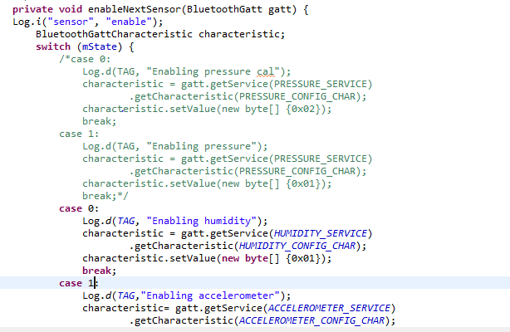

Above is obtained by uncommenting the needful lines of code.

Major functions for concentrating are

enableNextSensor --- for enabling the devices

readNextSensor—read the value