**q**

**KIET Group of Institutions, Ghaziabad**

***Computer Science and Information Technology***

**Project Report**

**on**

**TIC-TAC-TOE using C**

**SUBJECT: Data Structures using C**

**(KCS-351)**

**Submitted By:**

**SAYED OMAR AABID (2100290110149)**

**SHIV SHEKHAR (2100290110154)**

**SHIVAM YADAV (2100290110156)**

# ACKNOWLEDGEMENT

I’ve got this golden opportunity to express my kind gratitude and sincere thanks to my subject faculty **“Mr. Vinay Kumar”**, Computer Science and Information Technology Department, **KIET GROUP OF INSTITUTIONS** for their kind support and necessary counselling in the preparation of this project report. I’m also indebted to every person responsible for the making up of this project directly or indirectly.

I must also acknowledge or deep debt of gratitude each one of my colleagues who led this project come out in the way it is. It’s my hard work and untiring sincere efforts and cooperation to bring out the project work. Last but not the least, I would like to thank my parents for their sound counselling and cheerful support. They have always inspired us and kept our spirit up.

SAYED OMAR AABID (2100290110149)

SHIV SHEKHAR (2100290110154)

SHIVAM YADAV (2100290110156)

B.Tech(CSIT)

Semester: 3rd

# 

# ABSTRACT

We were doing a project "A tic tac toe game (single player)"which is invented in ancient Egypt invented by Romans. It is played by two players.

A game of tic-tac-toe using a user-defined type (Struct) for the gameboard.

The user needs to give input in form of row and column. Computers generate its random by using srand function in c which is used to generate random numbers and then using its remainder when divisible by 3 as position of 2D array.

# INDEX

|  |  |  |
| --- | --- | --- |
| S.NO. | TOPIC | PAGE NO. |
| 1. | Introduction | 5 |
| 2. | Requirement Analysis | 6 |
| 3. | Design | 7 |
| 4. | Coding Implementation | 8-15 |
| 5. | Result/Output | 16-17 |
| 6. | Reference | 18 |

# INTRODUCTION

**Problem Statement:** This is a project-based course for beginners to have knowledges about the C programming language. This project is for the students who have zero experience in the programming field. The project is replete with quizzes and exercises that help with understanding the theoretical and practical aspects of C language. We were allotted a task to make a mini project using C language with additional activities like quizzes and making daily log report

**Purpose:** This is a project-based course for beginners to have knowledges about the C programming language.

# REQUIREMENT ANALYSIS

**Functional Requirements:** No additional functional requirements required.

**Dependencies:** The program is made in C language so it will run on a code blocks compiler.

**Hardware and software requirements:** The basic will run on any working computer using any C compiler.

# DESIGN

**Methodology:** To use data structure to implement tic tac toe and display data.

**Flowchart:**

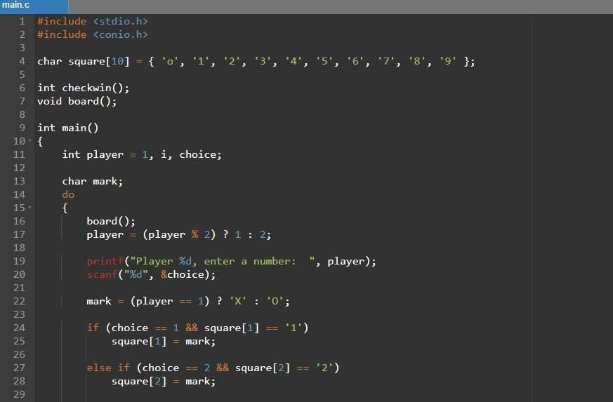**CODING AND IMPLEMENTATION**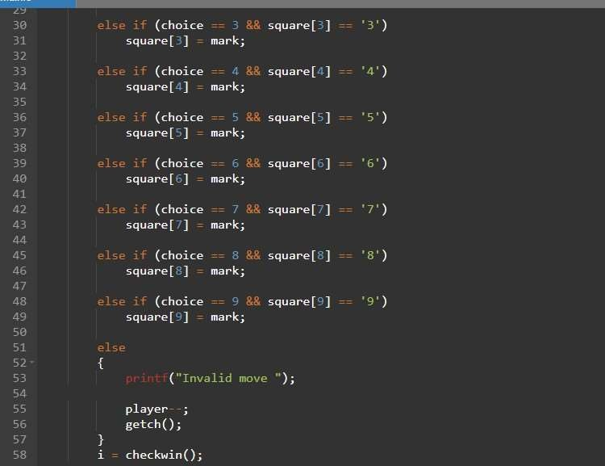

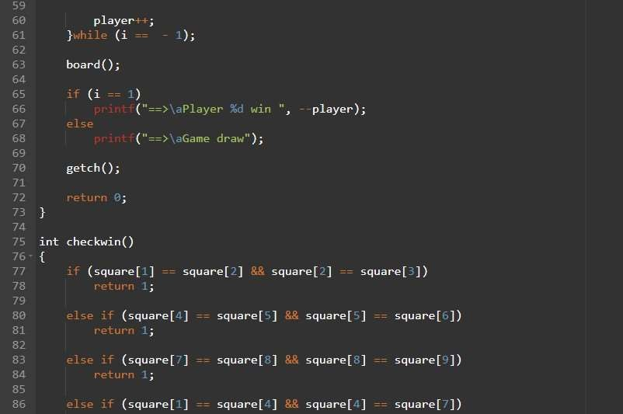

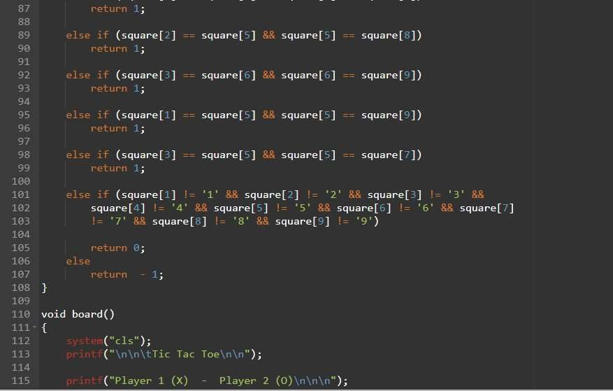

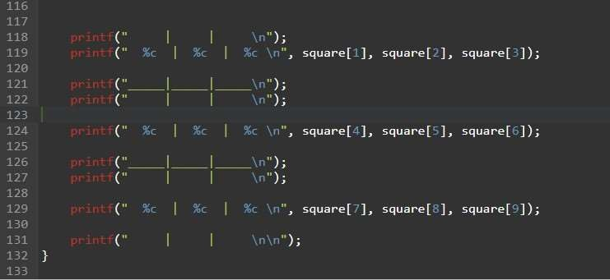

**SAMPLE OUTPUT**

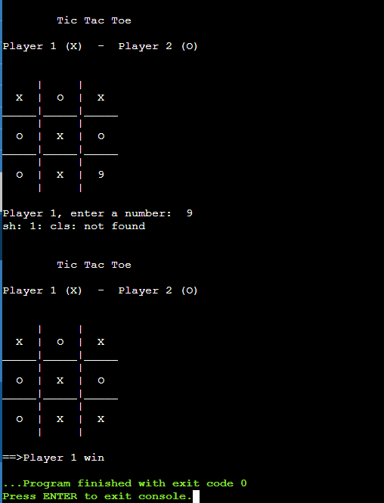

**REFERENCE**

* + - [Tic Tac Toe Code in C Programming With Source Code - 2022 (itsourcecode.com)](https://itsourcecode.com/free-projects/c-projects/tic-tac-toe-in-c-programming-with-source-code/#:~:text=A%20tic%20tac%20toe%20game%20c%20program%20first,order%20to%20make%20a%20mark%20X%20or%20O.)

**FUTURE SCOPE**

* Tic Tac Toe can be converted to a 3 player games from a 2-player game by using 3D array instead of 2D array.
* These tic-tac-toe panels improve hand-eye coordination and encourage better social interaction by better collaborative play.
* Play systems have incorporated alphabet panels and tic-tac-toe panels to help children improve their concentration