Project 2
CS 3130 – Algorithms
Connor Baniak

Array Setup:
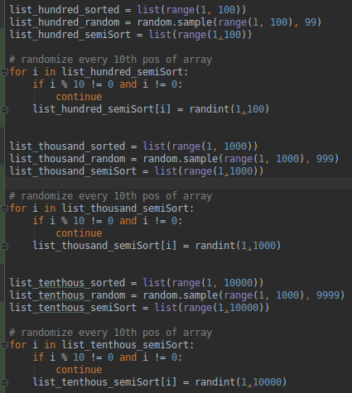
Timer Setup:
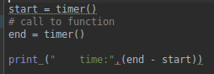

Selection Sort:
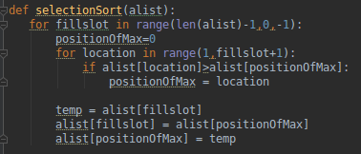
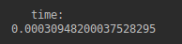
Size 100 Sorted:
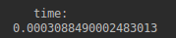
Size 100 Random:
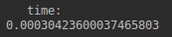
Size 100 Semi-sorted:

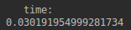
Size 1,000 Sorted:
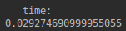
Size 1,000 Random:
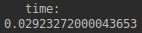
Size 1,000 Semi-sorted:

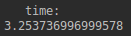
Size 10,000 Sorted:
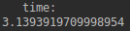
Size 10,000 Random:
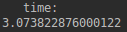
Size 10,000 Semi-sorted:

Insertion Sort:
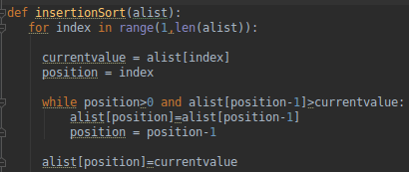
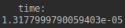
Size 100 Sorted:
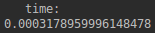
Size 100 Random:

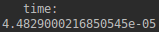
Size 100 Semi-sorted:

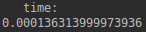
Size 1,000 Sorted:
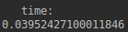
Size 1,000 Random:
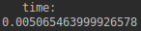
Size 1,000 Semi-sorted:

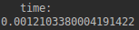
Size 10,000 Sorted:
Size 10,000 Random:
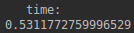
Size 10,000 Semi-sorted:

Bubble Sort w/ Swaps:
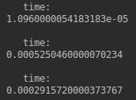
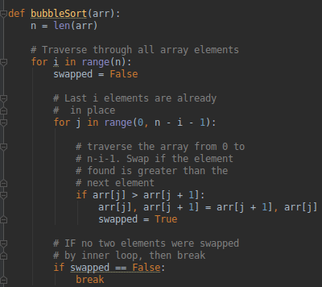

Size 100 Sorted:

Size 100 Random:

Size 100 Semi-sorted:

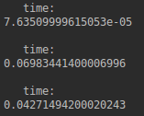
Size 1,000 Sorted:

Size 1,000 Random:

Size 1,000 Semi-sorted:

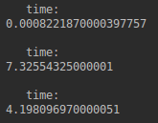
Size 10,000 Sorted:

Size 10,000 Random:

Size 10,000 Semi-sorted:

Bubble Sort w/o Swaps:
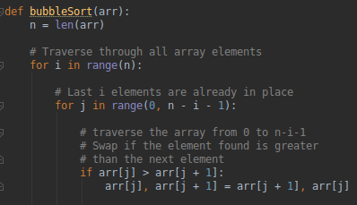
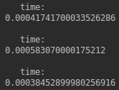
Size 100 Sorted:

Size 100 Random:

Size 100 Semi-sorted:

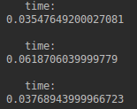
Size 1,000 Sorted:

Size 1,000 Random:

Size 1,000 Semi-sorted:

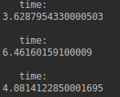
Size 10,000 Sorted:

Size 10,000 Random:

Size 10,000 Semi-sorted:

Quicksort:

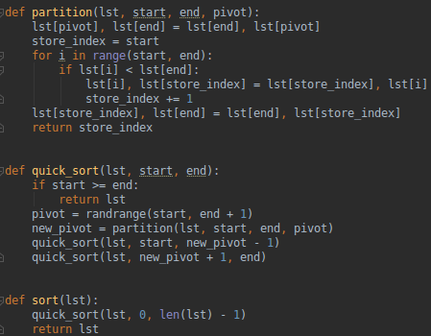
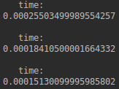
Size 100 Sorted:

Size 100 Random:

Size 100 Semi-sorted:

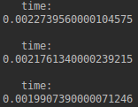
Size 1,000 Sorted:

Size 1,000 Random:

Size 1,000 Semi-sorted:

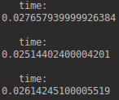
Size 10,000 Sorted:

Size 10,000 Random:

Size 10,000 Semi-sorted:

Mergesort:
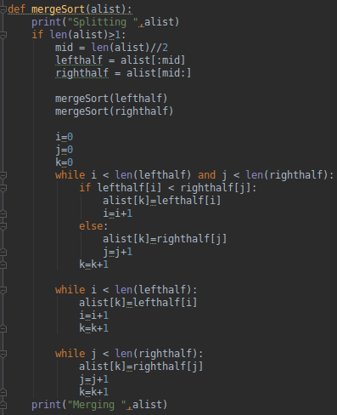
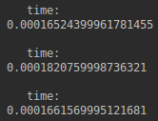
Size 100 Sorted:

Size 100 Random:

Size 100 Semi-sorted:

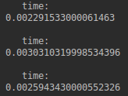
Size 1,000 Sorted:

Size 1,000 Random:

Size 1,000 Semi-sorted:

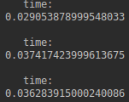
Size 10,000 Sorted:

Size 10,000 Random:

Size 10,000 Semi-sorted:

Analysis:

Graphics:

