Drew Roberts

**Solo Acoustic**

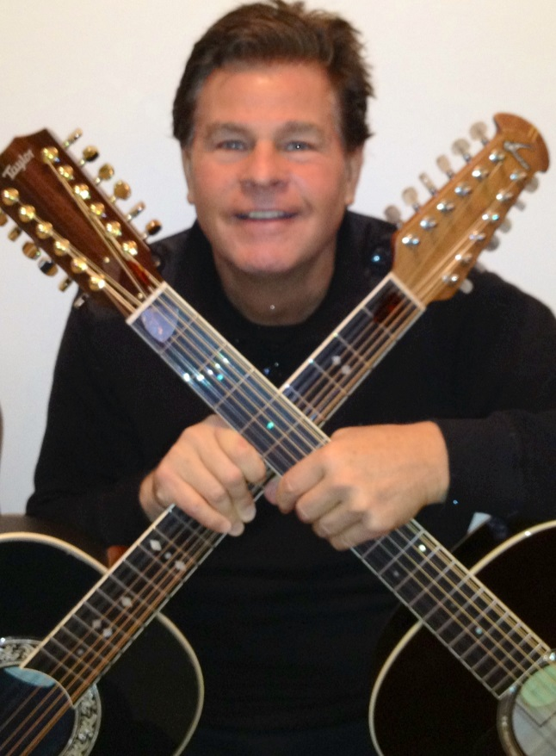

**[Date]**

**[Time]**

Enjoy the sounds and variety of 6 and 12 string guitars, warm vocals and harmonica in an eclectic mix of 60's classic songs and contemporary music. Featuring music by artists such as Eric Clapton, The Beatles, Billy Joel, The Byrds, James Taylor, Paul Simon, John Lennon, Sting, Bob Dylan, and many others.