The Fabulous Bredrock Brothers

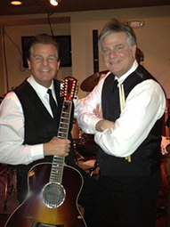

**[Date]**

**[Time]**

Enjoy the sounds and variety of a 12 string guitar, warm vocals, cocktail drums, and harmonica in and eclectic mix of classic songs and contemporary music by such artists as Eric Clapton, The Beatles, Billy Joel, The Byrds, James Taylor, Paul Simon, John Lennon, Sting, Crowded House, Bob Dylan, and many others.