The niche

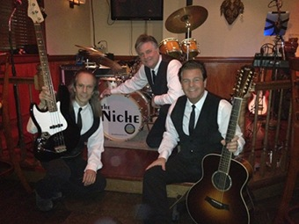

**[Date]**

**[Time]**

British and American 60's hits with a few "B" sides to keep you guessing... and yes, sometimes music from the 70's and 80's fill The Niche!