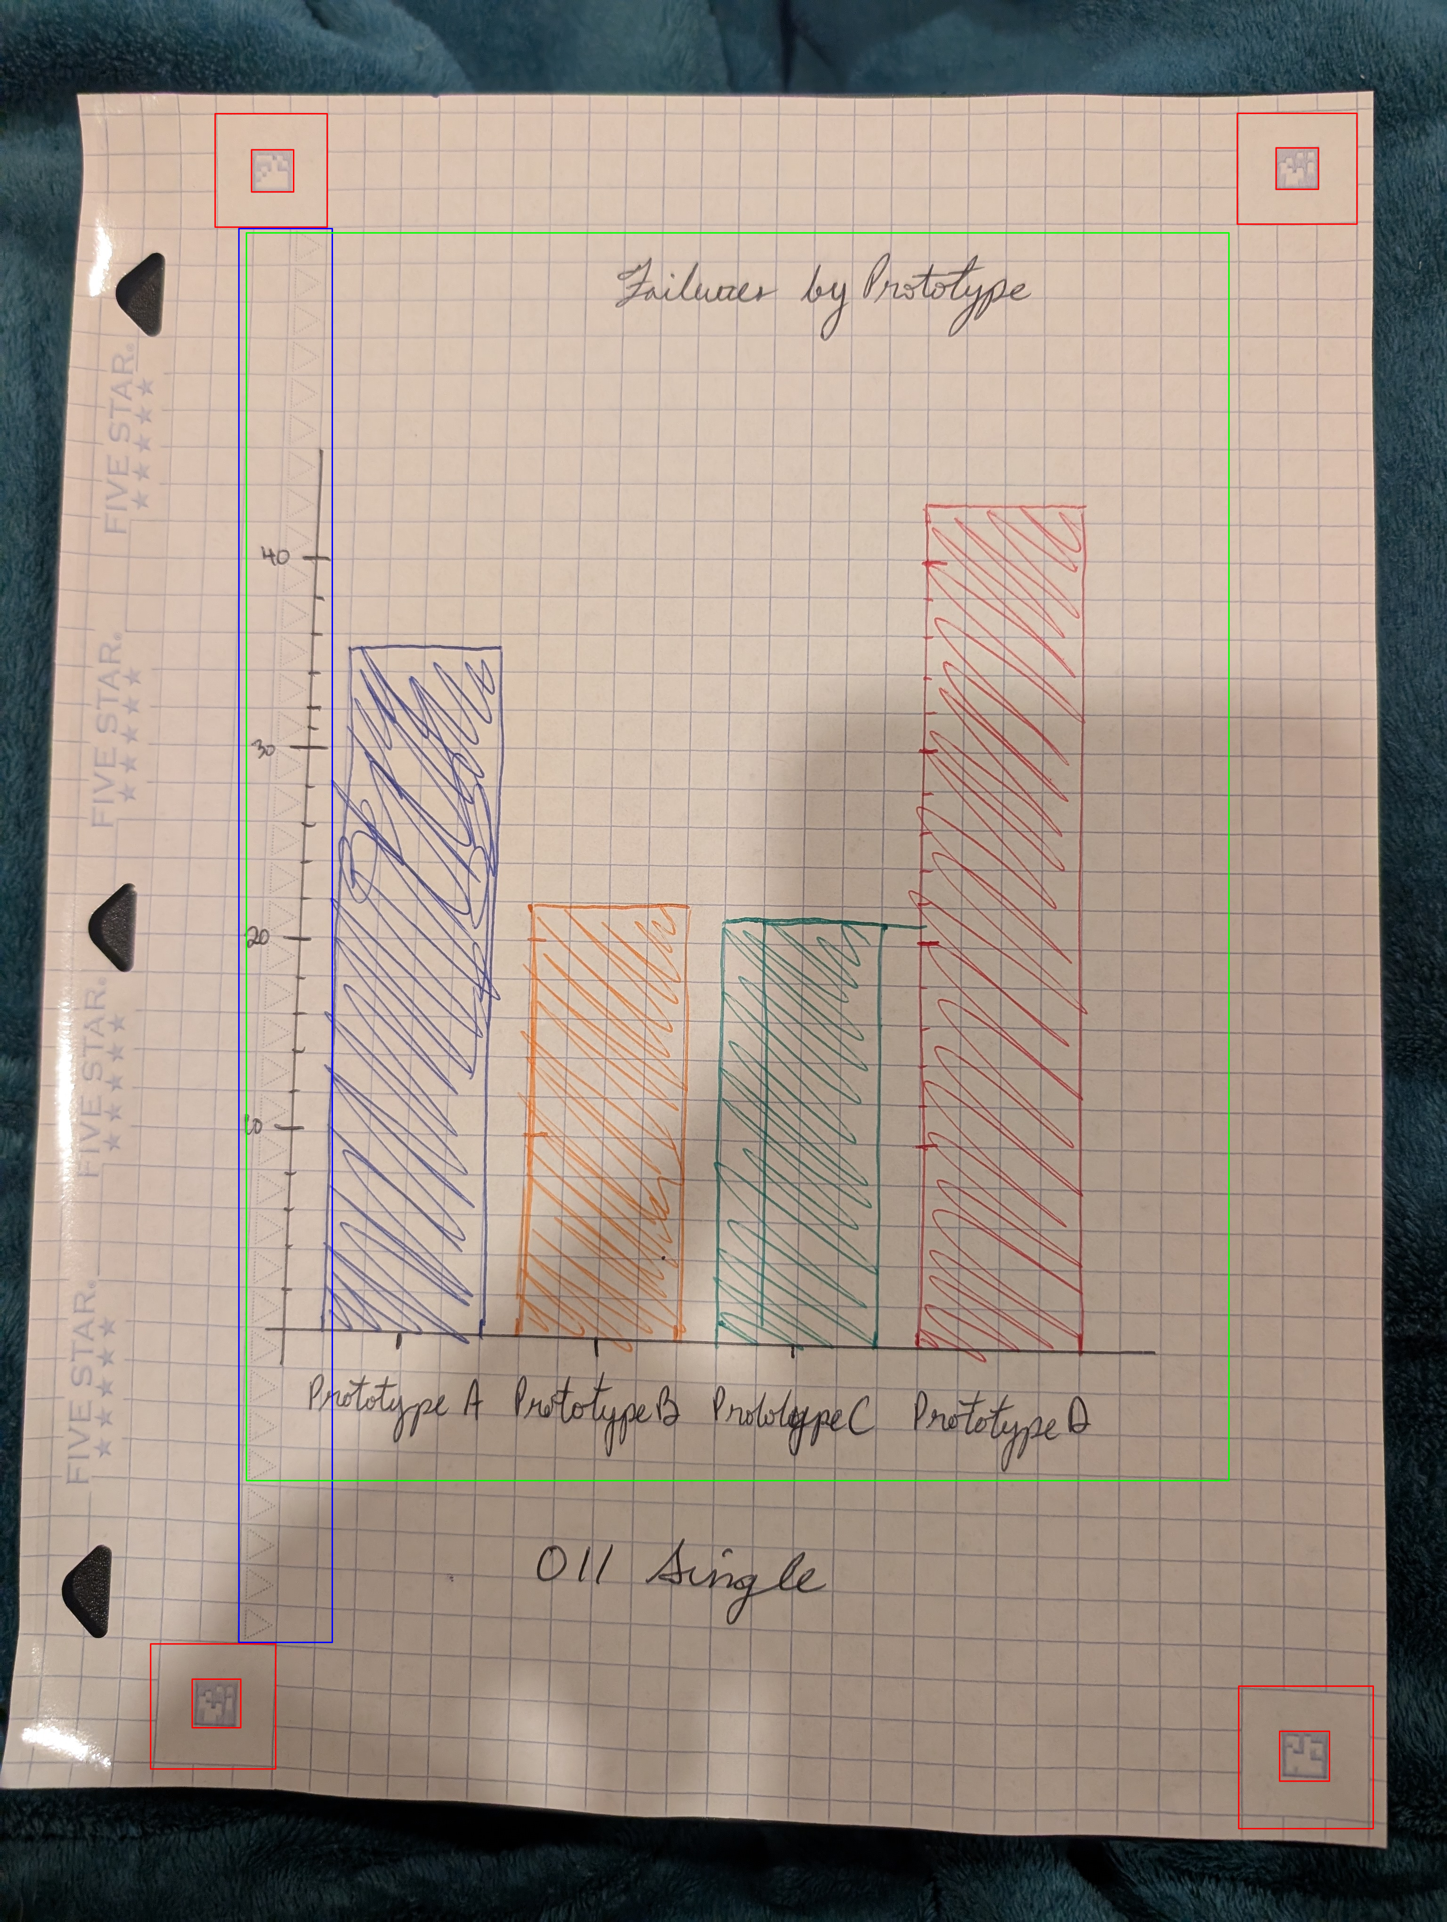
FieldChartOCR: Extraction of Handwritten Charts and Tables

0. Abstract
Handwritten charts and technical notes are rich with quantitative insight yet remain locked inside scanned pages. FieldChartOCR extends ChartOCR to converting hand-drawn charts and tables into structured datasets. The procedure goes through chart classification, element detection, and handwriting OCR, to information extraction. The focus is on delivering a practical tool that field technicians and researchers can rely on without exhaustive manual transcription.

1. Introduction
Digitizing handwritten technical notebooks is labour-intensive. Engineers, students, and analysts rely on annotations, sketches, and mixed layouts that resist automated extraction. Existing OCR tools, like ChartOCR, provide plain text at best; they ignore hand-drawn informatics in order to optimize accuracy. On the other hand, professionals (such as field technicians) must manually re-create charts in tools such as Excel, Desmos, or CAD systems—a significant barrier to iteration and collaboration.
The goal of FieldChartOCR is to build a unified pipeline that ingests handwritten graphs, tables, and mechanical annotations and produces structured artifacts suitable for analytics and visualization. By coupling deep learning with rule-based reasoning, I hope to generalize across chart families while maintaining transparency in intermediate outputs. Delivering this capability advances document understanding, accelerates knowledge sharing, and supports accessibility by providing machine-readable alternatives to complex figures.

2. Related Work
- Chart Understanding Frameworks: ChartOCR’s hybrid keypoint-and-rule architecture demonstrates the effectiveness of combining deep detection with domain logic. ChartSense and ReVision apply rule-based heuristics but struggle with diverse layouts. DVQA and FigureQA focus on question answering but assume neatly rendered charts.
- Diagram & Table Recognition: DiagramParseNet and other graph-parsing models detect nodes and edges in structured diagrams. DeepDeSRT and PubTabNet handle printed tables yet rely on sharp lines and consistent fonts, unlike the irregular strokes in hand-drawn notes.
- Handwriting OCR & Math Recognition: Transformer-based handwriting recognizers and MathOCR systems convert cursive and symbolic notation into LaTeX. They typically operate on grayscale inputs and overlook complex layouts.
- Document Normalization & Imaging: Research on illumination correction and phase-based representations inspires our preprocessing layer. Multispectral imaging studies inform our roadmap for future sensing modalities.

3. Proposed Work

3.1 Data Sources
- handwritten bar chart diagrams
- synthesized datasets in comma separated lists
- bar charts generated with matplotlib

3.2 System Architecture
- Preprocessing & Layout Normalization
  - Perform denoising, skew correction, grid suppression, and edge enhancement tailored to notebook paper.
  - Standardize contrast and dynamic range to support downstream detectors.
  - Note: I may move to scanning the images if this part proves too onerous.
- Chart Type Classification
  - Lightweight CNN-transformer hybrid predicts dominant chart categories for each region.
    - The goal is to match the 3 charts recognized by ChartOCR: bar charts, line charts, and pie charts.
  - Supports mixed-content pages by assigning probabilities per region.
- Element Identification & OCR
  - Shared detection backbone with heads for axes, scales, titles, data marks, and table structure.
- Semantic Assembly & Output
  - Associates text blocks with detected elements, enforces basic geometric constraints, and exports Markdown summaries plus CSV datasets.

3.3 Development Plan
- Phase 1: Build preprocessing pipeline, layout normalization, and table-to-CSV baseline.
- Phase 2: Train chart classifier and core element detectors; integrate handwriting OCR.
- Phase 3: Finalize semantic assembly, polish outputs, and iterate on error analysis.

4. Evaluation Plan
- Effectiveness Metrics
  - Chart classification macro-F1 across core categories (bar, line, scatter, tables).
  - Element detection precision/recall for axes, titles, and data marks.
  - OCR character error rate (CER) and table reconstruction F1.
- Efficiency Metrics
  - End-to-end runtime per page and memory footprint.
- Experimental Setup
  - Stratified train/validation/test split by chart type and handwriting style.
  - Baselines: ChartOCR, generic OCR plus heuristic extraction, and manual transcription samples.
  - Ablations on preprocessing and semantic assembly.

5. Timeline & Milestones
Phase | Milestone
1 | Finalize annotation schema, label initial dataset.
2 | Implement normalization prototype, integrate baseline handwriting OCR and chart classifier; evaluate on sample pages. (CURRENT)
3 | Deploy element detectors and table recognizer; stand up Markdown/CSV writers.
4 | Iterate on semantic assembly, run core evaluations, and prepare presentation materials.

Current progress: synthesized dataset, building dataset for QC square recognition using GIMP commandline.

6. Risks and Mitigation
- Limited Hand-Drawn Training Data
  - Mitigation: remove the information extraction steps and keep only the classification.
- Complex Page Layouts
  - Mitigation: flag difficult cases for human review.
- Lighting Noise
  - Mitigation: use normalization targets, augment brightness/contrast, and monitor detector confidence.

7. Conclusion and Future Work
Currently, FieldChartOCR is stuck in the early stages of OCR work. The page corner detection requires more fine-tuning to become robust. On an ideal sample photo, 4 corners are detected and the image can be cropped. However, average case scenarios where 1 or more corners are not detected proves difficult to remedy. I am improving the corner detection function by augmenting samples of the QC squares with computer-edited samples.

References
1. Liu, X., Chen, L., Wei, Y., Luo, Y., Zhang, H., & Zhou, S. (2021). ChartOCR: Data extraction from chart images via a deep hybrid framework. WACV 2021. https://openaccess.thecvf.com/content/WACV2021/papers/Luo_ChartOCR_Data_Extraction_From_Charts_Images_via_a_Deep_Hybrid_WACV_2021_paper.pdf
2. Savva, M., Kong, N., Chhoun, C., Agrawala, M., & Heer, J. (2011). ReVision: Automated classification, analysis, and redesign of chart images. UIST ’11, 393–402. https://doi.org/10.1145/2047196.2047247
3. Jung, D., Kim, W., Song, H., Hwang, J.-I., Lee, B., Kim, B., & Seo, J. (2017). ChartSense: Interactive data extraction from chart images. CHI ’17, 6706–6717. https://www.microsoft.com/en-us/research/wp-content/uploads/2017/02/ChartSense-CHI2017.pdf
4. Rowtula, V., Oota, S. R., & Jawahar, C. V. (2019). Towards automated evaluation of handwritten assessments. (Conference details unavailable). https://cvit.iiit.ac.in/images/ConferencePapers/2019/PID6008523.pdf
5. Huang, K.-H., Chan, H. P., Fung, Y. R., Qiu, H., Zhou, M., Joty, S., Chang, S.-F., & Ji, H. (2024). From pixels to insights: A survey on automatic chart understanding in the era of large foundation models. IEEE Transactions on Knowledge and Data Engineering. https://arxiv.org/pdf/2403.12027v4
6. Li, Z., et al. (2024). Improving handwritten mathematical expression recognition via integrating convolutional neural network with transformer and diffusion-based data augmentation. IEEE Access. https://www.researchgate.net/publication/380548640_Improving_Handwritten_Mathematical_Expression_Recognition_via_Integrating_Convolutional_Neural_Network_with_Transformer_and_Diffusion-Based_Data_Augmentation

Appendices
A1: Bar Chart Examples
A2: Page Normalization
A3: Custom Page Types and Features
A4: Example of Custom Anti-Cheat Paper

