OMNI Paper 2 Sandbox
Visual Results Report: Topological Archetypes v1.0
This report is written as an interpretive companion to the Topological Archetype Atlas. It focuses on what the results appear to be showing, rather than on the mechanics of the ranking engine.

1. What This Report Shows
The purpose of this report is simple: to make the results visible. The earlier ranking system identified the strongest aspect features, but it did not by itself show how the high-scoring, low-scoring, big-home-win, and gutting-home-loss lines actually behaved across the 360-degree field. The present visual package converts those ranked features into topology maps.
In plain language, each visual asks: as this aspect feature moves around the circle, where does one outcome become more common, where does the opposite outcome become more common, and where do the two regimes fight for dominance?

2. The HS/LS Story
The Top 10 HS/LS features do not behave like simple one-way indicators. They behave like antagonistic fields. In other words, the same feature can contain both run-expansion zones and run-suppression zones, depending on where the directed separation falls on the 360-degree circle.
The first ranked HS/LS feature in this atlas is Asc_x_VS_G-AZ. Its HS peak occurred at 260° with lift 1.294, while its LS peak occurred at 296° with lift 1.203. The two lines crossed 72 times, which is why this feature is best understood as a dynamic field rather than a single static signal.
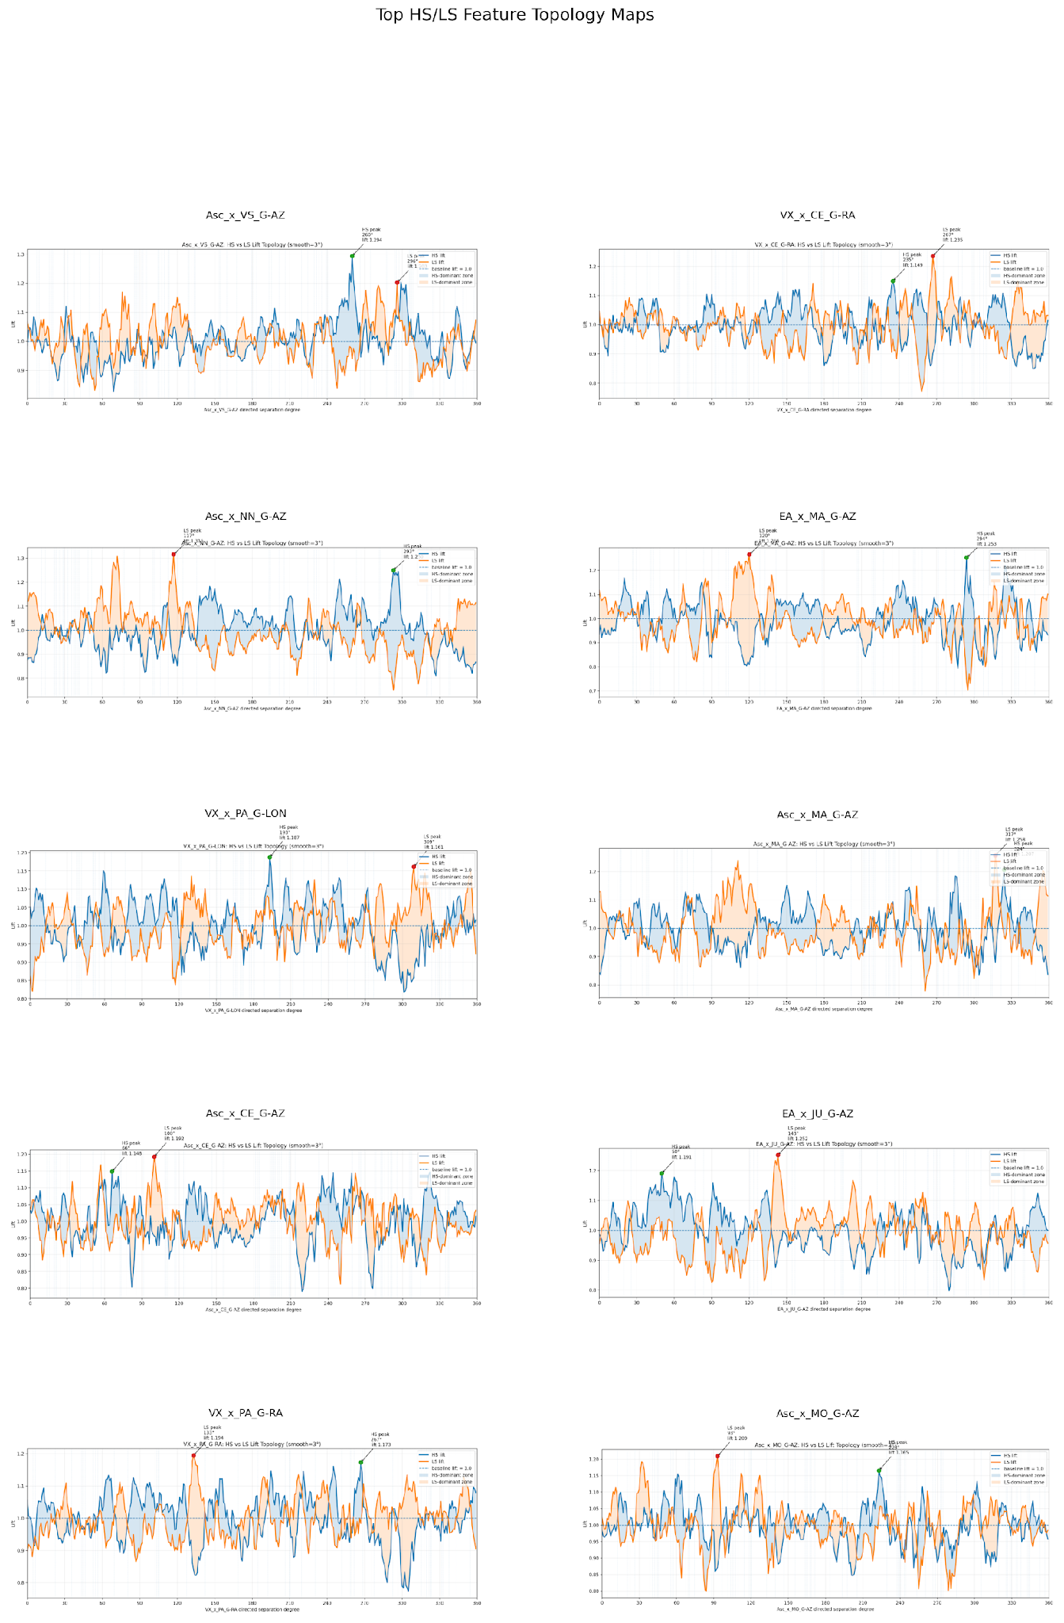
Figure 1. Contact sheet of the Top 10 HS/LS topology maps. Each panel shows a feature’s high-scoring and low-scoring lift curves across the 360-degree field.
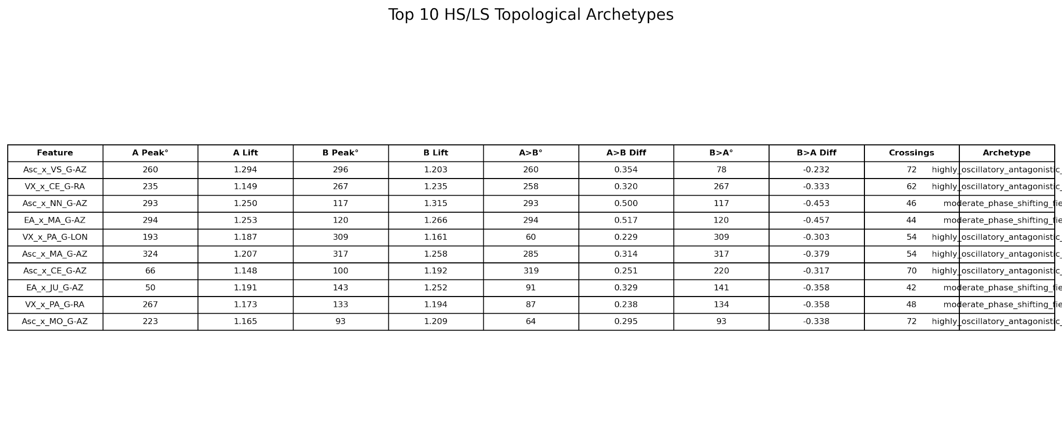
Figure 2. Summary table for the Top 10 HS/LS topology features.
The strongest HS-over-LS zone among the Top 10 HS/LS features occurred in EA_x_MA_G-AZ at 294°, with a differential of 0.517. The strongest LS-over-HS zone occurred in EA_x_MA_G-AZ at 120°, with a differential of -0.457.
The key interpretive point is that HS and LS are not simply opposites in a general sense. They occupy alternating local regions. A feature can become HS-dominant in one angular zone, LS-dominant in another, and unstable or contested in the transition regions between them.

3. The BHW/GHL Story
The margin-polarity results are even more dramatic. The BHW/GHL topology maps compare Big Home Wins against Gutting Home Losses. These are not total run outcomes; they are outcome-polarity states. This makes them especially important because they may reflect a different kind of field behavior than ordinary scoring volatility.
The first ranked BHW/GHL feature is EA_x_CE_G-AZ. Its BHW peak occurred at 238° with lift 1.362, while its GHL peak occurred at 46° with lift 1.184. The two lines crossed 66 times.
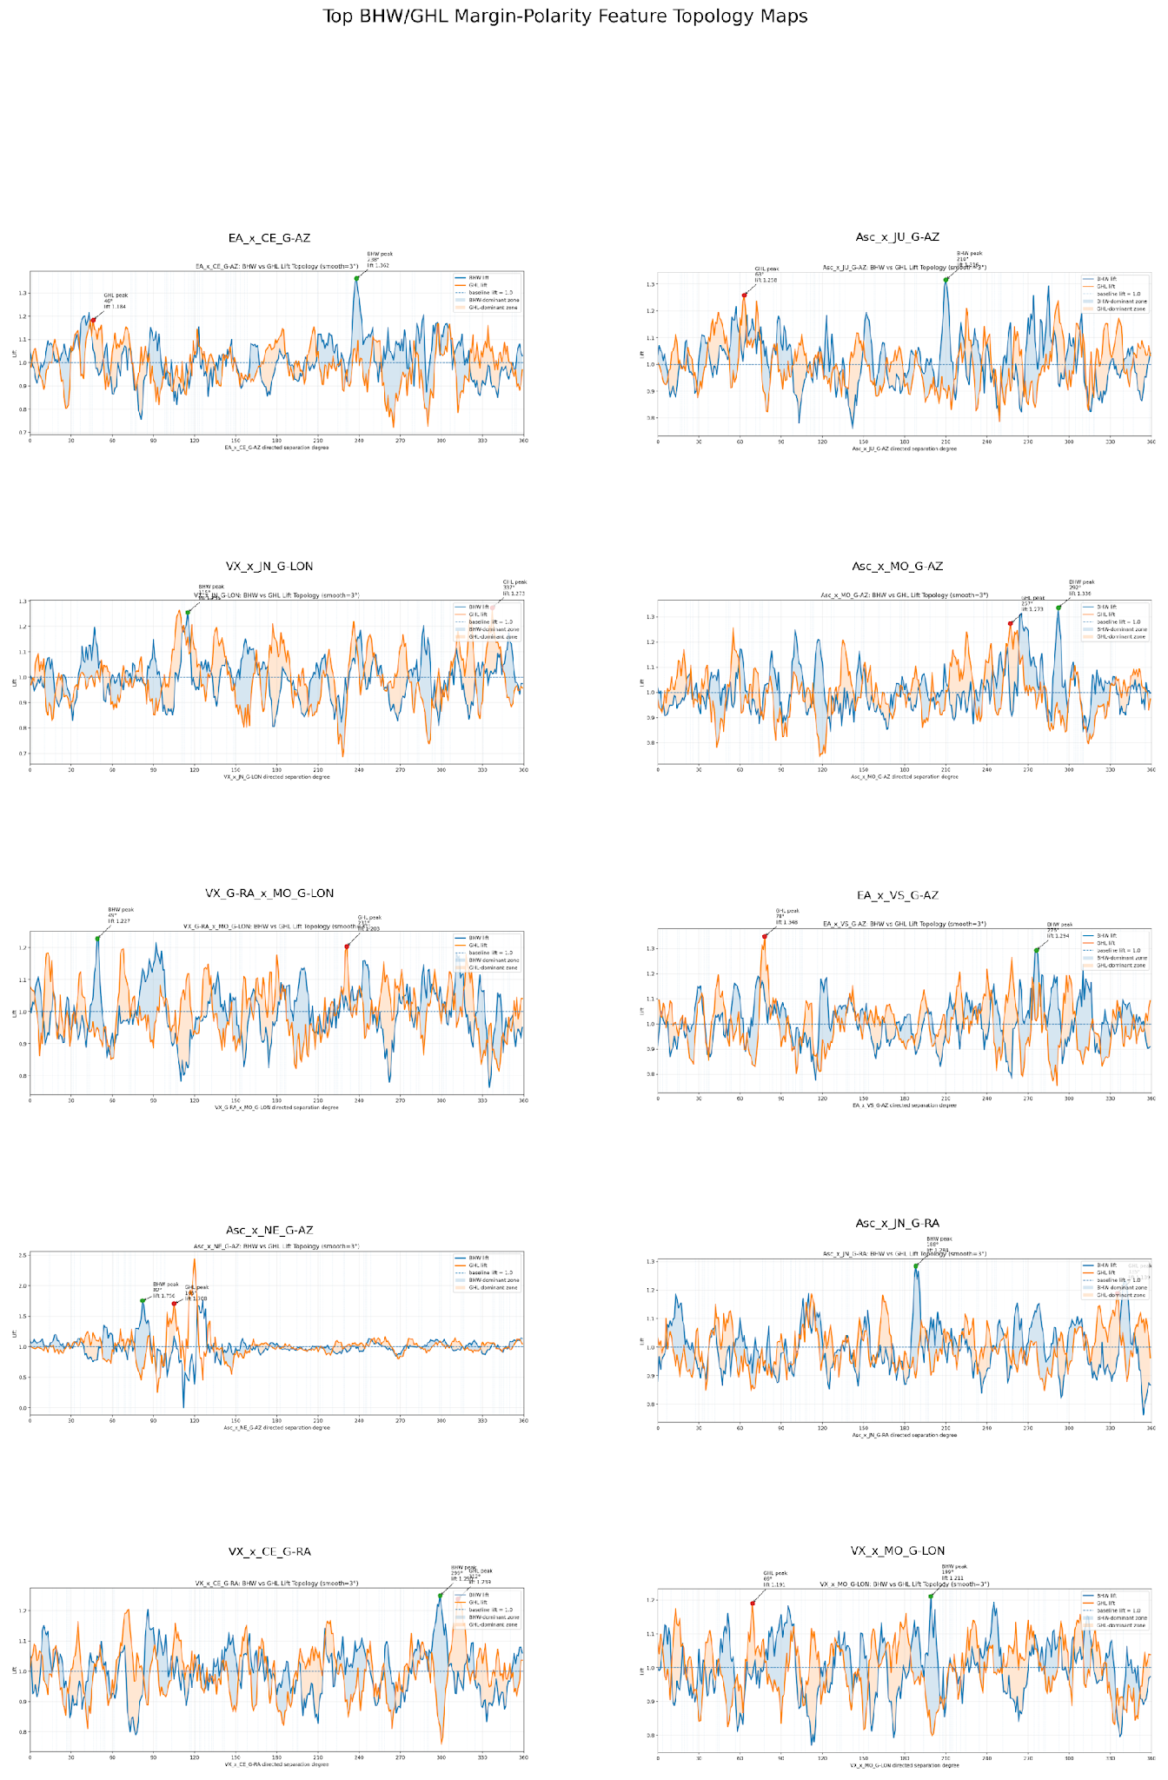
Figure 3. Contact sheet of the Top 10 BHW/GHL topology maps. These maps show margin-polarity fields: big home-win dominance versus gutting home-loss dominance.
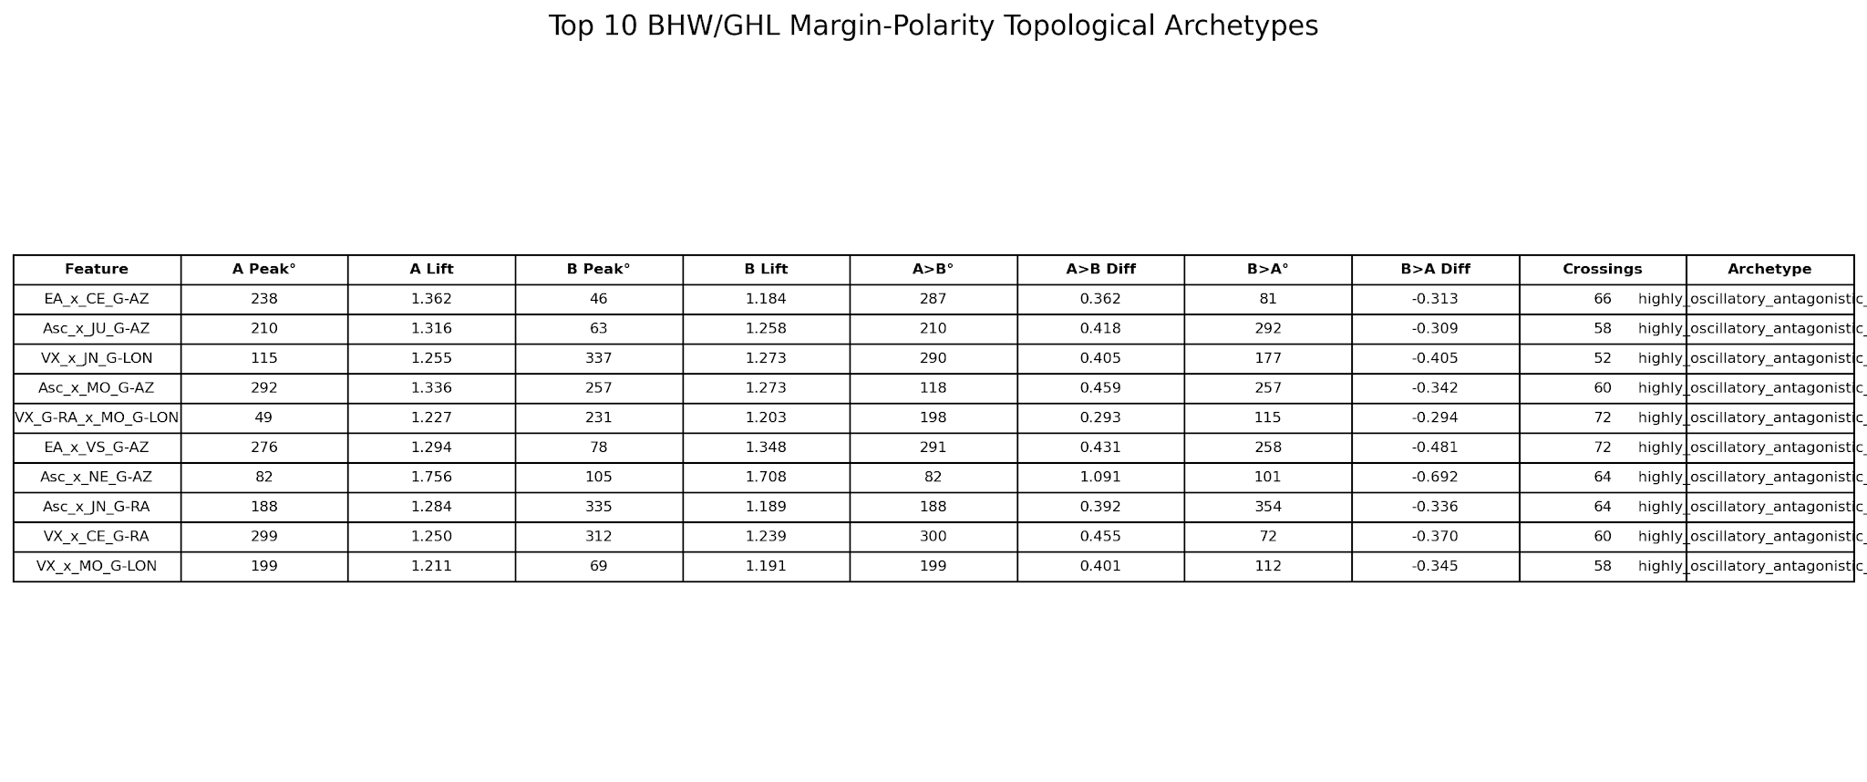
Figure 4. Summary table for the Top 10 BHW/GHL topology features.
The strongest BHW-over-GHL zone among the Top 10 margin-polarity features occurred in Asc_x_NE_G-AZ at 82°, with a differential of 1.091. The strongest GHL-over-BHW zone occurred in Asc_x_NE_G-AZ at 101°, with a differential of -0.692.
The BHW/GHL fields appear sharper and more violently polarized than the HS/LS fields. This suggests that margin polarity may be governed by more abrupt regime switching than total scoring alone.

4. What the Results Are Telling Us
The strongest conclusion from this visual phase is that the aspect features are not acting like simple yes/no indicators. They are acting like structured fields. The same feature can contain multiple behavioral regions: expansion ridges, suppression basins, transition boundaries, and contested corridors.
This is why the project can no longer be interpreted as simply asking whether a body is high-scoring or low-scoring. The body is not the whole message. The local geometry is the message. A planet or point may participate in many different regimes depending on where the angular separation falls.
The recurring phrase for this pattern is antagonistic regime topology. That means the geometry repeatedly alternates between competing outcome regimes around the circle. In HS/LS, the competition is between scoring expansion and scoring suppression. In BHW/GHL, the competition is between home-team dominance and home-team collapse.
This may be one of the most important conceptual developments in the OMNI project so far. The results are pushing the research away from simple symbolic astrology and toward a field-topology model of planetary influence.

5. Where To Look First
Start with Figure 1. Look at the Top 10 HS/LS maps. Do not try to memorize the numbers. Look for the way the lines cross, separate, and rejoin. Those crossings are the transition zones.
Then look at Figure 3. Compare the BHW/GHL maps with the HS/LS maps. The margin-polarity maps appear more extreme. This may mean that big emotional outcomes — blowout home wins and painful home losses — occupy a sharper geometric regime than ordinary high-versus-low scoring.
Finally, use Figures 2 and 4 as lookup tables. They tell you which features produced the strongest peaks, strongest dominance differentials, and highest crossing counts.

6. Next Step
The immediate next step is not machine learning. The immediate next step is interpretive cartography: reading the maps, identifying repeated field shapes, and naming the topology families that recur across different planetary pairs.
Once these topology families are understood, they can be converted into engineered features for Paper 2. But that should happen only after the visual behavior of the fields has been studied carefully.

