OMNI Geometry MLB — Paper 2 Exploratory Sandbox
Tier 1 Feature Separation Audit: Methods, Results, and Implications
Operational angular resolution of aspect features at MLB scheduling scale
Courtney Roberts Conrad · 28 May 2026 · Exploratory analysis (Charter §1) · Master SHA-256 e5a6bad6…ccdd1 · Report v1.1

1. Purpose
The audit answers, empirically and per feature, a question the project had previously treated implicitly: how much does each angular-separation feature differ between games that occur on the same MLB slate and start close together in real time, and how rapidly does it change as the start-time gap widens? The answer fixes the operational angular resolution at which each feature can discriminate among same-slate games — which in turn governs both the smoothing used in analysis and the way each feature should be engineered for the Paper 2 predictive model.

2. Method
Substrate: the locked Phase 1 per-event feature files, restricted to the 46,152 exploratory-partition events across 3,808 game-dates (the 952 confirmatory game-dates are withheld under the Charter §3 seal). The audit is outcome-blind — no game-outcome label is read — so it does not consume the confirmatory hold-out's inferential budget.
Timing: true UTC start instants (Game_DateTime_UTC) from the combined-positions master, joined to the per-event files by verified row order (zero date mismatches across all 57,635 events). UTC is required rather than local clock time because same-date games in different time zones start hours apart in reality; binning on UTC elapsed time makes “near-concurrent” genuinely near-concurrent and absorbs the same-region intuition automatically.
For each (origin × body × frame) feature, all within-slate game pairs are formed; for each pair the circular separation of the integer-quantized degree values and the UTC start-time gap Δt are computed. Pairs are binned by Δt (≤15, 15–30, 30–45, 45–90, 90–180, 180–360, >360 min). Reported metrics: near-concurrent (≤45 min) median and P90 separation — the same-slate discrimination floor; velocity_robust, the median separation divided by the median Δt within the 45–90 min bin (°/hr); and between-date drift (°/day) for the slow zodiacal timescale.
Scope: G-AZ is audited for all bodies, since diurnal motion moves every body in azimuth; G-LON and G-RA are restricted to features touching a fast point (Asc, MC, VX, EA, Moon), since a separation between two slow bodies is static within a day. The run covered 741 valid per-event files, with 80,481 near-concurrent (≤45 min) game pairs per feature.

3. Results

3.1 Two engineering classes
Features separate cleanly into two operational classes (Figure 1, Table 1). Same-slate discriminators show a near-concurrent median separation of at least 5°: same-slate games already differ enough in the feature to potentially occupy different regions of the lift surface. Slow-contextual fields show a near-concurrent median of approximately 0° (P90 ≤ 1°), i.e. below the engine's 1° quantization — near-concurrent games are indistinguishable in the feature, which can therefore carry only between-day or seasonal information.

3.2 Frame behaviour is body-dependent, not universal
For body × body features (Moon- or Mercury-origin), G-AZ is the only frame with same-slate variation (≈3° median, from diurnal motion), while G-LON and G-RA are flat within a slate (0°). For the four angles (Asc, MC, VX, EA), every frame is a same-slate frame (5–6°), because each angle sweeps the full circle daily in longitude and right ascension as well as azimuth. There is therefore no global rule that “G-AZ is the fast frame”; operational scale must be assigned per feature, which is what the audit does.

3.3 Angle-dominated spread; the body supplies the offset, not the spread
Within the angle-origin features, near-concurrent separation is essentially independent of the target body: every Asc × body G-LON feature reads ~5° at ~5°/hr regardless of body, and the Vertex set is uniformly ~6°. The angle's own motion dominates; the body barely moves over 45 minutes. The body still matters — through the constant offset that determines which part of the lift surface a slate occupies — but not through the same-slate spread. The consequence for Paper 2 is that the same-slate-varying component of angle × body features is collinear across bodies and should not be treated as independent same-slate signal.

3.4 The frame-velocity ordering flips; cross-coordinate constructions can erase discrimination
The Ascendant moves faster in ecliptic longitude (~5° per slate) than in its bounded azimuth arc (~2° per slate) — the reverse of the body × body ordering. Cross-coordinate constructions that pair an angle's slow component with a body's slow component (for example Asc G-AZ × Moon G-LON, ~2°) are slow-contextual despite involving a fast angle. The Part of Fortune shows the same logic in a different guise: Asc × Part-of-Fortune is slow-contextual (~0°) because the Part of Fortune is defined from the Ascendant and co-moves with it, whereas Vertex- and Midheaven × Part-of-Fortune retain ~3–4° of same-slate separation.

3.5 Astronomical validation
The slow-contextual between-date drift recovers known ephemeris motion: Moon × asteroid in G-LON drifts ≈ 12.8°/day, matching the Moon's ~13°/day zodiacal rate. The instrument is therefore measuring genuine motion rather than artifact.
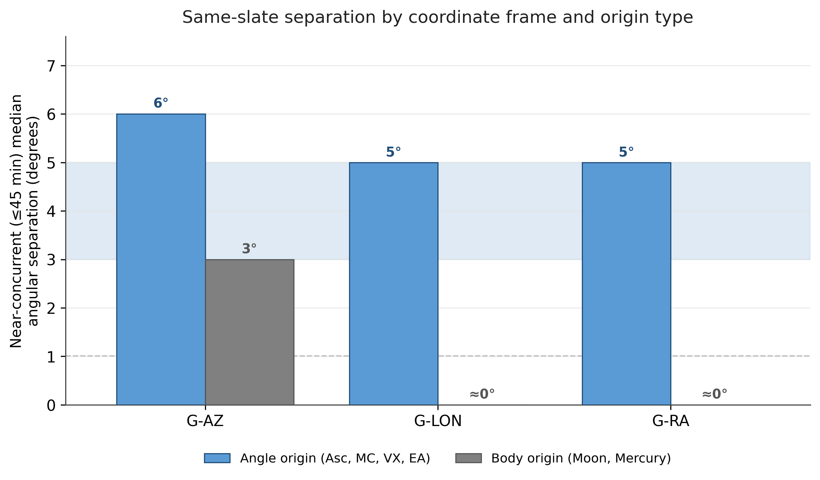
Figure 1. Near-concurrent (≤45 min) median angular separation by coordinate frame and origin type. Angle-origin features (Asc, MC, VX, EA) discriminate same-slate games in every frame; body-origin features (Moon, Mercury) discriminate only in G-AZ and are flat (≈0°) in G-LON/G-RA. Shaded band: Paper 1 3–5° smoothing range. Dashed line: 1° degree-quantization floor. Representative class medians; exact per-feature values in the master CSV.
Feature class | Frames | Near-conc. median | velocity_robust | Engineering role
Angle × body | G-AZ (Asc, EA) | ~6° | ~5–6°/hr | same-slate discriminator
Angle × body | G-LON, G-RA | ~5° (VX ~6°) | ~5–6°/hr | same-slate discriminator
Body × body (Moon, Mercury) | G-AZ | ~3° | ~3°/hr | marginal
Body × body (Moon) | G-LON, G-RA | ≈0° (P90 ≤1°) | ≈0–1°/hr | slow-contextual
Cross-coord. slow×slow; Asc × Part-of-Fortune | various | 0–4° | ≤3°/hr | slow-contextual / marginal
Table 1. Operational-class summary (representative near-concurrent medians; exact per-feature values in the master CSV).

4. What we learned
The 3°/5° smoothing windows inherited from Paper 1 fall empirically within the right operational range for the angle-origin same-slate discriminators — their near-concurrent medians of 5–6° sit inside the Paper 1 band, so those windows were not arbitrary for those features. The same windows are operationally meaningless for slow-contextual fields, which cannot resolve same-slate games at all and must instead be engineered as between-day or seasonal features. Most importantly, “same-slate discriminator versus slow-contextual field” is now a measured property of each feature across the full audited set, rather than an assumption.

5. Implications
For the exploratory phase, the audit replaces every prior “3° or 5°?” discussion with a per-feature, evidence-based resolution, and it surfaces a multicollinearity structure — the angle-dominated spread — to respect when assembling feature matrices.
For Paper 2 and model building, each feature now carries an operational class and a recommended resolution: same-slate discriminators are candidates for fine-resolution, event-level features, while slow-contextual fields are coarse between-day or state features. The audit's per-feature properties combine with the Step 2c local-gradient outputs to define same-slate discriminability as the product of within-slate spread (this audit) and local lift gradient (Step 2c) — the angle supplies the spread, the body's lift surface supplies the gradient. Together these per-feature properties form the input layer of the Paper 2 engineered-feature architecture and seed the operational-scale parameter registry.
Two broader implications follow. Different coordinate systems may encode predictive structure at fundamentally different temporal and operational scales; and operational movement is necessary but not sufficient for predictive utility — the question that follows this audit is which lift surfaces are both locally steep and operationally traversable, that is, where within-slate spread and local lift gradient are simultaneously large.

6. Provenance, reproducibility, and caveats
Data: locked Phase 1 per-event feature files (engine schema 2.0.2); UTC timing from MLB 2000 – no02-2024 Combined Calcd Positions.csv (Game_DateTime_UTC), row-order join verified at 0 mismatches over 57,635 events. Partition: exploratory only (3,808 of 4,760 game-dates); confirmatory partition withheld under the Charter §3 seal; the analysis is outcome-blind.
Outputs: feature_separation_audit_master.csv (SHA-256 e5a6bad6c54a5460c25674dd0a9aa61a5c3bd3c6c48c054568829262744ccdd1), feature_separation_audit_dt_bins.csv (the Δt-resolved separation profile, with median Δt per bin), and feature_separation_audit_drift.csv. Cell: tier1_feature_separation_audit.py v2.1.
Two caveats are carried forward. velocity_robust uses the 45–90 min bin ratio specifically to avoid the small-denominator instability of a per-pair separation/Δt estimator; it is recomputable from the dt_bins file as sep_median ÷ (dt_median_min/60). The operational_scale_flag is descriptive rather than a hard gate: several features sit exactly at the 5° boundary, so classification near the threshold is intended for ranking on the continuous near-concurrent values, not as a binary cut. The three operational classes are provisional working labels rather than a final taxonomy: they rest on heuristic thresholds and have not yet been linked to lift behaviour or tested for predictive usefulness.

