SEO PERFORMANCE AUDIT · SE RANKING  crcrepair.co.uk  Last 30 days (7 Oct – 5 Nov 2026) vs previous 30 days (7 Sep – 6 Oct 2026) · UK Google | 82  Site health score
What improved  - Backlinks moved from a net loss of 137 to a net gain of 99. Losses fell 94%.  - +17 referring domains net, against zero the period before.  - Domain authority rose 27 → 29.  - Slow-loading pages fell 15 → 0. Core Web Vitals pass on mobile and desktop. | What needs attention  - Traffic value fell 30.5% (£700 → £486) while visits dipped only 2%.  - Fewer keywords in the top 5 (−11) and top 10 (−12).  - Audit errors rose 39 → 43. Redirect chains rose 14 → 22.  - Every page has a broken external link and images without alt text.
Key metrics at a glance
ORGANIC VISITS (EST.)  1,693  −2.0% was 1,727  monthly, UK Google | TRAFFIC VALUE  £486  −30.5% was £700  equivalent ad spend | KEYWORDS IN TOP 5  283  −3.7% was 294  UK organic | KEYWORDS IN TOP 10  536  −2.2% was 548  UK organic
DOMAIN AUTHORITY  29  +2 pts was 27  SE Ranking InLink Rank | NEW BACKLINKS  111  +71% was 65  found in period | LOST BACKLINKS  12  −94% was 202  lost in period | NET REFERRING DOMAINS  +17  +17 was 0  18 gained, 1 lost
SITE HEALTH SCORE  82  audit 2 Nov was n/a  out of 100 | AUDIT ERRORS  43  +4 was 39  28 Sep → 2 Nov | AUDIT WARNINGS  880  +11 was 869  28 Sep → 2 Nov | PAGES CRAWLED  330  +7 was 323  28 Sep → 2 Nov
Organic traffic & traffic value · 13 months
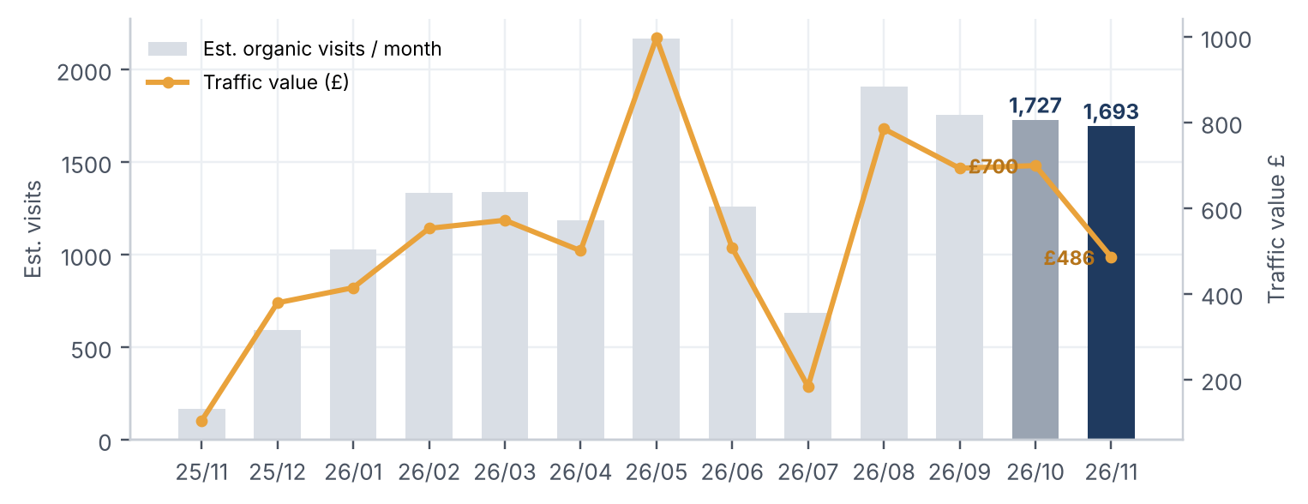
Dark bar = now, grey bar = 30 days ago. Visits are far above a year ago and close to last month's level, but the value of that traffic has dropped.

Rankings & authority
Keyword position spread  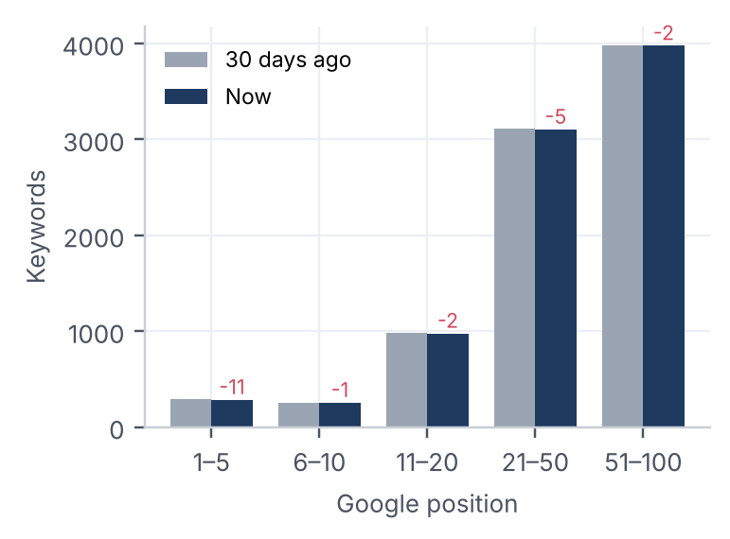  UK organic keywords by Google position, 30 days ago vs now. | New vs lost links  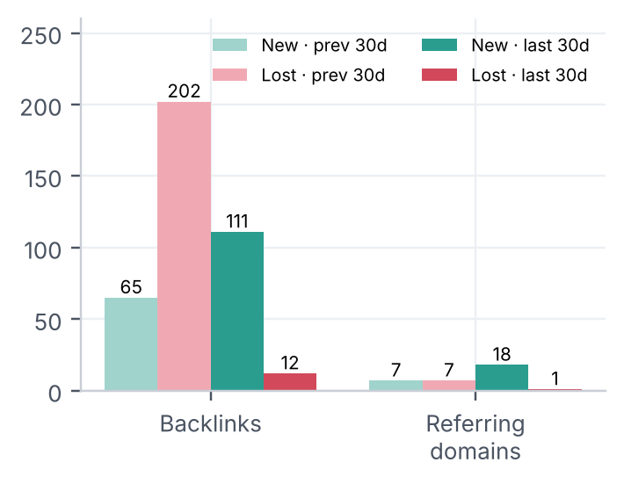  The previous period lost 202 backlinks. In the last 30 days only 12 were lost.
Live backlinks · 60 days  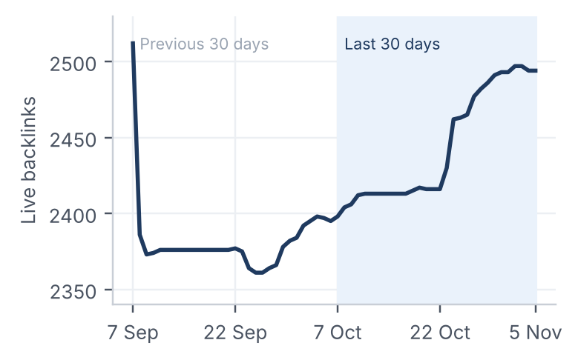  2,395 → 2,494 over the last 30 days (+99). 269 referring domains. | Domain authority (weekly)  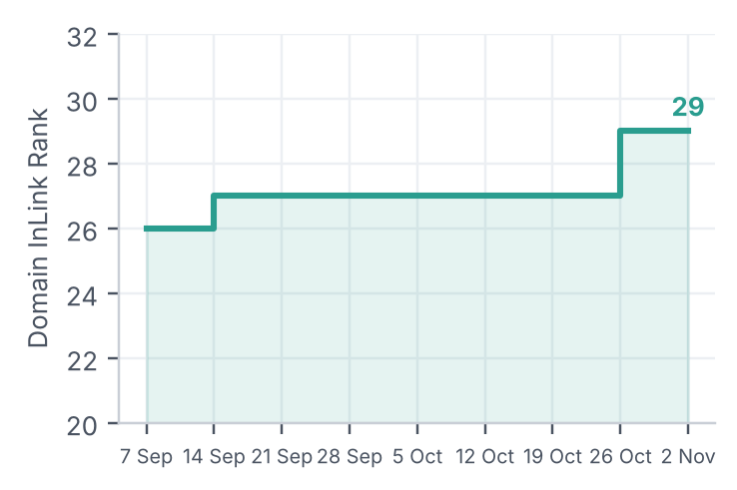  Stepped up from 27 to 29 in the week of 26 Oct.
Top organic keywords by traffic
Keyword | Searches / mo | Position | Est. visits
cracked screen | 6,600 | 5 | 184
screen broken | 8,000 | 25 | 76
tech repair | 1,600 | 5 | 72
crc repair | 70 | 1 | 32
crc | 4,400 | 6 | 20
screen replacement | 880 | 7 | 17
google repair | 590 | 16 | 15
phone repair glasgow | 210 | 2 | 12
screen repair near me | 1,300 | 14 | 12
fixed cracked screen | 320 | 4 | 11
Positions are unchanged on the leaders. 'cracked screen' (position 5) brings 11% of all organic visits.

Technical health & tracked keywords
Site audit: 28 Sep vs 2 Nov
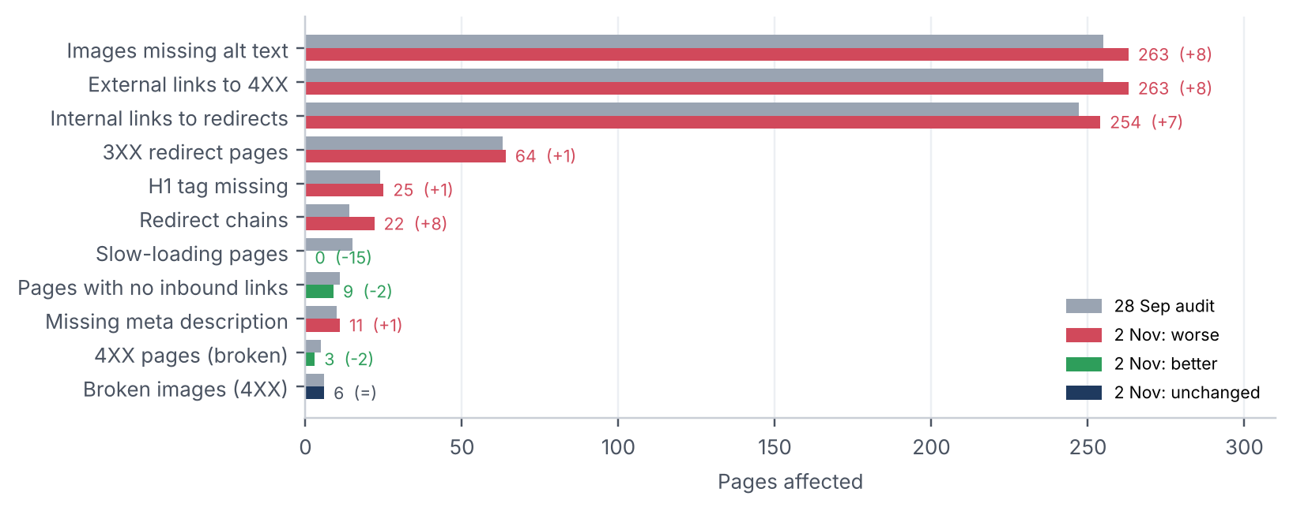
Rank tracker (455 keywords)  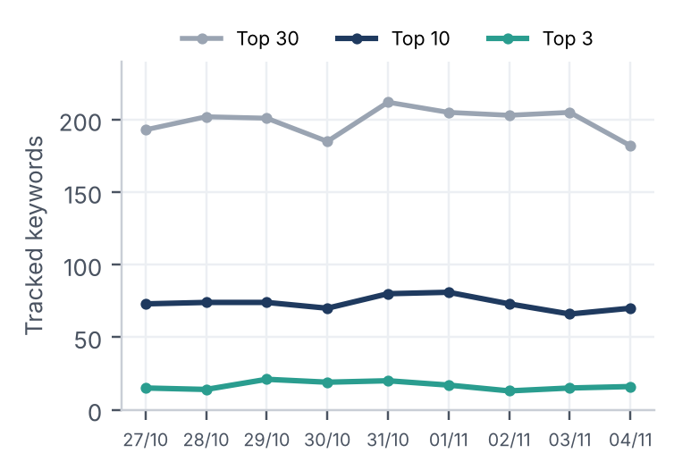  Tracking has had full coverage only since 27 Oct. Top 10: 73 → 70. Average position 28.1 → 29.1. 125 improved, 137 declined, 22 newly ranking. | Core Web Vitals (real users)  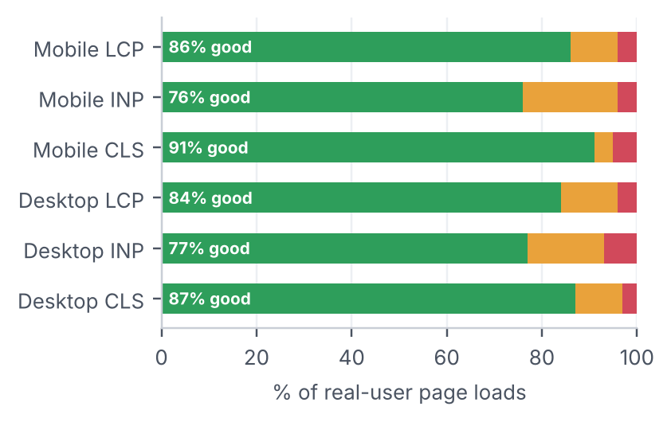  All six pass Google's thresholds (Chrome UX Report).
Biggest gainers
Keyword | Vol | Position | Δ
motorola service centers | 70 | 50 → 4 | +46
how much does phone screen repair cost | 590 | 63 → 31 | +32
iphone repair wolverhampton | 50 | 45 → 13 | +32
cost for phone screen repair | 170 | 78 → 48 | +30
screen repair services | 170 | 32 → 5 | +27
phone shops wolverhampton | 480 | 39 → 14 | +25
Biggest drops
Keyword | Vol | Position | Δ
phone shop plodder lane | 30 | 22 → 69 | −48
chester road phone shop | 260 | 20 → 64 | −43
how much to fix an iphone screen | 590 | 27 → 66 | −39
bournemouth pc repair | 390 | 46 → 85 | −39
get it repaired | 70 | 2 → 36 | −34
iphone repair high wycombe | 70 | 40 → 74 | −33
Gainers and drops compare the averages for 27–30 Oct and 1–4 Nov, for keywords with at least 30 searches/month.

Priority action plan
Quick wins: tracked keywords at positions 4–15
Keyword | Searches / mo | Position
screen replacement | 1,900 | 12
screen repair near me | 1,300 | 10
how much is it to fix a iphone screen | 590 | 10
screen repair near me samsung | 590 | 12
laptop battery replacement near me | 590 | 4
cell phone screen repairs near me | 590 | 14
tech geek feltham | 590 | 8
Actions
High | Fix the sitewide broken external link  263 pages (every page) link to a URL that returns 4XX. That pattern means one link in the header or footer template. Fixing it once clears the second-largest issue in the audit.
High | Remove redirect chains and point internal links at final URLs  Redirect chains rose from 14 to 22, and 254 internal links point at redirecting URLs. Update the menu and footer links and collapse each chain to a single 301.
High | Recover high-value keywords that slipped  Traffic value fell 30% while visits fell only 2%, which points to commercial keywords losing positions. Refresh the cost and price pages, e.g. 'how much to fix an iPhone screen', 'technology repair centre' and 'Bournemouth PC repair'.
Med | Push page-2 keywords onto page 1  'screen replacement' (1.9k searches/mo, position 12), 'screen repair near me samsung' (position 12) and 'cell phone screen repairs near me' (position 14). Add internal links and fuller content to the matching service pages.
Med | Add alt text and H1s  263 pages have images without alt text and 25 have no H1. Both are template-level fixes with a quick payoff for accessibility and image search.
Med | Connect Google Search Console to SE Ranking  Not connected yet, so this report has to estimate clicks. Connecting it gives real clicks and impressions for the next comparison.
Low | Keep the link-building momentum  Backlinks moved from a net loss of 137 to a net gain of 99, and authority rose 27 to 29. Keep earning links to the local pages (Glasgow, Romford, Stoke …), and diversify anchors beyond 'phone repairs'.
About this data
- Traffic, value and keyword counts are SE Ranking's UK estimates. "Now" is the snapshot of 5 Nov and "30 days ago" is the October snapshot. They model visits; they are not your analytics.
- Backlinks and referring domains are exact daily counts for 7 Oct – 5 Nov vs 7 Sep – 6 Oct.
- Site audit compares two crawls of the same audit (ID 424027): 28 Sep and 2 Nov. SE Ranking did not keep a health score for the 28 Sep crawl. A separate project audit on 27 Oct also flagged 276 pages loading an external JavaScript file that returns an error, plus 3 mixed-content pages. Neither issue appears in the 2 Nov crawl.
- Positions differ between tables. The rank tracker checks tracked keywords every day for its set location. The top-keywords table comes from SE Ranking's monthly UK database. The same keyword can therefore show a different position or search volume in each.
- Rank tracker was set up on 9 Oct and has had full daily coverage only since 27 Oct, so there is no previous-30-day rank tracker baseline. Today's check was 86% complete when the data was pulled, so it is left out.
- Google Search Console is not connected to the SE Ranking project, so real clicks and impressions are not included.

