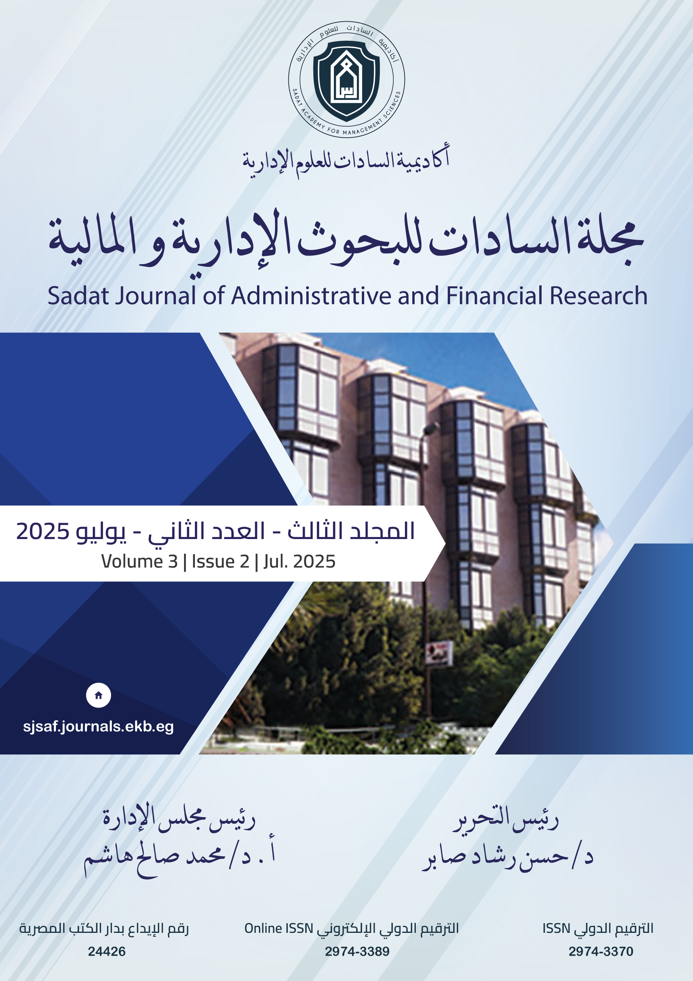

{JOURNAL_NAME}
Issued by:
Consulting, Research, and Development Center (CRDC) – Sadat Academy for Administrative Sciences

Chairman of the Journal’s Board:
Prof. Dr. Mohamed Saleh Hashem

Editor-in-Chief:
Dr. Hassan Rashad Saber

Executive Editor:
Mr. Nader Mekky

