# Acta de la 1ª evaluación

## Informe actilla:

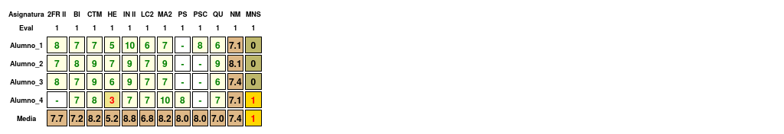

## Resultados generales:

### Resumen

|  |  |  |  |  |
| --- | --- | --- | --- | --- |
| Eval | N_al | Media | N_susp | Susp_alu |
| 1 | 4 | 7.42 | 1 | 0.25 |

Tenemos los siguientes datos: la nota media es 7.42, el número de suspensos es 1, el número de suspensos por alumno es 0.25

### Resumen de suspensos

|  |  |  |  |  |  |
| --- | --- | --- | --- | --- | --- |
|  | 0 susp. | 1 susp. | 2 susp. | 3 ó 4 susp. | > 4 susp. |
| Alumnos | 3 | 1 | 0 | 0 | 0 |

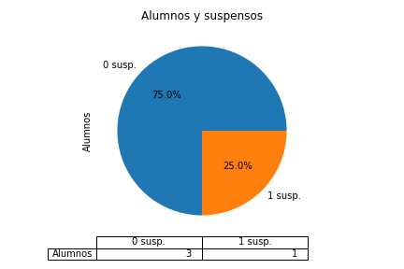

Alumnos con suspensos:

* Con 1 asignaturas:
  + Alumno_4 (HE)

### Resumen de nota media

|  |  |  |  |  |  |  |  |
| --- | --- | --- | --- | --- | --- | --- | --- |
|  | [0, 3) | [3, 4) | [4, 5) | [5, 6) | [6, 7) | [7, 9) | [9, 10) |
| Alumnos | 0 | 0 | 0 | 0 | 0 | 4 | 0 |

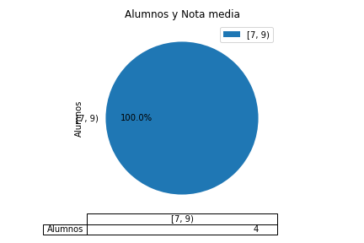

## Alumnos

### Notas medias

|  |  |
| --- | --- |
| Alumno | (‘Media’, 1) |
| Alumno_1 | 7.11 |
| Alumno_2 | 8.12 |
| Alumno_3 | 7.38 |
| Alumno_4 | 7.12 |

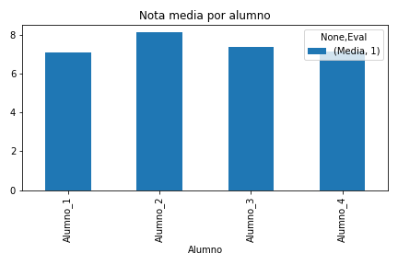

### Resultados por alumno

#### Alumno_1

Alumno_1 en la 1ªev: la nota media es 7.11, el número de suspensos es 0

|  |  |  |  |  |  |  |  |  |  |
| --- | --- | --- | --- | --- | --- | --- | --- | --- | --- |
| Eval | 2FR II | BI | CTM | HE | IN II | LC2 | MA2 | PSC | QU |
| 1 | 8 | 7 | 7 | 5 | 10 | 6 | 7 | 8 | 6 |

Por tanto: 2FR II es 8, BI es 7, CTM es 7, HE es 5, IN II es 10, LC2 es 6, MA2 es 7, PSC es 8, QU es 6

#### Alumno_2

Alumno_2 en la 1ªev: la nota media es 8.12, el número de suspensos es 0

|  |  |  |  |  |  |  |  |  |
| --- | --- | --- | --- | --- | --- | --- | --- | --- |
| Eval | 2FR II | BI | CTM | HE | IN II | LC2 | MA2 | QU |
| 1 | 7 | 8 | 9 | 7 | 9 | 7 | 9 | 9 |

Por tanto: 2FR II es 7, BI es 8, CTM es 9, HE es 7, IN II es 9, LC2 es 7, MA2 es 9, QU es 9

#### Alumno_3

Alumno_3 en la 1ªev: la nota media es 7.38, el número de suspensos es 0

|  |  |  |  |  |  |  |  |  |
| --- | --- | --- | --- | --- | --- | --- | --- | --- |
| Eval | 2FR II | BI | CTM | HE | IN II | LC2 | MA2 | QU |
| 1 | 8 | 7 | 9 | 6 | 9 | 7 | 7 | 6 |

Por tanto: 2FR II es 8, BI es 7, CTM es 9, HE es 6, IN II es 9, LC2 es 7, MA2 es 7, QU es 6

#### Alumno_4

Alumno_4 en la 1ªev: la nota media es 7.12, el número de suspensos es 1

* Suspende 1 asignaturas: HE

|  |  |  |  |  |  |  |  |  |
| --- | --- | --- | --- | --- | --- | --- | --- | --- |
| Eval | BI | CTM | HE | IN II | LC2 | MA2 | PS | QU |
| 1 | 7 | 8 | 3 | 7 | 7 | 10 | 8 | 7 |

Por tanto: BI es 7, CTM es 8, HE es 3, IN II es 7, LC2 es 7, MA2 es 10, PS es 8, QU es 7