Acta de la 1ª evaluación

IES Pedro Cerrada

4ºESO B

# Acta de la 1ª evaluación

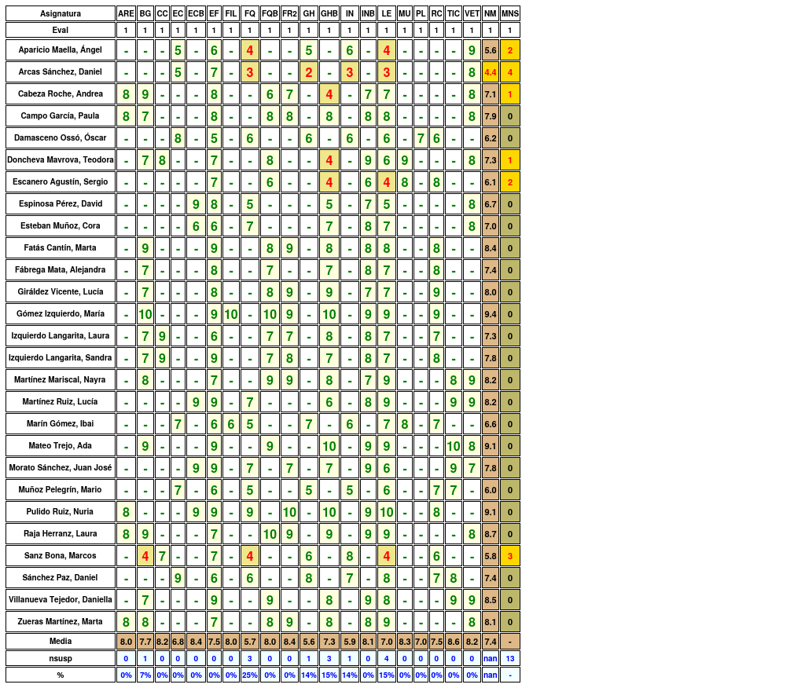

## Resultados generales:

A nivel de grupo, se tienen los siguientes datos:

* **nota media**: 7.48
* **número de suspensos**: 13
* **número de suspensos por alumno**: 0.48

El número de alumnos por suspensos se distribuyen de la siguiente manera:

* **0 susp.**: 21
* **1 susp.**: 2
* **2 susp.**: 2
* **3 ó 4 susp.**: 2
* **> 4 susp.**: 0

Gráficamente:

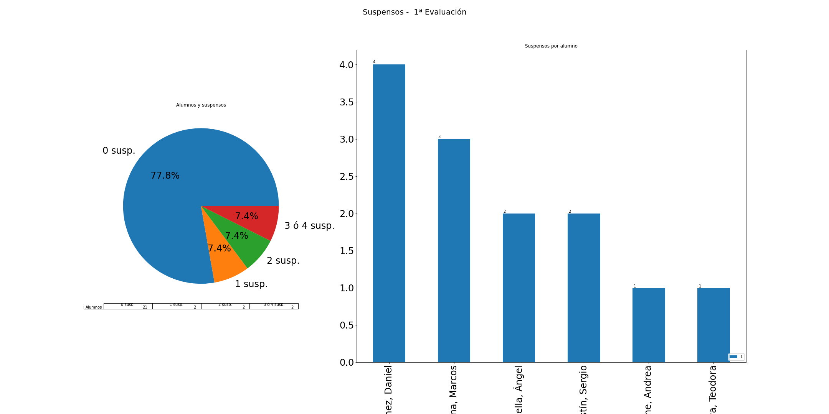

Alumnos con suspensos:

* Con **4** asignaturas:
  + Arcas Sánchez, Daniel (FQ, GH, IN, LE)
* Con **3** asignaturas:
  + Sanz Bona, Marcos (BG, FQ, LE)
* Con **2** asignaturas:
  + Aparicio Maella, Ángel (FQ, LE)
  + Escanero Agustín, Sergio (GHB, LE)
* Con **1** asignaturas:
  + Cabeza Roche, Andrea (GHB)
  + Doncheva Mavrova, Teodora (GHB)

El número de alumnos por nota media se distribuye de la siguiente manera:

* **[0, 3)**: 0
* **[3, 4)**: 0
* **[4, 5)**: 1
* **[5, 6)**: 2
* **[6, 7)**: 5
* **[7, 9)**: 16
* **[9, 10)**: 3

Gráficamente

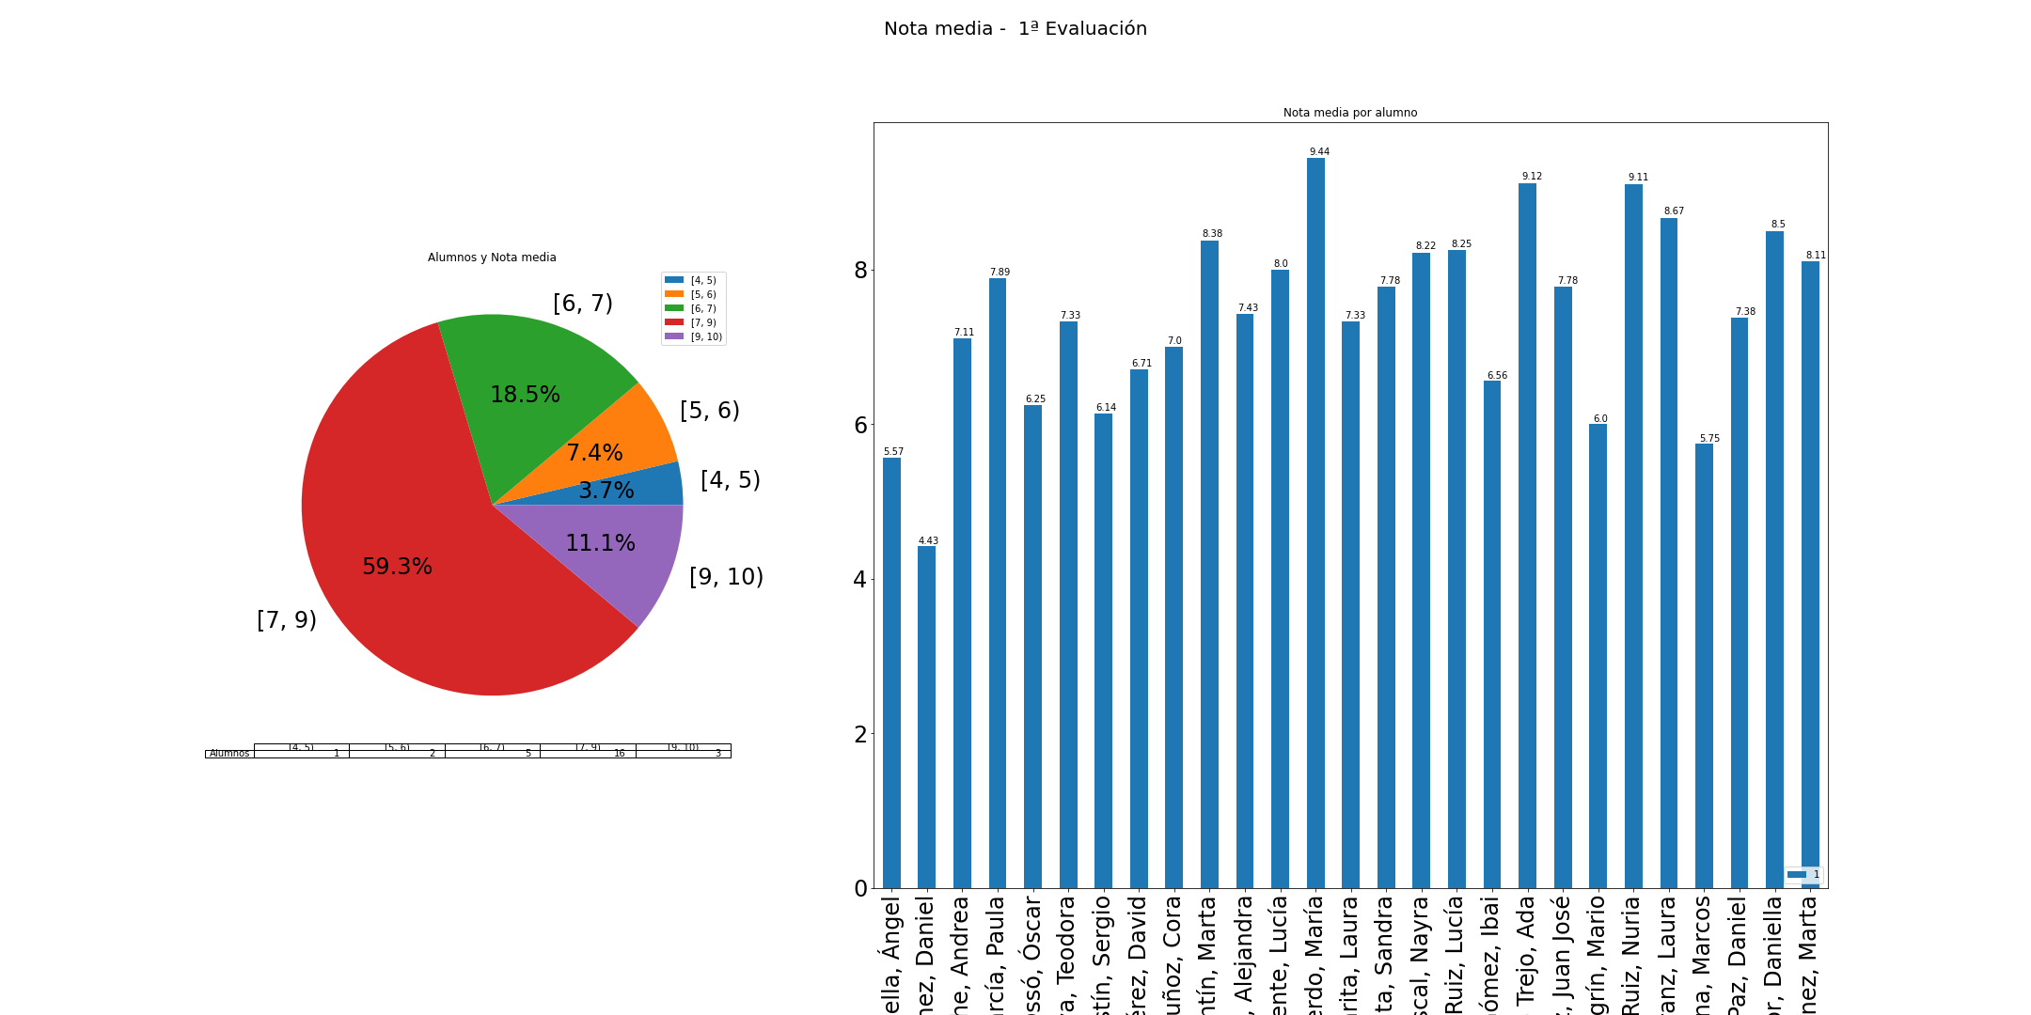

## Resultados por alumno

### Aparicio Maella, Ángel

* **Nota media**: 5.57, **Número de suspensos**: 2
* Suspensos: FQ, LE

|  |  |  |  |  |  |  |  |
| --- | --- | --- | --- | --- | --- | --- | --- |
| Eval | EC | EF | FQ | GH | IN | LE | VET |
| 1 | 5 | 6 | 4 | 5 | 6 | 4 | 9 |

* En concreto: **EC**: 5, **EF**: 6, **FQ**: 4, **GH**: 5, **IN**: 6, **LE**: 4, **VET**: 9

### Arcas Sánchez, Daniel

* **Nota media**: 4.43, **Número de suspensos**: 4
* Suspensos: FQ, GH, IN, LE

|  |  |  |  |  |  |  |  |
| --- | --- | --- | --- | --- | --- | --- | --- |
| Eval | EC | EF | FQ | GH | IN | LE | VET |
| 1 | 5 | 7 | 3 | 2 | 3 | 3 | 8 |

* En concreto: **EC**: 5, **EF**: 7, **FQ**: 3, **GH**: 2, **IN**: 3, **LE**: 3, **VET**: 8

### Cabeza Roche, Andrea

* **Nota media**: 7.11, **Número de suspensos**: 1
* Suspensos: GHB

|  |  |  |  |  |  |  |  |  |  |
| --- | --- | --- | --- | --- | --- | --- | --- | --- | --- |
| Eval | ARE | BG | EF | FQB | FR2 | GHB | INB | LE | VET |
| 1 | 8 | 9 | 8 | 6 | 7 | 4 | 7 | 7 | 8 |

* En concreto: **ARE**: 8, **BG**: 9, **EF**: 8, **FQB**: 6, **FR2**: 7, **GHB**: 4, **INB**: 7, **LE**: 7, **VET**: 8

### Campo García, Paula

* **Nota media**: 7.89, **Número de suspensos**: 0

|  |  |  |  |  |  |  |  |  |  |
| --- | --- | --- | --- | --- | --- | --- | --- | --- | --- |
| Eval | ARE | BG | EF | FQB | FR2 | GHB | INB | LE | VET |
| 1 | 8 | 7 | 8 | 8 | 8 | 8 | 8 | 8 | 8 |

* En concreto: **ARE**: 8, **BG**: 7, **EF**: 8, **FQB**: 8, **FR2**: 8, **GHB**: 8, **INB**: 8, **LE**: 8, **VET**: 8

### Damasceno Ossó, Óscar

* **Nota media**: 6.25, **Número de suspensos**: 0

|  |  |  |  |  |  |  |  |  |
| --- | --- | --- | --- | --- | --- | --- | --- | --- |
| Eval | EC | EF | FQ | GH | IN | LE | PL | RC |
| 1 | 8 | 5 | 6 | 6 | 6 | 6 | 7 | 6 |

* En concreto: **EC**: 8, **EF**: 5, **FQ**: 6, **GH**: 6, **IN**: 6, **LE**: 6, **PL**: 7, **RC**: 6

### Doncheva Mavrova, Teodora

* **Nota media**: 7.33, **Número de suspensos**: 1
* Suspensos: GHB

|  |  |  |  |  |  |  |  |  |  |
| --- | --- | --- | --- | --- | --- | --- | --- | --- | --- |
| Eval | BG | CC | EF | FQB | GHB | INB | LE | MU | VET |
| 1 | 7 | 8 | 7 | 8 | 4 | 9 | 6 | 9 | 8 |

* En concreto: **BG**: 7, **CC**: 8, **EF**: 7, **FQB**: 8, **GHB**: 4, **INB**: 9, **LE**: 6, **MU**: 9, **VET**: 8

### Escanero Agustín, Sergio

* **Nota media**: 6.14, **Número de suspensos**: 2
* Suspensos: GHB, LE

|  |  |  |  |  |  |  |  |
| --- | --- | --- | --- | --- | --- | --- | --- |
| Eval | EF | FQB | GHB | INB | LE | MU | RC |
| 1 | 7 | 6 | 4 | 6 | 4 | 8 | 8 |

* En concreto: **EF**: 7, **FQB**: 6, **GHB**: 4, **INB**: 6, **LE**: 4, **MU**: 8, **RC**: 8

### Espinosa Pérez, David

* **Nota media**: 6.71, **Número de suspensos**: 0

|  |  |  |  |  |  |  |  |
| --- | --- | --- | --- | --- | --- | --- | --- |
| Eval | ECB | EF | FQ | GHB | INB | LE | VET |
| 1 | 9 | 8 | 5 | 5 | 7 | 5 | 8 |

* En concreto: **ECB**: 9, **EF**: 8, **FQ**: 5, **GHB**: 5, **INB**: 7, **LE**: 5, **VET**: 8

### Esteban Muñoz, Cora

* **Nota media**: 7, **Número de suspensos**: 0

|  |  |  |  |  |  |  |  |
| --- | --- | --- | --- | --- | --- | --- | --- |
| Eval | ECB | EF | FQ | GHB | INB | LE | VET |
| 1 | 6 | 6 | 7 | 7 | 8 | 7 | 8 |

* En concreto: **ECB**: 6, **EF**: 6, **FQ**: 7, **GHB**: 7, **INB**: 8, **LE**: 7, **VET**: 8

### Fatás Cantín, Marta

* **Nota media**: 8.38, **Número de suspensos**: 0

|  |  |  |  |  |  |  |  |  |
| --- | --- | --- | --- | --- | --- | --- | --- | --- |
| Eval | BG | EF | FQB | FR2 | GHB | INB | LE | RC |
| 1 | 9 | 9 | 8 | 9 | 8 | 8 | 8 | 8 |

* En concreto: **BG**: 9, **EF**: 9, **FQB**: 8, **FR2**: 9, **GHB**: 8, **INB**: 8, **LE**: 8, **RC**: 8

### Fábrega Mata, Alejandra

* **Nota media**: 7.43, **Número de suspensos**: 0

|  |  |  |  |  |  |  |  |
| --- | --- | --- | --- | --- | --- | --- | --- |
| Eval | BG | EF | FQB | GHB | INB | LE | RC |
| 1 | 7 | 8 | 7 | 7 | 8 | 7 | 8 |

* En concreto: **BG**: 7, **EF**: 8, **FQB**: 7, **GHB**: 7, **INB**: 8, **LE**: 7, **RC**: 8

### Giráldez Vicente, Lucía

* **Nota media**: 8, **Número de suspensos**: 0

|  |  |  |  |  |  |  |  |  |
| --- | --- | --- | --- | --- | --- | --- | --- | --- |
| Eval | BG | EF | FQB | FR2 | GHB | INB | LE | RC |
| 1 | 7 | 8 | 8 | 9 | 9 | 7 | 7 | 9 |

* En concreto: **BG**: 7, **EF**: 8, **FQB**: 8, **FR2**: 9, **GHB**: 9, **INB**: 7, **LE**: 7, **RC**: 9

### Gómez Izquierdo, María

* **Nota media**: 9.44, **Número de suspensos**: 0

|  |  |  |  |  |  |  |  |  |  |
| --- | --- | --- | --- | --- | --- | --- | --- | --- | --- |
| Eval | BG | EF | FIL | FQB | FR2 | GHB | INB | LE | RC |
| 1 | 10 | 9 | 10 | 10 | 9 | 10 | 9 | 9 | 9 |

* En concreto: **BG**: 10, **EF**: 9, **FIL**: 10, **FQB**: 10, **FR2**: 9, **GHB**: 10, **INB**: 9, **LE**: 9, **RC**: 9

### Izquierdo Langarita, Laura

* **Nota media**: 7.33, **Número de suspensos**: 0

|  |  |  |  |  |  |  |  |  |  |
| --- | --- | --- | --- | --- | --- | --- | --- | --- | --- |
| Eval | BG | CC | EF | FQB | FR2 | GHB | INB | LE | RC |
| 1 | 7 | 9 | 6 | 7 | 7 | 8 | 8 | 7 | 7 |

* En concreto: **BG**: 7, **CC**: 9, **EF**: 6, **FQB**: 7, **FR2**: 7, **GHB**: 8, **INB**: 8, **LE**: 7, **RC**: 7

### Izquierdo Langarita, Sandra

* **Nota media**: 7.78, **Número de suspensos**: 0

|  |  |  |  |  |  |  |  |  |  |
| --- | --- | --- | --- | --- | --- | --- | --- | --- | --- |
| Eval | BG | CC | EF | FQB | FR2 | GHB | INB | LE | RC |
| 1 | 7 | 9 | 9 | 7 | 8 | 7 | 8 | 7 | 8 |

* En concreto: **BG**: 7, **CC**: 9, **EF**: 9, **FQB**: 7, **FR2**: 8, **GHB**: 7, **INB**: 8, **LE**: 7, **RC**: 8

### Martínez Mariscal, Nayra

* **Nota media**: 8.22, **Número de suspensos**: 0

|  |  |  |  |  |  |  |  |  |  |
| --- | --- | --- | --- | --- | --- | --- | --- | --- | --- |
| Eval | BG | EF | FQB | FR2 | GHB | INB | LE | TIC | VET |
| 1 | 8 | 7 | 9 | 9 | 8 | 7 | 9 | 8 | 9 |

* En concreto: **BG**: 8, **EF**: 7, **FQB**: 9, **FR2**: 9, **GHB**: 8, **INB**: 7, **LE**: 9, **TIC**: 8, **VET**: 9

### Martínez Ruiz, Lucía

* **Nota media**: 8.25, **Número de suspensos**: 0

|  |  |  |  |  |  |  |  |  |
| --- | --- | --- | --- | --- | --- | --- | --- | --- |
| Eval | ECB | EF | FQ | GHB | INB | LE | TIC | VET |
| 1 | 9 | 9 | 7 | 6 | 8 | 9 | 9 | 9 |

* En concreto: **ECB**: 9, **EF**: 9, **FQ**: 7, **GHB**: 6, **INB**: 8, **LE**: 9, **TIC**: 9, **VET**: 9

### Marín Gómez, Ibai

* **Nota media**: 6.56, **Número de suspensos**: 0

|  |  |  |  |  |  |  |  |  |  |
| --- | --- | --- | --- | --- | --- | --- | --- | --- | --- |
| Eval | EC | EF | FIL | FQ | GH | IN | LE | MU | RC |
| 1 | 7 | 6 | 6 | 5 | 7 | 6 | 7 | 8 | 7 |

* En concreto: **EC**: 7, **EF**: 6, **FIL**: 6, **FQ**: 5, **GH**: 7, **IN**: 6, **LE**: 7, **MU**: 8, **RC**: 7

### Mateo Trejo, Ada

* **Nota media**: 9.12, **Número de suspensos**: 0

|  |  |  |  |  |  |  |  |  |
| --- | --- | --- | --- | --- | --- | --- | --- | --- |
| Eval | BG | EF | FQB | GHB | INB | LE | TIC | VET |
| 1 | 9 | 9 | 9 | 10 | 9 | 9 | 10 | 8 |

* En concreto: **BG**: 9, **EF**: 9, **FQB**: 9, **GHB**: 10, **INB**: 9, **LE**: 9, **TIC**: 10, **VET**: 8

### Morato Sánchez, Juan José

* **Nota media**: 7.78, **Número de suspensos**: 0

|  |  |  |  |  |  |  |  |  |  |
| --- | --- | --- | --- | --- | --- | --- | --- | --- | --- |
| Eval | ECB | EF | FQ | FR2 | GHB | INB | LE | TIC | VET |
| 1 | 9 | 9 | 7 | 7 | 7 | 9 | 6 | 9 | 7 |

* En concreto: **ECB**: 9, **EF**: 9, **FQ**: 7, **FR2**: 7, **GHB**: 7, **INB**: 9, **LE**: 6, **TIC**: 9, **VET**: 7

### Muñoz Pelegrín, Mario

* **Nota media**: 6, **Número de suspensos**: 0

|  |  |  |  |  |  |  |  |  |
| --- | --- | --- | --- | --- | --- | --- | --- | --- |
| Eval | EC | EF | FQ | GH | IN | LE | RC | TIC |
| 1 | 7 | 6 | 5 | 5 | 5 | 6 | 7 | 7 |

* En concreto: **EC**: 7, **EF**: 6, **FQ**: 5, **GH**: 5, **IN**: 5, **LE**: 6, **RC**: 7, **TIC**: 7

### Pulido Ruiz, Nuria

* **Nota media**: 9.11, **Número de suspensos**: 0

|  |  |  |  |  |  |  |  |  |  |
| --- | --- | --- | --- | --- | --- | --- | --- | --- | --- |
| Eval | ARE | ECB | EF | FQ | FR2 | GHB | INB | LE | RC |
| 1 | 8 | 9 | 9 | 9 | 10 | 10 | 9 | 10 | 8 |

* En concreto: **ARE**: 8, **ECB**: 9, **EF**: 9, **FQ**: 9, **FR2**: 10, **GHB**: 10, **INB**: 9, **LE**: 10, **RC**: 8

### Raja Herranz, Laura

* **Nota media**: 8.67, **Número de suspensos**: 0

|  |  |  |  |  |  |  |  |  |  |
| --- | --- | --- | --- | --- | --- | --- | --- | --- | --- |
| Eval | ARE | BG | EF | FQB | FR2 | GHB | INB | LE | VET |
| 1 | 8 | 9 | 7 | 10 | 9 | 9 | 9 | 9 | 8 |

* En concreto: **ARE**: 8, **BG**: 9, **EF**: 7, **FQB**: 10, **FR2**: 9, **GHB**: 9, **INB**: 9, **LE**: 9, **VET**: 8

### Sanz Bona, Marcos

* **Nota media**: 5.75, **Número de suspensos**: 3
* Suspensos: BG, FQ, LE

|  |  |  |  |  |  |  |  |  |
| --- | --- | --- | --- | --- | --- | --- | --- | --- |
| Eval | BG | CC | EF | FQ | GH | IN | LE | RC |
| 1 | 4 | 7 | 7 | 4 | 6 | 8 | 4 | 6 |

* En concreto: **BG**: 4, **CC**: 7, **EF**: 7, **FQ**: 4, **GH**: 6, **IN**: 8, **LE**: 4, **RC**: 6

### Sánchez Paz, Daniel

* **Nota media**: 7.38, **Número de suspensos**: 0

|  |  |  |  |  |  |  |  |  |
| --- | --- | --- | --- | --- | --- | --- | --- | --- |
| Eval | EC | EF | FQ | GH | IN | LE | RC | TIC |
| 1 | 9 | 6 | 6 | 8 | 7 | 8 | 7 | 8 |

* En concreto: **EC**: 9, **EF**: 6, **FQ**: 6, **GH**: 8, **IN**: 7, **LE**: 8, **RC**: 7, **TIC**: 8

### Villanueva Tejedor, Daniella

* **Nota media**: 8.5, **Número de suspensos**: 0

|  |  |  |  |  |  |  |  |  |
| --- | --- | --- | --- | --- | --- | --- | --- | --- |
| Eval | BG | EF | FQB | GHB | INB | LE | TIC | VET |
| 1 | 7 | 9 | 9 | 8 | 9 | 8 | 9 | 9 |

* En concreto: **BG**: 7, **EF**: 9, **FQB**: 9, **GHB**: 8, **INB**: 9, **LE**: 8, **TIC**: 9, **VET**: 9

### Zueras Martínez, Marta

* **Nota media**: 8.11, **Número de suspensos**: 0

|  |  |  |  |  |  |  |  |  |  |
| --- | --- | --- | --- | --- | --- | --- | --- | --- | --- |
| Eval | ARE | BG | EF | FQB | FR2 | GHB | INB | LE | VET |
| 1 | 8 | 8 | 7 | 8 | 9 | 8 | 8 | 9 | 8 |

* En concreto: **ARE**: 8, **BG**: 8, **EF**: 7, **FQB**: 8, **FR2**: 9, **GHB**: 8, **INB**: 8, **LE**: 9, **VET**: 8