Functions and Alias
The alias functions “AS” is in the screenshots Date_format function:
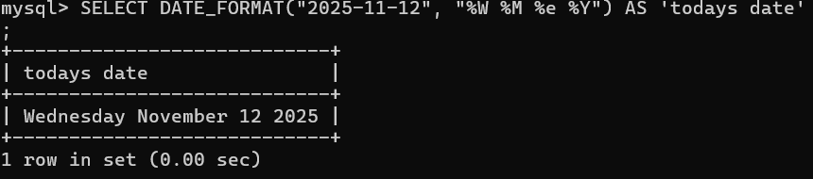
Date_format can be used to locate old dates in the database or show specific dates. In W3Schools.com an example they use is showing birthdates for employees.
Last_day function:
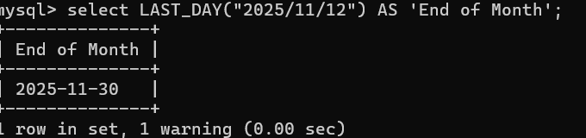
Last _day function can be used for billing and payroll, calculating the last day bills are due or ensure payments align with the last day of the month.
Local _time function:
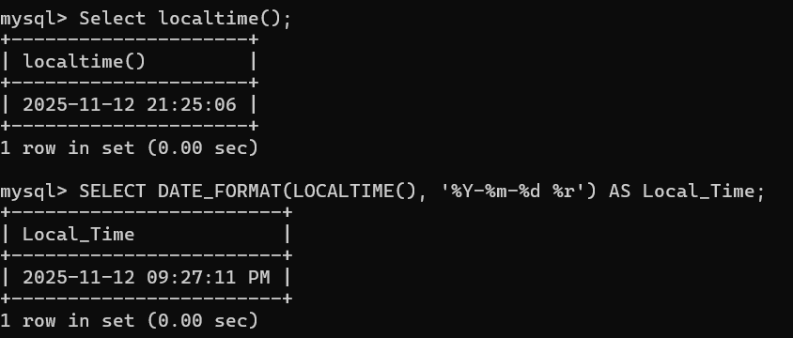
Local_time can be used for stamping when a user logs in, if you are keeping track of the information, or simply providing the time and date.

