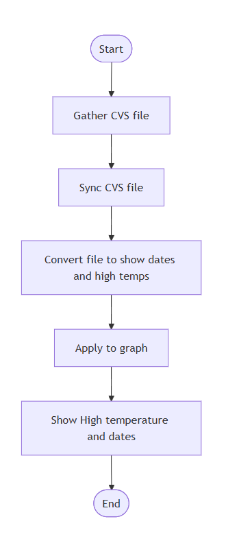
Flowchart #1

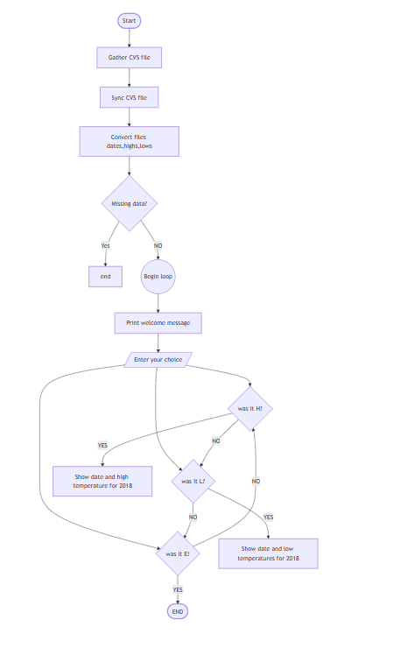
Flowchart #2 after adding high, low and exit codes.

