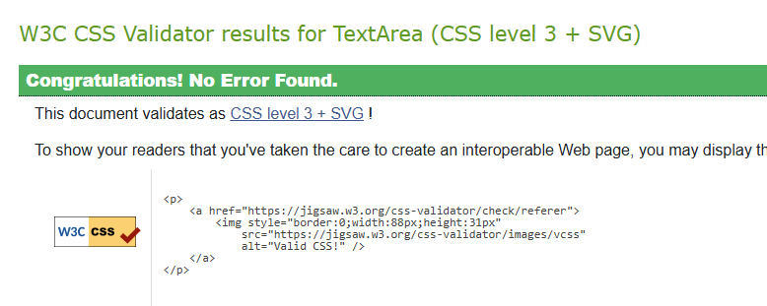
The HTML checker gave me header errors at first because of going from h1 to h3 instead of staying in order of going h1, h2, h3. For the checker, I did switch it to h2 but for following the instructions for using h3. I switched it back to h3.
