Wireframes
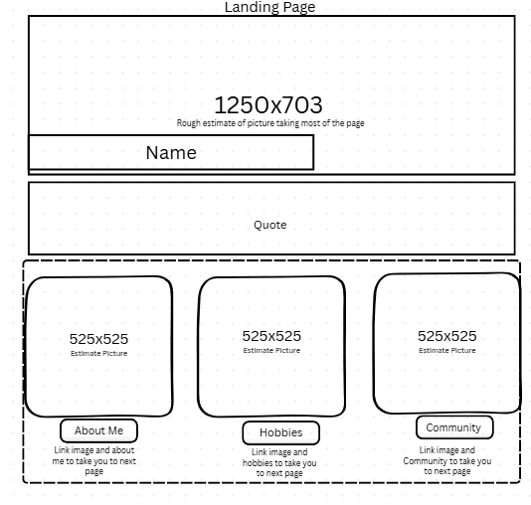
Landing page will carry a total of 4 pictures, sizing will vary. Name. Quote in middle of page. I will try to link an image and the heading as a link to click the picture or button to take you to page related to topic for landing page. Will also need to add a link to this landing page to take you to our index.
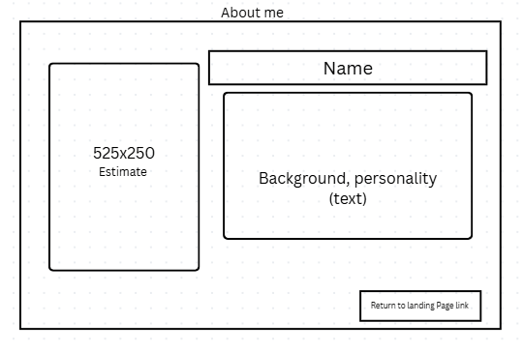
The details about me will contain 1 picture, 250 word summary, name and link to go back to landing page.
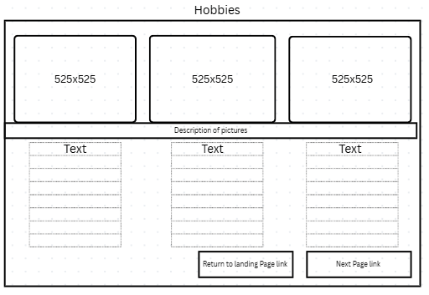
Hobbies will have 3 pictures, description of pictures, and small information about hobbies. Link to next page and link to return to landing page.
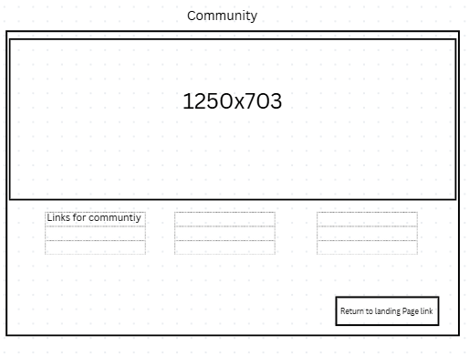
Community is an extra page, will have 1 image. Sharing external links to websites. Link to landing page.

Interview Questions for Edwin Leos
- How would you describe yourself to someone who’s never met you?
I would describe myself as someone with confidence, kindhearted but still genuine. I can come off as someone who’s very straightforward, but it always comes from a place of fairness.

- What does a typical day look like for you?
Get up early in the morning, ready to start the day on a positive note. Set up to go to my designated jobsite and start my daily inspections. (Certified welding Inspector-passed on his first try.) Typically, inspections take 3-4 hours, depending on the project size and project due date.

- What are you most passionate about right now, and how did that start?
Welding, playing video games, anything hands on and going to the gym. This started because life happened early on and instead of thinking about all the bad things, I decided to learn something new, this became part of my passions.

- What hobbies or activities help you recharge or feel like yourself?
Spending time outdoors helps me recharge, especially when I’m working with my hands or staying active. I enjoy projects that let me build or fix things, and I like activities that keep me moving and focused. Time with my girlfriend, family and close friends are also important to me, it helps me reset and stay grounded. Those moments, whether I’m busy or just relaxing, are what help me feel most like myself.
- What’s something important about you that most people don’t notice at first?
My loyalty, my strong worth ethic, assumptions based on my appearance.
- Who or what has influenced you the most in your life?
My grandfather has influenced me the most of my life because of his strong work ethic and constant positive attitude. This has helped shape my attitude greatly.
- What’s a challenge you’ve faced that helped shape who you are today?
I went through a lot of challenging times through my childhood that helped me learn how strong I could really be and set boundaries.
- What are you most proud of, big or small?
Passing my career building certifications on the first try.
- What values matter to you most in your work or personal life?
Dependability, honesty and integrity are the top values that I like to present in my professional and personal life.
- If someone only spent five minutes on your website, what do you hope they’d understand about you?
That I am strong willed, fair and can accomplish anything I set my mind to.

Summary
His name is Edwin Leos, he is the man in my life, and I admire him very much. If I were to describe him, I’d say he’s confident, genuine, and fair, with a strong sense of integrity and dependability. He’s a Certified Welding Inspector and even passed his certification on the first try! (This is a very hard test to pass on your first try, so don’t take it with a grain of salt.) Which really shows how focused and committed he is. At work, he approaches every inspection with care and precision, taking pride in doing things right and staying thorough no matter what the project.
He’s passionate about welding, staying active at the gym, and working with hands on projects. What really stands out to me is how he turns challenges into growth, he’s always learning, building, or pushing himself in some way. Outside of work, he values time with family, friends, and me, which helps him stay grounded and balanced. He loves being outdoors, staying active, and working on projects that keep him moving and focused.
One thing people might not notice right away is his loyalty and strong work ethic. He’s faced challenges early in life that taught him resilience and the importance of setting boundaries. His grandfather has been a huge influence on him, teaching him the value of hard work and a positive attitude, lessons he carries into everything he does.
Overall, he’s someone strong willed, dependable, and capable of achieving whatever he sets his mind to, but also thoughtful, kind, and grounded. He’s the kind of person who makes you feel like everything is in good hands, whether at work or in life.

Colors
#368722A /: Black 250 text
#1DA330: Header 3
#258A06: Header1Name
#A3D31D: After you click on links
#1D7D5D: Header 2 Quote
#0B8E54: Links
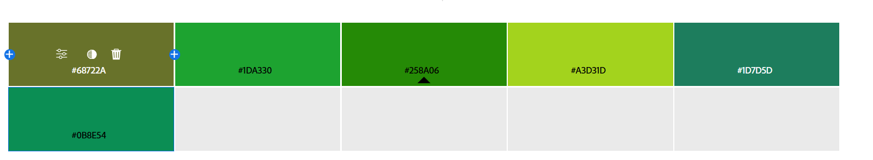

Pictures
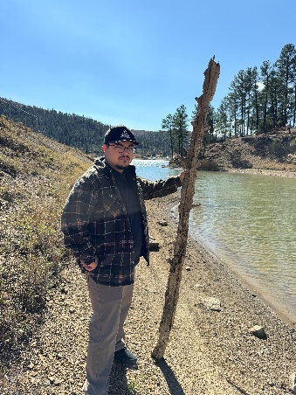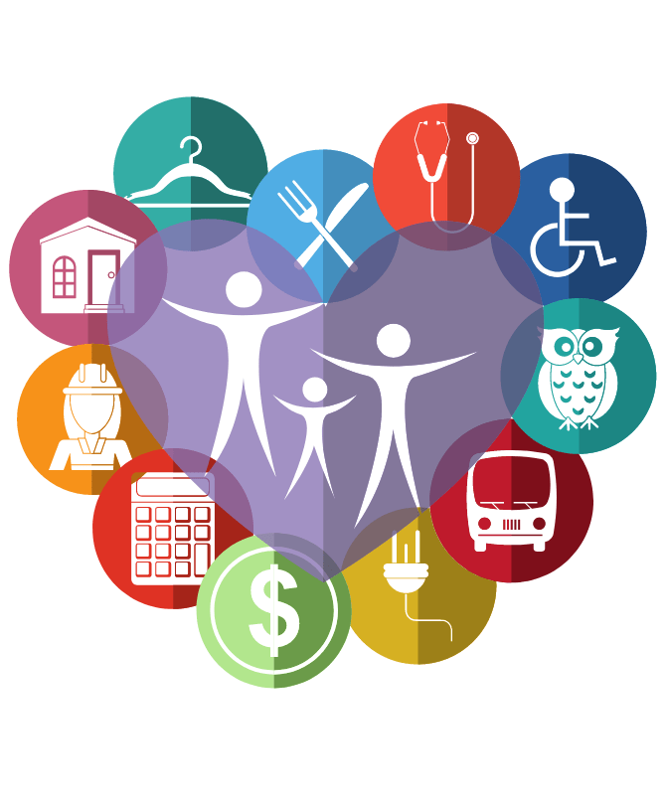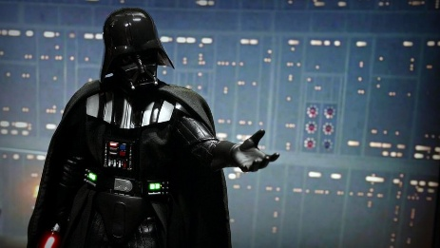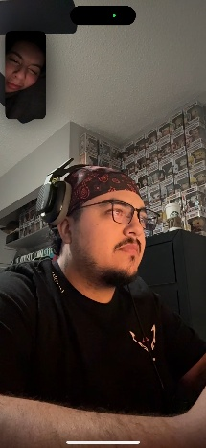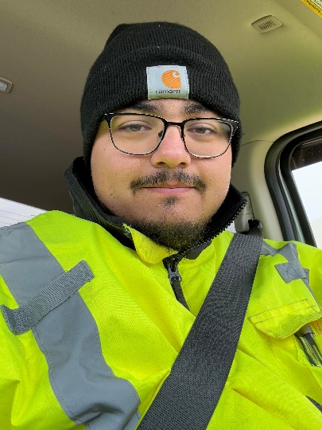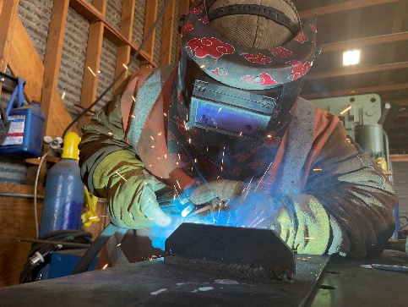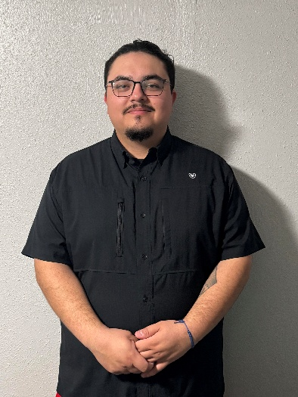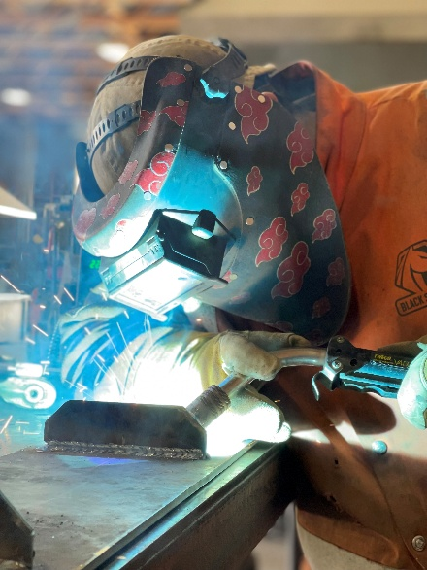

Resources:
Canva. (n.d.). Canva [Website]. https://www.canva.com
Lawrence Public Library. (n.d.). Community resources [Image]. Community Resources. https://lplks.org/community-resources/
StarWarsPR. (2015, December 10). Photo of Darth Vader "Join me and together we can rule the galaxy as father and son." [Photograph]. X. https://x.com/StarWarsPR/status/675036102458277888
OpenAI. (2023). ChatGPT (Feb 2026 version) [Large language model]. https://openai.com/chatgpt

