Developers: Sara White and Patrice Moracchini
Contents
Create a new todo task item 1
Delete a todo task item 2
For invalid URLs, provide users with a custom 404 error page 3
Prevent users from submitting a task form without entering a todo item 4
Prevent users from submitting the edit form without entering a todo item 6
Create a new todo task item 8
View a list of todo task items 9
Edit a todo task item 11
Delete a todo task item 12
For invalid URLs, provide users with a custom 404 error page 14

Test 1 | Create a new todo task item
 | Test Objective: Verify that a user can enter a valid task item (four or more characters) and add it to the Todo List. | Developer:  Sara White  Date tested: 2026/06/25 | Peer tester: Carolina Rodriguez  Date tested: 2026/06/28
Step | Action | Expected results: | Developer pass/fail | Tester pass/fail
1 | Go to https://buwebdev.github.io/todo/ | The website should load successfully | Yes | Yes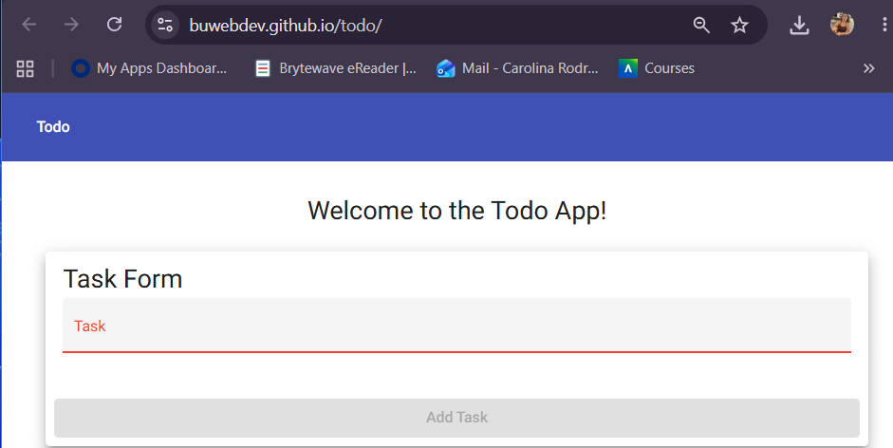
2 | Type in a task item (you can type “Test task item” | Add task button should remain grey/unclickable until at least 4 characters have been entered into the task form field | Yes | Yes -task button remains grey at 3 characters.  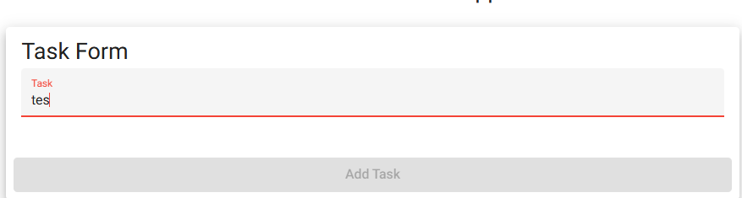
3 | Click “add task” | After clicking “add task” the new task item should be added to the bottom of the todo list | Yes | Yes
Comments | The website loaded with no issues. I was able to type in a task item using the provided text (Test task item). After 4 characters were present in the input field, the “add task” went from grey to dark pink. I was able to click the “add task” button and the new task appeared at the bottom of the to do list.

Test 2 | Delete a todo task item
 | Test Objective:  Verify that a user can remove an existing task item from the Todo List | Developer:  Sara White  Date tested: 2026/06/25 | Peer tester: Carolina Rodriguez  Date tested: 2026/06/28
Step | Action | Expected results: | Developer pass/fail | Tester pass/fail
1 | Go to https://buwebdev.github.io/todo/ | The website should load successfully | Yes | Yes  
2 | Click the trashcan icon to the right of a Todo List task item | Task item should disappear from Todo List | Yes | Yes – clicking trashcan icon removed “Test task item”.  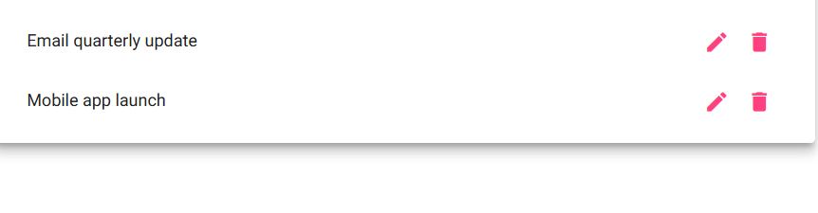
Comments | The website loaded properly and after clicking the trashcan icon, the task item was removed from the Todo list.

Test 3 | For invalid URLs, provide users with a custom 404 error page
 | Test Objective:  Verify that a custom 404 message displays when an invalid Todo website URL is entered | Developer: Sara White  Date tested: 2026/06/25 | Peer tester: Carolina Rodriguez  Date tested: 2026/06/28
Step | Action | Expected results: | Developer pass/fail | Tester pass/fail
1 | Go to https://buwebdev.github.io/todo/404test | The site does not load a regular Todo page | Yes | Yes
2 | Confirm a custom 404 message is displayed | User should see a custom 404 message (“not-found works!”) instead of a generic browser error | Yes | Yes – not found error works  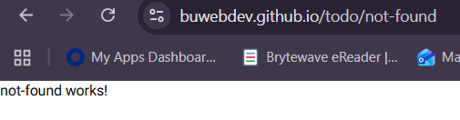
Comments | After visiting the provided invalid Todo URL, a page was displayed with a custom 404 message that read “not - found works!”

Test 4 | Prevent users from submitting a task form without entering a todo item
 | Test Objective:  Verify that the task form prevents a user from submitting a task item that is less than four characters. | Developer:  Sara White  Date tested: 2026/06/25 | Peer tester: Carolina Rodriguez  Date tested: 2026/06/28
Step | Action | Expected results: | Developer pass/fail | Tester pass/fail
1 | Go to https://buwebdev.github.io/todo/ | The website should load successfully | Yes | Yes -  
2 | Click inside the Task Form input field | Placeholder text (“Task”) should shrink above caret | Yes | Yes  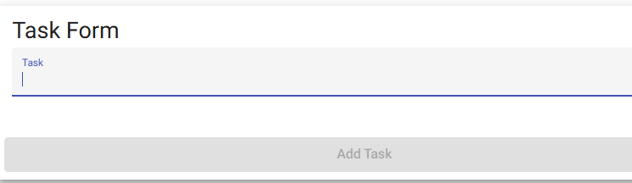
3 | Type “123” into the Task Form | “Add task” button should remain grey and inactive | Yes | Yes  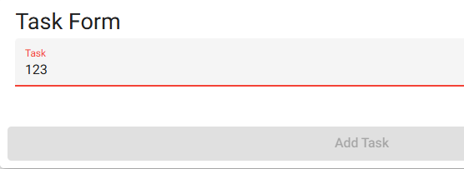
5 | Click “add task” | Nothing should happen. | Yes | Yes – task bar remains grey
Comments | After typing “123” (with no additional characters or spaces) into the task form, the “add task” button was greyed out. I attempted to click the button, and nothing happened.

Test 5 | Prevent users from submitting the edit form without entering a todo item
 | Test Objective:  Verify that the task form within the edit popup prevents a user from submitting a task item that is less than four characters. | Developer:  Sara White  Date tested: 2026/06/25 | Peer tester: Carolina Rodriguez  Date tested: 2026/06/28
Step | Action | Expected results: | Developer pass/fail | Tester pass/fail
1 | Go to https://buwebdev.github.io/todo/ | The website should load successfully and task items should be present in the Todo List | Yes | Yes  
2 | Click the edit icon to the right of one of the task items in the Todo List | Edit Form will pop up in the center of the page with the current task item in the input field | Yes | Yes  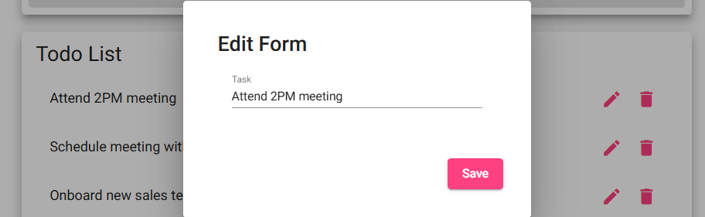
3 | Delete the text in the task item field (do not type anything into the field) | User should be able to delete the existing task item and the “save” button should appear grey | No | No – Task was deleted but remained on Todo List with blank in field.  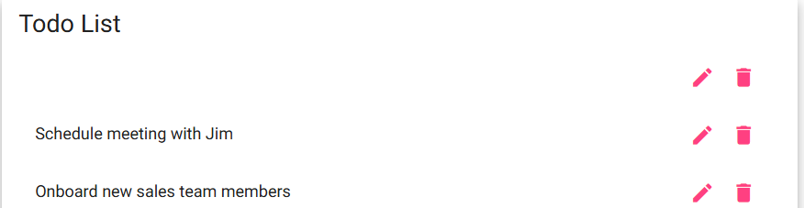
4 | Click the “save” button in the bottom right corner | Nothing should happen. The “save” button should not be clickable and should only be active and appear dark pink if four or more characters have been entered in the task item field | No | No – “Save” button remains active  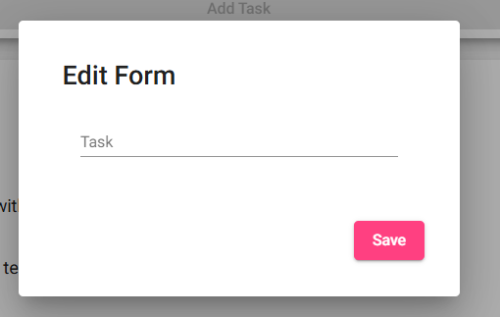
Comments | The website loaded successfully and the edit button is working correctly, but the “save” button does not grey out and is still active when no text or characters are in the task item field. I was able to save a blank task item.

Test 1 | Create a new todo task item
 | Test Objective:  The test checks that the user can add a task item to the Todo list. | Developer: Patrice Moracchini  Date tested: 2026/06/25 | Peer tester: Carolina Rodriguez  Date tested: 2026/06/28
Step | Action | Expected results: | Developer pass/fail | Tester pass/fail
1 | Visit https://buwebdev.github.io/todo/ | The browser displays the page. | Yes | Yes  
2 | Click in the task form box. | The cursor appears under “Task”. | Yes | Yes - 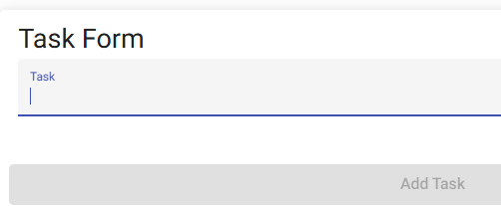
3 | Type the new task item. | The text appears as the user types it. | Yes | Yes
4 | Click “Add Task”. | The box is clickable and the task is submitted. | Yes | Yes – “Add task” is no longer greyed out after entering more than 3 characters.  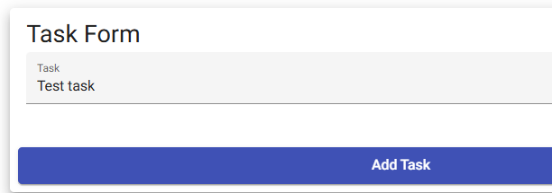
5 | Scroll down to check the task has been added. | The task appears at the bottom of the list. | Yes | Yes  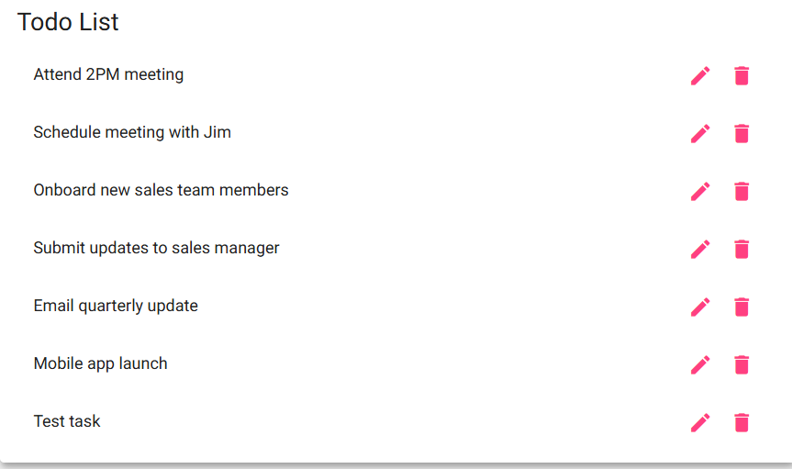
Comments | Peer comment- This test confirms that the main task creation feature works correctly. Creating a task is the highest-ranked requirements and should be verified early.

Test 2 | View a list of todo task items
 | Test Objective:  The test checks that the user is able to view a list of todo task items. | Developer: Patrice Moracchini  Date tested: 2026/06/25 | Peer tester: Carolina Rodriguez  Date tested: 2026/06/28
Step | Action | Expected results: | Developer pass/fail | Tester pass/fail
1 | Visit https://buwebdev.github.io/todo/ | The browser loads the page without error. | Yes | Yes  
2 | Scroll down to see the complete todo list | The page is responsive the scroll works and it displays the complete todo list. | Yes | Yes- After adding multiple tasks, the page is responsive to scrolling down.  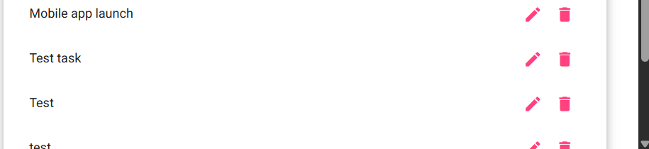
3 | Refresh the page. | The browser displays correctly the page with the todo list. | yes | No – refreshing the page eliminates any “additional” tasks added.  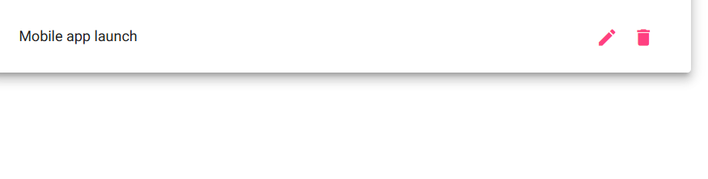
Comments | Peer comment- This test confirms that users can view task items after adding them. It also checks that multiple tasks are displayed clearly in the list. However, refreshing the page does remove any added tasks.

Test 3 | Edit a todo task item
 | Test Objective:  The test checks that the user can edit a task item from the list. | Developer: Patrice Moracchini  Date tested: 2026/06/25 | Peer tester: Carolina Rodriguez  Date tested: 2026/06/28
Step | Action | Expected results: | Developer pass/fail | Tester pass/fail
1 | Visit https://buwebdev.github.io/todo/ | The browser displays the page. | Yes | Yes  
2 | Click the pencil-shaped icon. | The icon is clickable and an “Edit Form” window appears with the task, a cursor and a save button. | Yes | Yes  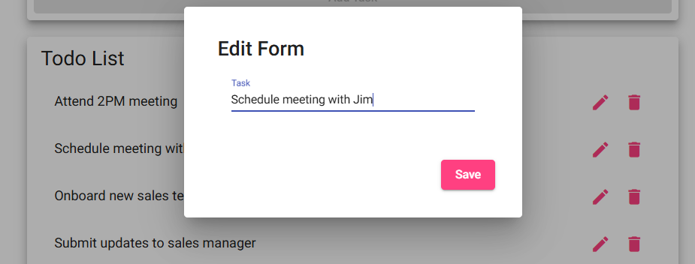
3 | Edit the task and submit it. | The task can be edited and saved. | Yes | Yes- task can be edited  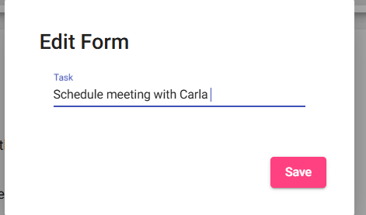
4 | Confirm that the task has been edited and appears in the list. | The edited task is listed. | Yes | Yes-updated task appear on list.  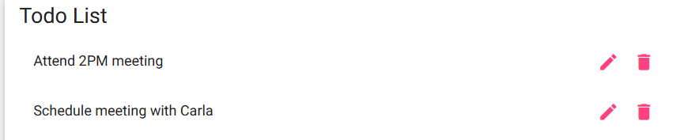
Comments | Peer comment -This test confirms that existing Todo items can be updated. The edit action should save changes and display the revised task in the list.

Test 4 | Delete a todo task item
 | Test Objective:  The test checks that the user is able to delete a task item from the list. | Developer: Patrice Moracchini  Date tested: 2026/06/25 | Peer tester: Carolina Rodriguez  Date tested: 2026/06/28
Step | Action | Expected results: | Developer pass/fail | Tester pass/fail
1 | Visit https://buwebdev.github.io/todo/ | The browser displays the page. | Yes | Yes  
2 | Click on the “trash can” shaped icon corresponding to the task that the user wants to delete. | The app removes the chosen task. | Yes | Yes
3 | Review the list. | The chosen task has been removed from the list. | Yes | Yes – Task was removed after clicking the trashcan  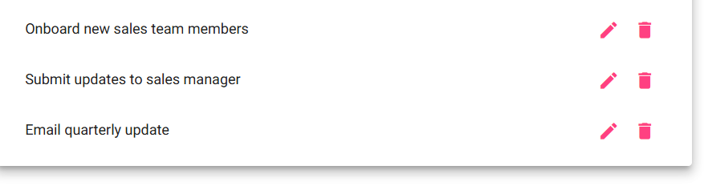
Comments | Peer comment- This test verifies that users can remove tasks they no longer need. Deleting tasks helps keep the list accurate and organized.

Test 5 | For invalid URLs, provide users with a custom 404 error page
 | Test Objective:  The test checks that when the user enters an invalid URL, the browser will display a custom 404 error page. | Developer: Patrice Moracchini  Date tested: 2026/06/25 | Peer tester: Carolina Rodriguez  Date tested: 2026/06/28
Step | Action | Expected results: | Developer pass/fail | Tester pass/fail
1 | Visit https://buwebdev.github.io/tod | The browser requests an address with a character missing. | Yes | Yes
2 | Review the displayed page. | A 404 error page with a custom message appears | Yes | Yes- error message but not with custom message- 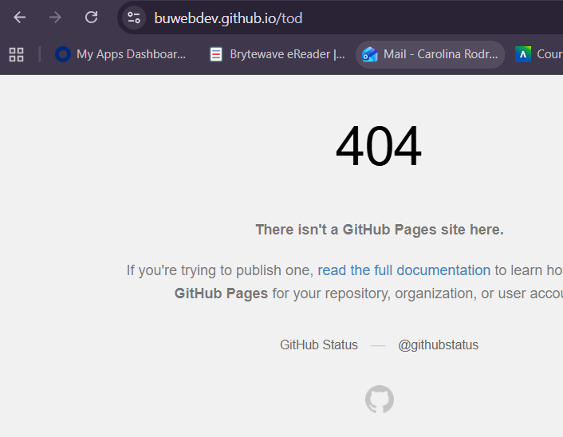
3 | Refresh the page with the same typo. | The same 404 error page appears. | Yes | Yes
4 | Enter the right address https://buwebdev.github.io/todo/ | The page displays correctly without error. | Yes | Yes  
Comments | Peer comment- This test verifies a 404 error message is displayed when the incorrect URL is entered. It does not however display a custom message unlike the first peer test/fail.

